KS2 Teacher Job Description

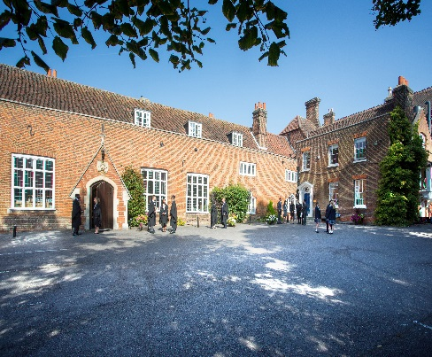
Introduction

Chigwell School is seeking a well-qualified, energetic and committed KS2 teacher to join our highly successful School in April 2018. It is anticipated that the successful candidate will have had experience in a similar role, in particular teaching Year 6 in another maintained or independent school. There may well be the opportunity in this post to be a subject co-ordinator. This is a full time, permanent position.

Background

Founded in 1629 by Samuel Harsnett, the son of a Colchester baker who went on to become Archbishop of York, Chigwell School stands on it original site with the original school building still in use. However, whilst Chigwell of today is conscious of its long-standing history, it is a forward-looking, ambitious, co-educational independent school of 930 pupils aged four to eighteen. It enjoys excellent facilities, a dedicated staff, bright and hardworking pupils, and a site of 100 acres.

Chigwell School is located in the picturesque village of Chigwell just over ten miles from central London and on the Central Line. The extensive, beautiful grounds are close to the edge of Epping Forest and it is rare for a school to have so much space and yet be so close to the centre of the Capital. Most pupils are day pupils but in the Sixth Form, there is a small community of international boarders, roughly twenty five from different countries, and these live in four small boarding houses.

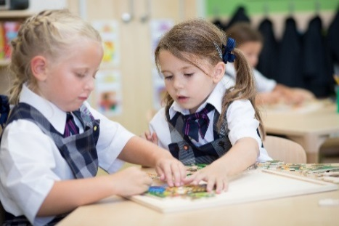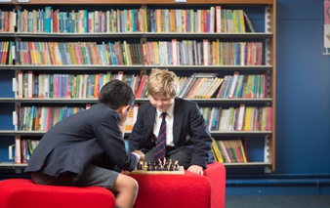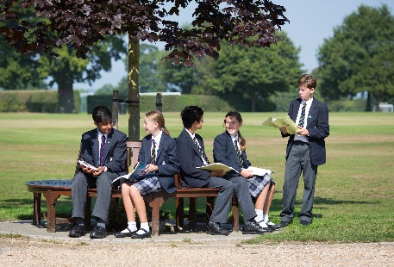
As well as being an academic school, Chigwell has the reputation for providing a rich and full education, with plenty of opportunities for all pupils who are enthusiastic, co-operative and able. Chigwell is a caring and friendly school, with a close sense of community, not least between colleagues. As the 2015 Good Schools Guide reports: Academically, pupils are put through their paces but it all seems to be done in such a civilised and pleasant manner that you are more likely to hear pupils talk about opportunities and prospects than pressure and stress. “Anyone who wants to do well here, will do well” said one student, and I can’t think of a nicer place to succeed.”

The School Development Programme

Over recent years, the School’s facilities have been extensively developed in order to enhance the educational experience that pupils receive. The development programme has included the following additions:
- 2008 Wilson Building teaching block
- 2008 Floodlit AstroTurf pitch
- 2009 Junior School library extension
- 2010 Complete redevelopment of catering facilities
- 2010 Sixth Form coffee shop
- 2010 Harsnett’s and Church House converted into boys’ boarding houses
- 2012 The Old Chigwellian Club and land was incorporated into the school estate
- 2013 Pre Prep School built and opened
- 2013 Two new science labs created
- 2014 Drama Centre balcony extended to provide additional music and drama rehearsal space
- 2016 The Risham Sarao Sixth Form Centre was completed

Currently, the extension of the Dining Hall is underway. In the future we plan to:
- Renovate the Chapel
- Develop the Sports Centre
- Expand our music facilities
- Further expand our provision of bursaries

Chigwell School

Some pupils join in Reception and there are two classes in each of the three Pre Prep year groups. A small number of other children join the Junior School at 7+ (Year 3) and there are two or three classes in each of the KS2 year groups. At 11+ (Year 7), there is a further entry with four classes making up Years 7 to 11. Again, there is a small entry into the Sixth Form. Entry at each stage is selective and although there are three main sections to the School (Pre Prep, Junior School and Senior School) these sections work closely together and there is a common ethos running throughout.

There are over a hundred teachers and together with the support staff, there is a friendly, mutually-supportive atmosphere. All teaching staff contribute to the extra-curricular programme.

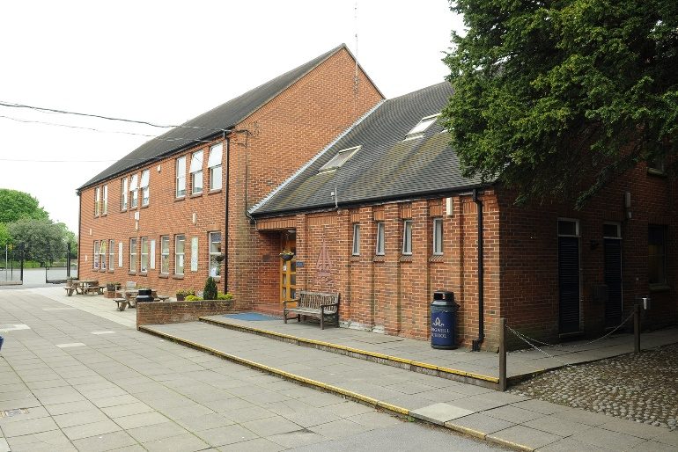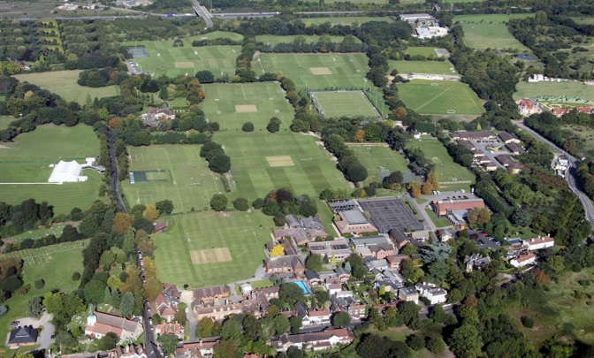

The Role

The successful applicant will be:
- A class teacher, able to teach across the range of subjects in KS2 to a high level.
- Able to work well with children, parents, carers, colleagues and other professionals.
- Possessed of the ability to motivate and enthuse young children to achieve high academic and personal standards.
- Able to show empathy and to create a structured, caring and stimulating environment for children to develop their potential.
- Involved in the successful, well-established extra-curricular programme.
- A team player with excellent communication, organisational and time management skills.
- Energetic, patient and able to show a sense of humour and a spirit of adventure.
- A contributor to school life as a whole.

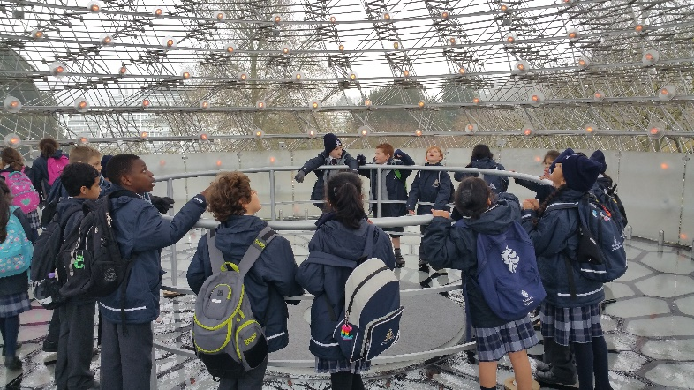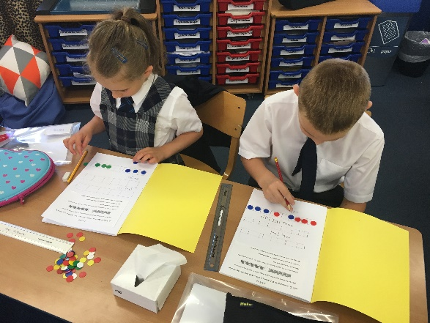

More specifically a KS2 teacher will:

- Promote high quality teaching and learning across a range of subjects.
- Keep clear records and monitoring the academic progress of pupils in the class.
- Assess pupil work providing appropriate feedback.
- Be an enthusiast in the classroom.
- Plan and present lessons in a variety of teaching styles.
- Provide a positive, safe and stimulating environment for pupils to learn in.
- Help, guide and advise pupils on a day to day basis.
- Deal with general classroom issues, communicating with colleagues when necessary.
- Maintain good order and set standards of discipline in line with the School ethos and rules.
- Communicate with parents as and when necessary.
- Write subject and pastoral reports and follow up any comments.
- Contribute to the extra-curricular life of the School.
- Deal with general classroom administration.
- Attend meetings of KS2 staff and other bodies to contribute to discussions on the academic, pastoral and co-curricular life of the School.

The Junior School

The Junior School is a thriving, high achieving, School that combines excellence academically with a caring ethos and a wide range of co-curricular opportunities. Pupils join the Junior School at 7 years old as day pupils from either Chigwell Pre Prep or from a wide range of primary or preparatory schools. Our academic and pastoral structures are designed to develop the 7 year old right through to the end of his or her teenage years.

Our children are taught in small classes with inspirational teachers and together they create the very happy atmosphere for which the school is renowned. Our pupils benefit from their access to the facilities of the whole school, such as the science laboratories, art and design centre, music department and Information and Communication Technology laboratories, and the extensive sports facilities.

There may well be the opportunity in this post to be a subject leader.

Chigwell School is increasingly using ICT as a teaching, learning and administrative tool. All rooms are networked, they have integrated whiteboards and have data projectors, and all teachers receive a laptop.

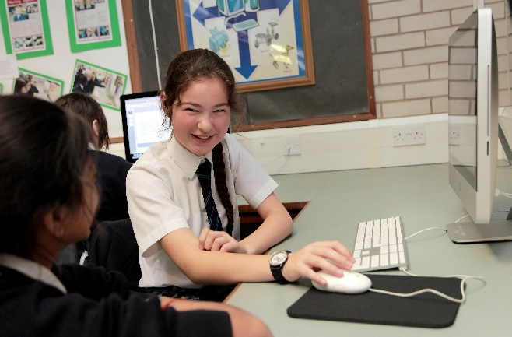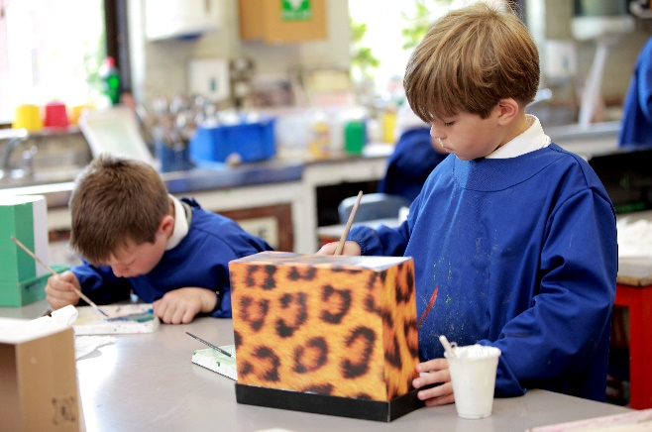

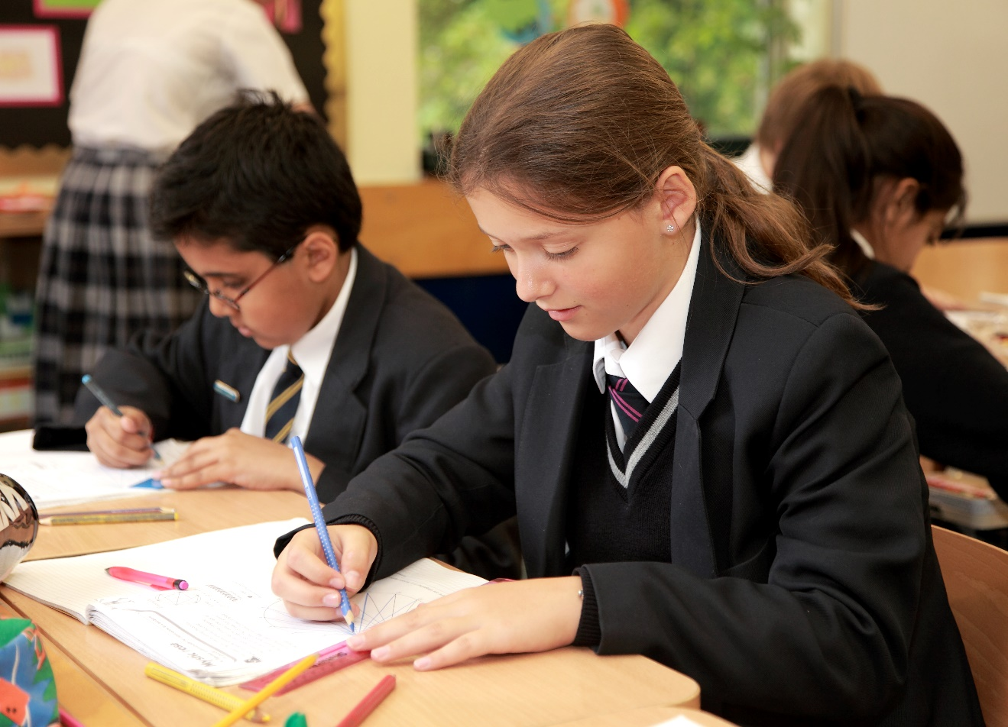

Salary: The salary on offer is competitive and based on National Pay Scales with a Chigwell enhancement.

Chigwell is a very happy place to work, the environment is pleasant and colleagues are supportive of each other. There are good relationships between teaching and support staff, staff and pupils, and between staff in different sections of the School. There is an induction programme and an annual appraisal system linked to INSET.

Hours of work: This is a full time position during term time only.

Benefits of working at Chigwell School include:

- A competitive salary  - Access to the School Pension Scheme  - Free lunch and refreshments during term time  - Childcare Vouchers  - Personal Accident Cover  - Employee Assistance Support Programme  - On site free parking and cycle racks  - Use of School Library | - Medical Centre on site  - Free use of School’s sports facilities outside of the School day  - Commitment to professional development  - A supportive community of highly motivated students and staff  - A beautiful working environment- 100 acres site beautifully landscaped with a number of listed buildings

Applications

Applicants should complete the teaching staff application form which can be accessed directly from our website: www.chigwell-school.org (Vacancies) and sent to the Headmaster’s P.A.: hmpa@chigwell-school.org The Head of the Junior School, Mr Andrew Stubbs, will be happy to answer any questions; he can be contacted at the School by telephone 020 8501 5725 or by e-mail to astubbs@chigwell-school.org

Closing date: Friday 5th January 2018. Early applications are welcome.

Chigwell is committed to safeguarding and promoting the welfare of children and young people and expects all staff and volunteers to share this commitment. Applicants must be willing to undergo child protection screening including checks with past employers, prohibition orders and enhanced DBS.

