 Matravers

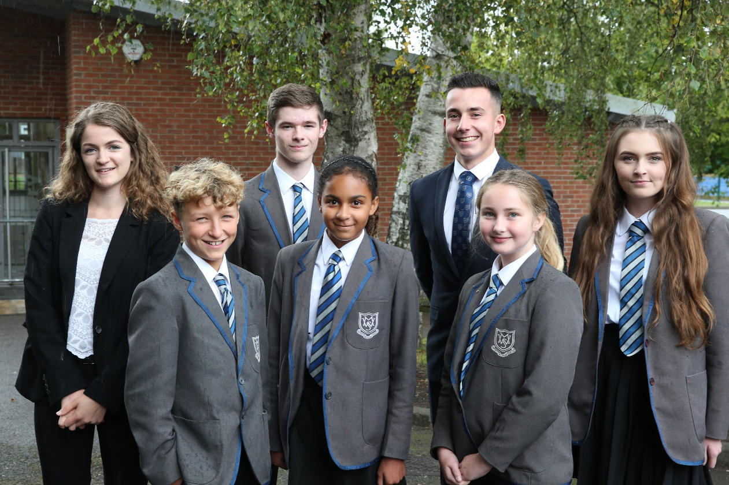

Candidate Information – 2017/2018

# Candidate Information – 2015/2016

Dear Candidate

Thank you for expressing your interest in a vacancy at Matravers School, which I am honoured and proud to lead.

I joined Matravers School in September 2013 from an Outstanding National Teaching School. My aims and ambitions for Matravers are very simple: to transform Matravers into an Outstanding National Teaching School where all students flourish. This is something that we are rapidly doing. Our latest Ofsted report from April 2015 confirmed this.

Matravers offers an incredibly lively and positive ethos alongside an outstanding range of opportunities that all students benefit from. Our cutting-edge learning environment, where everyone works together to achieve their full potential in their academic and personal development, is superb. Students at Matravers enjoy the ability to think creatively, critically and innovatively and possess a strong sense of responsibility, loyalty and moral purpose for the school and the wider community.

I believe that teaching needs to inspire learners and engage them through its vibrancy and energy. The passion with which teachers deliver their lessons at Matravers draws students into a culture of success and achievement. It is this culture that empowers every individual to recognise how they can improve and be supported to deliver higher standards.

Through our strong, close partnerships between students, their families and school staff we ensure that every Matravers student has the opportunity to let their light shine in whatever arena they excel; we provide the right conditions to ensure that this happens.

Our approaches focus are based on very traditional principles. Our calm and purposeful environment enables children to focus on their learning and succeed.

If you feel that you are able to significantly contribute to this incredibly successful journey then I look forward to meeting you and welcoming you into our exceptional learning environment.

Dr Simon Riding Headteacher

Matravers School is an excellent 11–18 National Teaching School Strategic Partner situated in the Wiltshire town of Westbury. We are a 1350 student school and have a staffing complement of 85 teachers. The Senior Management Team consists of: Headteacher; 3 Deputy Headteachers; and 3 Assistant Headteachers. All teachers are qualified to at least degree standard. The teaching staff work extremely hard for the school and have an outstanding reputation for their care of our students, their commitment to improving learning and for the mutual support and help they give each other. They form a strong team and are supported in the classroom by a large team of superb support staff.

Matravers is committed to safeguarding all the young people in our care. All members of staff and volunteers undergo enhanced Criminal Records Bureau checks every three years.

## Vision & Values

Our vision is for Matravers School to be a world-class centre for teaching and learning at the heart of the Westbury community. Achieving this involves ensuring that every Matravers student exceeds their potential in all aspects of their education. We will provide the outstanding teaching, learning and leadership needed to fulfil this goal. Our outreach and support of others ensures that we are working at the cutting-edge of education as a system leader

Our values are embedded in all that we do at Matravers School. We believe they reflect our approach to ensuring that our students receive the most fulfilling and rewarding education possible.

***Resilience*** We equip our students with high quality core skills and the aptitudes to use them in order that they become independent enquirers team workers; effective participants; self-managers; reflective learners; and creative thinkers. Our inspiring teaching and learning empowers our students to meet any challenge with confidence and succeed in life.

**Creativity** We embed confidence and self-belief within our students by inspiring a passion for learning which extends to every member of the community. Students strive for excellence; teachers, support staff and the wider community continually enhance a flexible repertoire of skills in order to enable students to exceed expectations..

***Ambition***We enable our students to realise that anything is possible. There are no ceilings or limits to our aspirations.  We embrace an atmosphere of success across the whole school, which is publicly recognised and celebrated.

***Happiness***We recognise that every student is an individual. We care greatly for each pupil, providing them with the support and guidance they need to be fulfilled and happy.

***Success*** We empower our students to raise their aspirations towards excellence. We ensure this happens by setting challenging targets and rigorously monitoring progress towards them.  Through our home/school partnership we engage parents in the learning success of their children.

**Dynamism**We ensure that our students grow and develop into well-rounded, reflective individuals with a strong sense of moral purpose. By doing so we encourage them to contribute positively to the world in which we live.

## The Facilities

Matravers is pleasantly situated in the centre of Westbury. The school buildings are a combination of traditional brick alongside a number of recent additional blocks which include:

* a specialised Photography, Art and Design block
* a Dance and Music centre
* a Sports Hall
* recently refurbished Food Court area
* a Drama block
* a state-of-the-art dedicated Post-16 centre
* ICT-rich environment (PC and Applemac suites) along with extensive online resources
* outdoor conservation areas and performance spaces
* a new astro-turf and fitness suite

We are a “Priority School Building Programme 2” School and in April 2018 a new 28 classroom block is being built onsite, alongside significant upgrades to another main block.

## Curriculum

All students at Matravers follow a broad and balanced “outstanding” curriculum specifically designed to maximise the progress that every student makes. Matravers operates a fortnightly timetable of 50 one-hour lessons which gives a weekly teaching time of 25 hours for the compulsory curriculum.

During Key Stage 3 (Years 7 to 9) all students study English, Mathematics, Science, Technology, Information Communication Technology (ICT), Humanities (History, Geography and RE), Modern Foreign Languages (French and Spanish), Physical Education, the Expressive and Performing Arts (Art, Dance, Drama & Music) and Personal Social Health and Economic (PSHE) Education & Citizenship. Setting occurs in a number of subjects to support individual student progression.

During Key Stage 4 (Years 10 and 11) every student follows a common core of English, Mathematics and Science. Students also study Physical Education and Personal, Social, Health and Economic (PSHE) Education & Citizenship. In addition to these core subjects, students have the opportunity to choose from different pathways. These Pathways are regularly reviewed and we work with students and parents to provide the best advice and guidance in relation to this.

At Key Stage 5 we offer an “outstanding” range of subjects that incorporate both academic and vocational study. There are many opportunities for additional study beyond the curriculum.

## School Day

|  |  |  |
| --- | --- | --- |
| 8.30 | — 8.50 | * Tutor Time/Assembly |
| 8.50 | — 9.50 | — Period 1 |
| 9.50 | — 10.50 | — Period 2 |
| 10.50 | — 11.10 | — Break |
| 11.10 | — 12.10 | — Period 3 |
| 12.10 | — 13.10 | — Period 4 |
| 13.10 | — 13.50 | — Lunch |
| 13.50 | — 14.00 | — Tutor Time |
| 14.00 | — 15.00 | — Period 5 |
| 15.00 | — 16.00 | — Prep |

**Additional Support**

Students with special educational needs are able to access a range of “outstanding” support provision throughout their time at Matravers. This support is based on individual needs and our Learning Support Team ensures that students are well cared for. Our outcomes for children with Special Educational Needs are “Outstanding”.

In addition to this we offer many ‘drop-in’ sessions and specific advice and guidance for students.

## Enrichment

Prep activities are “outstanding” as Matravers strongly believes in extending and enriching all students’ experience beyond the formal curriculum. Activities after school, at weekends and in the holidays provide new experiences and the chance to build on existing skills or interests.

Highlights include:

* participation in the Ten Tors event
* the Duke of Edinburgh Award
* Sports Leaders Award
* Dance Leaders Award
* Arts Award
* Gifted and Talented weekends
* Music and Art weekends
* Equestrian Team

Alongside this, we offer a vast range of educational visits and trips locally, nationally and internationally including: France, Ski Trip and The Gambia visit.

From September 2015, we have been operating our own Combined Cadet Force. We were one of the 100 schools selected for this expansion programme.

We do expect all students to engage in enrichment activities and take advantage of the “outstanding” opportunities that we offer.

## Arts

The Arts provides a wide range of exciting activities. A major art show each year showcases A-Level and GCSE students’ work, along with our annual “Design Exhibition”. The art studios are open after school, and there are life drawing classes for Year 11, 12 and 13 students. The Big Draw encourages drawing activities, museum and gallery visits are arranged and students work with professional artists and the Royal Academy.

There are numerous opportunities for students to take part in music, including choirs, instrumental ensembles and other groups.

Our amazing Dance companies, ‘KICKstart’, ‘make*SHIFT*’, ‘Musicality’ and “Endurance” perform at various venues and work with professional companies.

Students enjoy many visits to professional performances and Year 7 students go to the pantomime each year. Large numbers of students take part in our major productions which recently have included ‘Wizard of Oz’, ’Singin in The Rain’, ‘Oliver’ and this years ‘Beauty & The Beast’ in collaboration with our Feeder Primary Schools. Concerts are arranged as well as smaller productions, such as A-Level Drama performances, Music Recitals and Dance in Action shows.

## Sport

The Physical Education Department organises school teams and clubs for all ages in all of the main sports. Practices occur regularly. Inter-tutor competitions run throughout the year.

In addition to this we also provide for a range of specialised sports, depending on the aptitudes of students. We have many students who represent their sports locally, regionally, nationally and internationally.

## Homework

The responsibility for homework is shared between the home and school. This link is emphasised by the student planner which is issued to all students. It contains a diary as well as other useful information to help students to plan their work and enable parents to monitor it. The time students spend on their homework will increase as they move through the

school, typically from about thirty minutes a night in Year 7 to about two hours in Year 11. An after-school study club is available to support students three nights a week.

Sixth Form students are expected to complete four hours independent study per subject per week either at home or in study periods.

## Recognising Achievement

Matravers firmly believes in the importance of celebrating success and recognising when students have performed well. Our reward scheme recognises and promotes:

* Positive attitudes to learning;
* Outstanding achievement and learning behaviour;
* Students’ teamwork and independent learning;
* Praise and rewards have emphasis to encourage students to participate, perform and
* progress.

Celebration Assemblies run termly in order to recognise successful achievement alongside individual rewards and whole school reward events.

## Monitoring Progress

Students are set targets throughout their time at Matravers relating to academic progress and other key indicators of effectiveness. Targets are reviewed regularly with an expectation that students meet at least their minimum targets.

There are a number of opportunities for parents/carers to meet and discuss progress each year, including our ‘Pupil Progress Days’, which occur three times per year. Outside of these formal meetings, Tutors, Progress Leaders and Heads of Departments are always available to discuss any concerns.

## Promoting a Positive Learning Environment

Students are encouraged to demonstrate behaviours and attitudes towards learning that ensure Matravers is a productive and positive learning community. We do not negotiate on this.

Matravers believes that the Tutor is the key to the successful encouragement and monitoring of each student’s academic and personal development within the school. We do encourage parents to contact tutors if concerns arise. Tutor groups consist of approximately 25 students. Normally they and their tutor stay together for five years providing a supportive and caring group. Progress Leaders co-ordinate the work of the tutors.

The Matravers ‘personal tutoring’ scheme ensures that students’ academic and social progress is monitored through regular one-to-one meetings with the tutor. Pupil Progress Days further support this through the opportunity for parents to also be involved in this target-setting and review process. The Senior Management Team annually reviews the progress of each individual student with the Tutor and Progress Leader, enabling additional interventions to be put in place as necessary to ensure appropriate progress is achieved. This work is well supported by the services of school counsellors and the Pastoral Support Team, all of whom play an important role in helping students deal with any issues they may have which hinder learning.

Where one student acts in a way that prevents the learning of others, sanctions such as detentions or isolation will be imposed to remedy the situation or prevent it from occurring again. We run our own on-site ‘Alternative Provision’ centre which caters for students who need additional support and flexibility to achieve. We ask for the support of parents and carers in maintaining an environment and atmosphere in which high standards of work and regard for others may be achieved.

## Uniform

Our uniform policy reflects our values and reinforces our vision of high expectations, academic achievement and opportunity. All students in Key Stage 3 and Key Stage 4 are expected to wear the Matravers School Uniform. From September 2015, a new uniform has been introduced consisting of a Blazer and Tie. Key Stage 5 students are expected to wear ‘smart office wear’ which is defined in our Dress Code for students.

Our school uniform helps to identify our students as members of our school community and promotes a strong, cohesive school identity which supports high standards and expectations in all areas of school life. School uniform promotes harmony between different groups represented in the school, and it enhances security.

Smartness and high standards of appearance are expected at all times.

## Academic Achievement

Matravers School is on a journey of rapid improvement with results improving for the last four years. Our current Year 11 and Year 13 cohort is expected to smash all previous sets of results. This is being achieved through our relentless focus on the basics of Teaching & Learning which ensures that every student recognises their potential. We don’t accept excuses at Matravers and are constantly looking at ways to improve.

## Ofsted

At our last inspection in April 2015, Ofsted identified the following “outstanding” features across the school:

• The Headteacher’s outstanding leadership is driving forward the work of this rapidly improving school.

• The outstanding curriculum, including in the sixth form, is matched to students’ needs exceptionally well leading to the rapid improvements in attendance, behaviour and achievement.

• Students who are disabled and those with special educational needs make outstanding progress.

• Opportunities for students’ spiritual, moral, social and cultural development are rich and underpinned by an exceptional programme of extra-curricular activities. This aspect of the school’s work is outstanding.

• The outstanding provision for disabled students and those with special educational needs meets their needs exceptionally well.

• The quality of teaching across the curriculum, including in the sixth form, has improved rapidly. The majority is at least good and some is outstanding.

• Achievement in vocational subjects is outstanding.

• The outstanding sixth form curriculum is constantly reviewed to ensure that it meets students’ needs very well.

Alongside this all other aspects were identified as “at least good” or “rapidly improving”.

If you are ready to contribute to this, working in a thriving and rewarding environment, we would be delighted to hear from you. The future is incredibly positive.

Matravers



Matravers School Springfield Road Westbury

Wiltshire

BA13 3QH

Tel: 01373 822666

[www.matravers.wilts.sch.uk](http://www.matravers.wilts.sch.uk/)