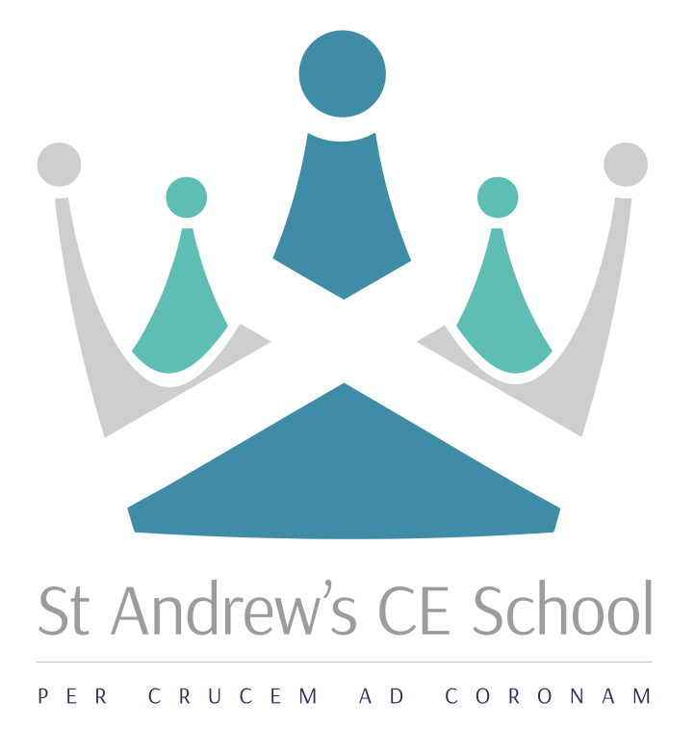

Information for Applicants

Director of Creative and Performing Arts
L7-11 (Outer London Scale)
Required for April 2018

Applications should be submitted by midday on Monday 19 February 2018
Interviews will take place on Monday 26 February 2018
Mission  ‘In God, Through Grace and Guidance,  to Grow and Give’ | Vision  We will ‘StAnd’ together in God’s Grace, to Guide and Grow young people who are motivated, curious and academically successful; who are ready to inspire and aspire to be the very best they can be. Who are ready to give back to their community, work hard and are equipped to embrace life’s many journeys.

Dear Applicant

Thank you for showing an interest in the post of Director of Creative and Performing Arts. Enclosed in this pack is information about the school and the job that you have enquired about. I hope that you will find this useful in helping you to decide if St Andrew’s would be a school you would be interested in joining.

I am the Headteacher, Kerry Targett and joined the school in September 2015. I believe this is a very exciting time to join the school, as it is in the process of building on the strong foundations of many successful years as a prominent and reputable school in Croydon. Recently however, the school has seen its fair share of challenges, particularly since OFSTED placed it in RI in November 2014 and did not move it on following a recent inspection under the new framework. On my arrival I rebranded the school which included a new staffing structure, with new leadership posts created to enable capacity for leadership at all levels. The Senior Leadership Team includes the Headteacher, four Assistant Headteachers and four Senior Leaders who have responsibility for key curriculum areas.

St Andrew’s is a five form entry, Church of England Voluntary Aided School for boys and girls aged 11 to 16. It is a Christian school, within the Diocese of Southwark, serving the Archdeaconry of Croydon. We welcome all students, whether or not they have an affiliation to Christianity or another Faith. We have a fully comprehensive intake; each Year Group includes a number of students with Education and Health Care Plans but also others capable of achieving top grades across the curriculum at Key Stage 4. The demographic of our student intake has changed greatly over the past few years and our students come to us from a range of areas within Croydon boroughs, many having complex home situations and challenges in their personal lives.

Although there are many challenges to overcome there is a great set of dedicated staff who have embraced the changes and improvements to ensure rapid progress; many of the students want to learn and have been reported by internal and external reviews to demonstrate great attitudes to learning in the classroom. There is a desire from the students to be involved in active lessons with opportunities to be creative and engage in meaningful discussions.

The school buildings were expanded between 1995-2000, with the provision in 2000 of a new technology and administration building. Additional buildings, including a drama and music block, additional ICT and technology rooms and some standard classrooms, were completed in autumn 2005. This year further refurbishment of teaching rooms and the new layout of the administration block to include a new reception area, meeting room and new library facility have been completed, along with a total refurbishment of the science block. All classrooms are equipped with projectors and inter-active whiteboards.

We know how important it is for career opportunities and will be expecting staff to be ambitious in their own development; our commitment to staff is to encourage attendance at PiXL events and recognised conferences, to study for an MA / recognised leadership qualifications, to collaborate with schools in the local area or the Diocese and / or to engage with research around teaching and learning.

I am looking for people to work in the team with great drive and determination, someone who is not afraid of challenge, who is personable and flexible but overall who has a passion for making improvement for students which will enable them to make better lives for themselves.

I would be keen to speak with you further should you be interested in a position within our school. Please do feel free to come and visit us if you want to really get an understanding of the work that we do. You are welcome at any time, please contact me on head@standhigh.net .

Kind Regards

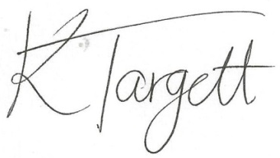

Kerry Targett
Headteacher

Key Information about the school

School: St Andrew’s CE School
Location: Warrington Road, Croydon CR0 4BH
Age Range: 11-16
Type of School: Voluntary Aided School
Denomination: Church of England
Number of Students: 486
Number of teaching staff: 41
Number of non-teaching staff: 36
%students achieving 5xGrade4+ inc EM: 42%

“In God, through Grace and Guidance, to Grow and Give”

From January 2018

Job title: Senior Leader – Director of Creative and Performing Arts
Salary: Leadership Scale: L7 - 11
Responsible to: Assistant Headteacher – Teaching and Learning
Strategic purpose
To ensure high standards of Teaching and Learning across the full Arts curriculum, including DT, Food Technology, Music, Drama and Art and PE, leading to outstanding outcomes for students. To lead the development of the Arts curriculum and its effective assessment and to make a significant contribution to the quality of teaching and learning across the school.

Specific Responsibilities

Strategic Direction and Development of The Creative and Performing Arts
- Establishing and maintaining policies and practices which promote high achievement through effective teaching and learning
- Creating an environment where students and staff develop and maintain positive attitudes towards teaching and learning
- Using data effectively to monitor and evaluate student progress; planning and implementing effective intervention to support all students to achieve highly
- Establishing and building links within the community, particularly with our feeder primary schools
- Responsible for the attainment and achievement of all students within Creative and Performing Arts
- Responsible for the creation and development of an innovative and exciting curriculum and assessment practices within all subject areas
- To consistently teach good and outstanding lessons which bring about excellent outcomes for all students
- To consistently ensure good and outstanding lessons are taught by all members of your faculty which bring about excellent outcomes for all students
- Strategically implement quality assurance measures to ensure attainment and outcomes for our students
- All leaders in the school will devise strategies for raising attainment and ensuring the School Development Plan is implemented successfully
- The post holder may be required to lead in curriculum areas within Creative and Performing Arts
- The post holder will ensure the classroom environment fosters independent and collaborative learning
- The post holder will ensure all classroom displays are meaningfully and purposefully aiding student outcomes
- The post holder will be responsible in ensuring that literacy and numeracy is delivered effectively across the curriculum
- Oversight of the Enrichment programme and Arts programme both in and out of school.
- Development of links with outside agencies and Arts groups to further enhance life experiences to our students.

Teaching and Learning of English / EAL
- Ensuring appropriate, challenging and differentiated programmes of Study and Schemes of Work (Medium Term Plans) are in place for all Performing and Creative Art teaching groups and related courses
- Securing and sustaining effective teaching of the subject through structured monitoring and evaluation of all aspects of teaching and learning and active participation in the school’s monitoring evaluation and review cycle through lesson observations, feedback to teaching staff, work sampling, student interviews and written reports to members of the Leadership Team as necessary
- Ensuring teaching and learning objectives are clear to all members of the curriculum team
- Ensuring effective development of students’ literacy, numeracy and ICT skills within the subject
- Developing the curriculum to meet the needs of all students; introducing, planning and implementing new courses of study to meet KS3 and KS4 curriculum initiatives and developments
- Mapping progress of students regularly against prior attainment and local and national norms and identify students at risk of underachieving
- To consistently ensure your teaching is at least good or outstanding and your outcomes are exemplary and in line with KPIs
- To consistently ensure the teaching of those in your faculty is at least good or outstanding and their outcomes are exemplary and in line with KPIs
- To consistently ensure quality across the faculty through rigorous quality assurance measures
- To regularly observe and develop colleagues and act as a beacon of best pedagogical practice
- To create, lead on and develop whole school continued professional development to ensure outstanding outcomes for students
- Seek opportunities to collaborate with other innovative and high achieving schools and other relevant networks to share and develop excellent pedagogies

Student Achievement and Attainment
- Ensure a rigorous assessment policy is in place so that MTGs can be accurately tracked and monitored in order to ensure all students make outstanding progress
- Set challenging targets that build on prior attainment of every student and ensure our KPIs are met
- Regularly evaluate student progress through assessed pieces of work that are levelled with clear targets to develop. Ensure the quality of feedback throughout the school is in line with the ‘Assessment for Learning’ policy
- Set, track, evaluate and report on both individual student progress and groups of students towards their targets
- Keep systematic records to show students’ understanding and completion of work and the identified strengths, areas for development and grades awarded
- Support and help colleagues to improve their effectiveness by developing their understanding and use of student data and strategies to address underachievement
- Ensure a consistent and continuous focus on student achievement using data to track and monitor the progress in every student’s learning
- Evaluate student progress across specified areas of responsibility through the use of appropriate assessments and records and regular analysis of the data
- Use national and local data effectively to analyse and evaluate student progress; planning and implementing effective interventions to support students. Use local and national statistical data and other information, in order to provide (a) a comparative baseline for evaluating students’ progress and attainment, (b) a means of judging the effectiveness of their teaching, and (c) a basis for improving teaching and learning

Leading and Managing
- Appraise and performance manage colleagues you line manage
- Share good practice through CPD internally and externally
- Model high standards at all times

Efficient and Effective Deployment of Staff and Resources within Creative and Performing Arts
- Using appropriate resources, in consultation with the Assistant Headteacher Teaching and Learning, for effective, efficient and safe teaching and learning within the subject area; accommodation, staff, time, courses, development opportunities and ICT equipment
- Creating an effective and stimulating learning environment for teaching and learning

Working with Others
- Liaison with parents / carers and staff
- Sustain effective, positive relationships with all staff, students, parents/carers, Governors and the local community. Liaise effectively with all stakeholders including parents/carers, feeder primary schools, local secondary schools, business and community partners, in line with strategic objectives
- Plan, chair and organise meetings as appropriate

General Responsibilities
- Take responsibility for the Performance Management of identified staff you line manage
- Develop and maintain a culture of high expectations for self and others
- Update the Headteacher, other senior leaders and the Governing Board on the effectiveness of the provision
- Lead by example as a teacher, and as a Senior Leader, achieving high standards of student attainment and progress, behaviour and motivation through effective teaching
- Challenge under‐performance at all levels, ensuring corrective actions are in place and evaluation takes place to analyse the impact of these remedial actions
- Support the development and maintenance of the School’s policies and practices to ensure consistent application
- Have a teaching allocation, whilst ensuring the overall needs of the school are met
- Take assemblies and participate in break, lunchtime, before and after hours’ supervision as required
- To offer 1 hour of extra-curricular activity for the students to be involved in (can be an activity of choice)
- Any other reasonable duties as requested by the Headteacher

Safeguarding Children
St Andrew’s School is committed to safeguarding and promoting the welfare of students and young people. We expect all staff to share this commitment and to undergo appropriate checks, including enhanced DBS checks

Key Events / Responsibility
- Leading and developing the Arts through annual exhibitions and concerts, whole school events.
- Organising fixture lists for sporting activities, sports day and inter house competitions
- Leading an inter house talent / multi-cultural evening / choir of the year competition
- Leading and supporting a bi-annual school production
- Supporting work in assemblies, church and at local schools

Key Documents Responsibility
- Relevant Contributions to the School Evaluation Document (SED)
- Relevant contributions to the School Development Plan (SIP)
- Relevant policy and practice contributions for the Staff Handbook
- Reports:
  - Contribution to Governors’ Report
  - Contribution to T&L, PPG and Behaviour Reports
Person Specification
Knowledge and Experience | Essential | Desirable
The holder of the post should:
- Have a second-class honours degree, or higher, or equivalent qualification
- Have experience of leadership within school
- Have an MA
- Have experience of effecting innovative practice within school
- Extensive experience of leading, coordinating and monitoring across a Science Department
- Clear evidence of successful teaching across the full ability and age range and at examination level
- Understand what constitutes effective and efficient tracking, monitoring and assessment, and translate that into practical strategies, with particular focus on success of interventions across the school
- Clear evidence of raising student achievement within a successful department as well as experience of raising the achievement of targeted groups
- Experience in a multi-cultural environment
- Up to date knowledge of the science curriculum.
Essential Skills and Abilities
The post holder needs to demonstrate the ability to:
- Inspire, lead and manage others effectively, deploying a range of appropriate strategies to this end as the circumstances demand
- Observe, monitor and evaluate the work of colleagues, responding appropriately
- Manage his or her time effectively, reconciling conflicting priorities
- Delegate responsibilities appropriately
- Effect positive relationships with students and colleagues at all levels
- Communicate effectively in different contexts
- Exercise a high degree of emotional intelligence
- Ability to carry out lesson observations, provide feedback and set suitable targets
- Ability to write clear and concise reports
- Ability to lead, manage and implement changes to the curriculum
- Find innovative and practical solutions to problems on a personal as well as an institutional level
- Demonstrate a calm and controlled demeanour under pressure, with the ability to manage behaviour in others and show emotional resilience
- Engage in personal and professional development
Special Conditions
The post holder is required to:
- Take part in the school’s performance management cycle
- Actively promote the school’s Christian ethos
- Have a current, Enhanced Disclosure from the Criminal Records Bureau

Director of Creative and Performing Arts
Senior Leader – L7 - 11
Required April 2018

St Andrew’s is a successful and highly supportive 11 - 16 Church of England school. St Andrew’s is a friendly school which fosters positive relationships between students of all ages and the staff. It is on a journey of rapid progress and high expectations and all staff are required to play a positive role in developing this focus with the students. The school has a strong Christian ethos which underpins the day to day work of students and staff.

We are seeking to appoint an outstanding teacher who:
- has the ability to lead and inspire staff and students
- is up-to-date on government legislation and curriculum initiatives for their subject
- is passionate about their subject
- would be accountable for student progress
- shows good understanding and use of data to monitor progress, identify under performance and set appropriate interventions
- has the ability to inspire, engage and create innovative lessons across KS3 and KS4
- has an absolute commitment to inclusive education
- loves a challenge
- has excellent inter-personal skills
- would be responsible for creating an exciting learning environment
- can work collaboratively with our local primary schools

In return we can offer:
- the opportunity to work with energetic, supportive and enthusiastic colleagues
- a refurbished department
- scope to make a significant contribution to a school with ambition and vision
- opportunities for professional development in collaboration with other schools and / or through an MA

The school runs an established induction programme. St Andrew’s is committed to safeguarding and promoting the welfare of students and young people and therefore expects all staff to share this commitment. All appointments are subject to a satisfactory Enhanced DBS check.

The application details are available via the school website: www.standhigh.net

Closing Date for Applications: Midday on Monday 19 February 2018

Interviews will be held on Monday 26 February 2018

General Information

Contact Details:

St Andrew’s CE School
Warrington Road
Croydon
CR0 4BH
t. 020 8686 8306
f: 020 8681 6320
e: office@standhigh.net
w: www.standhigh.net

Location Map:

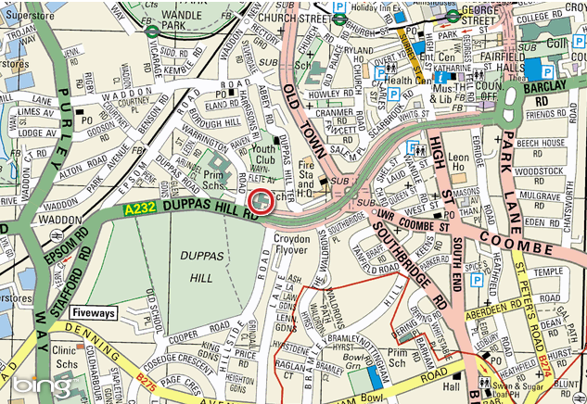

Nearest transport link:

Tube: Morden
Railway: Waddon
Tram: Wandle Park/Church Street

