RECRUITMENT PACK
Teacher of Computing
TMR/UPR
Required as soon as possible
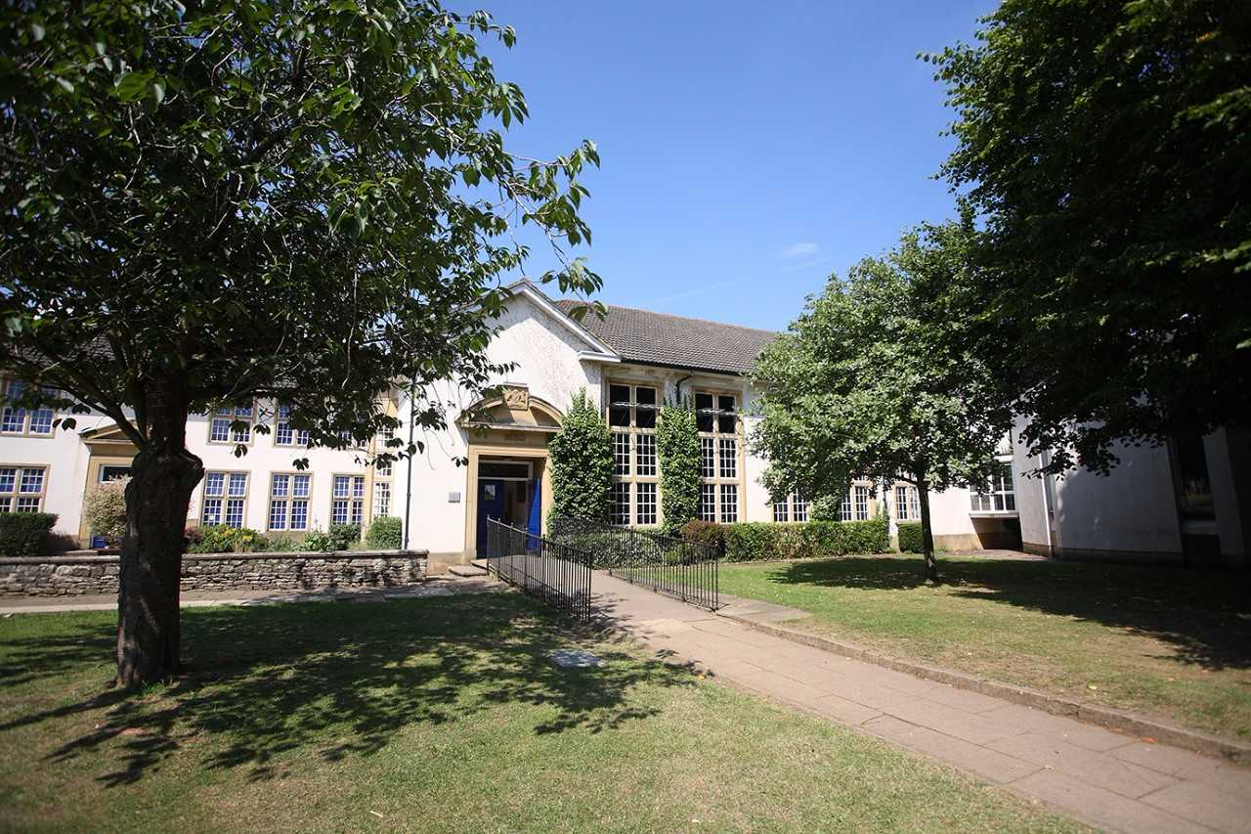

Introduction from the Headteacher

The Henry Box School is a successful, thriving mixed comprehensive school of over 1,200 students situated on Church Green in the historic market town of Witney. The school was founded in 1660 by local man, Henry Box, and the beautiful original school building is still in daily use in the centre of our attractive site. We are proud of our history and tradition and very excited about our future.

The school was inspected by Ofsted in November 2017 and was judged as ‘good’ in every category. The GCSE examination results in 2018 were good, with excellent ‘A’ Level results.

At The Henry Box School, we are fortunate to have fantastic staff, both teaching and support, experienced and supportive governors, and students who have positive attitudes and are keen to learn. Students and staff enjoy respectful relationships, and above all we are a very happy school.

Professional Development is central to our work and we offer opportunities and support for all staff to develop their skills. From our excellent NQT programme through to our ‘Future Leader’ programme, we are committed to recruiting and retaining the best. Being the lead school in our multi academy trust, we can also offer the opportunity for colleagues to develop their careers beyond one school if this is their area of interest.

The Henry Box School is committed to promoting the welfare of children and young people and expects all staff and volunteers to share this commitment. The appointment will be subject to enhanced DBS clearance, satisfactory references and other relevant pre-employment checks.

All staff at The Henry Box School have a responsibility to co-operate with and follow all Health and Safety requirements in accordance with the school Health and Safety Policy.

If you are interested in working in a forward thinking organisation, then Henry Box could well be the place for you. Our commitment to learning, leadership and literacy can found in our latest Ofsted report attached.

Further information about the role is given below.

Yours sincerely
W J Hemmingsley
Headteacher

About the role
Position: Teacher of Computing
Working Hours: Full time Permanent
Required: As soon as possible

We are looking for a well-qualified, committed and enthusiastic Teacher of Computing to join our successful 11-18 comprehensive school. This is an excellent opportunity for a talented and well qualified teacher to join a strong and successful International and Innovation Faculty. Applications are welcome from NQTs or experienced teachers. Visits to the school are welcome, by prior arrangement.

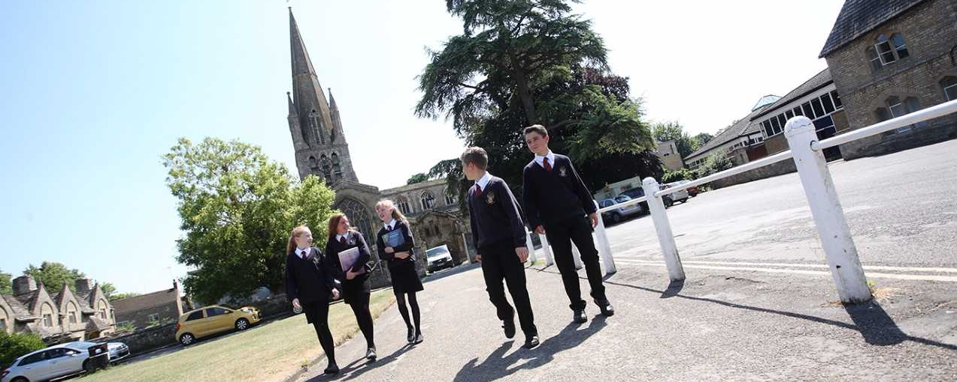

International and Innovation Faculty
The Innovation and International Faculty consists of Computing, Business and Modern Foreign Languages. The school leader of Innovation and International is supported by an assistant school leader and a team leader who is currently responsible for the Computing and ICT courses offered. However, all members of the faculty work closely together to plan a coherent, valuable progression through the key stages. This arrangement is designed to be flexible in order to create continuity and allow opportunities for staff development. The faculty works closely as a team offering professional support in a friendly environment. Regular meeting time is given to the collaborative planning and sharing of resources and each member of the team is encouraged to take some responsibility for the management and development of the faculty.

The faculty is situated primarily in one building, with Computing having three specialist classrooms, including one with flexible pop-up desks. All classrooms are equipped with a smart board or data projector and the ability to show DVDs. Additionally, the faculty has a bank of laptops for use in lessons. Schemes of work, resources, course outlines and teaching guides are available for each year group and offer a broad and balanced curriculum for all students as well as maintaining flexibility for teachers.

The faculty is committed to a wide range of learning and teaching styles and this is reflected in varied classroom activities and lesson planning. The principles and practices of formative assessment form a vital part of our planning and delivery of our curriculum across the key stages. A clear focus on preparing students for summative assessments and national examinations are also built into curriculum maps at all stages; this is a real strength of the faculty and something we are looking to further develop.

We wish to appoint an energetic, creative and enthusiastic Computing teacher who is committed to the development of both the subject and the International and Innovation Faculty. The successful candidate should be able to inspire and motivate students as well as have the ability to work well as part of a lively and professional team.

Health & Safety
All staff at The Henry Box School have a responsibility to co-operate with and follow all Health and Safety requirements in accordance with the school Health and Safety Policy.

Selection Criteria
Essential
- Qualified Teacher Status
- Ability to teach KS3, KS4 and KS5
- Effective behaviour management
- Ability to work as part of a team
- Knowledge of planning, assessment and record-keeping
- Commitment to further training and development
- Conscientious, enthusiastic and positive
- The ability to relate well to students, staff and parents
- Willingness and ability to be an effective tutor

Desirable
- Ability to teach KS5
- Willingness to teach PSHE
- Willingness to contribute to extra-curricular activities
- Evidence of improving practice by identifying and meeting CPD needs

JOB DESCRIPTION: TEACHER (MPR and UPR)

Post Title: Teacher of Computing
Purpose: To raise standards of attainment and achievement of learners

Reporting to: Faculty Leader and Assistant Faculty Leader where appropriate

This job description should be read in conjunction with the current School Teachers’ Pay and Conditions Document and the provisions of that document will apply to the post holder. You will be expected to carry out the professional duties of a teacher as outlined in the School Teachers’ Pay and Conditions Document currently in operation, or any subsequent legislation.

Liaising with: School Leaders, Faculty Leaders, House Leaders and relevant staff with cross-school responsibilities, relevant support staff

Working Time: Full Time Permanent Disclosure Level: Enhanced
Salary: TMR/UPR

TEACHING

SET HIGH EXPECTATIONS WHICH INSPIRE, MOTIVATE AND CHALLENGE PUPILS
- establish a safe and stimulating environment for pupils, rooted in mutual respect
- set goals that stretch and challenge pupils of all backgrounds, abilities and dispositions
- demonstrate consistently the positive attitudes, values and behaviour which are expected of pupils

PROMOTE GOOD PROGRESS AND OUTCOMES BY PUPILS
- be accountable for pupils’ attainment, progress and outcomes
- be aware of pupils’ capabilities and their prior knowledge, and plan teaching to build on these
- guide pupils to reflect on the progress they have made and their emerging needs
- demonstrate knowledge and understanding of how pupils learn and how this impacts on teaching
- encourage pupils to take a responsible and conscientious attitude to their own work and study

DEMONSTRATE GOOD SUBJECT AND CURRICULUM KNOWLEDGE
- have a secure knowledge of the relevant subject(s) and curriculum areas, foster and maintain pupils’ interest in the subject, and address misunderstandings
- demonstrate a critical understanding of developments in the subject and curriculum areas, and promote the value of scholarship
- demonstrate an understanding of and take responsibility for promoting high standards of literacy, articulacy and the correct use of standard Computing, whatever the teacher’s specialist subject
- if teaching early reading, demonstrate a clear understanding of systematic synthetic phonics
- demonstrate a clear understanding of appropriate teaching strategies

PLAN AND TEACH WELL STRUCTURED LESSONS
- impart knowledge and develop understanding through effective use of lesson time
- promote a love of learning and children’s intellectual curiosity
- set homework and plan other out-of-class activities to consolidate and extend the knowledge & understanding pupils have acquired
- reflect systematically on the effectiveness of lessons and approaches to teaching
- contribute to the design and provision of an engaging curriculum within the relevant subject area(s)

ADAPT TEACHING TO RESPOND TO THE STRENGTHS AND NEEDS OF ALL PUPILS
- know when and how to differentiate appropriately, using approaches which enable pupils to be taught effectively
- have a secure understanding of how a range of factors can inhibit pupils’ ability to learn, and how best to overcome these
- demonstrate an awareness of the physical, social and intellectual development of children, and know how to adapt teaching to support pupils’ education at different stages of development
- have a clear understanding of the needs of all pupils, including those with SEN; those of high ability; those with EAL; those with disabilities; and be able to use and evaluate distinctive teaching approaches to engage and support them

MAKE ACCURATE AND PRODUCTIVE USE OF ASSESSMENT
- know and understand how to assess the relevant subject and curriculum areas, including statutory assessment requirements
- make use of formative and summative assessment to secure pupils’ progress
- use relevant data to monitor progress, set targets, and plan subsequent lessons
- give pupils regular feedback, both orally and through accurate marking, and encourage pupils to respond to the feedback

MANAGE BEHAVIOUR EFFECTIVELY TO ENSURE A GOOD AND SAFE LEARNING ENVIRONMENT
- have clear rules and routines for behaviour in classrooms, and take responsibility for promoting good and courteous behaviour both in classrooms and around the school, in accordance with the school’s behaviour policy
- have high expectations of behaviour, and establish a framework for discipline with a range of strategies, using praise, sanctions and rewards consistently and fairly
- manage classes effectively, using approaches which are appropriate to pupils’ needs in order to involve and motivate them.
- maintain good relationships with pupils, exercise appropriate authority, and act decisively when necessary

FULFIL WIDER PROFESSIONAL RESPONSIBILITIES
- make a positive contribution to the wider life and ethos of the school
- develop effective professional relationships with colleagues, knowing how and when to draw on advice and specialist support
- deploy support staff effectively
- take responsibility for improving teaching through professional development, responding to advice & feedback from colleagues
- communicate effectively with parents with regard to pupils’ achievements and well-being

PERSONAL & PROFESSIONAL CONDUCT
- Uphold public trust in the profession and maintain high standards of ethics and behaviour, within & outside school
- treating pupils with dignity, building relationships rooted in mutual respect, and at all times observing proper boundaries appropriate to a teacher’s professional position
- having regard for the need to safeguard pupils’ well-being, in accordance with statutory provisions
- showing tolerance of and respect for the rights of others
- not undermining fundamental British values, including democracy, the rule of law, individual liberty and mutual respect, and tolerance of those with different faiths and beliefs
- ensuring that personal beliefs are not expressed in ways which exploit pupils’ vulnerability or might lead them to break the law.
- Have proper and professional regard for the ethos, policies and practices of the school in which they teach and maintain high standards in their own attendance and punctuality
- Have an understanding of, and always act within, the statutory frameworks which set out their professional duties and responsibilities.

In addition for UPR (STPCD)
- the teacher is highly competent in all elements of the relevant standards
- the teacher’s achievements and contribution to an educational setting or settings are substantial and sustained

General Responsibilities
- taking appropriate responsibility for one’s own health, safety and welfare and the health and safety of pupils, visitors and work colleagues in accordance with the requirements of legislation and locally-adopted policies; including taking responsibility for raising concerns with an appropriate manager

Additional duties
- play a full part in the life of the school community, to support its distinctive mission and ethos, and to encourage and ensure staff and students follow this example
- to promote and lead extra-curricular activities in line with the traditions and expectations of the school within the context of a life work balance

Other Specific Duties
- undertake the role of Form Tutor if required
- share in supervisory duties according to the school’s published rotas
- keep up to date with school information e.g. the weekly bulletin, staff handbook and to clear your pigeon hole daily
- participate in any arrangements within an agreed national framework for the appraisal of your performance and that of other teachers
- continue personal development as agreed
- engage actively in the appraisal process
- whilst every effort has been made to explain the main duties and responsibilities of the post each individual task undertaken may not be identified
- employees will be expected to comply with any reasonable request from a line manager to undertake work of a similar level that is not specified in this job description
- employees are expected to be courteous to colleagues and to provide a welcoming environment to visitors and telephone callers
- the school will endeavour to make any necessary reasonable adjustments to the job and the working environment to enable access to employment opportunities for disabled job applicants or continued employment for any employee who develops a disabling condition.
- undertake any other duty as specified by STPCD not mentioned in the above

For all staff - You have specific responsibilities under Health & Safety / Child Protection legislation to ensure that you:

- take reasonable care for your own health and safety, and that of others affected by what you do, or do not do
- cooperate on all issues involving health and safety
- use work items provided for you correctly, in accordance with training and instructions
- do not interfere with or misuse anything provided for your health, safety or welfare
- report any health and safety concerns to your line manager as soon as practicable
- report any safeguarding children / child protection concerns to a senior member of staff
- attend safeguarding training as requested

This job description is current at the date shown, but, in consultation with you, may be changed by the Headteacher to reflect or anticipate changes in job commensurate with the grade or job title.

The Application Process
We are seeing to appoint the best possible candidate and our recruitment process will reflect our desire to undertake all possible measures to achieve this.

Applicants should download the teaching staff application form from our website.

In addition to the completed application form please submit a letter of application that is no more than two sides of A4.

All applications will be acknowledged upon receipt. Shortlisting will take place shortly after the closing date and candidates will be notified further only if they are successful in being shortlisted. The date for interviews and associated assessment activities will be confirmed in due course.

If you decide you want to be part of our dynamic team, we look forward to receiving your completed application form by our closing date.

Closing date: Tuesday 13th November 2018 at 9am.

In the meantime, if you have any queries about this role, please do not hesitate to contact Abbie Muchecheti (HR Manager) on 01993 848166 Monday to Friday 8.00am – 4:00pm (email jobs@millacademy.co.uk).

