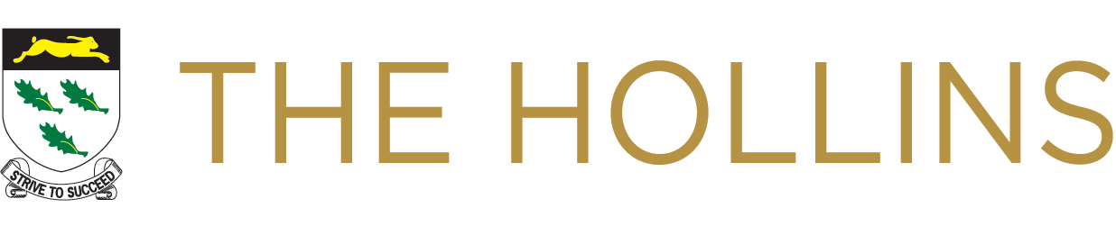

RE/PSHE/CITIZENSHIP DEPARTMENT INFORMATION

Religious Education at The Hollins is delivered by three specialist teachers with pupils receiving at least one hour per week of RE throughout their time at The Hollins. These lessons are taught in dedicated RE rooms. As a department we are also responsible for Citizenship and PSHE. The RE staff are therefore at the forefront of a number of cross-curricular ventures, such as Global Learning, Generation Global video conferencing, Amnesty Youth group, Fair Trade school and Eco/Sustainable Schools. We promote learning outside the classroom and run a number of exciting trips. We also invite guest speakers into school, and encourage our pupils to adopt an enquiry approach to the subjects. The school has been awarded the RE Quality Mark Gold Standard for its provision. We work closely with the careers officers and the Extended Services programme to deliver a varied and meaningful experience for our pupils.

RE plays a central role in the curriculum at The Hollins; not only does the department have a tradition of successful GCSE results, which make a positive contribution to the whole school results (66% of students achieving 4 or above in 2018), but it also contributes to the pastoral excellence of The Hollins, the delivery of SMSC and SEAL aspects of the curriculum. Through this work we have earned countywide, national and international recognition. The Lancashire Agree Syllabus, which we follow, addresses the central question ‘What does it mean to be human?’ Whether our students are religious or not, we endeavour to help them to make sense of a complex world and give them the opportunity to explore their own beliefs and attitudes, religious or not, as well as learn about the beliefs of others.

The RE department was praised in our recent Ofsted inspection; “Pupils’ social, moral, spiritual and cultural education is excellent”, highlighting the department as a real strength of the school.

In Key Stage 3, pupils will study philosophy and ethics, focusing on Christianity, Islam, Buddhism, Sikhism, Judaism and Hinduism as well as non-religious belief systems such as humanism and atheism, and explore their own ideas in relation to these.

We begin our Edexcel GCSE course in Year 9. In Key Stage 4, pupils receive five hours of Religious Studies per fortnight. All pupils are entered for GCSE RE, following the Edexcel Specification B course: Religion and Ethics through Christianity and Religion, Peace and Conflict through Islam. This course also meets some of the National Curriculum criteria for the study of citizenship, and includes some PSHE.

Off timetable days for the study of PSHE and citizenship themes are held for Key Stage 4 pupils at various times in years 10 and 11.

