JOB DESCRIPTION

TEACHER OF ENGLISH
Responsible to: Director of Teaching and Learning
Head of Department
Pupil Progress Managers

All teachers are responsible for the intellectual, personal and social development of pupils in their care. There are school policies and procedures, which should be followed, and on a day to day basis, guidance and support is provided by PPM and Heads of Faulty who are in turn supported by the Senior Management Team. The Staff Handbook provides detailed guidance on policies and procedures.

As a member of the English Department, the teacher will:
- Ensure improved examination results by:
- Teaching English across a wide range of ages and abilities, and from Year 7 to ‘A’ level, as required.
- Being responsible for the progress, assessment, welfare and discipline of the pupils she/he teaches under the direction of, and with the support of the Head of Department;
- Enabling pupils to achieve the highest standards at an individual level;
- Monitoring, assessing and the progress of all pupils;
- Identifying any pupil with special learning needs and taking appropriate action;
- Contributing to the preparation of units of work for use throughout the department;
- Familiarise herself/himself with the resources available within the department, the Library and the school in general;
- Valuing the pupils’ work in a variety of ways, including the presentation / publication / display of work for as wide an audience as possible, rapid marking and return of work and also other forms of praise and rewards;
- Setting regularly and marking homework for all pupils in accordance with the school policies;
- Working under the general direction of the Head of Department, adhering to, and helping to develop department resources.
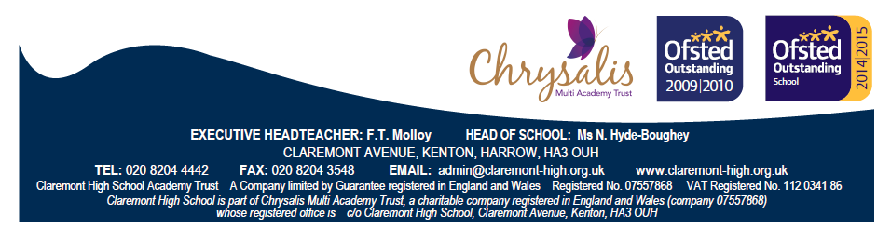

- Provide an environment conducive to learning by:
  - Insisting upon proper standards of discipline and safety in the classroom;
  - Ensuring that the teaching area has excellent attractive and up-to-date displays; is graffiti and litter free; and is orderly both in appearance and conduct of pupils.

- Set an example of excellence, thereby, providing a role model of excellence for the pupils by:
  - Being punctual to lessons at all times and ensuring pupil punctuality to class;
  - Insisting upon good manners, courtesy, kindness, self-control and safe behaviour from the pupils at all times;
  - Observing all rules on Health and Safety.
  - Supporting the School Code of Conduct and general Ethos.

Person Specification
Knowledge and Understanding
- Qualified teacher status.
- Degree or equivalent qualification.
- Awareness and understanding of current issues and developments in English.

Skills and Abilities
- Evidence of good classroom practice and excellent teaching, including the use of different learning styles.
- Evidence of teaching, which demonstrates good progress and achievement of pupils across the ability range.
- Ability to work as a team member and to form good working relationships with colleagues.
- Good communication, organisational and administrative skills.
- Ability to meet deadlines and show good attention to detail.
- Ability to undertake tasks related to monitoring and evaluation.
- Commitment and ability to work with colleagues to improve classroom effectiveness and raise achievement.
- Ability to manage students firmly, fairly and effectively.
- An enthusiastic approach to working with children.

In addition, the successful candidate will need....
- Commitment to Equal Opportunities.
- Good ICT skills.
- Good personal presentation.
- An excellent record of attendance and punctuality.

Contd.....

As a member of a year team, under the guidance of the Head of Year, tutors are responsible for implementing school policies and procedures in order to achieve the best possible attendance, punctuality and personal organisation of pupils’ work and high standard of behaviour through:

- Accurate registration and follow up of absences, lateness and other administration of school procedures;
- Use of the diary to monitor homework and behaviour and to communicate with parents;
- Following up concerns from other staff or referring them to the Head of Year or Head of Faculty, as appropriate;
- Monitoring class and homework through work reviews, interim reports and profiles;
- Being the first point of contact with parents and subject teachers where there is a problem and alerting them as soon as possible;
- Organising the duty rota and briefing the class for the responsibility desk; (Years 7-9);
- Maintaining high standards of pupils’ uniform and personal appearance;

- Teaching the PSE programme, and contributing to lesson preparation;

- Encouraging pupil involvement in whole school and extra-curricular activities such as charity activities, sport, music, drama, IT, helping at special events;
- Ensuring that this involvement is recognised through the ‘Community Award’ scheme;
- Providing appropriate guidance and administrative support for year-specific activities such as Year 7 induction, Year 9 options, transition to Sixth Form;
- Writing and organising reports for parents, teachers and other professionals as requested;
- Caring for the environment of the form room and year base and maintaining an up to date form notice board;
- Sharing responsibility for appropriate use of the year base.

It should be noted that these are the basic responsibilities of all teachers in accordance with the legally determined teachers Terms and Conditions of Service. All teachers should become involved in working parties, committees, extra-curricular activities and professional development opportunities both for personal job satisfaction and for career development reasons.

