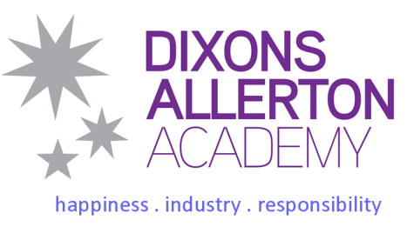

Teacher- Director of Learning - English
Required for 28 August 2018
Dixons Allerton Academy, Bradford
Salary range: L10 to L14

Dixons Allerton Academy are looking to appoint a hardworking, determined and inspirational, Director of Learning for the English faculty, who can achieve exceptional outcomes that allows our scholars to have ambitious life choices.

Our Vision is to improve scholar achievement, develop character, create an academic culture and raise
aspirations by ensuring daily practices are outstanding. Our values driven culture genuinely enables teachers
to teach and scholars to learn.

Our Mission is that scholars leave here saying: At DAA, I developed good moral principles and achieved exceptional outcomes that allowed me to have ambitious life choices.
Scholars will learn that the core 'Values to Achieve' are: Happiness, Industry and Responsibility
Scholars will learn that the 'Keys to Achieve' are: Self-determination, Mastery and Purpose

The successful candidate will:

- Be committed to the vision, mission and core values of the Academy
- Be able to demonstrate an understanding of and take responsibility for promoting high standards of literacy, articulacy and the correct use of standard English
- Have a proven track record of raising standards for pupils of all abilities in a challenging environment
- Be working in a multi-ethnic environment promoting social cohesion and challenging social barriers to progress
- Have thorough knowledge and understanding of current curriculum developments and how students learn

We moved to our new £27 million building in September 2013. The Academy is all-through from 3 -18 years of age, with places for 52 nursery children, 420 primary children, 1,200 11-16 scholars plus 240 post 16 scholars.

We positively welcome applications from all sections of the community. The Academy is committed to safeguarding and promoting the welfare of children and young people and expects all staff and volunteers to share this commitment. Successful applicants will need to provide a current enhanced DBS certificate and
check via the Update Service or undertake an enhanced DBS clearance for the Academy.

All potential applicants are welcome to visit the Academy for an opportunity to learn more about us and
our vision, mission and core values. For further details and information please contact Ms Bernadette
Gill, HR Officer on 01274 770230 x2654 or access our website at www.dixonsaa.com.
To apply, please email all application forms and covering letters to HR at hr@dixonsaa.com

The closing date for applications is 12 noon on Tuesday 1 May 2018
Interviews/selection will be held Friday 4 May 2018

