

**Audley Avenue**

**Newport**

**Shropshire**

**TF10 7DS**

**Telephone**: 01952 386500

**Email**: burton.borough@taw.org.uk

**Website**: www.burtonborough.org.uk

**Twitter**: @BurtonBorough

**Candidate Information Pack**

**Design Technology Teacher 0.8 FTE**

**and**

**Design Technology Teacher Second**

**In department TLR 2.1 0.8FTE**

**Posts Available from: September 2018**

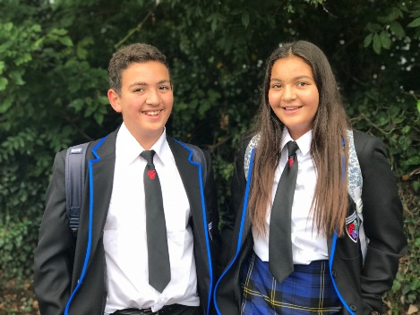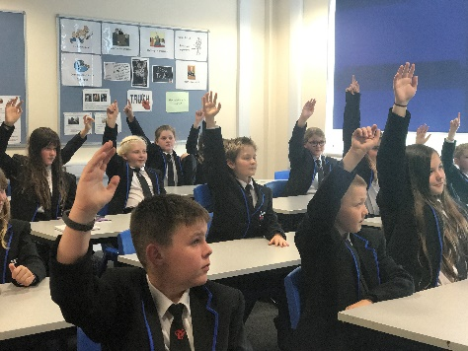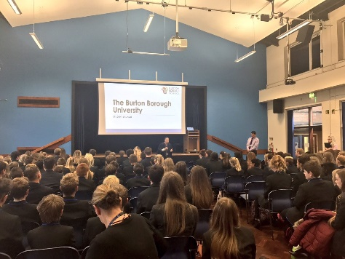

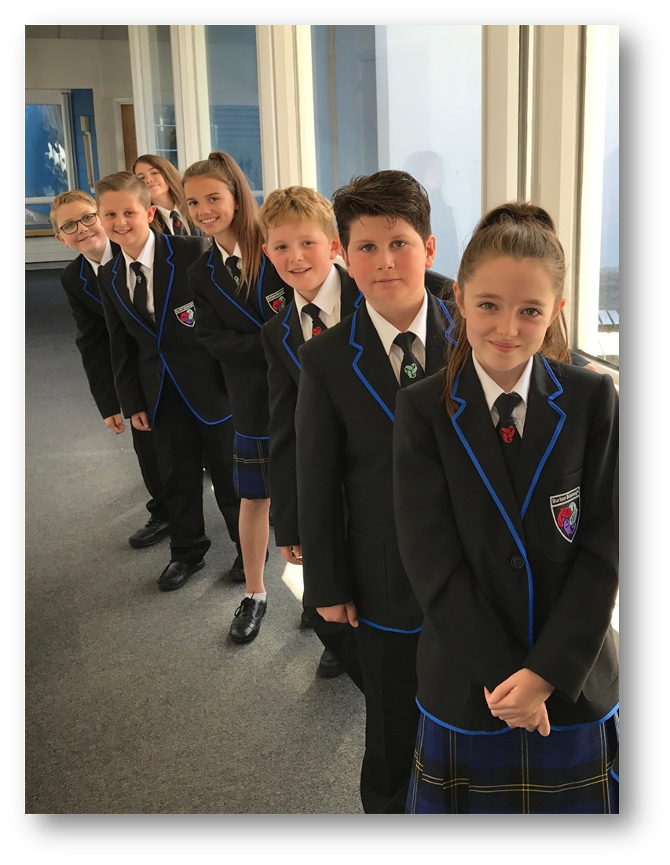

**Welcome to Burton Borough School**

**Dear Candidate,**

**Thank you for your interest in this post at The Burton Borough School. We are an inclusive school and it is our firm belief that all students, no matter what their backgrounds, needs or ability are able to succeed and reach their full potential given the right care support and guidance. We believe that all students have different gifts and we nurture these to bring out the best in each of them. Staff at Burton Borough have high expectations and the drive, commitment and passion to help young people succeed, preparing them well for the next stage of their education.**

**We want our students to be well-rounded and not only rely on rote so that they are able to compete with their peers not only nationally but internationally. However, in order to do this, we must model this behaviour ourselves by being lifelong learners, engaging in research, keeping abreast of new initiatives and staying at the forefront of education. We must work together in sharing best practice, reach out and help each other to develop our pedagogy to make us even stronger practitioners to help our students achieve what they are capable of.**

**There is a strong community feel at Burton Borough and the established smaller communities within the school ensure that our students reach their full potential. It is important to us that staff know each student and their families personally so that any potential issues are picked up quickly. In addition, we have vertical tutor groups with members from all years, which again contributes to a smaller community feel. Everybody supports one another and understands that when we work together, we instil a belief that we will achieve the best outcomes.**

**On top of all of this, a new modern £8 million building opened in June 2015 with the latest facilities to aid us with our teaching and learning.**

**From the moment you walk through the doors at Burton Borough you will feel the vibrant, caring and supportive atmosphere. I look forward to meeting you if you decide that you want to join us on our exciting journey.**



**Christine Raymont-Hall**

**Principal**

**Contents of the Pack**

1. **About The Burton Borough School**
2. **Job description**
3. **Person Specification**
4. **Safeguarding**
5. **Local information / How to find us**

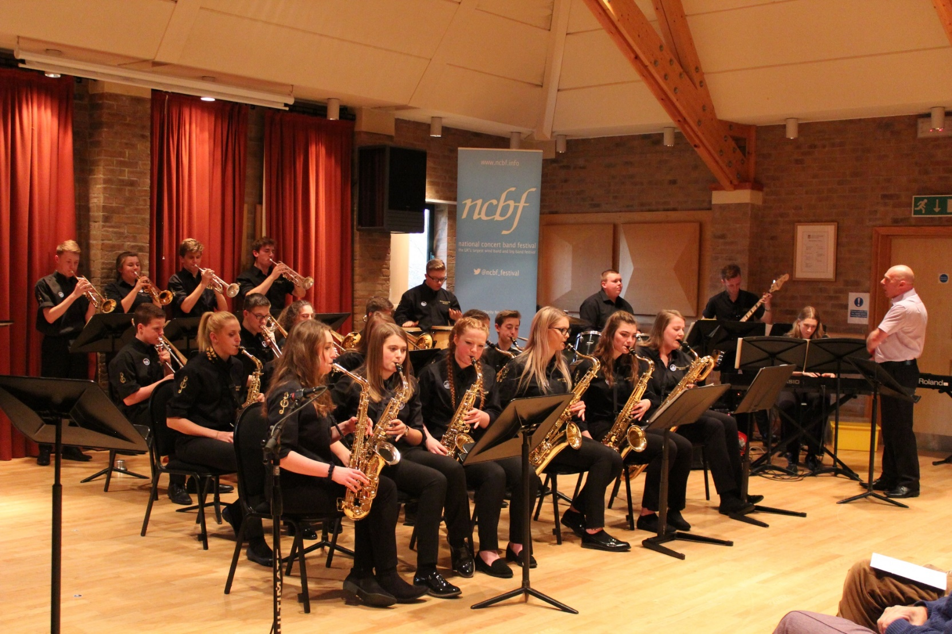



**About the School**

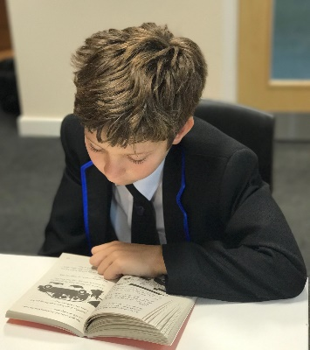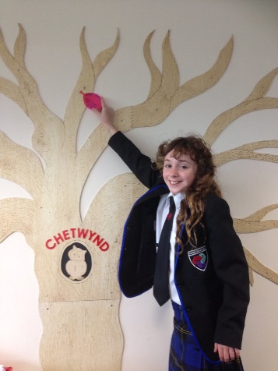



**Burton Borough is a vibrant and exciting school to work in and our successes were recognised by our recent Ofsted inspection in March 2018:**

* **“Behaviour is good. Pupils are respectful, polite and well mannered. Relationships between pupils and staff are highly positive”**
* **“Pupils look smart in their new uniform, are punctual and well prepared for lessons. As a result, learning time is hardly every wasted”**
* **“The prevailing culture of mutual respect prepared pupils well for life in modern Britain. Pupils work well and socialise well together, valuing and respecting others’ views”**
* **“The new principal is highly ambitious for the pupils. Leaders have a clear and accurate understanding of how to make the necessary improvements to pupils’ progress”**
* **“Safeguarding is effective”**

**As an inclusive school, our aim is to provide an excellent education for all students, no matter what their background, needs or abilities. To achieve this, we ensure that we continually adapt our practice and engage with research. This is an exciting time to join the school if you are someone who embraces change and enjoys trying out new things. You will also be someone who views working in education as the most important job in the world, and will therefore be prepared to “go the extra mile”.**

**Your Professional Learning**

**A great school has to have a great staff and at our school this means an entitlement to high quality professional development. We are very proud of our professional development opportunities in the school. All teachers, whether you are an NQT or Senior Leader, are expected to improve their craft in the classroom and to share their expertise with their colleagues. This will include the successful applicant to this post.**

**Our CPD provides personalised learning opportunities to support staff to meet their appraisal objectives and to help them move on to the next stage in their teaching career, whether that is securing the foundations during their NQT year or working with staff who aspire to leadership.**

**This year, all staff are engaged in their own research projects that they will be sharing with the rest of their colleagues and publishing their findings in a journal. We believe the best CPD is CPD that is bespoke and tailored to your interests and needs. Research projects this year vary from subject specific research, wellbeing and mental health and leadership and management to name a few.**

**Job Title Design technology Teacher**

**Job Description**

|  |
| --- |
| **Job Purpose** |
| To provide the highest quality of education, care and preparation for life for all students in the school in accordance with the Teacher Standards (indicated in brackets through the rest of this document in italics). |
| **Major Tasks** |
| **Duties & Responsibilities:**  Main Responsibilities as a Subject Teacher  To participate with the Head of Subject and other colleagues in the development of appropriate syllabuses, materials, schemes of work and lesson plans, which should engage, stimulate and challenge students of all abilities, and should cater for all learning styles. This may include taking responsibility for particular courses; (*TS1, TS4,* *TS5*)  To ensure that all lessons are planned, prepared and delivered with clear differentiation to cater for students of all abilities and backgrounds whilst ensuring individual student progress; (*TS1, TS2, TS5*)  To share in the preparation and delivery of SMSC elements in all lessons across the curriculum; (*TS8)*  Employ a variety of interactive teaching methods appropriate to the age and ability of each individual student to promote a love of learning and children’s intellectual curiosity; (*TS4*)  Impart knowledge and develop understanding through effective use of lesson time; (*TS3,* *TS4*)  To maintain an up to date knowledge of the subject, and utilise a range of teaching methods in line with currently acknowledged best practice; (*TS3*)  Demonstrate an understanding of and take responsibility for promoting high standards of literacy, articulacy and the correct use of standard English, whatever the teacher’s specialist subject; (*TS3*)  Reflect systematically on the effectiveness of lessons and approaches to teaching; (*TS4*)  To take responsibility for improving teaching through appropriate professional development, responding to advice and feedback from colleagues; (*TS8*)  Set homework and plan other out-of-class activities to consolidate and extend the knowledge and understanding pupils have acquired on a regular basis according to the homework policy; (*TS4, TS8*)  To use directed time to actively contribute to the wider life of the school by organising and running appropriate extra-curricular activities. (*TS8*)  To fully incorporate the teaching of skills including literacy, mathematics and communication into subject delivery. (*TS3*)  **Management and assessment**  Know and understand how to assess the relevant subject and curriculum areas, including statutory assessment requirements; (*TS6*)  To take responsibility for particular aspects of the subject(s) in consultation with the Head of Subject (*TS8*)  Use relevant data to monitor progress, set targets and plan subsequent lessons; (*TS6*)  Be accountable for students attainment, progress and outcomes; (*TS2*)  Know and understand how to assess the relevant subject and curriculum areas, including statutory assessment requirements; (*TS6*)  To register each class using the electronic registration system according to school procedures. (*TS7*)  To take responsibility for the safe keeping of the laptop/surface pro used for registration etc. (*TS7*)  To keep appropriate records and to complete assessments and profiles of students as required by whole-school policy. (*TS6*)  To maintain the allocated teaching areas to ensure that they are conducive to a stimulating and exciting learning experience. (*TS8*)To take reasonable care of one’s own health and safety and that of others and inform the Business Manager of any concerns with regard to health and safety.  To monitor and control the use and storage of teaching materials, books and equipment. (*TS8*)  To supervise the use and care of the school fabric and equipment by the students and to ensure their adherence to relevant health and safety regulations. (*TS8*)    **Communications and Meetings**  Communicate effectively with parents with regard to pupils’ achievements and well-being; (*TS8*)  Develop effective professional relationships with colleagues, knowing how and when to draw on advice and specialist support; (*TS8*)  To alert Head of Learning Area, Senior Leadership Team and other staff to problems arising with individual students in accordance with whole-school policies; (*TS7*)  To participate actively in meetings with colleagues and parents; (*TS8*)  To attend CPD sessions and working parties related to new initiatives in teaching and learning. (*TS8*)    **Finance**  To be informed about the financial basis of the operation of the school and to assist in seeking ways of deploying resources to the maximum benefit of the students; (*TS8*)  To ensure that equipment, books and premises are maintained in accordance with school policies. (*TS8*)  **General Duties**  To adhere to the policies and procedures of Burton Borough School.  To carry out ‘the duties of a school teacher’ as set out in the School Teachers’ Pay and Conditions Document & Teacher Standards.  To share in the corporate responsibility for the development and well-being of all students.  Make a positive contribution to the wider life and ethos of the school;  Demonstrate consistently the positive attitudes, values and behaviour which are expected within the school’s community based on mutual respect between students and staff  To take a pro-active part in the school’s appraisal system, both as a reviewer and reviewee, with the ultimate aim of improving standards of teaching and learning in school |
| **Contacts & Relationships** |
| * With students – daily * With students’ parents/carers – as required linked to incidents, complaints etc * With professionals linked to students – as required dependant on need/care plans etc * With visitors, or other external bodies – as required * With staff within school - daily * Establish constructive relationships and communicate with other agencies / professionals |
| **Physical Demands** |
| The school is on one site with 4 main buildings sited alongside the sports field. The post holder will be required to move around buildings accordingly. |
| **Other** |
| Whilst every effort has been made to explain the main duties and responsibilities of the post, each individual task undertaken may not have been identified. The postholder will be expected carry out any other duties as are within the scope, spirit and purpose of the job, commensurate with the grade.  The postholder will be expected to participate in training and other learning activities and performance development as required  The postholder will be expected to actively follow Telford & Wrekin Council policies, including those such as Equal Opportunities, Human Resources, Information Security and Code of Conduct etc. |

**PERSON SPECIFICATION**

|  |  |
| --- | --- |
| **Criteria** | **Standard** |
| **Qualifications** | | * Qualified Teacher Status; * Degree in relevant subject area; * To be, or aspire to be, an outstanding classroom practitioner; |
| **Experience** | | * A proven track record of examination success |
| **Knowledge** | | * Strong current subject knowledge; * A positive disposition; * A willingness to develop excellent ICT skills; * An effective communicator with exceptional interpersonal skill. * Influencing and negotiation skills |
| **Skills** | | * Very good ICT skills, e.g. production of reports, correspondence, inputting / updating information * Able to relate well to children and adults, including all stakeholders and other professionals. * Able to use analytical, judgmental, creative and developmental skills * Able to demonstrate sensitivity and tact particularly when dealing with the more sensitive issues * Able to maintain confidentiality * Able to work accurately and with attention to detail * Able to undertake short term planning, e.g. managing own workload, managing the work of others, ensuring deadlines are met, planning for school activities, e.g. school trips / sports day * Able to deal with more complex queries and know when to refer to more senior staff * Able to work constructively as part of a team and to understand school roles and responsibilities and own position within these * Able to self-evaluate learning needs and actively seek learning opportunities |
| **Personal style & behaviours** | * Customer focused * Has a friendly yet professional and respectful approach which demonstrates support and shows mutual respect. * Open, honest and an active listener * Takes responsibility and accountability * Committed to the needs of the pupils, parents and other stakeholders and challenge barriers and blocks to providing an effective service. * Demonstrates a “can do” attitude including suggesting solutions, participating, trusting and encouraging others and achieving expectations * Is committed to the provision and improvement of quality service provision * Is adaptable to change/embraces and welcomes change. * Acts with pace and urgency being energetic, enthusiastic and decisive * Has the ability to learn from experiences and challenges * A sense of humour! * Is committed to the continuous development of self and others by keeping up to date and sharing knowledge, encouraging new ideas, seeking new opportunities and challenges, open to ideas and developing new skills. |

**Teachers’ Standards**

|  |  |
| --- | --- |
| **TS1 Set high expectations which inspire, motivate and challenge pupils.** | |
| **a) Establish a safe and stimulating environment for pupils, rooted in mutual respect.** |  |
| **b) Set goals that stretch and challenge pupils of all backgrounds, abilities and dispositions.** |  |
| **c) Demonstrate consistently the positive attitudes, values and behaviour which are expected of pupils.** |  |

|  |  |
| --- | --- |
| **TS2 Promote good progress and outcomes by pupils** | |
| **a) Be accountable for pupils’ attainment, progress and outcomes** |  |
| **b) Be aware of pupils’ capabilities and their prior knowledge, and plan teaching to build on these.** |  |
| **c) Guide pupils to reflect on the progress they have made and their emerging needs.** |  |
| **d) Demonstrate knowledge and understanding of how pupils learn and how this impacts on teaching.** |  |
| **e) Encourages pupils to take a responsible and conscientious attitude to their own work and study.** |  |

|  |  |
| --- | --- |
| **TS3 Demonstrate good subject and curriculum knowledge** | |
| **a) Have a secure knowledge of the relevant subjects and curriculum areas, foster and maintain pupils’ interest in the subject, and address misunderstandings.** |  |
| **b) Demonstrate a critical understanding of developments in the subject and curriculum areas, and promote the values of scholarship** |  |
| **c) Demonstrate an understanding of and take responsibility for promoting high standards of literacy, articulacy and the correct use of standard English, whatever the teacher’s specialist subject.** |  |

|  |  |
| --- | --- |
| **TS4 Plan and teach well-structured lessons** | |
| **a) Impart knowledge and develop understanding through effective use of lesson time.** |  |
| **b) Promote a love of learning and children’s intellectual curiosity.** |  |
| **c) Set homework and plan other out-of-class activities to consolidate and extend the knowledge and understanding pupils have acquired.** |  |
| **d) Reflect systematically on the effectiveness of lessons and approaches to teaching.** |  |
| **e) Contribute to the design and provision of an engaging curriculum within the relevant subject areas.** |  |

|  |  |  |
| --- | --- | --- |
| **TS5 Adapt teaching to respond to the strengths and needs of all pupils.** | | |
| **a) Know when and how to differentiate, using approaches which enable pupils to be taught effectively.** |  | |
| **b) Have a secure understanding of how a range of factors can inhibit pupils’ ability to learn, and how best to overcome these.** |  | |
| **c) Demonstrate an awareness of the physical, social and intellectual development of children, and know how to adapt teaching to support pupils’ education at different stages of development.** |  | |
| **d) Have a clear understanding of the needs of all pupils, including those with special educational needs; those of high ability; those with English as an additional language; those with disabilities; and be able to use and evaluate distinctive teaching approaches to engage and support them.** |  | |
| **TS6 Make accurate and productive use of assessment.** | | |
| **a) Know and understand how to assess the relevant subject and curriculum areas, including statutory assessment requirements.** | |  |
| **b) Make use of formative and summative assessment to secure pupils’ progress** | |  |
| **c) Use relevant data to monitor progress, set targets, and plan subsequent lessons.** | |  |
| **d) Give pupils regular feedback, both orally and through accurate marking, and encourage pupils to respond to the feedback.** | |  |

|  |  |
| --- | --- |
| **TS7Manage behaviour effectively to ensure a good and safe learning environment.** | |
| **a) Have clear rules and routines for behaviour in classrooms, and take responsibility for promoting good and courteous behaviour both in classrooms and around the school, in accordance with the school’s behaviour policy.** |  |
| **b) Have high expectations of behaviour, and establish a frame work for discipline with a range of strategies, using praise, sanctions and rewards consistently and fairly.** |  |
| **c) Manage classes effectively, using approaches which are appropriate to pupils’ needs in order to involve and motivate them.** |  |
| **d) Maintain good relationships with pupils, exercise appropriate authority, and act decisively when necessary.** |  |

|  |  |
| --- | --- |
| **TS8 Fulfil wider professional responsibilities** | |
| **a) Make a positive contribution to the wider life and ethos of the school.** |  |
| **b) Develop effective professional relationships with colleagues, knowing how and when to draw on advice and specialist support** |  |
| **c)Deploy staff effectively** |  |
| **d) Take responsibility for improving teaching through appropriate professional development, responding to advice and feedback from colleagues.** |  |
| **e) Communicate effectively with parents with regard to pupils’ achievements and wellbeing.** |  |



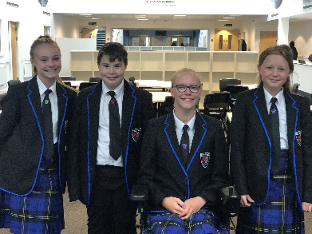

**Safeguarding**

**Burton Borough School fully recognises it responsibility to safeguard and promote the welfare of student and young people. We are committed to ensuring that its students have opportunity to thrive within a safe learning and working environment. Our school expect all staff and volunteers to share this commitment. Our Safeguarding Policy, which applies to all staff, Governors and volunteers working in the school, has five main elements:**

1. **Ensuring we practise safer recruitment in checking the suitability of staff and volunteers to work with our students**
2. **Raising awareness of child protection issues and equipping students with the skills they need to keep them safe**
3. **Implementing procedures for identifying and reporting cases, suspected cases, of abuse**
4. **Supporting students who have been abused in accordance with their agreed protection plan**
5. **Establishing a safe environment in which students can learn and develop.**

**The staff at Burton Borough School are aware of how they share in the school’s responsibility to safeguard and promote the welfare of students and young people. Our ‘Professional Code of Conduct’ establishes expectation in relation to conduct towards students and all staff are issued with the strict guidelines on what are considered to be safer working practices which must be observed at all times. If any member of staff has a concern that the school’s code of conduct or expected safer working practices were not being followed, and a student or students were as a result as risk, then they would be expected and supported to raise the concern under the school’s adopted ‘whistleblowing policy and procedure’.**

**Our school also operates within other policies relating to safeguarding, child protection and the welfare of students.**

**To ensure that safer practice in recruitment is reflected at every stage of the recruitment process, our school operates within a Safer Recruitment Policy. Members of the school staff and Governing Body have attended and passed training on Safer Recruitment. All successful applicants will be subject to an enhanced DBS disclosure and references will be checked. All employees of the school will receive compulsory child protection training.**







**Local Information**

**Newport, Shropshire is a market town in the borough of Telford and Wrekin. It is located on the Shropshire/Staffordshire border, equidistant from Shrewsbury, Stafford and Wolverhampton. We are the only comprehensive school in Newport with two single sex, selective grammar schools nearby. Despite this, our students are of high ability when compared to school nationally.**

**How to find us**

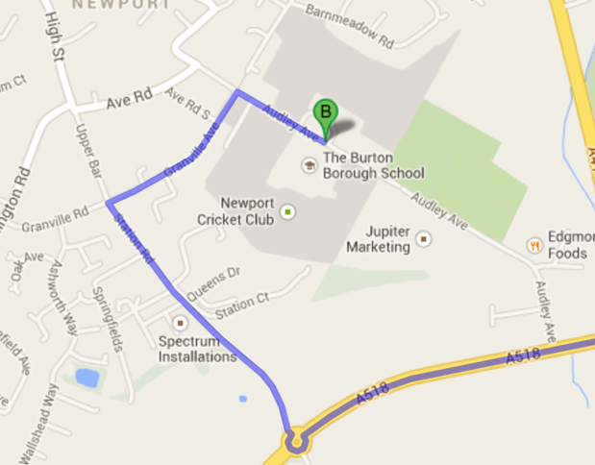

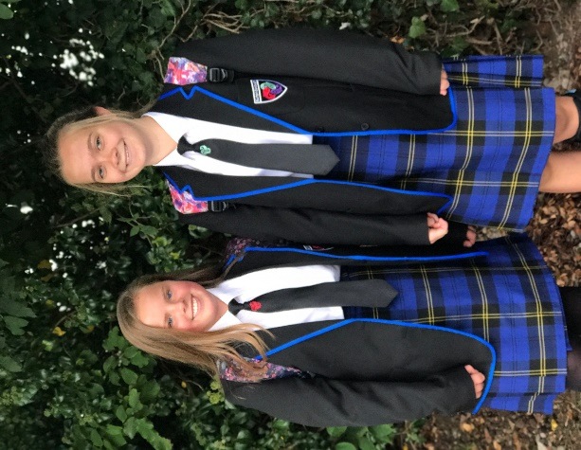

**From the North: At Junction 14 (M6), take the B5026 to Eccleshall, then take the A519 following the signs for Newport**

**From the South: At Junction 12 (M6), take the A5 exit to Telford/M54, exit at Junction 3 (A41) following the signs for Newport**

**Burton Borough School**

**Audley Avenue**

**Newport**

**Shropshire**

**TF10 7DS**

**Telephone**: 01952 386500

**Email**: burton.borough@taw.org.uk

**Website**: www.burtonborough.org.uk

**Twitter**: @BurtonBorough

**Audley Avenue**

**Newport**

**Shropshire**

**TF10 7DS**

**Telephone**: 01952 386500

**Email**: main.bbs@taw.org.uk

**Website**: www.burtonborough.org.uk

**Twitter**: @BurtonBorough