Design & Technology Teacher (Maternity Cover)
Job Description

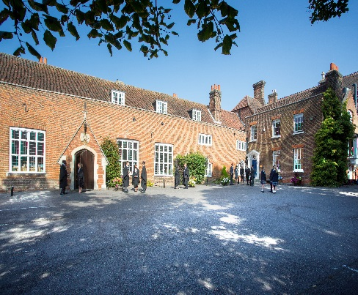

Introduction

We require a well-qualified and enthusiastic teacher to join a lively, successful and popular department for a maternity cover commencing in February 2018. The Design and Technology department at Chigwell offers a broad and exciting curriculum that aims to develop pupils’ knowledge and awareness of contemporary design and technology. Pupils study and engage in a breath of design issues, ranging from aesthetics and ergonomics (what a product looks and feels like) through to the technological and functional aspects of product design (how it works). The D&T Department currently has a bias towards Resistant Materials at Key Stage 3, GCSE and A level. Therefore, the applicant should have the ability to teach the subject from Year 7 through to Year 13. Experience of using CAD/CAM would be essential.

Background
Founded in 1629 by Samuel Harsnett, the son of a Colchester baker who went on to become Archbishop of York, Chigwell School stands on it original site with the original school building still in use. However, whilst Chigwell of today is conscious of its long-standing history, it is a forward-looking, ambitious, co-educational independent school of 930 pupils aged four to eighteen. It enjoys excellent facilities, a dedicated staff, bright and hardworking pupils, and a site of 100 acres.

Chigwell School is located in the picturesque village of Chigwell just over ten miles from central London and on the Central Line. The extensive, beautiful grounds are close to the edge of Epping Forest and it is rare for a school to have so much space and yet be so close to the centre of the Capital. Most pupils are day pupils but in the Sixth Form, there is a small community of international boarders, roughly twenty five from sixteen countries, and these live in four small boarding houses. They bring an international influence to the Sixth Form as a whole.

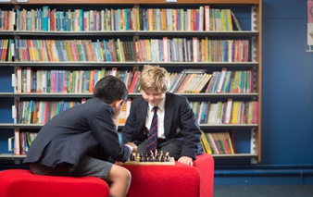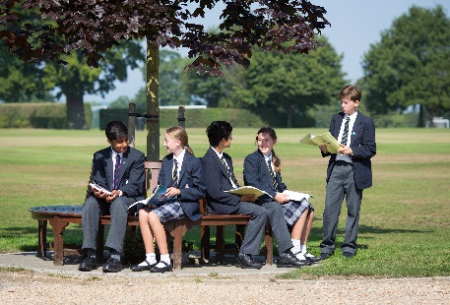

As well as being an academic school, Chigwell has the reputation for providing a rich and full education, with plenty of opportunities for all pupils who are enthusiastic, co-operative and able. Chigwell is a caring and friendly school, with a close sense of community, not least between colleagues. As the 2015 Good Schools Guide reports: Academically, pupils are put through their paces but it all seems to be done in such a civilised and pleasant manner that you are more likely to hear pupils talk about opportunities and prospects than pressure and stress. “Anyone who wants to do well here, will do well” said one student, and I can’t think of a nicer place to succeed.”

The School Development Programme

Over recent years, the School’s facilities have been extensively developed in order to enhance the educational experience that pupils receive. The development programme has included the following additions:
- 2008 Wilson Building teaching block
- 2008 Floodlit AstroTurf pitch
- 2009 Junior School library extension
- 2010 Complete redevelopment of catering facilities
- 2010 Sixth Form coffee shop
- 2010 Harsnett’s and Church House converted into boys’ boarding houses
- 2012 The Old Chigwellian Club and land was incorporated into the school estate
- 2013 Pre Prep School built and opened
- 2013 Two new science labs created
- 2014 Drama Centre balcony extended to provide additional music and drama rehearsal space
- 2016 The Risham Sarao Sixth Form Centre was completed

Currently, the extension of the Dining Hall is underway and in the future the plan is to:
- Renovate the Chapel
- Develop the Sports Centre
- Expand our music facilities
- Further expand our provision of bursaries

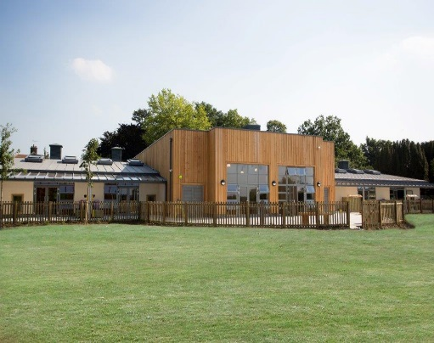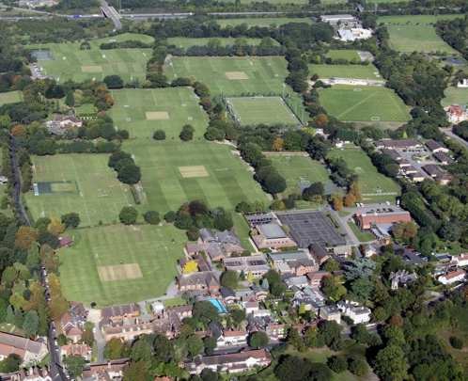

The School

Some pupils join in Reception and there are two classes in each of the three Pre Prep year groups. A small number of other children join the Junior School at 7+ (Year 3) and there are two or three classes in each of the KS2 year groups. At 11+ (Year 7), there is a further entry with four classes making up Years 7 to 11. Again, there is a small entry into the Sixth Form. Entry at each stage is selective and although there are three main sections to the School (Pre Prep, Junior School and Senior School) these sections work closely together and there is a common ethos running throughout.

There are over a hundred teachers and together with the support staff, there is a friendly, mutually-supportive atmosphere. All teaching staff contribute to the extra-curricular programme.

The Design and Technology Department at Chigwell School
Design & Technology is taught in a well-equipped, purpose built facility. In addition to the two main workshops, there is a project storeroom, a technicians’ prep/resources room and an office. One of the workshop areas also hosts a computer suite, 12 desktop machines and 12 laptops in addition to a laser cutter, 3D printer and dye sublimation equipment. There are extensive facilities for work with a wide range of materials and processes. The department currently consists of one full time teacher and three part-time teachers of D&T. The department also has highly experienced, reliable and full time technical support.

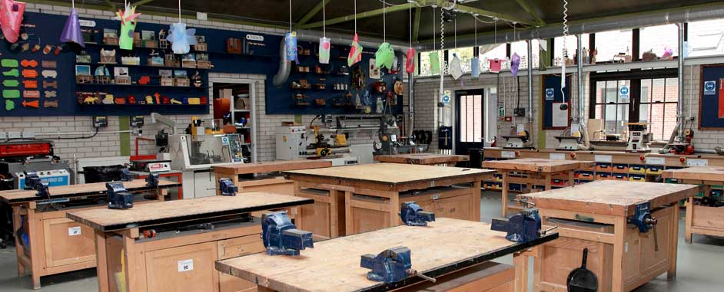

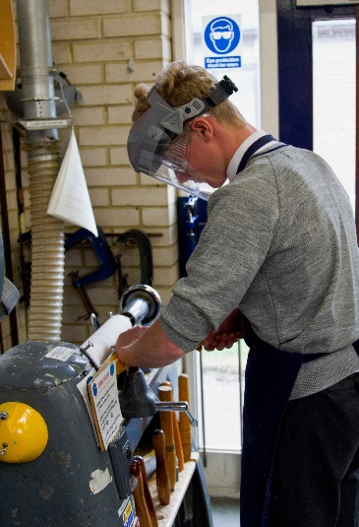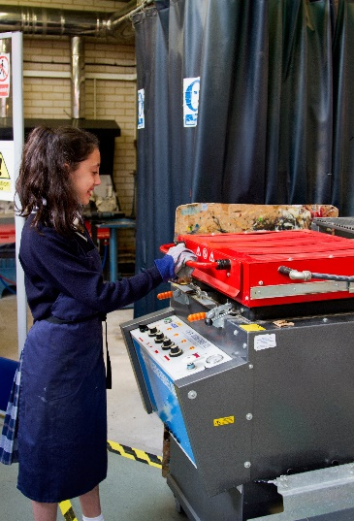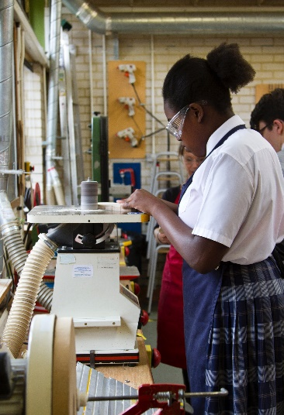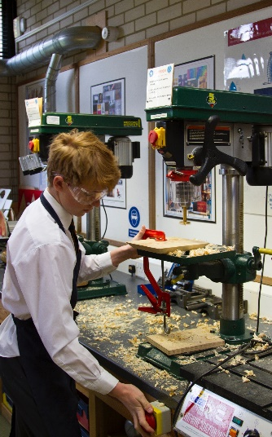

The Role
The Design & Technology department, aims to provide a stimulating and challenging learning environment that engages the interest of all pupils and fosters their development as confident and creative product designers. The methods of teaching are broad and varied and each Scheme of Work is designed to augment understanding of the role of design and technology in the world around us.
Throughout Key Stage 3 pupils study the dominant areas of Design and Technology and by the Remove year (Year 9) all pupils possess a clear understanding of aesthetics, ergonomics, the design process, graphical communication techniques, materials, electronics, mechanisms, CAD CAM, sustainability issues and industrial production methods. At GCSE and A Level pupils have the opportunity to further develop and refine their skills
in relation to their own areas of interest.

The emphasis at Key Stage Three is to introduce pupils to resistant materials and workshop processes focusing on wood, metal and plastic. In summary, Design and Technology in Years 7, 8 and 9 teaches pupils a vast range of skills and workshop processes and aims to fully prepare them for the GCSE course.

At GCSE level pupils follow the AQA Resistant Materials syllabus. Each pupil has the opportunity to develop their own design concepts relating to a choice of given contexts. Over the last few years the Design and Technology department at Chigwell have achieved some excellent GCSE results, with the majority of candidates gaining A*/A grades for the coursework component of the course.

A level students follow the AQA Design & Technology specification. This course offers students the opportunity to design and make a marketable, working product of their choice. The course also demands high quality products that solve the original problem specified by each student. At Chigwell, the majority of A level students achieve notable grades, with 100% of candidates achieving A*-B grades in recent years.
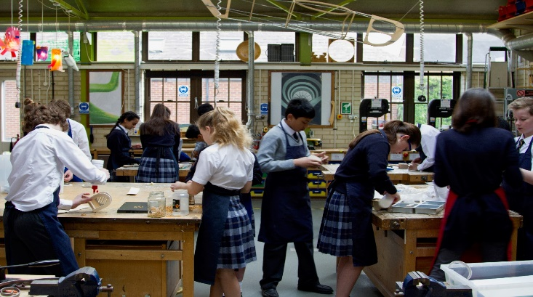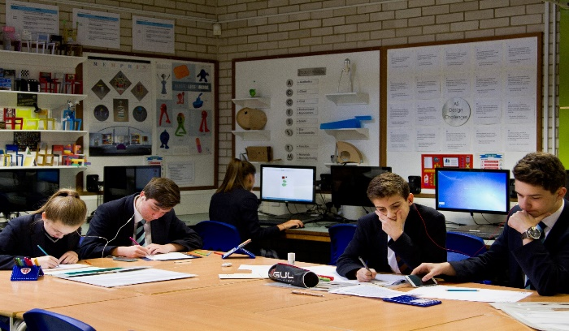

Person Specification

We are looking to recruit a creative and dynamic well-qualified teacher with a background in resistant materials, engineering or product design.

Requirement | Essential or Desirable?
Qualifications / Education / Training:  - Good honours degree  - Qualified Teacher Status  - Evidence to commitment to CPD | Essential  Essential  Desirable
Experience:  - Experience of teaching DT across Key Stages 3 to 5  - Experience of teaching DT to a range of abilities  - Application of a range of learning and teaching strategies  - Experience of planning for progression in DT  - Experience of monitoring an evaluating impact of teaching sessions  - Effective classroom management | Essential  Essential  Essential  Essential  Essential  Essential
Skills and Knowledge  - A good knowledge of the current GCSE and NC requirements of the subject  - A good knowledge and understanding of current curricular developments in Design & Technology  - Ability to demonstrate excellent teaching practice against the current Teaching Standards at Key Stages 3, 4 and 5.  - Ability to inspire, motivate and encourage young people  - Ability to adapt sessions appropriately dependent on the needs of young people  - Ability to maintain a high standard of teaching which ensures all students are actively engaged in their learning and make excellent progress  - Ability to use ICT to enhance the quality of learning within the classroom. | Essential  Essential  Essential  Essential  Essential  Essential  Essential
Personal Attributes:  - Enthusiasm and passion for teaching and learning  - Excellent communication and interpersonal skills; the ability to communicate with people at all levels  - Excellent planning and organizational skills  - Self-motivated and able to use own initiative  - A willing and flexible approach to work  - Team player  - Commitment to equal opportunities  - Interest and ideas of cross- curricular collaboration  - Interest in and willingness to take part in extra-curricular activities  - Commitment to links and partnerships with schools and other organisations | Essential  Essential  Essential  Essential  Essential  Essential  Essential  Desirable  Desirable  Desirable

Salary: The successful applicant will be appointed on to the main national salary scale (incorporating London Fringe). There is an additional scaled Chigwell Allowance and a competitive benefits package.

Benefits of working at Chigwell School include:

- A competitive salary  - Access to the School Pension Scheme  - Free lunch and refreshments during term time  - Childcare Vouchers  - Personal Accident Cover  - Employee Assistance Support Programme  - On site free parking and cycle racks  - Use of School Library | - Medical Centre on site  - Free use of School’s sports facilities outside of the School day  - Commitment to professional development  - A supportive community of highly motivated students and staff  - A beautiful working environment- 100 acres site beautifully landscaped with a number of listed buildings

Hours:

This post is a maternity cover. The hours of work will be 8.00am to 4.00pm Monday to Friday with associated teaching commitments e.g. marking, parent’s evenings etc.

Applications

Applicants should complete the teaching staff application form which can be accessed directly from our website: www.chigwell-school.org (Vacancies) and sent to the Headmaster’s P.A.: hmpa@chigwell-school.org. The Headmaster, Mr Michael Punt, will be happy to answer any questions; he can be contacted at the School by telephone 020 8501 5701 or by e-mail to mpunt@chigwell-school.org. The closing date for this application is 16th October 2017

Chigwell is committed to safeguarding and promoting the welfare of children and young people and expects all staff and volunteers to share this commitment. Applicants must be willing to undergo child protection screening including checks with past employers, prohibition orders and enhanced DBS.

