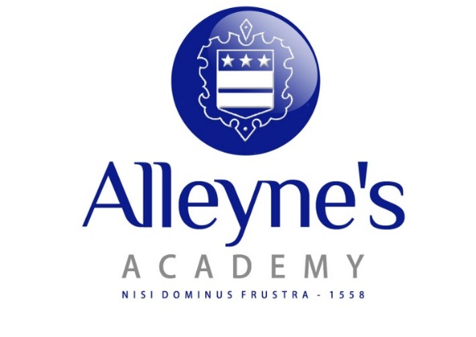

November 2016

Dear Applicant,
Thank you for your interest in the post of Deputy Headteacher at Alleyne's Academy. We are seeking a replacement for our current Deputy Headteacher, Mrs W Moore, who is retiring in August 2017.
Alleyne’s is a caring, innovative converter academy. We are proud of the successes of our students both academically and in their many and varied extra-curricular activities.
We are seeking a Deputy Headteacher with vision and energy, someone to work with the senior team and myself to lead the school forward building on its current success, providing inspiring education for our students.
Further information about Alleyne’s can be seen on the school’s website: www.alleynesacademy.co.uk. If you would like to visit the school prior to applying, please contact Mrs. M Barnes (01785 354205) who will arrange for a convenient time for you to look around the school. Please do not hesitate to contact the school for further information or clarification.
I look forward to receiving your application.
Yours sincerely,

Ms K Lockett
Headteacher

Alleyne’s Academy, Oulton Road, Stone, Stafford, Staffordshire, ST15 8DT
Tel: 01785 354 200 Fax: 01785 354 250
Headteacher: Ms K Lockett

