Curriculum Plan 2017-18
Y9
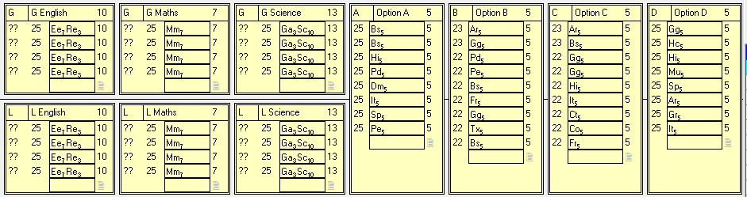
Y10
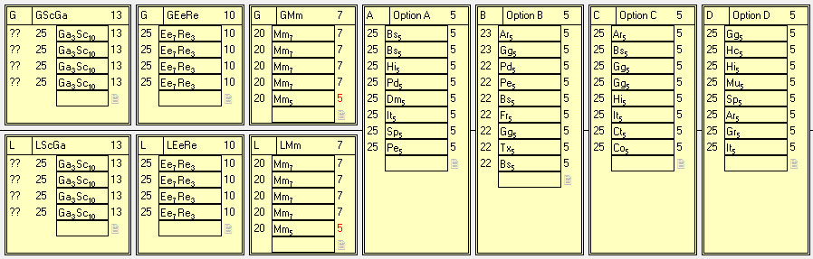
Y11
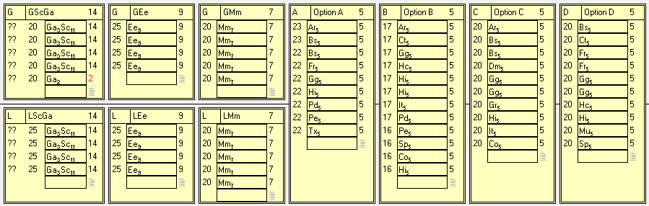
Y12
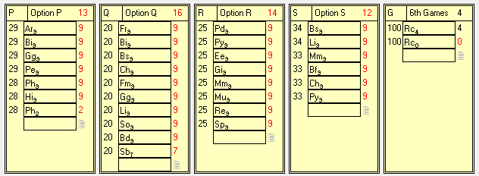
Y13
