Lincoln
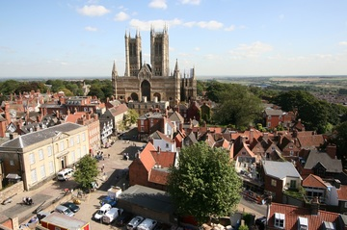

Our school is located within the city of Lincoln. The city itself being nestled in the heart of lush green Lincolnshire countryside. Lincoln is a great city. The winning combination of a vibrant city centre and its historic quarter, both with a broad range of cultural activities and venues make Lincoln a fantastic environment in which to live and raise a family. Lincoln was recently listed in a Sunday Times feature describing the top UK cities to live in. It describes Lincoln as being great for its “historic core and leafy outskirts.”

History and Heritage
Lincoln has a long and fascinating history, which is evident from the sites of interest and beautiful architecture in the city. Lincoln Cathedral is one of the finest medieval buildings in Europe and is a landmark that can be seen for miles around. Lincoln Castle is home to the Magna Carta, dating back to 1215. For more information about Lincoln’s history go to the Lincoln Story.
http://www.visitlincoln.com/things-to-do/by/attractions

Places to Study

Lincoln has a choice of educational establishments offering a wide range of courses, degrees and study options. Our Higher Education establishments include:
- The University of Lincoln has quickly climbed up the league tables and is now in the top 50 thanks to its excellent campus, the high quality of the academic and personal support available to students and the excellent way in which the University of Lincoln works with the rest of the city
- Bishop Grosseteste University has been in Lincoln for 150 years. A beautiful campus with an intimate and friendly feel BGU benefits from being a short stroll into Lincoln's Cathedral Quarter
- Lincoln College an establishment for further education. The campus facilities have recently been enhanced with a 37m investment in the new Deans Building - a state of the art sport and health centre.

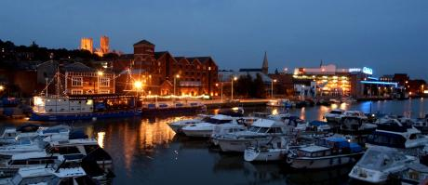
Eating Out
From high street chains such as Pizza Express and Nando’s to independent restaurants offering Italian, Indian, Chinese, Thai, Japanese and traditional English, you will be spoilt for choice when eating out in Lincoln.
http://www.visitlincoln.com/food-drink

Places to Stay

If you need a place to stay can take advantage of the variety of hotels in Lincoln, whether it be a large nationally recognised chain on the waterfront or a boutique hotel in the Bailgate.
http://www.visitlincoln.com/stay

Shopping
Lincoln offers a great shopping experience, with a host of well-known high street brands in the city centre. Boutiques and specialist shops can be found on Steep Hill as well as in the cobbled streets of the Bailgate.
Lincoln’s two thousand year-old Steep Hill has recently been awarded the prestigious title of Britain's "Great Street 2012" by the Academy of Urbanism. The historic street has a one in seven gradient and is celebrated for its bijou boutiques and independent shops. The cobbled streets, proximity to Lincoln Cathedral and ancient buildings make it popular with tourists too.
Craft fairs, farmers’ markets and Lincoln’s world-famous Christmas Market offer local foods, handmade crafts and unique gifts.
http://www.shoplincoln.co.uk/

Stage and Screen
Film enthusiasts can watch the latest blockbusters at the nine-screen Odeon cinema.
If you enjoy something more theatrical, the Theatre Royal and Lincoln Drill Hall offer a programme of national and local drama throughout the year. As does Lincoln University’s own Lincoln Performing Arts Centre (LPAC), which hosts comedy, dance, drama and music performances from touring companies and students.

Arts and Culture
Lincoln offers a rich and diverse arts scene with public art, galleries and studios across the city. These include the Usher Art Gallery and the Sam Scorer Gallery.
The city also has a number of museums, including the Museum of Lincolnshire Life and The Collection: Art and Archaeology in Lincolnshire.
http://www.visitlincoln.com/things-to-do/by/museums-galleries

Sports and Leisure
The city caters to all your sporting needs with various fitness and leisure centres, swimming pools, parks and local sporting clubs.
http://www.visitlincoln.com/things-to-do/by/sport-and-fitness

Further Afield
Lincoln is within easy access of cities including London, Nottingham, Sheffield and Leeds, with good rail and road links. London Kings Cross station is two hours away by train. The city’s central location allows for easy access to a number of airports such as East Midlands, Doncaster and Sheffield for domestic, European and international flights.
The seaside resorts of Skegness, Mablethorpe, Cleethorpes and Sutton are only an hour away. Why not try kite surfing, sandcastle building or simply walking along the dunes?

