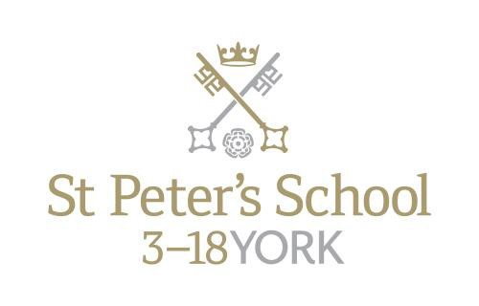

Teacher of Classics

Full Time from September 2017

The Post

The post would equally suit a new entrant to the profession or a teacher wishing to broaden his or her experience. The successful applicant should be able to teachLatin and Classical Civilisation at all levels from the Third Form (Year 9) to Oxbridge entry. The ability to teach Greek would be welcome, though not essential.

The Department

The department currently comprises three full time and two part time specialist teachers.

For the first year at St Peter’s (Year 9, approximately 105 pupils), all pupils study a classical subject, and this divides into 3 sets for Latin and 2 sets for Classical Civilisation. At the end of Year 9, pupils choose their GCSE subjects. Those studying classical subjects at St Peter’s have increased in number in recent years and approximately 70% of the year group opts to study a classical subject to GCSE.

There are two sets for Latin and three for Classical Civilisation in both Years 10 and 11. In the Sixth Form there are currently five pupils studying the new linear Latin course in the L6th and six studying for A2 in the U6th; for Classical Civilisation there are seventeen at AS and twelve at A2. We anticipate a positive uptake for the forthcoming year as we complete the move to linear A levels throughout the department. In the last five years, pupils have been awarded places at Oxford, Cambridge, London, Bristol, Manchester, Edinburgh and other universities to study a variety of classical degrees.

Recently, the department has also been involved in the York Independent and State School Partnership programme with some excellent feedback from all concerned. The local Classical community is very supportive and we aim to meet regularly to discuss current issues, share strategies and to consider ways of promoting the subject locally.

For Latin, we follow the Cambridge Latin Course, which is supplemented from departmental resources by more traditional methods for teaching grammar: extension tasks for the most able often include English-Latin translation. The OCR syllabus is followed at GCSE and A-Level. For Classical Civilisation, the department has extensive resources built up over many years, and all members of the department are happy to share ideas and resources. The OCR syllabus is followed at GCSE and A-Level.

Greek has recently been re-introduced into the mainstream timetable in combination with Latin (‘Gratin’) at GCSE level. Our first cohort was examined in summer 2014 and nearly all pupils achieved A* in both Latin and Greek; subsequent groups have achieved similar success. This is an exciting project that we are sure will grow and prosper; we now have Greek candidates at every level of the school and hope to continue this tradition.

The department is well resourced, and with good accommodation. There are three dedicated classrooms, all of which have been recently refurbished. Each classroom also has a computer and printer as well as its own digital projector.

Sixth Formers regularly attend a variety of conferences, talks and plays. Previously, the department has visited Hadrian, Persia and Pompeii exhibitions at the British Museum, as well as a staging of Aristophanes’ Frogs at the Bloomsbury Theatre in London. This year will also attend lectures at a variety of venues and have already enjoyed the National theatre Live broadcast of Medea and Antigone. We also work on projects within our local Classics community, and this year we will be reviving a Classics Reading competition and staging a regional Classics quiz. We are also hosting the author Ben Kane for a day of lectures and Peter Jones came to speak as part of our Lecture Series (which is open to the public).

Meanwhile a party of Year 10 pupils regularly visits Hadrian’s Wall in what has become an increasingly popular overnight trip. Overseas trips are also an important aspect of departmental life. There was a trip to Greece in 2011 and a trip to Pompeii took place in October 2013. In October 2015 47 pupils visited Pompeii and Rome and we now have 71 pupils signed up to join this trip in October 2017.

Salary

The starting salary will be at a point on the St Peter’s salary scale, related to, but currently 11.5% above, the old National Scale.

Other Opportunities

The school works a busy six day week and the person appointed will be expected to play an active part in the school’s tutorial system and in its extra-curricular life. The guideline teaching load is 28 forty minute lessons in a 40 period week. The School’s extra-curricular programme is broad and is well-supported by the teaching staff. An overview of the current range of activities is attached. While the standards of both girls’ and boys’ sport at the School are high, all sports have a number of competitive teams and so an ability to coach sports would be an added recommendation. Opportunities exist to choose to become involved with the School’s active Music Department, the Community Action programme and the various dramatic productions staged annually. Because of the breadth of activity on offer, there is scope for the interests and expertise of the successful candidate within the framework of extra-curricular activity provision. There is also a broad range of School trips each year, from expeditions to Ecuador and India, major sports tours, Choir tours to Europe, numerous cultural visits as well as Ski trips. The School runs an active and well-supported CCF and a large number of children complete Duke of Edinburgh awards each year.

All teachers at St Peter’s take on pastoral roles as tutors in either a day house or a boarding house. This gives some responsibility given guidance from a Housemaster or Housemistress for the personal, social and academic development of around twelve children. In many houses it is the normal practice to follow a group of tutees through the school and so see them fulfil their potential. Tutors are an important point of contact with parents who value the overview which the tutor can take on their child’s progress.

Background

St Peter’s School was founded in AD 627. With its junior and pre-prep schools, St Olave’s School and Clifton Pre-preparatory School, St Peter’s enjoys a very strong reputation for providing exceptional opportunity for its pupils. It lies within a short walk of the centre of the historic city of York, close to international airports and at the hub of road and rail communications. It is one of very few schools in the North of England to offer three distinct phases of education each sharply identified and focused towards the needs of its pupils at each age group, set within an overall context of trust, confidence-building, inspiration and opportunity.

St Peter’s School is on a very firm financial footing with no borrowings. The School is generating a healthy surplus and is able to plan confidently for future developments.

Applications

Please return a completed application form and accompanying letter to: Mr Leo Winkley, Head Master, St Peter’s School, York, YO30 6AB
Tel: 01904 527408
Fax: 01904 527302

Or by email to c.crawford@stpetersyork.org.uk

The closing date for applications is 10am on Friday 2nd December 2016

Interviews will be held on Friday 9th December 2016

St Peter’s School is committed to safeguarding and promoting the welfare of children and young people and expects all staff and volunteers to share this commitment. Applicants must be willing to undergo child protection screening appropriate to the post, including checks with past employers and the Criminal Records Bureau.

November 2016

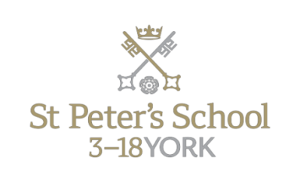
St Peter’s School, founded in AD 627, is one of the oldest schools in the world. With its junior and pre- prep schools, St Olave’s School and Clifton School and Nursery, St Peter’s enjoys a very strong reputation for providing exceptional opportunity for its pupils. It occupies a 47-acre campus on the banks of the River Ouse, and lies within a short walk of the centre of the historic city of York. It is one of very few schools in the North of England to offer three distinct phases of education each sharply identified and focused towards the needs of its pupils at each age group, set within an overall context of trust, confidence-building, inspiration and opportunity.

The School is fully co-educational. The boarding community makes up around one third of the Senior School, with 561 pupils in Years 9-13. The School is on a very firm financial footing with no borrowings. St Peter’s is generating a healthy surplus and is able to plan confidently for future developments.

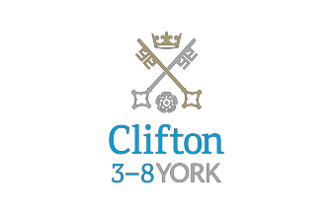
York is one of the most attractive cities in the north of England with its lively blend of commerce, history, learning and culture. The city is well-connected: Leeds and Yorkshire’s east coast are 45 minutes away while trains from York station (a ten minute walk from the School) reach London, Edinburgh or Manchester in around two hours.

Clifton School and Nursery for day girls and boys aged 3 to 8 years, has its own building with use of extensive play areas, sports hall and swimming pool. Under the leadership of the Head, teachers use the attractive buildings and play areas to maximum advantage, teaching a broad and balanced curriculum which gives a wide variety of experiences, and emphasises the importance of basic skills. The curriculum is based on the National Curriculum and Primary Strategy, but goes well outside – both within the school day and during the wide range of co-curricular activities and visits beyond School.

Clifton enjoys separateness, a clear identity and its own House system. It allows smooth academic progression and provides tailor-made approaches and facilities for each age group. Clifton received the Archant “Best Pre-prep School 2011” - a national award.

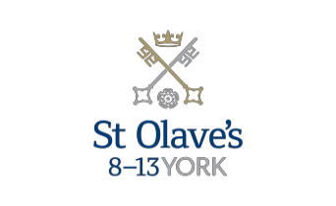

St Olave’s School (pronounced ‘olives’) for girls and boys aged 8 to 13 years, is adjacent to the main campus of St Peter’s and introduces boarding as an element of the School. Under the leadership of the Master, the teaching staff provide expertise in the 8 to 13 range, guaranteeing subject specialism to challenge and support every pupil.

The curriculum is wide and challenging with expert teaching from the earliest age. There are many opportunities for recreational and competitive sport with girls’ and boys’ teams enjoying success both regionally and nationally. There are numerous co-curricular activities to choose from on a weekly basis. Music plays a central role in school life involving the full range of orchestral instruments.

Boarding is an integral element of the School and is accommodated in Wentworth, a boarding House on the main school campus. St Olave’s has retained its own identity – a school within a school – giving all pupils a sense of pride and identity. It is recognised as a school in its own right, playing a vital role in the success of Clifton and St Peter’s.
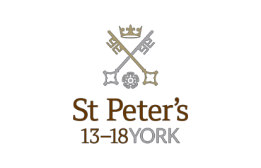
St Peter’s School, for children aged 13 to 18 years, is underpinned by the acknowledgement that academic rigour and challenge are essential elements. Through outstanding teaching, first rate facilities, high expectations and sheer determination on the part of its pupils, St Peter’s achieves considerable success across a broad curriculum.

The four vibrant and successful boarding Houses for boys and girls lend a vitality to the pastoral life of the School. Inspiration from living in close proximity to a cultured and historic city adds further richness to the pupils’ lives. The Ofsted inspection of Boarding in December 2010 found the School’s provision to be Outstanding.

The School Chapel stands at the centre of the campus and regular services (three mornings a week) give pupils and staff the opportunity to reflect together on the spiritual values of the community and on the meaning and significance of what is happening locally, nationally and globally.

Music, Art and Drama are central to the cultural and academic depth of the School. The Sports programme is extensive providing a wide range of choice for both girls and boys; results are excellent. St Peter’s pupils’ co-curricular achievements are considerable. The excellence of the teaching and facilities allows pupils to thrive.

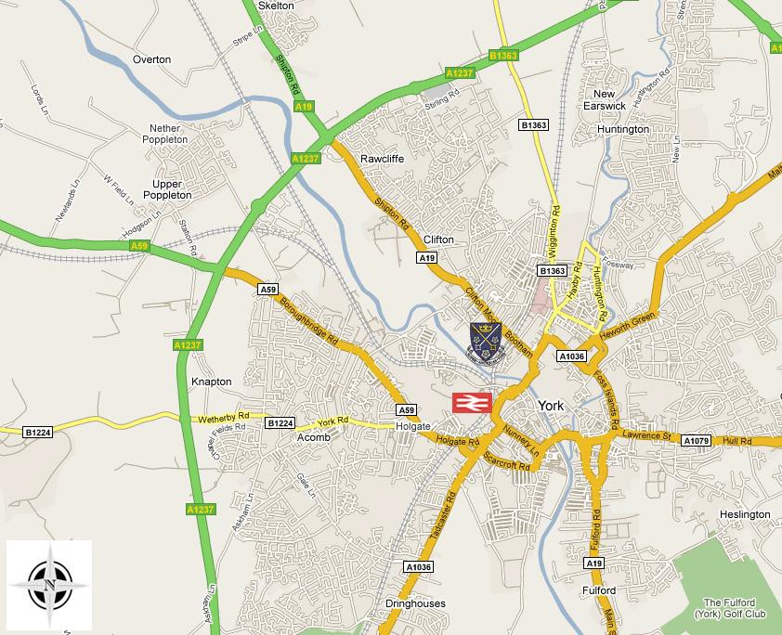

A guide to the City of York can be found at http://www.visityork.org/

The school’s website can be visited at www.stpetersyork.org.uk. The most recent inspection report is available on the ISI website.

Pupils at St Peter’s are encouraged to take part in a wide and varied choice of extra- curricular activities. These activities are presented alongside the main team games provision and include:

MUSIC  Jazz Ensemble Guitar Group Choir Swing/Wind Bands  Barber Shop / Barbie Shop Harmony Orchestra / String Orchestra  Brass Group  String Quartet/Piano Quintet | COMMUNITY ACTION  Silver Surfers Signing for the deaf Young Enterprise
CREATIVE  Drama Art  DT Club Cookery | OTHER SPORTING ACTIVITIES  Squash / Table Tennis / Badminton / Modern Dance / Street Dance Trampoline  Weights / Body Tone / Gym Running / Swimming / Water Polo Football / Rugby sevens  Circuits
MAJOR SPORTS  Netball Hockey Rugby Cricket Tennis Rowing | DUKE OF EDINBURGH  (Bronze, Silver & Gold)  CHESS CCF DEBATING

