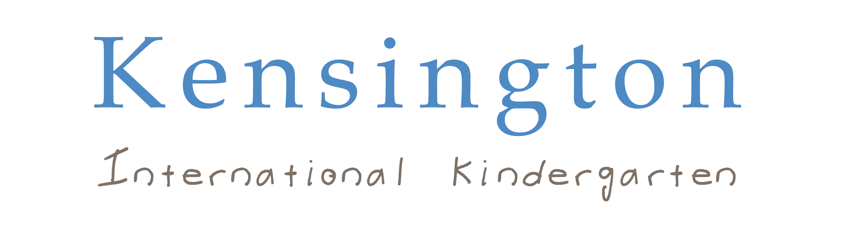
Early Years Teacher Personal Specifications
 | Essential | Desirable | Method of  Assessment
Qualifications | Degree -  B.Ed (Hons) or PGCE with QTS or equivalent. | Additional coaching or other specialist qualifications appropriate to the job. | Certificate
Experience | A thorough knowledge and understanding of the EYFS  An excellent classroom practitioner  At least 3 years’ experience in a full time teaching position in within a recognised education organization or College placements if recently qualified. | Experience in an Independent School  Understanding and experience of working in inclusive settings  Experience of teaching in an international setting | Reference
Skills | Highly developed or developing teaching skills  Excellent subject knowledge  Make full use of the additional opportunities for curriculum enrichment in the wider school environment and the local and international community  Display flair and creativity in engaging, enthusing and challenging groups of pupils  Up-to-date knowledge of ICT and the new technologies, and of how to make use of them to enrich teaching and improve learning  Excellent oral communication skills, especially in relation to children and young people  Ability to supervise and manage groups of children and young people with confidence  Excellent levels of numeracy and literacy  A positive attitude towards children and young people including the ability to demonstrate and promote positive values, attitudes and behavior  Ability to work collaboratively with colleagues across the School  Excellent administrative, organisational and ICT skills  The ability to work under pressure and prioritise work in a busy school environment  The post-holder will be expected to undertake development and training appropriate to the post | The desire to develop new skills through in-service training. | Application Form Interview
Knowledge | Know and understand what constitutes excellence in teaching and learning  Experience of AfL  How to make use of recent research and findings regarding different types of intelligence and how children learn  Excellent Written and verbal Communication skills  Team player capable of working independently | Other programmes of study  Knowledge of Child Protection | Application Form Interview
Personal Competencies & Qualities | Be articulate and inspiring, confident, stable and supportive, highly able and innovative  Stamina, energy and drive in abundance, with the ability and determination to attain and maintain very high educational standards and to raise pupil standards of achievement to the very highest levels  Think creatively and imaginatively to anticipate and solve problems and to identify opportunities  Know how to plan and prioritise time and actions effectively  Self-supporting with the ability to work as part of a team  A sense of humour and a genuine understanding and liking of our children  Approachable, open and honest  Dedicated, conscientious and hard working  An excellent health and attendance record over the last two years  Enjoys the challenge of stimulating young minds  Demonstrate a consistent record of positive parental involvement in learning and a generally high level of satisfaction  A willingness to contribute to whole school development  Provide a role model for pupils and other staff through personal and professional conduct  The ability to relate well to the children and create a caring and supportive atmosphere in the classroom  Shows initiative  A willingness to share ideas and to learn from others  A thoroughly professional approach to all aspects of the role |  | Interview

