HEAD OF ACADEMIC MUSIC

SENIOR SCHOOL (13-18)

The Appointment

Cheltenham College is seeking a well-qualified and experienced graduate to lead this highly successful department from September 2017. The appointee will have the scope to review all academic aspects of the Music Department and to contribute to the wider academic and intellectual development of the College as a whole. It will be an ideal post for someone looking to move on to a Director of Music post in due course. The successful candidate will teach Music to A Level and beyond; interest and experience in teaching and developing Music Technology is highly desirable.

The College
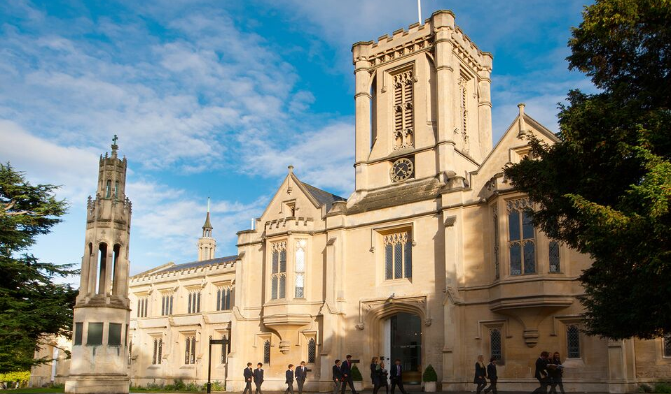
The College consists of two inter-dependent fee-paying schools within a single executive structure. The Senior School [13-18], founded in 1841, is the oldest of the Victorian public schools and is predominantly a boarding school of about 660 pupils, including a Sixth Form of approximately 280 pupils. The Prep School [3-13] is largely a day school of some 400 pupils. Both schools are fully co-educational. The schools are situated in their own spacious grounds near the centre of Cheltenham, a flourishing Cotswold town. They have fine academic records and a considerable reputation for sport, drama and music.

The Music Department

The Music Department consists of three full time members of academic staff (including the Head of Academic Music), together with Heads of Vocal Studies; Strings; Wind Brass and Percussion; Pop and Jazz; Exams and Performance; a Department Secretary and around thirty visiting music teachers (peripatetic). It is housed in a magnificent former stately home, with spacious classrooms and enviable rehearsal and performance spaces. The recently developed recording suite consists of three rooms, comprising two live studios and one control room. It is equipped with a state of the art recording desk and software with three iMac computers all running Logic Pro Studio X. Additionally there is a new Music ICT Suite which houses a further sixteen iMacs, all running Logic Pro X, GarageBand, Sibelius 8 and midi keyboard controllers.

College is fortunate to have superb performance spaces, and Thirlestaine Long Gallery and Big Classical are frequently used for large scale orchestral performances. College is also well known for its choirs, who are privileged to sing in the magnificent Chapel for services and concerts. Recent tours have included visits to Italy, Spain and New York, and in February 2016 the orchestras, choirs and bands of both College and the Prep School gave a gala performance in London’s Cadogan Hall to great acclaim.

All members of the 3rd Form study Music, and have the option to continue at GCSE and beyond at A Level. Many students also take the opportunity to undertake an EPQ with musical performance as well as research and recording specialities. The AQA syllabus is followed for both GCSE and A Level courses. Music Technology is currently offered on an individual basis, and there are thriving studio activity clubs and modern instrument performing ensembles as part of College’s extra-curricular activities programme.

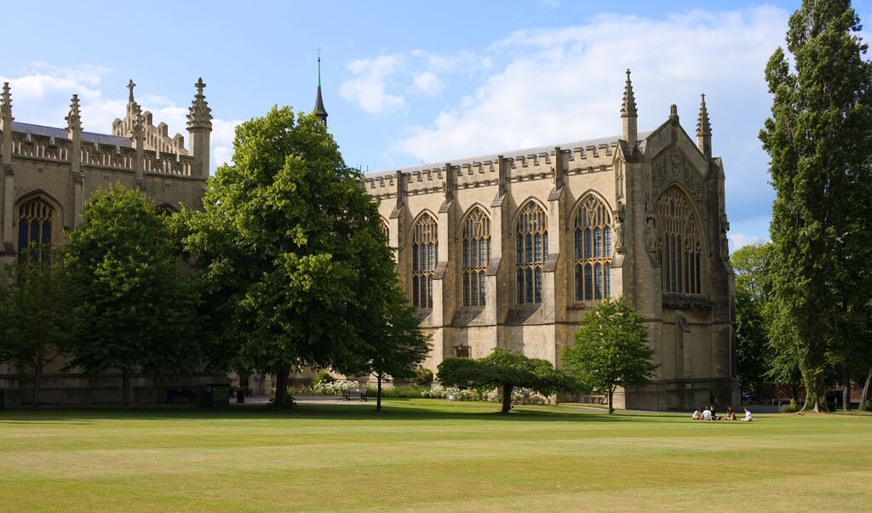
From the 1 December 2016, Cheltenham College will become an All Steinway School, and will take delivery of five Steinway Concert Grand pianos, including two of the flagship ‘Model D’ instruments; and fifteen new upright pianos.

Recent collaborations have included performances and master classes with the ‘Tallis Scholars’, and from September 2016 both the College Symphony Orchestra and Prep School musicians have begun a new partnership with the City of Birmingham Symphony Orchestra, who regularly visit, coach and perform with College instrumentalists.

Weekly informal lunchtime concerts mean that everyone has an opportunity to perform and develop their skills in a variety of venues, and these are keenly supported by both staff and students.

College staff form a vibrant Common Room with a great community feel. There are regular social events involving families, and the annual staff concert is increasingly popular.

Cheltenham itself is a centre for the arts, with internationally renowned Music, Jazz, Literature and Science Festivals. College Students and ensembles regularly perform as part of these, and College have hosted a number of major Festival events over the last few years.

Job Specification

The Head of Academic Music is responsible to the Headmaster, via the Deputy Head (Academic), and the Director of Music, for the teaching, leadership, administration and development of Academic Music in the Senior School. He or she is a member of the Heads of Departments’ Committee.

In particular, he or she will bear the following responsibilities:

Leadership and Development

- Establishing a vision for Music in the academic life of the College;
- Formulating a departmental development plan;
- Ensuring that teaching and learning are excellent, specifically through lesson observation, appraisal, continuing professional development and departmental audit;
- Fostering a delight in the subject, an excellent work ethic and a culture of high expectations, achievement and success amongst staff and pupils, and setting the highest academic standards;
- Encouraging independent learning specifically through the use of formative assessment and thorough, imaginative schemes of work;
- Maintaining excellent communications with the department and relaying College academic policy to the department;
- Further developing the appropriate use of ICT as a tool for teaching and learning;
- Assisting in appointing new staff; providing opportunities for responsibility to be assumed by members of the Department;
- Representing the Department within the College and promoting Music in the wider academic community including feeder schools;
- Assist the Director of Music in coordinating professional development reviews within the Department.

Administration

Teaching and Learning:

- Monitoring and recording the learning of pupils in the department, and overseeing the support of those with additional needs;
- Writing and updating schemes of work and programmes of study;
- Monitoring and supporting the progress of both new and established staff;
- Organising lectures and talks by outside speakers;
- Providing curriculum information as required;
- Dealing with syllabus enquiries, updating, investigating alternatives and changing syllabuses as necessary;
- Establishing and overseeing subject enrichment within the co-curricular programme;
- Researching, updating and ordering resources;
- Arranging departmental displays;
- Managing and organising trips, where appropriate;
- Monitoring the setting of prep
- Providing information for 3rd Form pupils making GCSE choices and 5th Form pupils making A Level choices;
- Meeting and communicating with parents when required;
- Preparing and presenting the Departmental Academic Review and supplementary documentation;
- Keeping up to date with subject developments;
- Producing and updating a departmental handbook.

Universities:

- Assisting with university applications, including organising and conducting mock interviews in accordance with the arrangements made by the Head of Upper College;
- Collating and disseminating up-to-date University and UCAS information;
- Providing comments for UCAS references as well as other relevant details as required;
- Providing assistance, extra tuition and general guidance for Oxbridge applicants.

Examinations:

- Organising internal examinations, including setting, marking and moderating papers, collating statistics and publishing results;
- Organising entries for public examinations;
- Providing details of estimated public examination entries and candidates for re-sits, and supplying predicted grades;
- Dealing with examination boards, including complaints, re-marks and appeals;
- Handling public examination results, including answering parental enquiries, and providing comments, data and statistics as required.

General:

- Managing the departmental academic budget;
- Writing references when required;
- Reviewing and updating the departmental handbook;
- Providing occasional reports for College publications on departmental academic developments;
- Assisting the Director of Music in the organisation of weekly departmental meetings;
- Attending HoDs’ and other meetings as required;
- Making arrangements for cover of absent members of the department;
- Teach a number of individual lessons on their specialist instrument/voice

Skills and characteristics

- Vision and leadership;
- Outstanding teaching and communication skills;
- Excellent administrative and organisational abilities.
- A musician who is passionate about the delivery of musical education in all styles and genres, and keen to create musical opportunities both in and out of the classroom for students of all ages and levels of experience
- Team player, with the ability to create a happy and constructive atmosphere in which students can thrive
- Up to date knowledge of the Music industry, as well as associated equipment and software
- Willingness to contribute to the Music Department’s co-curricular programme of ensembles and performances in their area of expertise

Expectations

Members of Common Room are expected to teach their subject[s], to act as tutors, to be attached to day or boarding Houses, to make a substantial contribution to the co-curricular programme and to support the boarding ethos of the College.

Although hours of work are not specified precisely, the working day begins with a registration period at 8.30 am and will often include evening commitments during term times. Members of Common Room are expected normally to be on site throughout the working day and to be available even when they have no formal commitments. Saturdays begin at 8.30 am and all full-time members of Common Room are expected to be in College whether or not they are teaching. There are College and/or House-based activities at weekends in which they are also expected to play a part. Outside of the formal term times they are expected to be in College for College or departmental INSET and to be available to fulfil any reasonable duties.

Chapel is central to College life reflecting its Christian foundation. On weekdays all members of Common Room are expected to attend the brief morning service. Attendance on Sundays is not obligatory, but is encouraged.

The College sets the highest professional standards in every respect.

Cheltenham and the Cotswolds

Cheltenham is an extremely attractive Regency town of about 120,000 people. It is situated at the foot of the Cotswold escarpment and a wide range of outdoor activities are thus on our doorstep. The College is situated about 10 minutes’ walk south of the town centre. The town has a vibrant cultural life, and hosts a number of nationally-renowned festivals. The Times Literature festival in October is the best known and affords the College the opportunity to take students to attend talks from leading authors (including economists, historians and politicians) and other events in a range of subjects. The College Choirs have illustrated high profile Literature events with choral excerpts as part of talks for the last three years. Science, Music, Jazz, Cricket, and Food and Drink festivals, in addition to thriving markets and dozens of outstanding restaurants contribute further to making Cheltenham an enjoyable place to live and work.

Terms and Conditions:

- Heads of Department teach a reduced timetable in order to undertake duties and play an appropriate part in the co-curricular life of the College.
- Service with the College is pensionable in accordance with the Teachers’ Pension Scheme and permanent members of staff are entitled to a substantial reduction in fees for their children.
- Assistance with accommodation may be available.
- Members of staff may use the College sports’ facilities (at staff allocated times).
- The College has its own salary scale.
- Subsidised health scheme membership (Benenden).
- Discounts and offers for College staff from local businesses and retailers.

The deadline for applications is 12 noon prompt on Thursday 1 December 2016. Further information may be obtained from Mr David McKee, Director of Music on 01242 265674. Interviews will be held on 8 December 2016.

