SENIOR SCHOOL (13-18)

Teacher of Physics

The Appointment

A strong graduate is required from September 2017 to teach the subject across the full ability and age ranges in a successful and thriving department. Shortlisted candidates will have a good degree in Physics or a related discipline. The post would suit equally an experienced teacher looking for a new challenge, or a teacher beginning his or her career. The successful candidate will teach Physics from Year 9 to A Level, and will contribute to the College’s extraordinary Games and Activities programme. This is initially a one-year appointment, and there may be scope to extend the post in due course.

The College
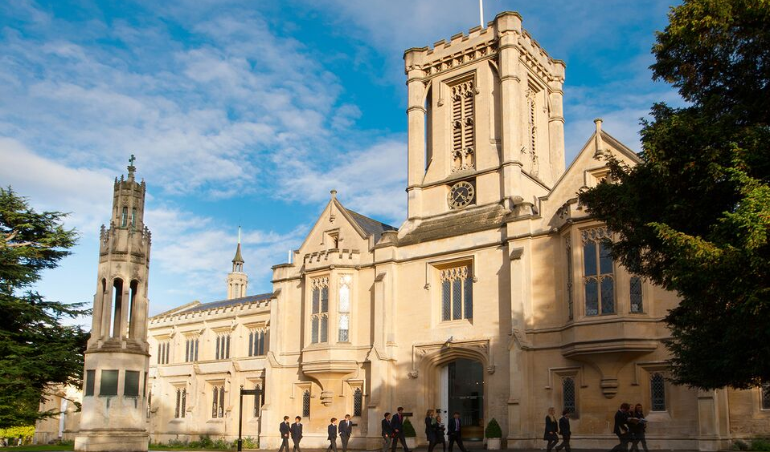
The College consists of two inter-dependent fee-paying schools within a single executive structure. The Senior School [13-18], founded in 1841, is the oldest of the Victorian public schools and is predominantly a boarding school of about 660 pupils, including a Sixth Form of approximately 280 pupils. The Prep School [3-13] is largely a day school of some 400 pupils. Both schools are fully co-educational. The schools are situated in their own spacious grounds near the centre of Cheltenham, a flourishing Cotswold town. They have fine academic records and a considerable reputation for sport, drama and music.

The Science Department

The Science Department is housed in a brand new building of 15 laboratories, a library, 3 prep rooms and a resources room. The Department believes strongly in the centrality of practical work in Science, and the teaching staff are supported by six technicians. The three departments work closely together, and some colleagues teach more than one of the disciplines. All three Science departments have excellent public examination results at GCSE and A Level.

Sciences are some of College’s most popular options. Uptake of the three Sciences at A Level is notably strong; each department caters for three or four Sixth Form sets in each year group. Every laboratory has wireless access to the College network and the internet, and is equipped with a data projector and visualiser. All laboratories were refurbished in the summer of 2014 and can now be considered state of the art. All staff are supplied with an Apple MacBook.

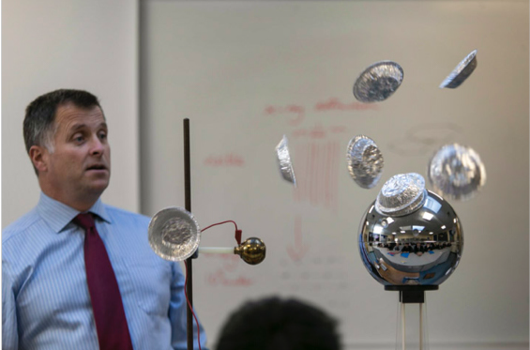 | The Physics department has five laboratories located  around a central prep room and office. Each teacher  has their own laboratory as well as a desk in the  office to facilitate the sharing of ideas. We utilise the  latest resources and have the best (Pasco and Vernier)  data logging equipment as well as subscriptions to the  Doddle, Kerboodle and eChalk online platforms.  College has recently moved to the Office 365 platform  for communication and the storage and sharing of  resources.
The department has a strong record of academic success with many students moving on to study STEM degrees at top universities after achieving A* grades. Extension classes are offered to the highest-attaining pupils to support such applications, and to prepare them for the Physics Olympiad competitions. College’s small class sizes and strong pastoral emphasis mean that all students are known well as individuals, thus facilitating the outstanding improvements that our students make. Staff give willingly of their time outside of lessons to support this student progress. |  | 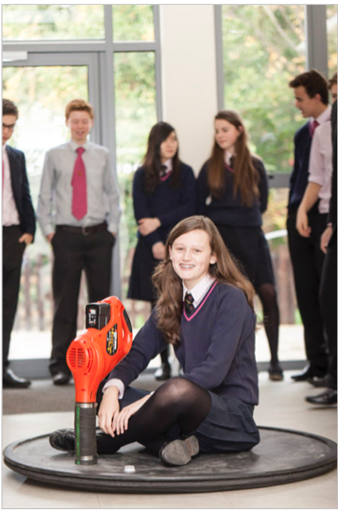
Expectations

Members of Common Room are expected to teach their subject[s], to act as tutors, to be attached to day or boarding Houses, to make a substantial contribution to the co-curricular programme and to support the boarding ethos of the College.

Although hours of work are not specified precisely, the working day begins with a registration period at 8.30 am and will often include evening commitments during term times. Members of Common Room are expected normally to be on site throughout the working day and to be available even when they have no formal commitments. Saturdays begin at 8.30 am and all full-time members of Common Room are expected to be in College whether or not they are teaching. There are College and/or House-based activities at weekends in which they are also expected to play a part. Outside of the formal term times they are expected to be in College for College or departmental INSET and to be available to fulfil any reasonable duties.

Chapel is central to College life reflecting its Christian foundation. On weekdays all members of Common Room are expected to attend the brief morning service. Attendance on Sundays is not obligatory, but is encouraged.

The College sets the highest professional standards in every respect.

Cheltenham and the Cotswolds

Cheltenham is an extremely attractive Regency town of about 120,000 people. It is situated at the foot of the Cotswold escarpment and a wide range of outdoor activities are thus on our doorstep. The College is situated about 10 minutes’ walk south of the town centre. The town has a vibrant cultural life, and hosts a number of nationally-renowned festivals. The Times Literature festival in October is the best known and affords the College the opportunity to take students to attend talks from leading authors (including economists, historians and politicians) and other events in a range of subjects. Science, Music, Jazz, Cricket, and Food and Drink festivals, in addition to thriving markets and dozens of outstanding restaurants contribute further to making Cheltenham an enjoyable place to live and work.

Terms and Conditions:

- The College has its own salary scale.
- Service with the College is pensionable in accordance with the Teachers’ Pension Scheme and permanent members of staff are entitled to a substantial reduction in fees for their children.
- Members of staff may use the College sports’ facilities (at staff allocated times).
- Subsidised health scheme membership (Benenden).
- Discounts and offers for College staff from local businesses and retailers.

Closing date for applications is Thursday 1 December at 12 noon prompt and interviews will be held on Friday 9 December. If you would like any further information on the role, please feel free to contact the Head of Physics, Mr Stuart Cooper at s.cooper@cheltenhamcollege.org or on 01242 265600 (ext 254).

November 2016

