Castle Donington College
Head of Design
TMR / UPR plus TLR 2b (£4,395)

Start date: Monday 24th April 2017 or earlier

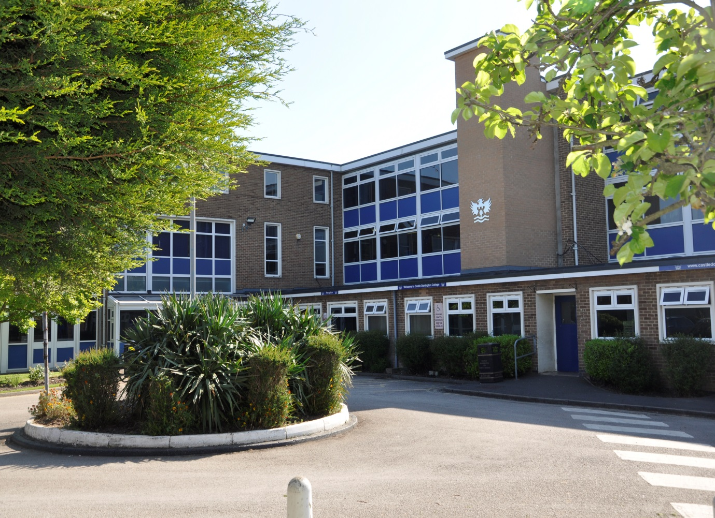

Subject Leader: Design

Dear Applicant,

Thank you for your interest in the post of Head of Design at Castle Donington College. I hope the enclosed pack will be of interest to you and I look forward to receiving your completed application.

Castle Donington College has the makings of an outstanding school. In March 2015 we received an Ofsted rating of Good with Outstanding behaviour and safety. We are a small Leicestershire High School currently in our final year of educating pupils within the 10-14 age range. We welcome our first Year 10 cohort in September 2017 as we make the transition to an 11-16 School. We are very proud of our community and the pupils we serve and so are seeking to appoint an inspirational leader with the highest personal, academic and professional standards to lead our Design Department.

The Design Department is currently housed in 4 specialist rooms and an ICT suite. A small department of 4 staff delivering the KS3 curriculum to groups on rotation. Units of work covered at KS3 include; Art, Food, Graphics, Resistant Materials, Product Design and Textiles.

- Head of Department – Vacancy
- Teacher of Art – Ashley Brennan
- Teacher of Textiles – Rachel Canny
- Teacher of Resistant Materials – Sally Danes (also Head of Key Stage 2/3 Transition)

You will demonstrate a clear vision, regarding the introduction of GCSE courses, whilst maintaining and developing the existing KS3 curriculum. You will be able to articulate a strategy to demonstrate impact in achieving further increases in attainment and progress for all pupils.

All our Middle Leaders have the highest expectations of themselves, their team staff and the pupils. They work closely to sharing best practice and drive school improvement. This is a very important appointment at a critical time. We are nine months away from introducing our first year of GCSE and a KS4 curriculum. The advertised post comes with its challenges and will require personal drive and ambition. However we believe candidates with passion for their subject, innovative teaching, leadership experience or potential will flourish and the rewards will be great. We can offer a coherent programme of support through induction and have a strong commitment to professional development through our Professional Learning Programme. Your development as a Middle Leader will be a key priority for us.

We welcome and encourage prospective candidates to come and visit to meet our staff and pupils to experience first- hand the ethos and values of the College.

Yours faithfully,

Julie Sheppard
Principal

Vision
At Castle Donington College, we are concerned, first and foremost with people. The staff and governors are committed to providing the best possible education for all of our students. We care passionately about the quality of education we provide.
Although our facilities are modern, we consider traditional attitudes and values to be important. We aim to provide individual, caring attention for each child and to create a stimulating environment so that effective teaching and learning can take place. Castle Donington College has high expectations of its students both academically and socially.
What pupils can expect from us:

- A challenging inclusive curriculum
- A wide range on curriculum activities
- Good and outstanding teaching everyday
- Targets and timely support
- Outstanding pastoral care
- The highest expectations without exception
- Values rooted in respect, kindness, trust and support
- A safe learning environment free from disruption
- To be well prepared for next stage in education, training or employment and for adult life

What we expect from pupils:

- Excellent attitude to learning
- A relentless desire to achieve in all areas
- Excellent attendance
- Impeccable conduct every day
- Curiosity and resilience
- to capitalise on advice and feedback in order to improve
- The highest aspirations for their futures

How to apply

Appointment of | Head of Design
Salary | TMR/UPR plus TLR 2b (£4,395)
Start date | April 24th 2017 or sooner if possible
Closing date | Thursday 8th December 11.00am
Interview date | Tuesday 13th December

We encourage you to apply for the post online. You can access the pack through our website. Download the application form and once completed send it via email ldeley@castledonington.leics.sch.uk

Alternatively post or deliver by hand to:

Lorraine Deley
Principal’s PA
Castle Donington College
Mount Pleasant
Castle Donington
DE74 2LN

If you are shortlisted you will be contacted by email or letter with further details prior to interview.

Please be aware, as the applicant, you are responsible for ensuring your application reaches us before the deadline/closing date. Late applications will not be accepted.

Person Specification- Head of Design
 | Essential / desirable | Method of assessment
Qualifications and Knowledge
Qualified to degree level and above | E | A
Qualified to teach in the UK | E | A
Right to work in the UK | E | A
Understanding of role regarding safeguarding and child protection | E | I,R
Knowledge of KS3 and KS4 curriculum in Design | E | A
Understanding of assessment and monitoring of Design | E | A,I,R
Specific and up to date knowledge appropriate to lead Design in the College | E | A,I,R
Experience
Recent teaching of Design at KS4 | E | A,I,R
Recent teaching of Design at KS2 and KS3 | D | A,I,R
Experience of leadership | D | A,R
A proven track record of excellent outcomes for pupils | E | I,A,R
Experience of teaching in more than one school | D | A,I
Experience of coaching others | D | A,I
Teaching and Learning
Excellent classroom practitioner | E | I,R
Able to use data effectively to monitor, implement appropriate intervention and raise attainment and levels of progress | E | A,R
Willingness to implement strategies to improve and sustain the highest quality teaching, learning and achievement | E | A,I,R
Strong communication, planning and organisational skills | E | A,I,R
Ability to apply highly effective behaviour for learning strategies | E | I,R
Ability to demand high standards, using flair and creativity to engage, enthuse and challenge pupils of all abilities, needs and backgrounds. | E | A,I,R
Leadership
Effective organisational skills including the ability to meet deadlines | E | A,R
Effective leadership skills | E | A,I,R
High expectations for accountability and consistency | E | A,I,R
Belief in the potential of individuals | E | A,I,R
Ability to work independently and as part of a team | E | A,I,R
Commitment to take a lead in promoting innovations that raise pupils’ levels of attainment and progress | E | A,I,R
Skills and attributes
Commitment to own professional development | E | A,I,R
Able to work in ways that promote equal opportunities | E | A,I,R
Self-aware, empathic, able to manage feelings, motivate and effective social skills | E | A,I,R
The ability to influence and motivate others | E | A,I,R
Excellent health and attendance record | E | A,R
Able to demonstrate resilience, motivation and commitment to driving up standards | E | A,I,R
I interview R reference A application

Job Description - Head of Design
Job Title: | Head of Design | Reporting to: | Leadership Team
Department: | Design | Line Managing: | Department Staff
Working with: | The Leadership Team, Middle Leaders, relevant teaching staff, tutor team, support staff, parents | Salary | TMR / UPR plus TLR2b
Post Type | Permanent / full time

Safer Recruitment Statement
Castle Donington College is committed to safeguarding and promoting the welfare of pupils and young people and expects all staff and volunteers to share this commitment.

Responsibilities of all teachers:
- Carry out the duties of the teacher in accordance with the national statutory Standard Teacher Pay and Conditions document and Teacher Standards
- To ensure all pupils are safe at all times
- Carry out appropriate duties and participate in meetings as defined by the relevant rota and calendar
- Personally and collectively support pupils in becoming confident individuals, successful learners and responsible citizens
- Treat all pupils with dignity, building relationships rooted in mutual respect and at all times observing proper boundaries as appropriate to their professional role within the College
- Respond speedily to parental concerns
- Act as role models by demonstrating a professional level of dress, appearance and behaviour.
- Treat all colleagues with respect
- Have a proper and professional regard for the ethos, policies and practices of the College and maintain high standards of punctuality and attendance
- Engage actively in the Performance Management process
- Show a tolerance of and respect for the rights and beliefs of others
- Be expected to comply with any reasonable request from a manager to undertake work at a similar level that is not specified in this job description
Role of all teachers:
As an expert practitioner, to make the education of pupils your first concern. To be accountable for achieving the highest possible standards in work and conduct. Teachers at the College act with honesty, integrity and work in the best interests of the pupils at all times.
All teachers will:
- Encourage good progress and outcomes
- Demonstrate good subject knowledge
- Plan and teach well-structured lessons
- Adapt teaching to respond to the strengths and needs of all pupils
- Make accurate and effective use of assessment data
- Be a Form tutor
- Manage behaviour effectively to ensure a safe and productive learning environment
- Fulfil wider professional responsibilities
- Keep themselves and others safe

Responsibilities of the post holder
To act as the professional lead for your department inspiring teachers and pupils to have a passion for your subject, continuously improving classroom practice and achieving excellent outcomes for all pupils by taking responsibility for:
- Ensuring teaching, behaviour and outcomes are good or better
- Monitoring the quality of learning and teaching as part of the College’s quality assurance programme.
- Leading and supporting members of the department through the Performance Management Appraisal process
- Manage the professional development of staff within the curriculum area and evaluate the impact on teaching and learning
- Ensuring the quality of teaching is good or better by identifying and sharing best practice internally and externally
- Implementing staff coaching and intervention strategies as well as having regard for staff welfare
- Ensuring all pupils engage and make progress by leading planning and pedagogy that includes differentiation, groupings and best use of teaching staff
- The procurement and effective use of resources for learning and use of the latest technologies for learning to ensure best pupil outcomes and experience
- Managing strategically the developments of curriculum demands to promote best practice and progress for all pupils
- Ensuring that all pupils in the subject area achieve at least nationally expected levels of progress and a high proportion exceed them
- Challenging pupils and supporting relevant staff by ensuring behaviour strategies are followed consistently by the department in line with College procedures.
- Identifying, tracking, analysing and responding to data in relation to reporting on outcomes, to ensure that the highest outcomes possible are achieved
- Leading on the creation of schemes of learning that challenge, stretch and fire the imaginations of all pupils
- Maintaining up to date whole school and department plans for area improvement and evaluating impacts
- Ensuring that effective and regularly evaluated transition arrangements are in place for our pupils
- Ensuring that there are rigorous quality assurance measures in place for the department
- Ensuring that incidents of poor pupil behaviour are successfully dealt with to minimise disruption to learning
- Creating, coordinating and evaluating effective intervention to eradicate pupil performance gaps
- Being proactive in engaging parents in their child’s learning and potential learning by providing parental education and support
- Engaging with and developing educational partnerships that enhance the learning and outcomes for our pupils by providing training, moderation, support
- To manage and administer area budget effectively

The responsibilities listed above are subject to the general duties and responsibilities contained in the statement of conditions of employment and National Teaching Standards.
This job description is current at the date shown, but following consultation with you, may be changed by the Principal to reflect or anticipate changes in the job which are commensurate with the salary and job title.
April 2016

