November 2017

Dear Candidate

Thank you for showing an initial interest in a teaching position at the British School of Beijing, Shunyi, one of the Nord Anglia Education family of schools which now numbers 43 schools committed to the same purpose, providing the best possible education for more than 35,000 students located in 15 countries. Each school has a unique character and an educational offer tailored to meet the needs of its community. But we are all united by our ‘Be Ambitious’ philosophy – we are ambitious for our students, our colleagues and our family of schools, and believe that every student can achieve more than they ever dreamt possible given the right support and opportunities, in school and through our Global Campus.

If you choose to apply, and are appointed, you will join what I believe is a quite exceptional school, to which I am proud to send my own daughter. At BSB we are, quite simply, passionate about education and believe that our young people can achieve amazing things whilst they are with us. Our students are outstanding; coming from approximately sixty different nationalities, they fully embody the principles on which our school is based: high academic standards, exemplary respect and good manners towards others, getting involved in everything the school has to offer, and, perhaps above all, enjoying their time with us to the full. BSB is a dynamic and happy place to be. We refer to ourselves as ‘the BSB family’ and we mean it!

I hope the various attachments and our school website will give you a clear flavour of our school and an understanding of whether you would like to be part of our continued success and our quest to develop even further.

If you feel that BSB is for you, and you meet the criteria in the attached documents, I very much look forward to reading your application.

With best wishes

Yours sincerely

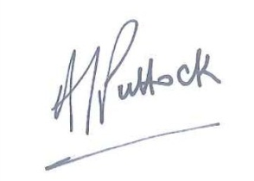

Andy Puttock
Principal

