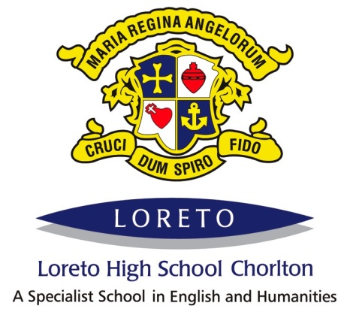

PERSON SPECIFICATION FOR TEACHER OF MATHEMATICS

 | Essential | Desirable | Evidence
Qualifications | - Qualified Teacher status in Secondary mathematics teaching.  - Good honours degree or equivalent. | Evidence of continuous INSET and commitment to further professional development. | Application Form & Certificates
Experience | - Teaching mathematics across KS3 & KS4.  - Employing strategies in own classes to raise attainment. | Employing or leading successful initiatives in mathematics which have raised student attainment. | Application form  Letter of application  References
Knowledge and understanding | Statutory curriculum requirements and the requirements for assessment, recording and reporting of pupils’ attainment and progress.  High level of subject knowledge.  Up to date knowledge of the characteristics of high quality teaching and the main strategies for improving and sustaining high standards of learning and achievement for all pupils  - Effective strategies for the promotion of good student behaviour and for dealing with challenging behaviour.  - Effective strategies for implementing successful intervention.  - Thorough understanding of current education polices and practice particularly relating to Physical Education, Equal Opportunities, Health & Safety, SEN and Child Protection.  - The positive links necessary within school and with all its stakeholders. | - The history and distinctive ethos of Loreto schools.  - An understanding of the Catholic faith | Letter of application  Interview  References
Skills | Ability to:  - teach all abilities and ages to a high standard, utilising good classroom teaching skills, to promote good student progress;  - work as part of a team and on own initiative;  - make a contribution to extra-curricular life of the school;  - promote the school’s aims positively and use effective strategies to enthuse students with a love of learning and of mathematics;  - communicate effectively, both orally and in writing, to a variety of audiences;  - create a safe, happy, challenging and effective learning environment;  - manage student behaviour and maintain high disciplinary standards;  - organise self and complete administration tasks efficiently. | Outstanding practitioner with ability to deliver consistently good and outstanding lessons. | Letter of application  References  Interview
Personal characteristics | - Have a commitment to supporting the full life of the school, including the programme of extra-curricular activities.  - Approachable, empathetic, patient and possessing a sense of humour.  - Enthusiastic, energetic, adaptable, resourceful and creative.  - High standards.  - Display an awareness, understanding and commitment to the protection and safeguarding of children and young people.  - Have an understanding of and willingness to uphold the core values of the Loreto order. | Inspirational teacher with ability to enthuse and engage all students and fellow staff. | Letter of application  References  Interview

