CHURCH OF ENGLAND
PRIMARY SCHOOL
London Borough of Merton

Queen’s Road, Wimbledon
London SW19 8LX
Telephone: 020 8540 8059
Email: school@thepriory.merton.sch.uk
www.thepriory.merton.sch.uk
CHURCH OF ENGLAND
PRIMARY SCHOOL
London Borough of Merton

Queen’s Road, Wimbledon
London SW19 8LX
Telephone: 020 8540 8059
Email: school@thepriory.merton.sch.uk
www.thepriory.merton.sch.uk

Thank you for your interest in the position of Head Teacher at our school. We welcome you and hope that you find this information pack useful.

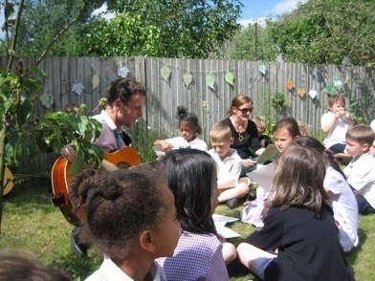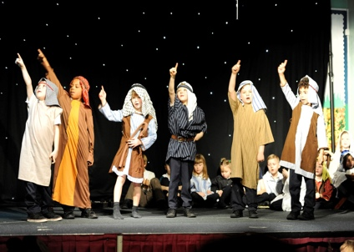
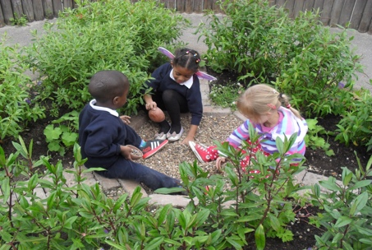
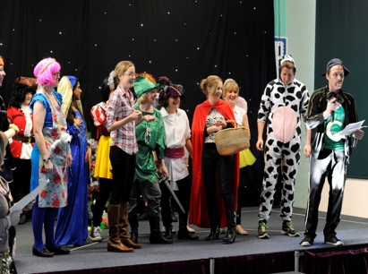

In this pack you will find:

Information about the school

A letter from the Chair of Governors
Mission Statement
Summary of key data
Ofsted Inspection letter

Job Description and Personal Specification
Application information.

Letter from our Chair of Governors
Dear Applicant,
Thank you so much for your interest in applying for the post of Head Teacher at The Priory Church of England Primary School. We have prepared this pack to give you the flavour of the school, but nothing beats coming to meet us and the children. Please contact our School Administrator, Maria Coyne, e-mail: school@thepriory.merton.sch.uk
We love the diversity of our school population. We aim to encourage every child to achieve her/his potential regardless of gender, ethnicity, class or ability. Although we are a faith school, we respect the faith of all our children, while retaining our Christian ethos. Our curriculum is creative and varied. We have both a Gold Sports Mark and a Gold Arts Mark.
We have a wonderful Victorian triple decker building with extensive grounds, including a prize - winning wildlife garden. We are currently upgrading our playground to improve the children’s playtime experience.
Our teaching staff are committed, interesting and intelligent people, who take their jobs seriously and creatively. They are ably supported by our dedicated TAs and friendly, efficient office staff.
Our Governing Body is talented and supportive, bringing a wide range of skills to the school.
We have recently undergone a short Ofsted when our self - assessment of “good” was ratified by the inspector. We are not far off “outstanding” and understand what we need to do to achieve it. We are looking for a Head Teacher who would share that aspiration and lead the school to greater success.
Our current challenges are:
- Reducing our in-school gap between pupil premium and non- pupil premium children.
- Recruiting and retaining staff in an area with a high cost of living.
- Dealing with a high mobility of children with many new entrants having no English.
- Navigating the changes in Government policy to the best possible benefit of the school.
We include a word cloud showing the main qualities we are looking for. This is a wonderful opportunity for an enthusiastic, approachable and ambitious person to join our school at this exciting time.
We will be sorry to lose our present head, Ms White, but wish her all the best in her retirement. If you feel you are the person to lead us into the future, please let us know. If you have any questions you can either telephone me on 07957421525 or e- mail murielgreig@hotmail.co.uk
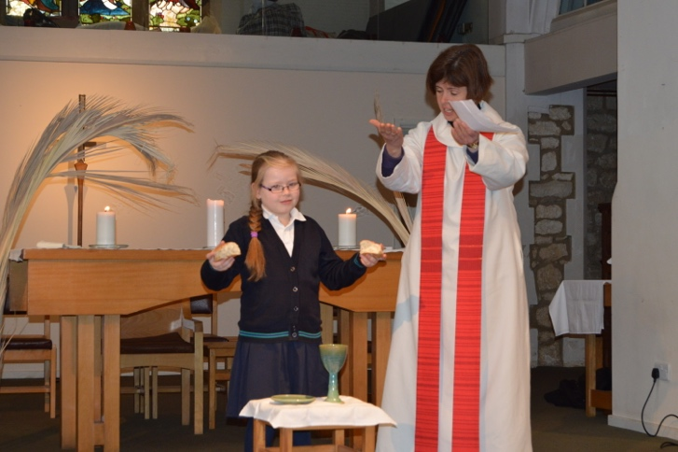
Our Mission Statement
CHURCH OF ENGLAND
PRIMARY SCHOOL
London Borough of Merton

Queen’s Road, Wimbledon
London SW19 8LX
Telephone: 020 8540 8059
Email: school@thepriory.merton.sch.uk
www.thepriory.merton.sch.uk
“The Priory is a vibrant, Church of England school, aiming to provide an outstanding education, for all children to be happy and confident as they are challenged within a Christian environment of creativity, love and respect.”

We have strong links with our local church, Holy Trinity. The Ministry team, Chris Palmer and Kate Tuckett, lead our whole school collective worship every Thursday and we hold school services at the church throughout the year.

The Christian ethos underpins the life of the school and is celebrated through worship, art, music and literature. The children have a strong sense of our Christian values whilst also celebrating and respecting the many other religions that are represented within the school.

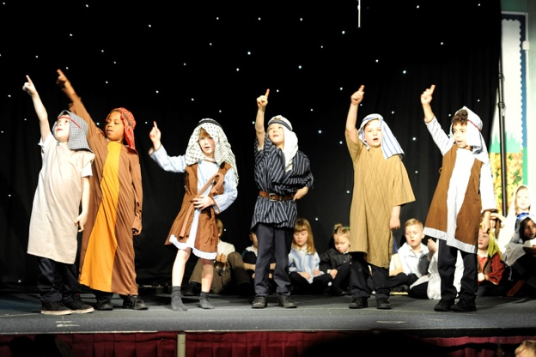
The sense of community extends beyond the school gates with our annual Lent Appeal.This is run through our House system. Each house chooses a charity to support and the House Captains and Sports Captains organise sports competitions, playground activities and table top sales to raise money for their chosen charity. This is pupil led and extremely popular and successful. The children are proud to help others and they choose charities that have special significance to them such as the Shooting Stars Hospice.

Annually the whole school community supports the Livingstone Trust in Tanzania, The Lunchbowl Network in the Kibera slum, Sport Relief, Comic Relief and Children in Need.

The Governing Body

We have a committed, enthusiastic and experienced governing body with representatives from the Richard Thornton Trust, who own our buildings, foundation governors from the local parishes of St. Mary’s and Holy Trinity, parents, staff and the local authority.
“Governors are highly skilled and knowledgeable.” (Ofsted November 2016).

Governors work closely with the staff and SLT whilst maintaining a respect for the difference between strategic and operational roles within the school. Aside from their responsibilities on committees, Governor of the Month visits and liaising with their link member of staff, our governors also attend school performances, special assemblies, parent consultations and events organised by the parents through The Friends of Priory School Association (FOPSA).

Governors are committed to promoting and supporting the well- being of all staff and have worked hard to create positive relationships with everyone who works in the school.

“Leaders have successfully created a culture where staff and pupils feel safe and valued.” (Ofsted November 2016)

Our Staff
Our staff work as a creative, inspiring and happy team. They deliver high quality lessons and enhance the children’s learning with a huge range of additional activities such as trips, drama sessions, one day spectaculars, dress up days, cookery sessions and workshops.
They promote the children’s learning through curriculum coffee mornings for parents where parents can see work from nursery up to Year 6 and speak to children about their learning experience. Curriculum leaders offer workshops for parents in order that they can support their children’s learning at home effectively.
The staff are fun! They participate in dress up days, all fundraising activities led by the children and they also perform exclusively for the children in the annual Christmas pantomime and sing in a staff choir at the Christmas carol concert.
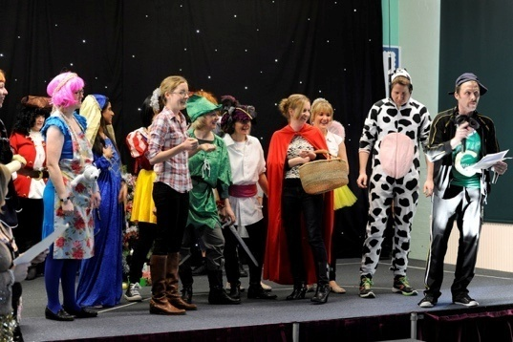
Our staffare a team and everyone is valued whether they have a role in the classroom, the office, the playground or the After - School Club.

FOPSA

The Friends of Priory School Association organise many fundraising events throughout the year which are attended by parents, children, staff and members of the local community. Their support is invaluable and the funds raised have been used for many projects which include updating the sound system in the hall, maintaining our award - winning wildlife garden, funding playground improvements and supporting various individual projects requested by teachers.

Whilst the role of FOPSA could interpreted as that of fundraising, it has a key role within the school, enhancing and promoting the link between home school and the local community. Parents are encouraged to be parent reps, to engage with curriculum workshops and to help with reading in class. FOPSA is an additional voice within the school reaching out to all parents within the school community.

Awards

We are extremely proud to hold the Gold Arts Mark, Gold Sports Mark, Merton in Bloom First Prize and a bronze Eco award. These awards are a testament to the dedication and talent of our staff as we have held these awards for consecutive years and are the only school to have received the Merton in Bloom prize four times. Our staff are committed to a holistic and creative approach to their teaching and these awards demonstrate that their efforts have been recognised. The benefit to the children is obvious as they are learning within a vibrant, creative and inspiring environment.

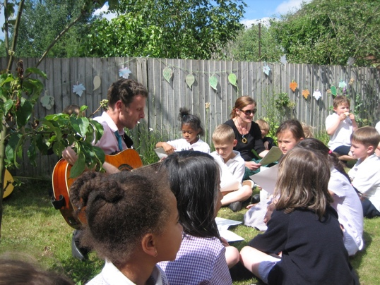

Transport Links

The school is well served by bus, rail, underground and tram services.
- It is a 10 minute walk to central Wimbledon with mainline train services, the District Line underground service and Tramlink service.
- It is a 5 minute walk to Haydons Road Thameslink station.
- There are bus stops outside of the school offering comprehensive bus services.
- It is a 15 minute walk to South Wimbledon and Colliers Wood underground stations and the Northern Line
The school has car parking and secure bike racks.

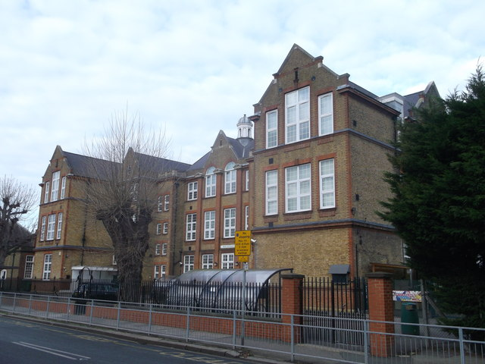

THE PRIORY
Provisional KS1 SATS RESULTS 2016
ATTAINMENT
SUBJECT | THE PRIORY 2016  EXPECTED STANDARD | NATIONAL 2016  EXPECTED STANDARD |  | MERTON 2016  EXPECTED STANDARD |  | THE PRIORY 2016  HIGHER STANDARD |  | NATIONAL 2016  HIGHER STANDARD | MERTON 2016  HIGHER STANDARD
READING | 70% | 74% |  | 74% |  | 16% |  | 24% | 27%
WRITING | 60% | 66% |  | 64% |  | 7% |  | 13% | 16%
MATHS | 72% | 73% |  | 73% |  | 16% |  | 18% | 20%
SCIENCE | 96% | 60% |  | 59% |  | NA |  | NA | NA
READING, WRITING, MATHS COMBINED | 54% | 60% |  | 59% |  | 2% |  | 9% | 11%
PROGRESS from EYRs to KS1
SUBJECT |  |  | EXPECTED + PROGRESS 2016 |  |  |  | ACCELERATED PROGRESS 2016
READING |  |  | 70% |  |  |  | 16%
WRITING |  |  | 60% |  |  |  | 7%
MATHS |  |  | 72% |  |  |  | 16%

THE PRIORY
Provisional KS2 SATS RESULTS 2016
ATTAINMENT
SUBJECT | THE PRIORY 2016  EXPECTED STANDARD | NATIONAL 2016  EXPECTED STANDARD | MERTON 2016  EXPECTED STANDARD |  | THE PRIORY 2016  AVERAGE SCALED SCORE | THE PRIORY 2016  HIGHER STANDARD |  | NATIONAL 2016  HIGHER STANDARD | MERTON 2016  HIGHER STANDARD
READING | 70% | 66% | 69% |  | 105 | 28% |  | 19% | 22%
WRITING | 64% | 74% | 72% |  | NA | 4% |  | 15% | 16%
MATHS | 80% | 70% | 75% |  | 105 | 22% |  | 17% | 25%
SPAG | 82% | 72% | 77% |  | 106 | 32% |  | 23% | 30%
SCIENCE | 76% | 81% | 82% |  | NA | NA |  | NA | NA
READING, WRITING, MATHS COMBINED | 54% | 53%  Floor Standard 65% | 56% |  | NA | 2% |  | 5% | 7%
PROGRESS
SUBJECT | THE PRIORY 2016  EXPECTED STANDARD |  |  | NATIONAL 2016  EXPECTED STANDARD |  |  | MERTON 2016  EXPECTED STANDARD
READING | 2.1 |  |  | (Floor Standard -5) |  |  | 2.2
WRITING | -1.7 |  |  | (Floor Standard -7) |  |  | -2.0
MATHS | 2.6 |  |  | (Floor Standard -5) |  |  | 2.3

0= At expected progress
+=Above expected progress
-=Below expected progress

The 2016 key stage 2 assessments are the first which assess the new, more challenging national curriculum which was introduced in 2014. New tests and interim frameworks for teacher assessment have been introduced to reflect the revised curriculum. Results are no longer reported as levels, and each pupil will now receive their test results as a scaled score and teacher assessments based on the standards in the interim framework.
As you are aware, this curriculum has a much higher expectation and many children who would have been considered to be working ‘At Standard Expectation’, would now be ‘Working Towards or Below Standard Expectation’. The criteria for marking of these tests or teacher assessments have also been very rigid and specific. As a result, school results and national results are very different to previous years and they cannot be compared, due to the very different standards of expectation required.
The Reading, Maths and SPAG tests were all externally marked and the Writing and Science were teacher assessed in school, according to the set criteria ‘Interim Frameworks’ from the Government. The National Expectation results are quite different this year, due to the high standard expected. This has also been due to the varied methods of assessment of writing across different Local Authorities. Despite the higher expectations Reading, Maths and SPAG are above the National, with the exception of Writing, which has lowered our combined score, but The Priory combined is still above the National. A scaled score of 100 represents the expected standard on the test. Pupils scoring 100 or more have met the expected standard on the test. Pupils scoring 110 or more have met the Higher Standard on the test.
We are very proud of our Year 6 pupils and staff who have all done very well.

Ofsted Piccadilly Gate Store Street Manchester M1 2WD
17 November 2016
Jane White Headteacher The Priory CofE School Queen’s Road Wimbledon London SW19 8LX
Dear Ms White
T 0300 123 4234 www.gov.uk/ofsted
Short inspection of The Priory CofE School
Following my visit to the school on 5 October 2016, I write on behalf of Her Majesty’s Chief Inspector of Education, Children’s Services and Skills to report the inspection findings. The visit was the first short inspection carried out since the school was judged to be good in November 2011.
This school continues to be good.
The leadership team has maintained the good quality of education in the school since the last inspection.
You have successfully created a welcoming, harmonious and caring atmosphere and have secured a culture of high expectations among the staff. There is strong support for leadership among staff and their morale is high. The overwhelming majority of parents responding to the online survey, Parent View, agree that pupils are taught well and looked after effectively. Staff were equally positive in their responses to a staff questionnaire. The pupils that the inspector met said they love their school.
You have high expectations and are ambitious for all pupils at the school. The staff and governors share your aspirations and are highly committed to ensuring that pupils do well.
Relationships between staff and pupils are positive; this helps pupils in their learning and supports their well-being.
You, other leaders and the governing body work effectively together to drive improvements and to ensure that the school continues to improve. You have successfully raised pupils’ achievement in mathematics, the area for improvement from the last inspection.
Governors are highly skilled and knowledgeable; the governing body keeps a close check on the work of the school. Governors support and challenge you effectively to bring about improvements.
Middle leaders contribute effectively to the whole-school improvement plan. Subject leaders for mathematics and English are involved in checking the quality of teaching and the progress that pupils make.
Taken together, the successes resulting from the work of senior and middle leaders and the governing body indicate that the school has the capacity to improve further.
The local authority provides the school with minimal advice and support because it rightly considers your school to be good. Furthermore, the local authority accurately judges that the school’s leaders demonstrate a strong capacity to sustain and improve on the good quality of education provided.
Safeguarding is effective.
Leaders have successfully created a culture where staff and pupils feel safe and valued. Almost all parents responding to the online survey, Parent View, agree that their children feel safe at school and are looked after well. Pupils that the inspector met said that they feel safe and are easily able to approach a member of staff if they have any concerns about
their safety. They are taught well about unsafe situations and how to keep themselves safe, including when using the internet. Pupils said that behaviour is good and bullying is not an issue for the school.
The school’s safeguarding policies and procedures are effective. Staff have received training on the current updated policy on safeguarding and child protection procedures. Staff and governors have completed the training on the ‘Prevent’ duty and show a good understanding of the need to be vigilant about extremism and radicalisation. Governors are highly committed to keeping children safe and free from harm and ensure that staff receive regular updates on safeguarding and child protection matters. Governors make their own checks on safeguarding arrangements, including ensuring that checks on the suitability of staff are fully in place. Leaders ensure that safeguarding documents, records, processes and procedures are fit for purpose and successfully implemented.
Inspection findings
- Pupils enjoy reading and are encouraged to read widely. The inspector met pupils in Years 2 and 6 to discuss their reading and listen to them read. They said that they ‘love reading’ and read with enthusiasm and expression. Pupils in Year 2 said that they used their knowledge of phonics to read unfamiliar or difficult words. Pupils make strong progress in reading throughout the school and their reading test results at the end of Year 6 were above average in 2016.
- In writing, the results at the end of Year 6 in 2016 were not as good as in mathematics and reading. Results at the end of key stage 1 suggest that writing has been weaker than mathematics and reading over the last three years.

- Through your close checks on the school’s assessment information, you have identified that pupils’ progress in writing in key stages 1 and 2 is sometimes slower than in mathematics and reading. You already have plans in place to ensure that pupils’ progress in writing is as strong as in reading and mathematics.
- You and I visited classrooms to observe pupils’ learning and checked their books. Pupils, especially in the upper part of key stage 2, are already making improvements in their writing through opportunities to write at length and for different purposes. Leaders are rightly focusing on providing pupils with more opportunities to write in different subjects, and to experience a wider range of forms and styles of writing as they develop their skills.
- The differences in attainment between disadvantaged pupils and other pupils nationally increased at the end of key stage 2 in 2016, particularly in mathematics.
- Through your regular analysis of attainment and progress, including your meetings with staff to check their pupils’ progress, you and other leaders also know that some disadvantaged pupils are not currently making the same strong progress in mathematics as their classmates.
- You and other leaders have already been successful in targeting effective support for disadvantaged pupils in Years 3 and 4 in 2015 through deploying additional skilled staff, including experienced teachers. This has had a marked impact on improving the progress of this group of pupils in reading, writing and mathematics. This targeted support is now being widened throughout the school in key stages 1 and 2.
- Through our book checks and discussions, including my meeting with the subject leader for mathematics, we agreed that sometimes learning moves on too fast for these pupils before they have consolidated their knowledge of mathematical concepts.
- Your information shows that the most able disadvantaged pupils make good and sometimes rapid progress in reading, writing and mathematics.
- Raising the achievement of disadvantaged pupils overall is the key priority for the school. We agreed that this is the main reason why the school remains good and is not outstanding.
- The attendance of disadvantaged pupils has been low and their attendance in 2016 was in the lowest 10% of all mainstream schools nationally. I was also mindful of the link between pupils’ attendance and their progress, particularly as one of my key lines of enquiry was to do with the progress of disadvantaged pupils.
- You and other leaders have been successful in improving pupils’ attendance overall through celebrating and rewarding good attendance and by following up poor attendance with parents. Pupils’ attendance was above average in 2015/16 with the vast majority of pupils having high attendance. However, your own information shows that attendance is not improving quickly enough for some disadvantaged pupils and it remains markedly lower than that of their classmates.

- I also considered how the school promotes British values and prepares pupils for life in modern Britain. It is clear that the school’s work on promoting British values and preparing pupils for life in modern Britain is effective. Pupils are taught about British values through learning about the rule of law, democracy and respecting different points of view. Pupils learn about different cultures and religions represented in the British society and respect for diversity.

Next steps for the school
Leaders and those responsible for governance should ensure that:
- pupils make the same strong progress in writing as they do in reading and mathematics
- the difference in attainment for the disadvantaged pupils in mathematics at key stage 2 is diminished so that they do as well as other pupils nationally
- the attendance of disadvantaged pupils is as good as their classmates. I am copying this letter to the chair of the governing body, the director of education for the Diocese of Southwark, the regional schools commissioner and the director of children’s services for Merton. This letter will be published on the Ofsted website. Yours sincerely Avtar Sherri Ofsted Inspector Information about the inspection The inspector agreed to prioritise the following areas with the school at the start of the inspection:
- the progress of disadvantaged pupils at key stage 2, particularly in mathematics
- the progress of pupils in writing in key stages 1 and 2
- the attendance of disadvantaged pupils
- the effectiveness of safeguarding
- the school’s work on promoting British values and preparing pupils for life in modern Britain. I carried out a range of activities to explore these areas during the inspection. I met with you; other senior leaders and subject leaders; five governors, including the chair of the governing body; and a representative of the local authority. I listened to pupils in Years 2 and 6 read and discussed their reading with them. I spoke with pupils in lessons, during breaktime and in a group consisting of 12 pupils from key stage 2.

You and I jointly observed the learning in six lessons and looked at pupils’ work in their books. I scrutinised safeguarding policies and documents. I also considered other school information and documentation, including information about pupils’ attainment and progress in each year group, the school’s improvement plans and self-evaluation statements. I examined the school’s website for policies and information and to see whether it met the requirements on the publication of information. I looked at your attendance information. You, the deputy headteacher and I undertook a book scrutiny. I also took into account the views of 73 parents who responded to the online survey, Parent View, and 32 responses to a questionnaire completed by staff.

Job Description
Job title: Head Teacher of The Priory Church of England Primary School
Terms and conditions: Nationally agreed terms and conditions apply
Accountable to: The Governing Body
Manages: All professional and associate staff
Job purpose: The Priory is a vibrant, Church of England school, aiming to provide an outstanding education, for all children to be happy and confident as they are challenged within a Christian environment of creativity, love and respect. In partnership with parents and the whole community we strive to maintain a high standard of education, developing the full potential of everyone within a caring and supportive ethos.
The Head Teacher of The Priory will provide professional leadership to secure the continued success and improvement of the school and the holistic development of children. By working with the Governing Body, motivating and supporting all staff and managing the day-to-day operation of the school, they will ensure that all our pupils benefit from high quality education and achieve the highest possible standards, within the Christian framework of the school. Ensuring the effective involvement of the Southwark Diocesan Board of Education (SDBE), Merton Local Authority, parents/ carers and the whole community is a key aspect of the role.
Leadership and management
- Working with the Governing Body and staff to develop and implement a strategic vision for the school, analysing and planning for its future needs and further development and ensuring that this is effectively communicated, understood and acted upon by the staff, pupils and parents/ carers.
- Ensuring that strategic planning takes into account the diversity, values and experience of the school and community at large, with particular reference to SEN(D), EAL and disadvantaged children.
- Ensuring that all children have access to high quality teaching and learning, based on a broad and balanced curriculum.
- Leading and managing staff and fostering effective relationships between all members of the school community.
- Ensuring the efficient and effective management and utilisation of the school’s human and financial resources, to include in-house training.
- Monitoring, evaluating and reviewing the range, quantity, quality and use of all available resources in order to improve the quality of education, improve pupils’ achievement and to secure value for money.
- Leading the celebration and development of the school’s Christian ethos
- Monitoring and safeguarding the school’s inclusive values and ensuring that the principle of equal opportunities prevails at all times in relation to pupils, parents, staff, governors and other stakeholders, as appropriate.
- Ensuring that the management, organisation and administration of the school support its values and aims.
Outcomes for children
- Securing and sustaining the highest quality of teaching and learning possible as a key priority, working closely with the Governing Body through:
  - ensuring rigorous monitoring and evaluation of teaching, learning and assessment and the outcomes achieved by pupils;
  - ensuring effective professional development for teaching and non-teaching staff; and
  - setting realistic but challenging targets for pupils and staff.
- Developing an effective partnership with parents to support and improve pupils’ achievement and personal development and encourage parents’ participation in the life of the school.
- Ensuring a consistent and continuous focus on pupils’ achievement, using data and benchmarks to monitor progress in every child’s learning and setting targets for improvements in educational standards for all members of the school community.
- Creating and maintaining a nurturing environment that promotes and secures good behaviour, calm discipline, pastoral care and support through which academic success can flourish.
- Ensuring that learning is at the centre of strategic planning and resource management.
- Closing the gap between the achievement of disadvantaged and non-disadvantaged pupils.
- Establishing creative, responsive, effective and holistic approaches to learning and teaching, the use of assessment and curriculum design and identifying and sharing good practice.
- Creating and promoting positive strategies which ensure high standards of behaviour and attendance, which challenge prejudice and provide an effective means for managing instances of bullying.
- Ensuring a culture and ethos of challenge and support where all pupils can achieve success and become engaged in their own learning.
- Demonstrating and articulating high expectations and setting stretching targets for the whole school community.
- Celebrating the successes of all children.
Safeguarding
- Being responsible for monitoring and ensuring that all safeguarding policies and procedures are followed by all teaching and support staff.
- Ensuring that each Designated Safeguarding Officer is given the appropriate resources to carry out the duties of their role effectively.
- Ensuring that all staff are fully aware of safeguarding procedures and that these are rigorously implemented.
- Ensuring effective safety, security and supervision of the pupils, buildings and grounds.
Developing and sustaining the Christian ethos
- Encouraging a suitable system of guidance, support and pastoral care for pupils and staff, including maintaining positive partnerships with parents to support pupils’ achievement and strong links with the Church, the SDBE, the local community and Merton Local Authority.
- Fostering a positive, caring and inclusive Christian ethos, in which individuals feel valued and where personal endeavour and responsibility are encouraged, and promoting an understanding of, and respect for, other faiths and cultures.
- Building a school culture and curriculum which takes account of the richness and diversity of the school’s communities.
- In conjunction with local clergy, lead collective worship and encourage others to take responsibility for worship and prayer.
- Nurturing the school as a praying and worshipping community.
Accountability for the school’s resources
- Fulfilling commitments arising from contractual accountability to the Governing Body.
- In conjunction with the Governing Body, producing an annual budget for the school, setting appropriate priorities for expenditure and allocating funds and resources accordingly.
- Managing expenditure within the agreed budget and reporting regularly to Governors.
- Ensuring management systems, structures and processes work effectively in line with legal requirements.
- Determining sound reporting systems which inform the appropriate members of the school community and beyond, including regular reports to the Governing Body at both full Governing Body and committee level.
- Producing and implementing clear evidence-based improvement plans and policies for the development of the school and its facilities.
- Managing HR policies and procedures including recruitment and retention of high-calibre staff, induction, performance management and continuous professional development.
- Ensuring that all school policies are compliant with statutory requirements, consistent with the school’s vision and ethos, regularly reviewed by the Governing Body and updated as appropriate.
- Maintaining appropriate educational and administrative records.
Team building and developing self
- Motivating, empowering and enabling the teaching and support staff to develop expertise in their respective roles by use of high quality professional development within school and beyond.
- Inspiring, leading, motivating, supporting, challenging and developing the senior leadership team and phase leaders.
- Working with staff to maximise their contribution towards improving the quality of education provided and standards achieved, including SEN(D), EAL and disadvantaged pupils.
- Ensuring constructive working relationships are formed within the teaching team and between staff, pupils and parents/ carers.
- Ensuring individual staff accountabilities are clearly defined, understood and agreed and are subject to rigorous review and evaluation.
- Developing a school ethos which enables everyone to work collaboratively, share knowledge and understanding, celebrate success and accept responsibility for outcomes.
- Ensuring continued development of effective pastoral systems for pupils and staff.
- Ensuring that all staff recognise their accountability for the success of the school.
Interacting with the local community
- Creating an outward facing school which is active in engaging with other schools, organisations and partners in the local community to develop, implementing and championing best practice and generating creative new ideas and opportunities to help improve the education of all pupils.
- Seeking and developing appropriate opportunities to invite into the school and forge links with parents, carers, community figures and businesses to enhance and enrich the school.
- Working with the SDBE and Merton Local Authority to ensure maximum benefit from both.
- Building on the current work to retain external awards, including in sport, the environment and the arts.
This job description is not exhaustive. The Head Teacher will be required to carry out the full range of professional duties which may reasonably be requested by the Governing Body, as set out in the relevant paragraphs of the current edition of the DfE School Teachers’ Pay and Conditions document. This job description may be amended at any time after discussion with the Head Teacher, and will be reviewed annually as part of the performance management process when key tasks related to the school priorities will be determined.
Personal Specification

Key: E = Essential, D = Desirable

Personal qualities
Enjoys working with children and takes them seriously and is ambitious for their development | E
Listens first; values the wisdom of others | E
Has integrity, is resilient; calm, organised, and flexible under pressure | E
Self-aware and striving for personal growth | E
Willing to take risks and learn from failing and making mistakes | E
Able to maintain life balance, and support and encourage others to do so | E
Empathetic, nurturing, and approachable | E
Has courage to tackle difficult issues, avoid defensiveness, and communicate decisions clearly and sensitively | E
Has high expectations of self and others and ability to challenge constructively in order to achieve this | E
Has fun and shares fun | E
Relishes the challenges and opportunities of leadership | E
Takes a creative approach to problem solving | E
Faith
Practising, committed Christian | E
Passionate about applying Christian faith to the mission and ethos of the school and able to celebrate, lead and develop that ethos | E
Member of the Church of England | D
Keen to work closely with the local parish church and Southwark Diocesan Board of Education | E
Enthusiastic about leading collective worship in ways that enlarge children’s vision of God and themselves | E
Sensitive to those of other faiths and no faith and respect for the views of all | E
Qualifications and training
Qualified teacher status | E
Degree level education or higher | E
Clear evidence of commitment to professional development | E
NPQH | D
Experience
At least three years’ dynamic leadership as Head Teacher, Deputy Head, or Assistant Head that has inspired, motivated others and raised standards | E
Successful strategic working and cooperation with senior colleagues, teaching and support staff, governors, parents, and the wider community | E
Commitment to broad education, creative arts, sport, and co-curricular activities | E
Teaching in more than one school including in a church school across the full primary range | D
Professional skills
Clear educational vision and ability to apply it to school improvement across the ability and age range, then inspire and empower others to carry the vision forward | E
Strong communication skills (spoken and written) with pupils, staff, parents, carers, governors, and wider stakeholders | E
Innovative and creative strategic thinking, planning, and self-evaluation, especially for disadvantaged, SEN(D) and EAL children | E
Has a pastoral heart for the whole school community, looking for ways to improve everyone’s school experience | E
Ability to manage change effectively with appropriate consultation | E
Ability to delegate appropriately and in ways that empower and demonstrate trust in others | E
Ability to model and lead good teaching practice | E
Professional knowledge and understanding
An in-depth knowledge of how children learn and an understanding of best practice in teaching, learning and assessment, as well as current issues and debates in education policy and statutory requirements that relate to the management of schools | E
Understanding of finance and ability to manage a budget to secure best outcomes | E
Knowledge and understanding of the accountabilities of the Head Teacher and the measures required to secure the best possible Ofsted outcomes and, as part of this, a knowledge of the Ofsted framework and a clear understanding of the process of school improvement | E
Understanding of and personal commitment to responsibilities in relation to Safeguarding, Health and Safety, and Equal Opportunities legislation | E
Commitment to full inclusion of all pupils, so that everyone, including SEN(D), EAL, and disadvantaged children, have the chance to achieve their potential | E
Understanding of how to develop and provide stewardship of the school’s environment, buildings, and equipment | E

Candidates should ensure that they address all these headings in their application. Shortlisted candidates will be selected entirely on the basis of the extent to which they meet the selection criteria in their application form and supporting statement.

Application Information
Pay range: Leadership scale 20 -24 (subject to experience)
Start date: 1st September 2017
School Visits: Visits to the school are strongly encouraged and warmly welcomed. To arrange a visit please contact Maria Coyne, the school administration officer.
E-mail: school@thepriory.merton.sch.uk
Application Form
Applications must be submitted using our application form which can be downloaded from the school website. This includes a section on Christian Faith and Practice and requires candidates to provide a referee to support your suitability to lead a Church of England school.
Closing date for applications: 12.00 noon on Friday 20th January 2017
Completed applications can be e-mailed to Maria Coyne: school@thepriory.merton.sch.uk
Or delivered to Maria Coyne:
The Priory C of E Primary School
Queens Road
Wimbledon
London
Sw19 8LX
Shortlisting and Interview
Shortlisting will take place on Monday 23rd January 2017, after which all candidates will be contacted. Interviews will take place over two days on Tuesday 7th February and Wednesday 8th February 2017. Shortlisted candidates will be asked to attend for both days. Information about the interview days will provided to shortlisted candidates.
References
References will be taken up upon shortlisting of candidates. One of two professional referees must be your current head teacher (if you are currently a deputy or assistant) or chair of governors (if you are a head teacher).
Appointment
The successful applicant will be appointed to the role from 1 September 2017, the first day of Autumn term. Appointments will be subject to satisfactory references and the provision of a satisfactory enhanced DBS clearance.

