Deputy Headteacher
Millside School
Recruitment Pack

“Inspiring and supporting young people to make positive choices about the future”

Closing Date: 1200 noon on Monday 30th April 2018
Interviews: Wednesday 9th May2018

Start: 1st September 2018 (Autumn Term)

Welcome to Haybrook College Trust
“Inspiring and supporting young people to make positive choices about the future.”

The College: an overview
Haybrook College Trust provides a flexible and creative range of education provisions in Slough for over 200 pupils, aged 11 – 19, who have been excluded or who exclude themselves from local education. All the young people who attend the College have significant and complex Social Emotional and Mental Health Difficulties (SEHMD). The College includes a KS3 and KS4 PRU and a SEMH Special School. In September 2011 a post 16 provision, The Gateway, was successfully established through partnership working with Slough Pit Stop Project. This is targeted at young people with SEMHD who have been, or who would become NEET if not for this provision. The College also runs Wexham Park Hospital Schoolroom (WPHS) which provides an education for young people of statutory school age who have serious medical conditions and who are too ill to attend school. On average 35% of pupils at the College have a statement or an Education Health and Care Plan (EHCP) for social, emotional and/or mental health needs. Almost all of the pupils at Haybrook arrive with attainment levels well below the national average and those entitled to Free School Meals is well above the national average. Deprivation is also a significant factor affecting the families of many of the young people attending the College.

Our values and vision
The vision of the College is to inspire, educate and support young people with complex needs to make positive choices that lead to success and achievement. Despite the social, emotional and mental health needs that our young people face, we continue to focus on learning. Offering opportunities to achieve a range of accreditations including English and Maths, is a priority. However, we also strive to ensure that we are preparing young people to make the successful transition to Education, Employment or Training (EET). The success of the College lies in the delivery of personalised programmes that meet the learning needs of individual pupils or that re-engage young people into learning.

Haybrook College lies at the heart of Slough’s educational community and its development reflects the town’s approach to inclusive education. The collegiate approach is reflected in the ongoing discussions around the High Needs Block and decisions pertinent to the commissioning of places at the College by the Local Authority and also by schools/academies. The successful implementation regarding ‘top up’ funding paid by local schools for a commissioned place, reflects the recognition that there is a collective responsibility towards this cohort of young people. Increasingly, the College is being approached by schools and other Local Authorities for support or ideas about the development of local provision to meet the needs of a cohort of young people with increasingly complex SEMHD.

Each educational provision is managed by a Centre Manager. Flexible, personalised education programmes are successfully provided through small group teaching, using a team of highly skilled teachers, tutors and learning mentors and Sports Coach Mentors (SCM) who are effective in supporting young people to self-manage their behaviour.

The College Provision
- The Pupil Referral Unit (PRU)

Across the PRU provision, we offer six unique programmes across four sites, each with its own curriculum, identity and specialism. However, the ‘culture of Haybrook’ transcends all of these programmes which helps to create the ‘Haybrook ethos’.

- Millside Special School
Millside is a Co-Ed Secondary Special School for children with complex Social, Emotional, and Mental Health Difficulties (SEMHD) located on the Haymil site. It is the only secondary SEMH special school in the local authority. The school population is drawn mainly from Slough, although there is a small number of students from other neighbouring boroughs.
There are currently 54 young people in roll (93% M and 7% F). All of the pupils at Millside have a Statement of Special Educational Needs, or Education Health and Care (Plan EHCP), for SEMHD. However, an increasing number have been diagnosed as having ASD (34%) and many of these have additional diagnosed special needs such as a learning difficulty or a speech and language and / or a social communication difficulty. As a result of this the School provides a plethora of multi-agency support to meet the wide range of needs within the school. The capital build will enable a therapeutic wing to be created to provide a more holistic approach to the educational offer.

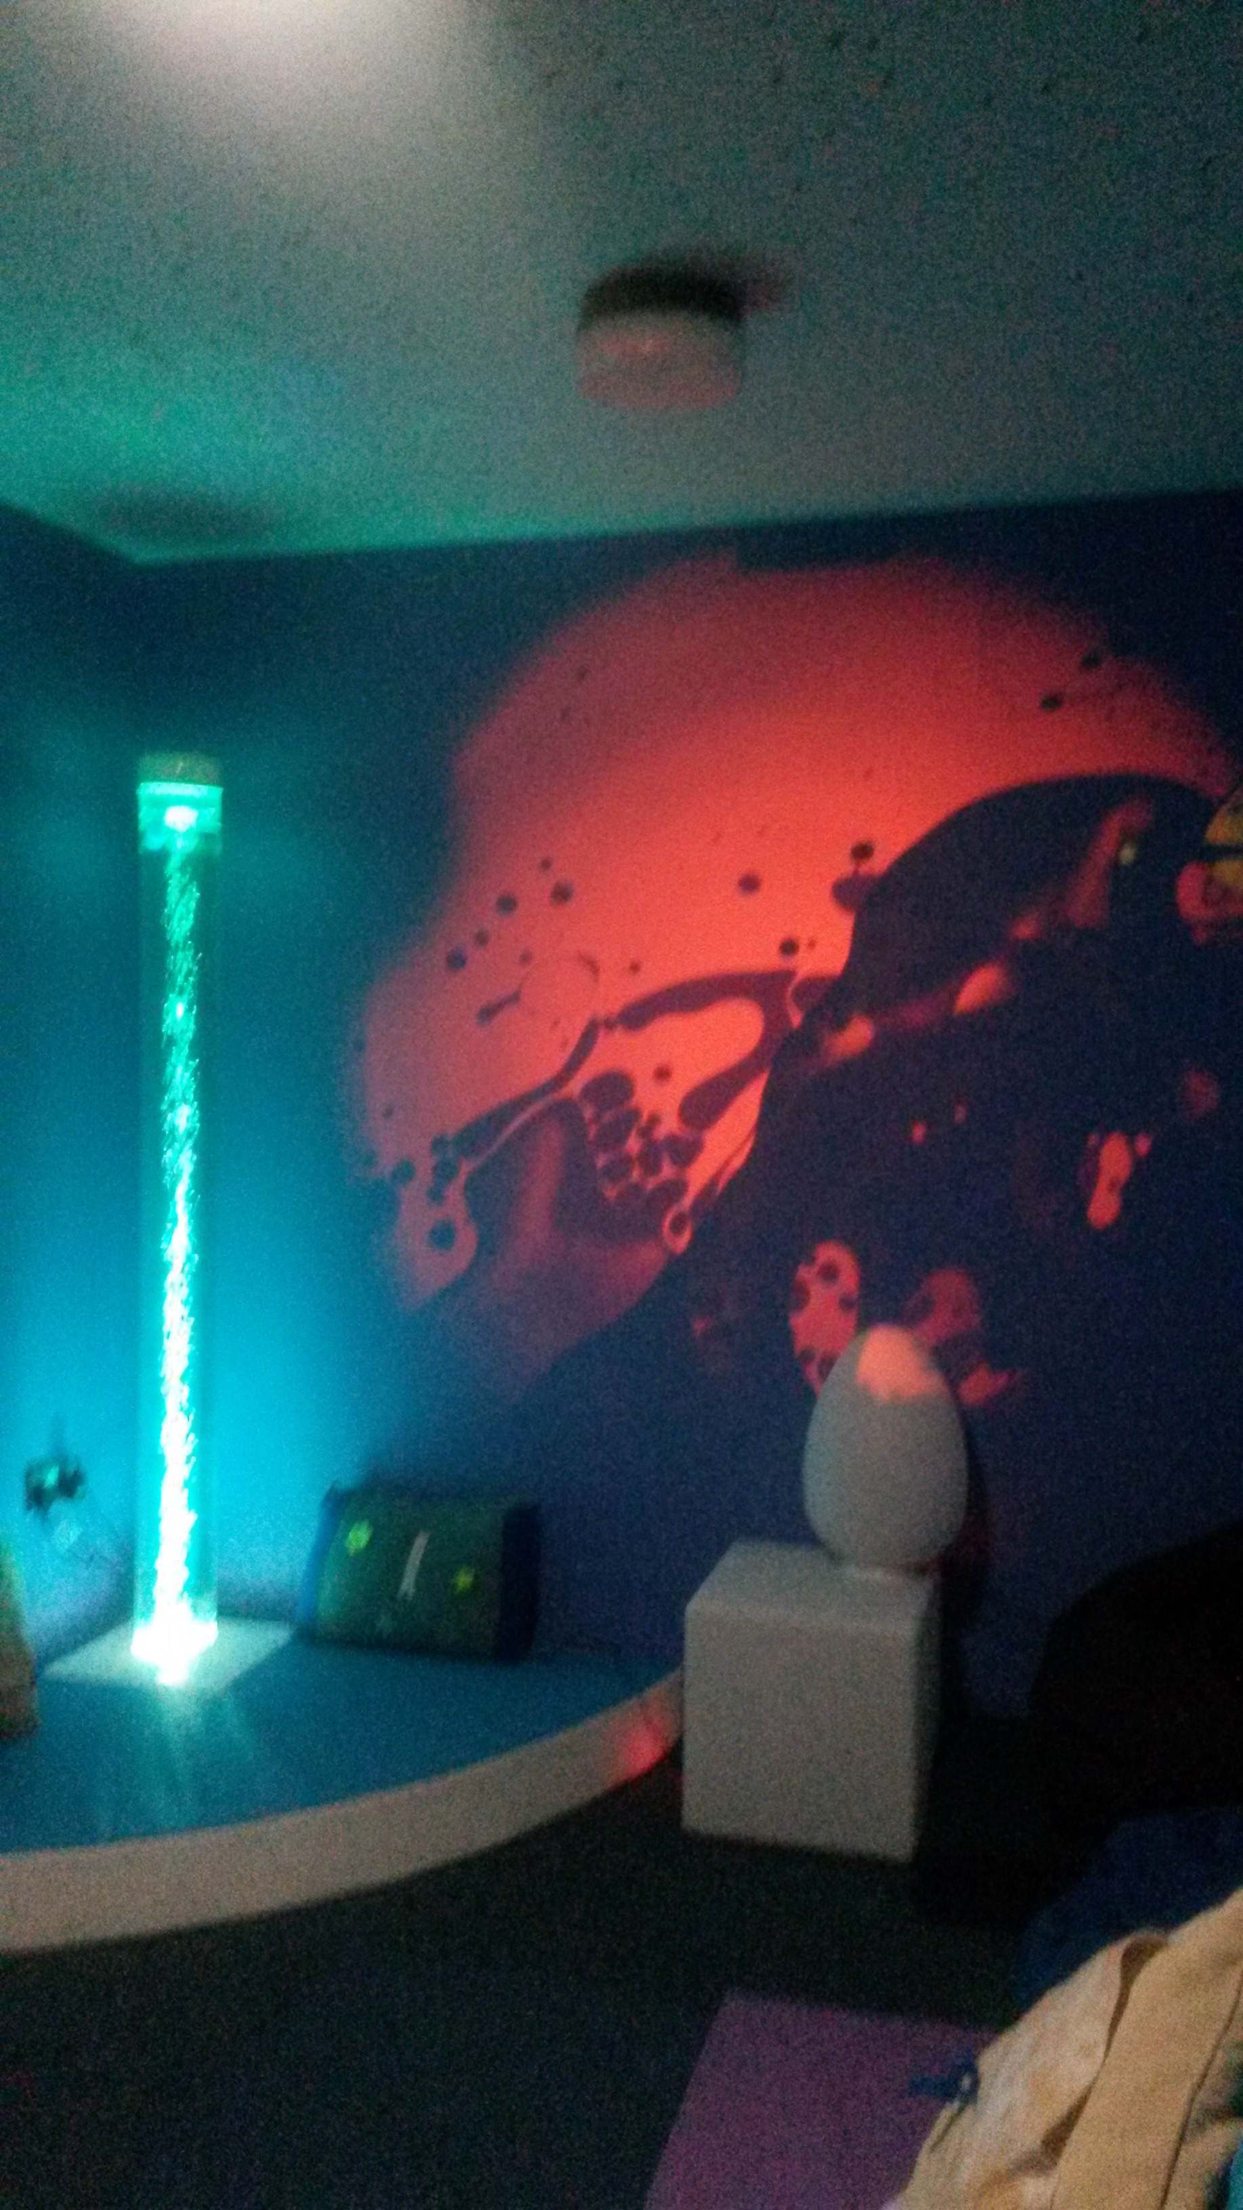

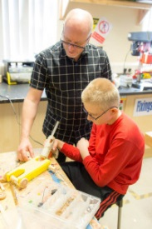
The vast majority of pupils at Millside arrive with attainment levels well below the national average. Many are disengaged from learning and have had negative experiences of school prior to joining the College. Those entitled to Free School Meals is well above the national average – 66%. 54% of the school population is on, or has been on, either a Child Protection Plan or Child in Need plan.15% of the school population is, or has been looked after during their time at Millside. 61% of students travel to and from school on transport arranged through, and provided by, the school making regular face to face contact with parents possible.

Communication between the school and families is good. Families are in general very supportive of their children and the school, with the overwhelming majority stating that the school is making a marked and positive difference to their children’s educational and social well-being.

- Additional offers
Post 16 provision: The Gateway
Vocational Provision: Construction, Motor Vehicle and Catering
Wexham Park Hospital School
Our Curriculum
All young people attending the College face a range of ‘barriers to learning’ and the curriculum offer is created to remove as many of these as we can.
It is designed to ensure that young people have the best possible chance of a successful transition into Education Employment and Training (EET). It is also created to ensure that we can offer personalised pathways for students with the most complex needs.
General principles:
- Young people have the entitlement to a broad and balanced curriculum offer
- All young people have the opportunity to achieve at least 5 GCSEs or equivalents.
- All young people leave with a recognised English and maths qualification.
- The curriculum offer includes lots of opportunities for active and practical approaches to learning. The vocational offer at Pitstop, Construction Hut and Kitchen Craft supports this.
- Supporting independent learning, behaviour and leadership underpins everything that we do.
- The curriculum is underpinned by Careers Education Information and Guidance (CEIAG) and all staff see this as their responsibility.

Behaviour Management
At Haybrook we value everyone as an individual, capable of growth, change and development despite previous behaviours associated with their Social Emotional and Mental Health (SEMH) difficulty. Our motto: “Inspiring and supporting young people to make positive choices about the future,” guarantees that we work unstintingly with young people to help them achieve their absolute best in terms of academic outcomes. Additionally staff work closely with pupils to encourage and support them to take more responsibility for their behaviour so that they can move successfully into either further Education Employment or Training (EET). Unacceptable behaviour is always challenged in an appropriate and systematic way.
Our relationships are underpinned by the principles of, equality, mutual respect, fairness and consistency. We have high expectations that support the development of young people as effective and responsible citizens.
The purpose of the behaviour policy is to encourage the best possible behaviour from all of our young people and we endeavour to work alongside pupils and parents/carers to plan individual approaches to maintain positive conduct.
Our priority is to encourage good behaviour by:

- Creating a climate in which the management of behaviour is: “Firm, Fair, Flexible and Forgiving”.
- Recognising that low self-esteem is very often the root cause of many of the challenging behaviours that we see at the College – although also recognising that young people with low self-esteem can behave in quite different ways.
- Providing a relevant and appropriate curriculum which is tailored to meet the individual needs and preferred learning styles of the pupil to promote independent learning.

