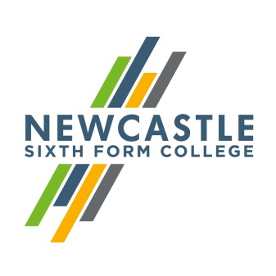
Gerard Garvey
Principal

Dear Applicant,
Teacher of Sociology
Department of Social Sciences

Thank you for your interest in Newcastle Sixth Form College. I am delighted that you are considering becoming part of our team. As the largest provider of A Levels in the Newcastle area, we are always keen to add new talent. I hope that the information below proves useful as you put your application together.

Expert and enthusiastic staff are fundamental to our success. As an inclusive sixth form we attract students from the full range of ability and we only offer academic qualifications (GCSE and A Levels). This means that we rely upon staff who are ambitious for their students and willing to go the extra mile in supporting them to realise their potential. Our students come from across the region and bring a variety of different social and cultural experiences. We are keen to celebrate this; in recent years we moved to rainbow lanyards and have developed a culture of inclusivity, with events promoting equality and diversity at every opportunity.

Our team is relatively small; there are 100 staff who teach and support about 100 students on our Access to Level 3 (GCSE) and approximately 1200 students on an A Level programme. This post is for a teacher of Sociology in the Department of Social Sciences. GCSE and A level Sociology results are good and we are looking for an outstanding teacher to help maintain this position and generate further improvements in value added.

We are also keen for all our teachers to be involved in our wider enrichment programme, and we look forward to hearing how you would be able to contribute to this, as well as acting as a personal tutor for a group of Year 12 or 13 students.

I hope that you will visit our website to find out more about the College, and if you wish to visit us to look around informally we would welcome that. If you would like to arrange a visit, please contact Lisajane Clark on 0191 226 6225.
Yours faithfully,
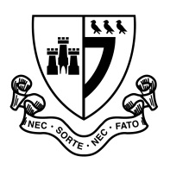
Gerard Garvey
Newcastle Sixth Form College, Westmorland Road, Newcastle upon Tyne, NE4 7SA
T: 0191 272 1001 E: enquiries@newcastlesixthformcollege.ac.uk
www.newcastlesixthformcollege.ac.uk
Principal

 | Newcastle Sixth Form College  Information for Applicants | 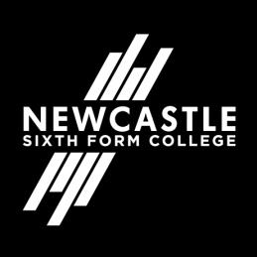

Newcastle Sixth Form College
Newcastle Sixth Form College is a dedicated academic college focusing on the needs of 16 to 18 year olds in a purpose built multi-million pound Sixth Form College. Our breadth of A Level subjects is second to none in the region and our students are nurtured to achieve the best possible results for them to move on to higher education at universities and colleges or into the workplace.
Our culture is based on support and challenge for both students and staff. We provide the highest standards of teaching and learning and a wide range of exciting opportunities for our students to develop their skills, talents and interests while they are with us. We aim to help our students develop a responsible and positive attitude in an all-inclusive environment where different cultures and diversity are embraced. We expect that all students and staff will share in these values.

Social Sciences Department
This is a large department responsible for delivering GCSE and A Level Sociology (AQA) in addition to A Level Psychology (Edexcel). These are popular choices at A Level, with over 400 students currently enrolled on each subject. The Social Sciences department takes an active approach to teaching and learning, ensuring that students are fully immersed in the current affairs and social concerns of today. Lessons are reinforced by a range of interactive resources as well as high profile guest speakers from all corners of society. Staff strive to make their lessons fun and relevant, as well as preparing students thoroughly for their final examinations.

Newcastle upon Tyne
Newcastle upon Tyne is the regional capital of the north east and renowned as one of the best student cities in the UK. A vibrant student population and a warm and friendly atmosphere make it a popular destination for students from far and wide.
World-class culture, vibrant nightlife, fantastic shopping, award-winning dining, inspiring heritage and acclaimed architecture are just some of the things you can expect from this exciting city. Newcastle has a population consisting of nationalities from all over the world and offers something for everyone.
Newcastle benefits from a low cost, quick transport link – the Metro, so you can see everything the local area has to offer. Newcastle also has its own international airport and major train station both with excellent links. With so much to do and fantastic transport links to get you there, Newcastle really is a city you’ve got to experience for yourself.

