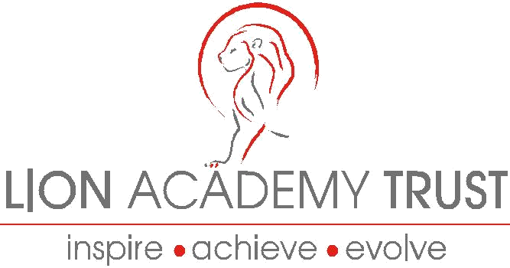

EQUAL OPPORTUNITY STATEMENT

1.1 Good government really matters. At Lion Academy Trust we recognise the impact that
our activities can have on the quality of life of the people and communities that we serve.
It’s our job (in partnership with others) to protect the environment; improve public health; support the vulnerable; educate for life, develop the economy of the area; promote and foster choice and democracy.

What we do can make a real difference in the life of the people we serve. We are determined to be a modern school working with the community for the community – and equality of opportunity is at the heart of our thinking and effort.

1.2 Equal opportunity in service delivery means that we recognise the different and equivalent needs of the individuals and communities we serve and that we aim to meet them in a fair, objective and open way.

1.3 Equal Opportunity in employment means offering genuine equivalent treatment to our staff across the whole range of our employment and recruitment practices.

1.4 Our aim is to enable all our employees to make their distinctive contributions to the benefit of the people of Waltham Forest.

1.5 Therefore the Lion Academy Trust is determined (and enthusiastic) about developing a working culture that is fair and inclusive. Sadly, prejudice, whether conscious or unconscious is still a matter of fact in society as a whole. We don’t underestimate the power of the influences which work against equality of opportunity in organisations, institutions and individuals.

1.6 But we believe that a commitment toward equality and diversity is right for society, right for the Lion Academy Trust, right for staff, right for customers and right for our communities. We will regularly review the effect of our employment practices to make sure that they are appropriate and that they work the way we intend. We will encourage our staff and partners to welcome diversity, respect each person’s individuality and value their creativity. We expect our managers to champion our values, challenge prejudice and role-model appropriate behaviour.

1.7 We will take stock of our progress regularly, using a variety of measures. We will ask our staff, customers, suppliers and partners what they think. We are committed to improving our performance, and people’s perception of it, consistently over time.

Employment with Disabilities

Lion Academy Trust considers all applications from people with a disability bearing in mind the aptitudes of the individuals concerned. Where an existing employee becomes disabled, every effort is made to ensure that employment with the school continues and provides appropriate training, career development and opportunities for promotion.

