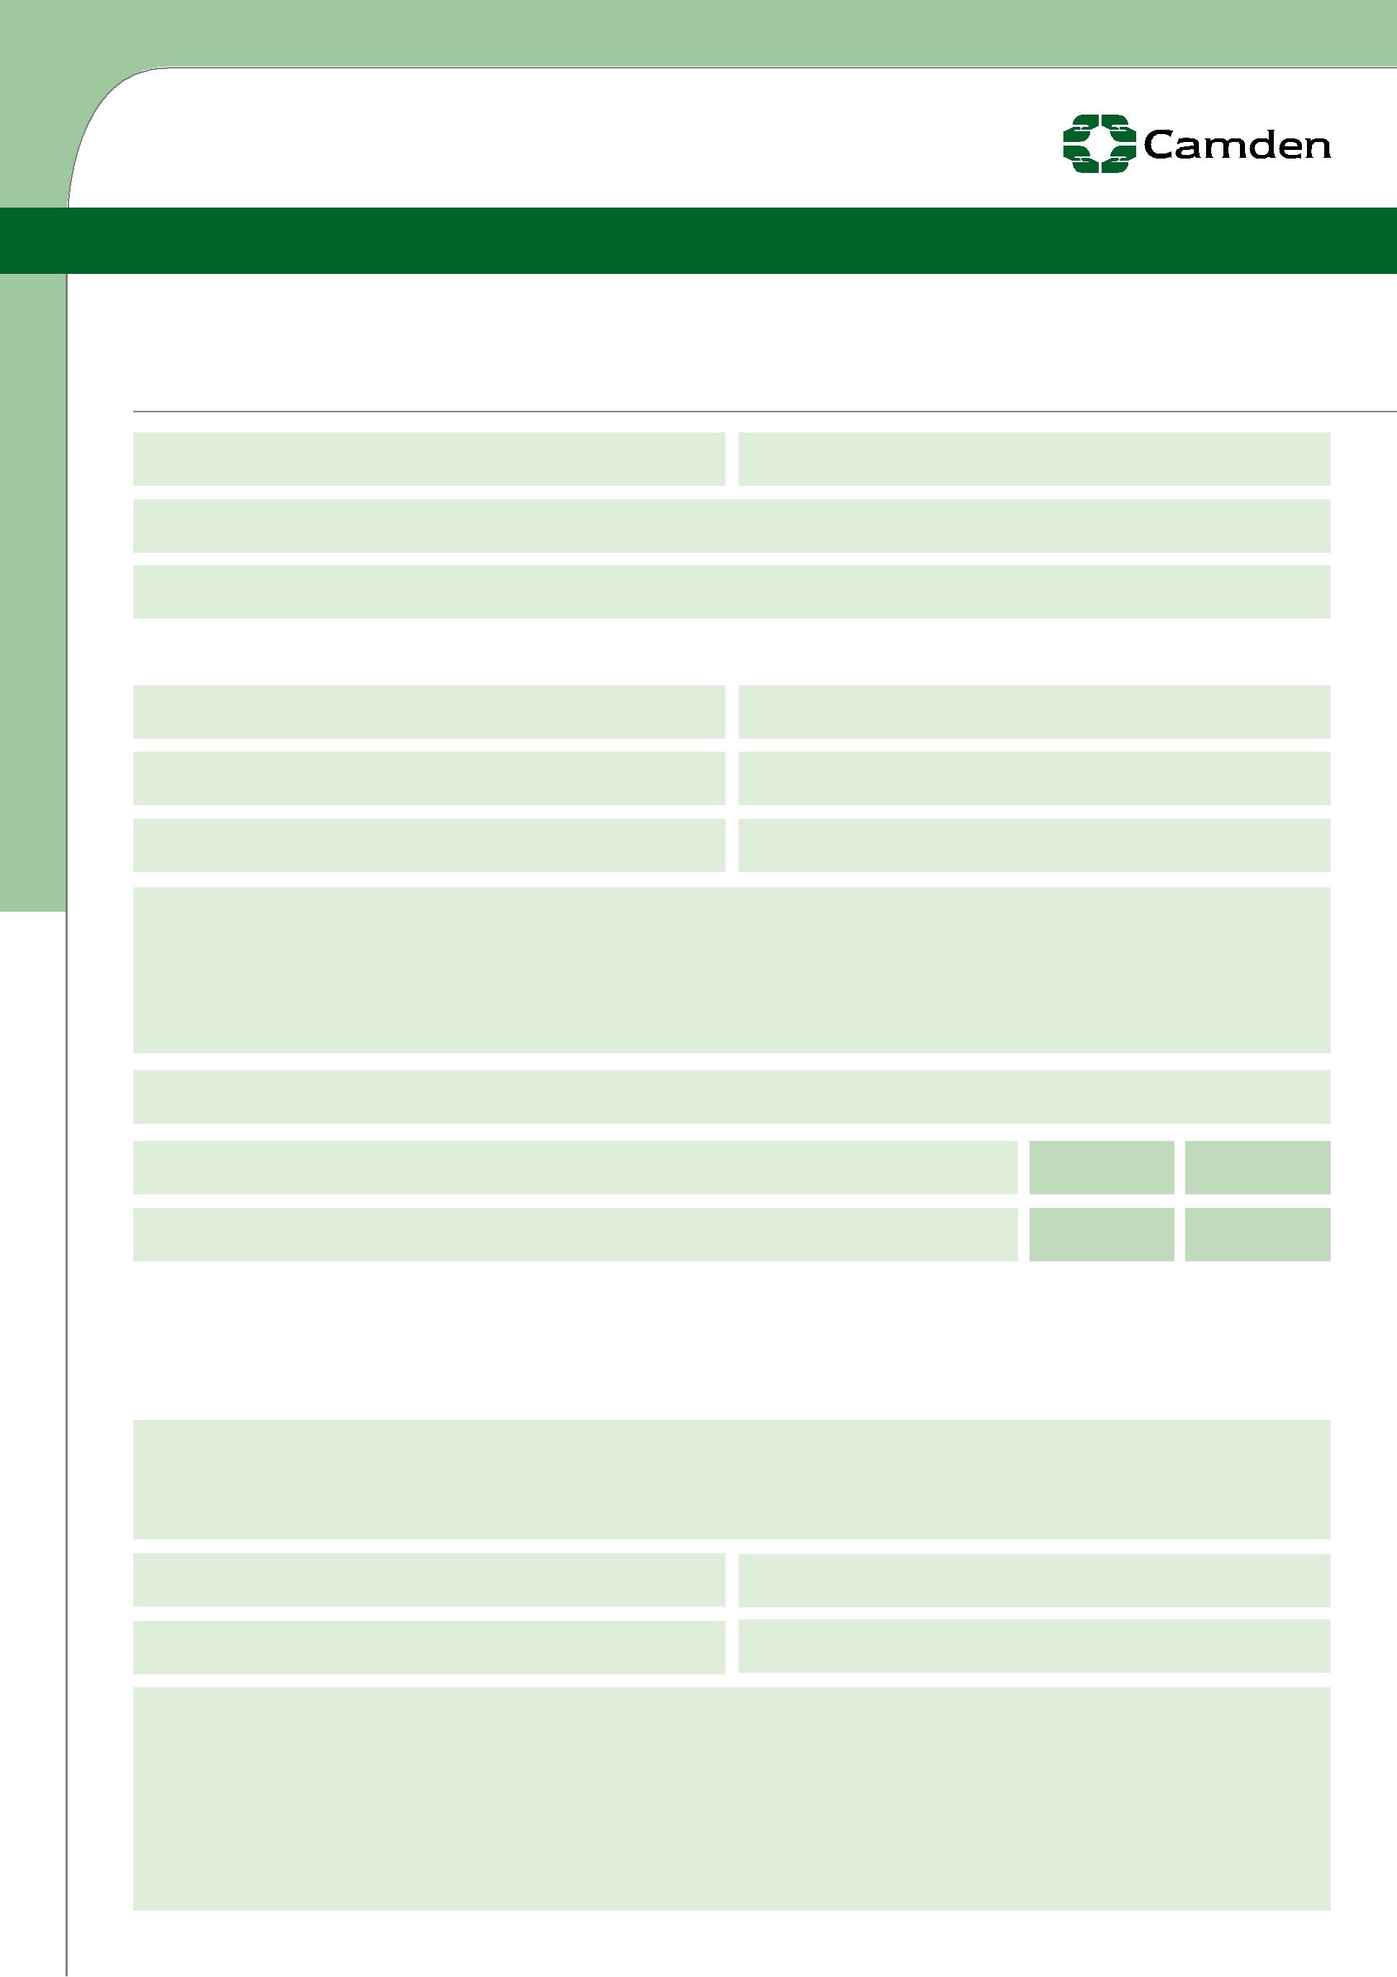
London Borough of Camden

J O B A P PL I C A T I O N F O R M

Please complete in type or black ink and refer to guidance notes. Confidential

Return completed form to:

Hawley Infants School, Buck Street, London NW1 8NJ or admin@hawley.camden.sch.uk

Applicant or employee no : Job reference no :

Post applied for :

Where did you see this post advertised?:

PART A PERSONAL DETAILS (use block letters)

Last name : Daytime tel. no :

First name : Mobile phone no :

Title : Home tel. no :

Current Address :

Email address :

Are you applying for this post as a job share? | YES | NO
Do you require a work permit (please refer to guidance notes)? | YES | NO

PART B EMPLOYMENT HISTORY, RELEVANT SKILLS & EXPERIENCE

Please tell us about all jobs, both full and part time, you have had since leaving secondary education, including voluntary or unpaid work. Starting with your most recent include details of leaving reasons and periods when you did not work. Continue on a separate sheet if necessary.

Name and address of present or most recent employer :

Job Title : Basic salary :

Date started : Until :

Brief description of duties :

Re-Order: 15266 Job App

  From: | To: | Job title, brief description of duties
 | FT/PT | Employer’s name and address
“mmyy” | “mmyy” | and reason for leaving.


PART C EDUCATION, QUALIFICATIONS AND TRAINING

Please give brief details of courses attended and examination results.

Secondary, further and professional education and qualifications

Education establishment attended Date Examination/Results

Other training courses attended (including short, in-service training)

Course title, level, results (if appropriate) Date

Membership of professional bodies (including registration numbers)

(Teachers only) DfES no :

(Social Workers only) GSCC registration no :


EXPERIENCE/RELEVANT SKILLS/FURTHER INFORMATION

Please state how your experience, skills, abilities and achievements to date would make you a suitable candidate for this post. Include details of any relevant unpaid or voluntary work. Please continue/attach a separate sheet

if necessary.

PART D REFERENCES

Personal references will not be accepted.

We will approach your last two employers, or your employers for the last five years (whichever is the longer), for references. Please provide contact details for all referees as required, one of which must be your current employer.

If you have not been employed please give the name of the head of education or training establishment and/or the manager of a voluntary group for whom you have worked.

A referee will normally be approached when/if a conditional offer is made.

Name : Job title :

Address :

Email :

Telephone no : Fax no :

Name : Job title :

Address :

Email :

Telephone no : Fax no :

PART E RELATIVES/OTHER INTERESTS

Canvassing of Councillors or officers in relation to this appointment will disqualify you.

Are you related to a Councillor/employee of the Council or Governor of the school | YES | NO
to which you are applying? | YES | NO

If yes, please give brief details :

If appointed, do you have any business and/or financial interests which might | YES | NO
conflict with the duties of this post? | YES | NO

If yes, please give brief details :

Have you left the employment of the London Borough of Camden in the last two | YES | NO
years by reason of redundancy? | YES | NO


PART F CRIMINAL RECORDS DISCLOSURE

i) All applicants

All applicants for posts within the Council are required to disclose any unspent convictions.

ii) Applicants for posts that in the normal course of the post-holders duties have access to children, young persons and/or vulnerable adults

All applicants for posts in these categories are required to disclose all convictions, cautions, reprimands and final warnings, both spent and unspent as such posts are exempt from the provision of the Rehabilitation of Offenders Act 1974. If you are offered a post in this category it will be on a conditional basis, subject to a satisfactory Criminal Records Bureau disclosure.

For all applicants, any criminal record information should be disclosed on a separate sheet and attached to your application form in a sealed envelope. Such information will be treated in the strictest confidence and only appropriate officers involved in your application process will be able to view this information.

Withholding criminal record information may lead to the withdrawal of an offer of employment, or if following appointment, to disciplinary action, which may result in dismissal.

PART G PREVENTION AND DETECTION OF FRAUD

We have a duty to protect public funds. We may use the information you have provided on this form for the prevention and detection of fraud. We may also share this information with other bodies administering public funds solely for these purposes.

PART H DECLARATION

I declare that the information supplied as part of my application is true and complete, and for any of this information to be checked and verified. I understand that any deliberate omission, falsification or misrepresentation as part of my application may be grounds for rejecting my application or should the discovery occur following appointment, termination of my employment.

Signed : Date :
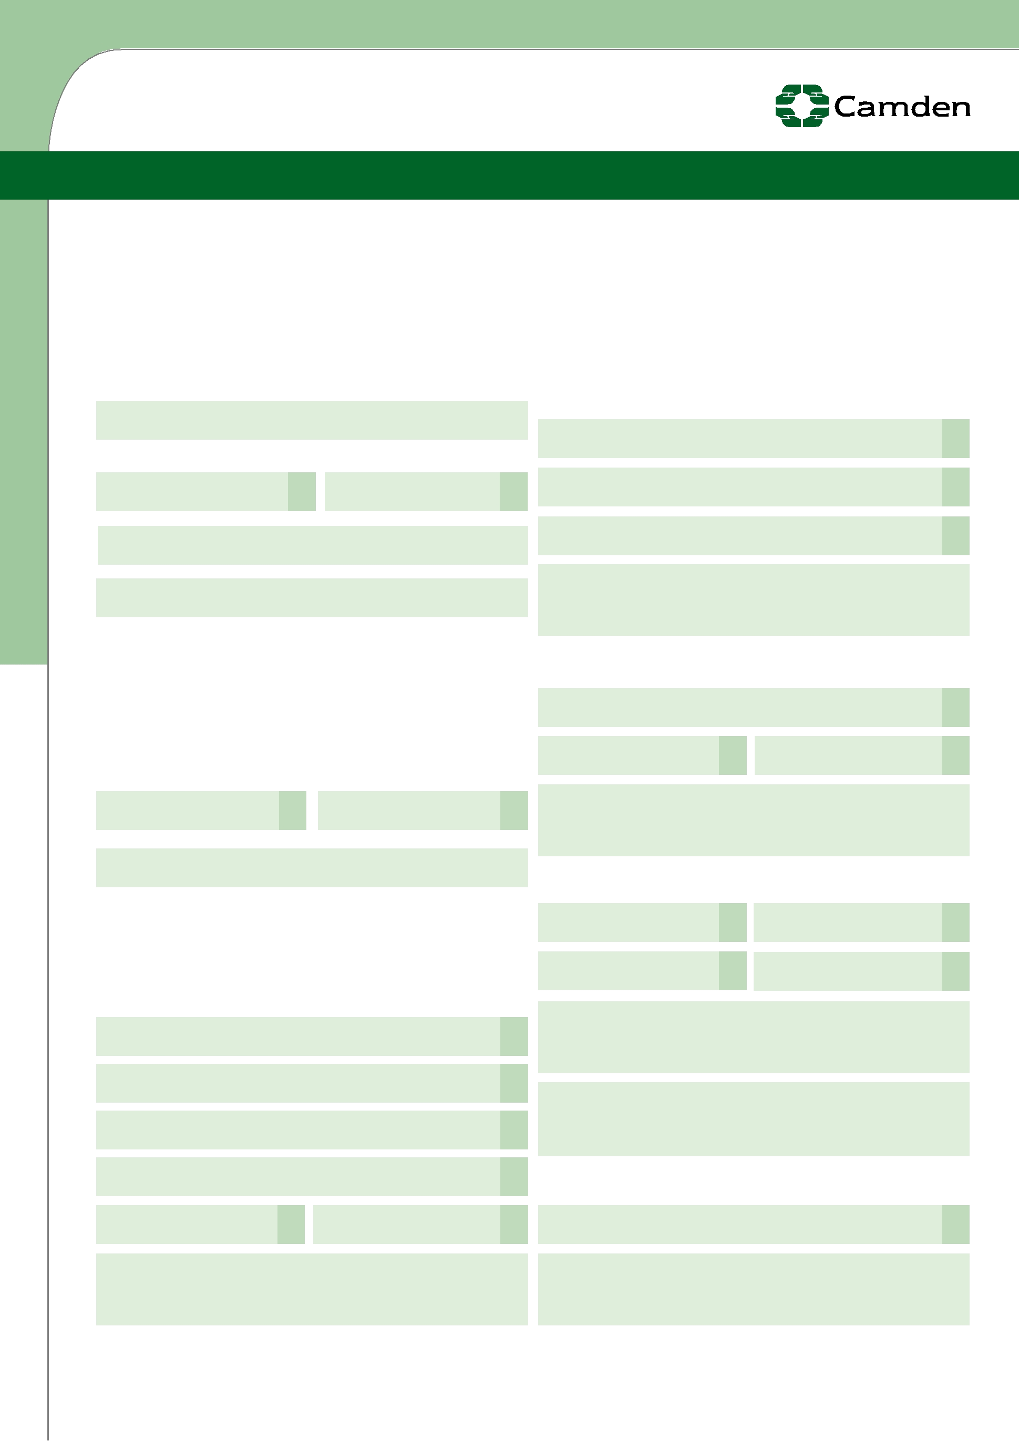
London Borough of Camden

V A L U I N G D I V E R S I T Y I N E M P L O Y M E N T

The London Borough of Camden is committed to equality and diversity in employment. In order to monitor and ensure the effectiveness of this, all applicants are asked to provide the following information. Any information given will be treated in the strictest confidence, and will be used solely for the purposes of monitoring.

This part of the form will be separated from the rest of your Job Application Form upon receipt and will not be considered as part of the short listing or appointment process.

What is your gender?: Please tick (✓)

Male Female

What is your date of birth?

Disability:

Under the terms of the Disability Discrimination Act 1995 ‘a person has a disability if he/she has a physical or mental impairment which has a substantial and long-term adverse effect on his/her ability to carry out normal day to day activities’. Individuals with the following conditions can now automatically be classified as having a disability: HIV, cancer, multiple sclerosis, severe disfigurements, certified blindness or partial sightedness.

Do you consider yourself to have a disability as defined above?

Yes No

Mixed:

White and African

White and Asian

White and Caribbean

Any other Mixed background, please specify:

Asian

Bangladeshi

Indian Pakistani

Any other Asian background, please specify:

What is your ethnic group?: Please tick (✓)

Our ethnic background describes how we think of ourselves. Ethnic background is not the same as nationality or country of birth. The groups listed below reflect the largest ethnic groups in Camden. You are asked to choose the ethnic group that is closest to how you see yourself and specify a more specific group if you wish.

White:

Albanian (excluding Kosovan)

Greek or Greek Cypriot

Kosovan

Turkish or Turkish Cypriot

White British White Irish

Black:

African Congolese African Nigerian

African Somalian Black Caribbean

Any other African background, please specify:

Any other Black background, please specify:

Chinese or other ethnic group:

Chinese

Any other White background, please specify:

Any other group, please specify:



