March 2017

Dear Prospective Applicant,

May I first of all thank you for showing interest in this post and I hope that after reading the material included, you wish to apply.

Tottington High School is a successful school in the north of Bury serving various townships. Results are generally above local and national averages. Please visit our main school website and our student website ‘The Echo’ as well as read our latest Ofsted report to get ‘a feel’ for our school.

Our staff are very committed to ensuring the best quality education for our young people and I know that the successful applicant will see this is an excellent opportunity to gain experience in this temporary post.

We have several roles available for September 2017 as follows: two posts for mainscale Mathematics, and one in the Science Faculty teaching general Science. It would be beneficial to be able to teach Physics and KS4.

I hope after having reading information about our school that you feel Tottington High School is a school that will suit your ambitions and skills. Thank you for any consideration you have given to your possible application and you are of course welcome to contact us for any further information you need including a visit.

Deadline for applications is noon Thursday 23rd March. Interviews will be held wb 27th March.

Yours sincerely,
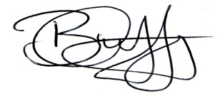
Mr. Brian Duffy
Headteacher

