Dear Applicant,

Thank you for taking the time in applying for this advertised position and for your interest in Box Hill School.

Please find enclosed:

The application form and explanatory notes regarding completion of the form and recruitment process.

A job description.

The School’s Child Protection Policy Statement.

To be considered for the post please return the correctly completed application form and equal opps. form, no later than Wednesday 21 June 2017 by 9am, along with a formal letter of application outlining the skills you feel you possess that are necessary for the role.

If your application is successful you will be invited to interview within three weeks of the closing date. Please be assured we will contact you by telephone or email to inform you further on the interview process where appropriate.

If you do not hear from us your application has not been successful and we wish you well in your employment search.

Yours faithfully

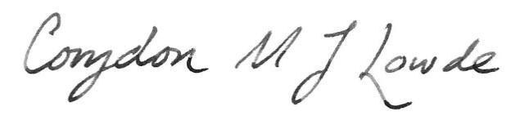
Corydon Lowde
Headmaster

