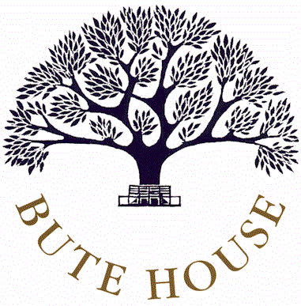

PERSON SPECIFICATION

Role: TEACHING ASSISTANT

 | ESSENTIAL  These are qualities which are required to do this job. No applicant would be considered if they did not have these. | DESIRABLE  These are additional qualities, which may be useful when the panel is selecting the final shortlist. | METHOD OF ASSESSMENT
Qualifications | Minimum Level 2 NVQ or equivalent  First Aid qualification or the willingness to obtain this. |  | Certificates
Experience | Experience of working with young children |  | Application form  References
Skills | Good interpersonal skills.  Ability to work on own initiative.  Good written and numerical skills. | Computer literacy. | Interview  References  Application form  Interview
Knowledge |  | Of working in a school environment and the curriculum. | Interview
Personal competencies and qualities | Enjoyment of working with children.  The ability to develop positive relationships with young people.  High levels of honesty and integrity.  The ability to take personal responsibility, a readiness to reflect and self evaluate and the ability to change, improve and develop. |  | Interview  References

Please Note: Bute House is committed to safeguarding and promoting the welfare of children. The successful applicant for this job will be required to undergo child protection screening appropriate to the role and an enhanced Disclosure and Barring Service Check before they start work at the school as well as taking up references before interview.

