Further Information for Interested Teachers
Britannica International School
www.britannicaschool.hu
August 2017

Dear Applicant
Thank you for your interest in our school. The intention of this booklet is to give you a short flavour and insight into what the school is about and has to offer you as part of your teaching career.
Britannica International School was established in 1993, and was the first British style secondary school in Hungary. Today it is a thriving school of over 390 students from around 50 nationalities. In 2008, the school became part of the Orbital Education Group, a British education company with schools in China, Ecuador, Hungary, Russia and Spain.
At Britannica we offer a British style education to the international community here in Budapest. We provide a nurturing learning environment which places a strong emphasis on fostering positive relationships throughout our global learning community. Our recent staff and student surveys indicate that the strong working relationships between staff and students are a major strength and that this is a key element in parents sending their children to Britannica. As a school, we believe that all children can be successful and they should be encouraged to make the most of their talents. Success can be achieved in a variety of ways. Academic success is valued highly, but it is also our belief that the all-round development of each child is just as important. Through our extra-curricular programme, the school also provides an array of opportunities. Throughout their time with us at Britannica, we want our students to feel proud of both themselves and of the school.
If you were successful in being appointed to our school, we would offer you a full induction programme at the start of the year before the students return. This is designed to help you orientate to school life and also life in the beautiful city of Budapest.
In 2015, the school achieved full Accreditation status from the Council of International Schools. In December 2016 they also recognized us as a ‘school of good standing’. This illustrates the consistency and quality of what is on offer at Britannica.
Following a period of rapid growth in our primary department and the arrival on a new site in the 12th District, the school has undergone many changes. We are now in a phase of further development, strengthening our systems and continuously evolving our approaches to teaching and learning. We are focused on embedding the quality of our provision consistently across the whole school. We continue to grow rapidly in terms of student numbers with a vision of two form entry throughout the school by 2021.
If you are successful, I am sure you will find the role stimulating and rewarding along with the opportunity to enjoy the range of treasures that Hungary has to offer. Thank you for your interest in Britannica and wish you every success with your application.

Mr N McGarry
Principal

Information Summary

SCHOOL
Set amongst the Buda Hills, Britannica International School is the oldest and one of the leading international schools in Budapest, Hungary.
Originally a Secondary school, Britannica moved to its existing site in 2010 and now also has a thriving Primary Department.

FACILITIES
Britannica is a well-resourced school with its own indoor, heated swimming pool, gym, sports tent, newly refurbished ICT suite and other specialist rooms. What makes Britannica unique is its family atmosphere where students, parents and staff pull together.

STAFFING
We have 56 classroom-based staff, made up of 27 teachers and TA’s in primary and 29 specialist teachers working in secondary, including a small group of eight working across the whole school.

CURRICULUM
Britannica aims to bring ‘The best of British Education to Hungary’ by offering a British style education in Primary with close links to the National Curriculum whilst embracing its internationalism.
In the Secondary Department, the Cambridge International General Certificate of Secondary Education (IGCSE) is offered at KS4 and the Cambridge Advanced Subsidiary Levels (AS) and Advanced Levels (A Levels) at KS5.

ACCREDITATION
The award of Accredited Status from CIS demonstrates that a school is aligned with the demanding CIS Standards for Accreditation. It shows that the school has achieved high standards of professional performance in international education and has a commitment to continuous improvement.
Britannica is the first British style school in Budapest to achieve this quality mark and we are very proud of this achievement.
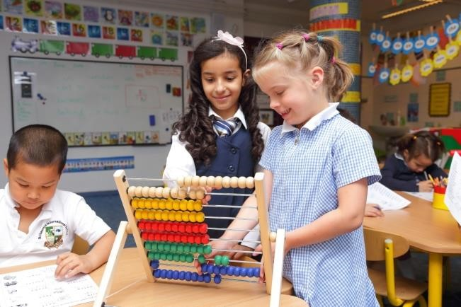

EXPERIENCE AND QUALIFICATIONS SOUGHT

Essential:
- A university degree and a teaching qualification;
- A minimum of 1 year’s teaching with relevant experience in an English National Curriculum school either in the UK or Overseas is preferred;
- NQT’s will be considered;
- For Secondary teaching positions - the ability and experience to teach across the age range from Year 7 to Year 13.

An Advantage:
- Previous international experience;
- Experience of teaching Cambridge International Examinations (CIE) IGCSE;
- Experience of teaching Cambridge International Examinations (CIE) AS/A Levels;
- Competence and confidence with ICT in the classroom, including BYOD.

PROFESSIONAL QUALITIES SOUGHT
- Positive attitude;
- Flexible approach;
- Accepting of responsibility;
- School comes first;
- Appearance – Smart, Professional Dress and appearance;
- Deep pride in the quality of your students’ work;
- Commitment and loyalty to the school;
- A positive role model to other staff and students;
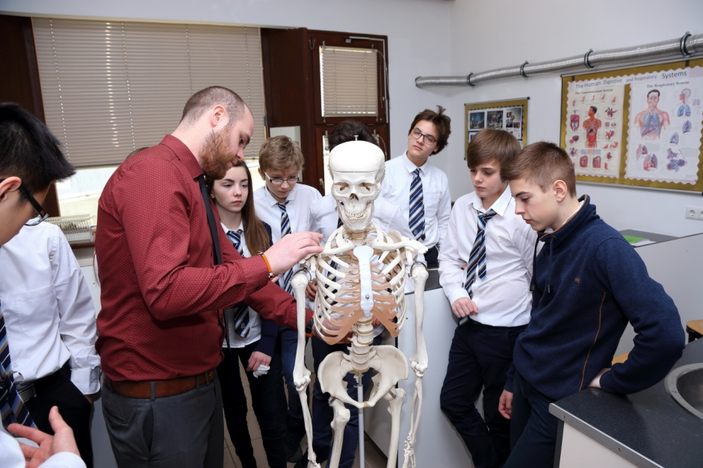

PERSONAL QUALITIES SOUGHT
- Fluent English speaker;
- A positive and professional approach to school life;
- Personal confidence and determination;
- A willingness to go the “extra mile”;
- Strong interpersonal skills;
- Good communication skills both orally and in writing;
- Reliability and integrity;
- Sense of humour;
- Creativity and vision;
- Able to work under pressure and meet deadlines;
- Able to manage own time and workload;
- Highly organised and able to prioritise;
- Good ICT skills.

WHAT CAN YOU EXPECT FROM US?
- To be treated fairly and with respect;
- A safe, attractive and friendly working environment;
- A purpose-built school with good facilities;
- A good level of resources and materials;
- To work hard – we have high expectations of our teachers;
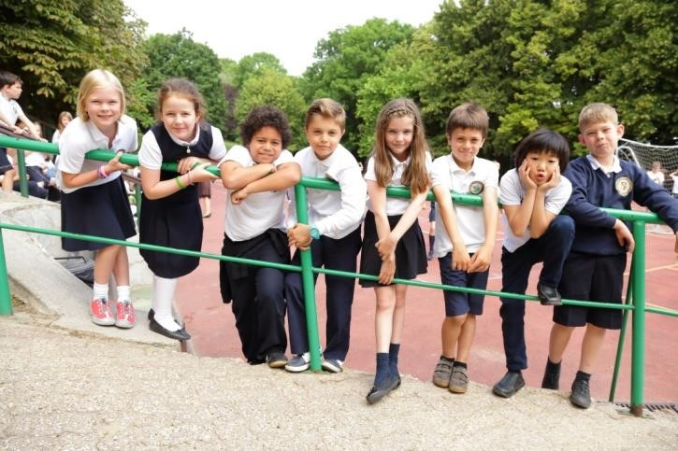
- Collegial support.

WHAT MAKES THE SCHOOL SPECIAL?
A small school family atmosphere;
- British style education;
- Academically successful;
- High standards of behavior: positive behavior policy;
- Good levels of parent satisfaction and support;
- Individual successes are recognised, rewarded and celebrated;
- A range of extra-curricular activities;
- The development of each child as a global citizen;
- Students develop as life-long learners;
- Traditional virtues and good manners are reinforced;
- Children feel proud of themselves and the school;
- An international mix of students from nearly 50 Countries.

INTERNATIONAL TEACHING
Teaching overseas is different and does present some additional challenges. Please consider the following if you have not taught overseas before
- Learn as much as possible about the host country in advance, so that you have realistic expectations;
- Anticipate a challenging adjustment period of at least three months before making a decision about the move and whether you like it or not;
- Always try to understand the host country perspective. It will be different!
- Try to be flexible in your thinking, attitude and approach, maintaining a sense of humour.
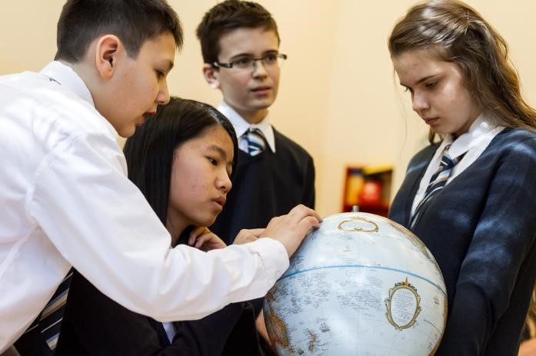

SALARY AND BENEFITS
We offer a good working environment and a salary that is competitive within the context of Hungary.

LIFE in BUDAPEST
Budapest is Eastern Europe’s up and coming expat hotspot and an increasing number of people are relocating to Budapest each year. And no wonder, the Hungarian capital has all the things Western European cities have to offer – good quality of living, diverse culture and attractive job opportunities – with a much lower cost of living.
You may wish to visit the following website which compares the cost of living in different cities around the world.

http://www.numbeo.com/cost-of-
living/compare_cities.jsp?country1=United+Kingdom&country2=Hungary&city1=Brigh ton&city2=Budapest

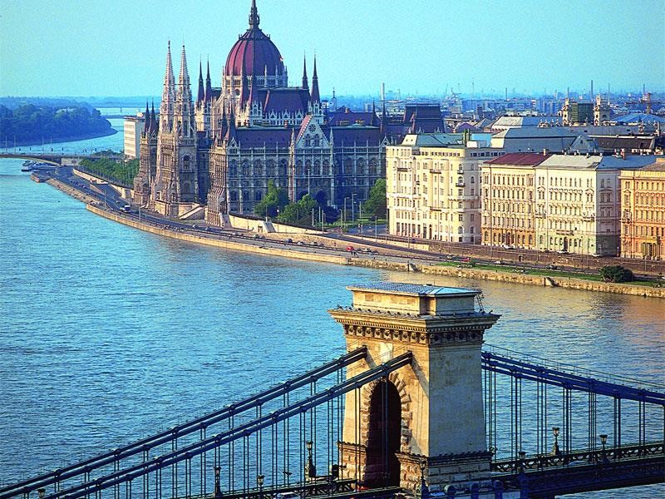

Ever since Hungary joined the EU in 2004, an increasing number of international companies have opened branch offices in Budapest, making more lucrative positions available for expats than the traditional language teacher jobs. An important thing to keep in mind is that the cost of living will be different in the Hungarian capital and can be cheaper than in some European cities.
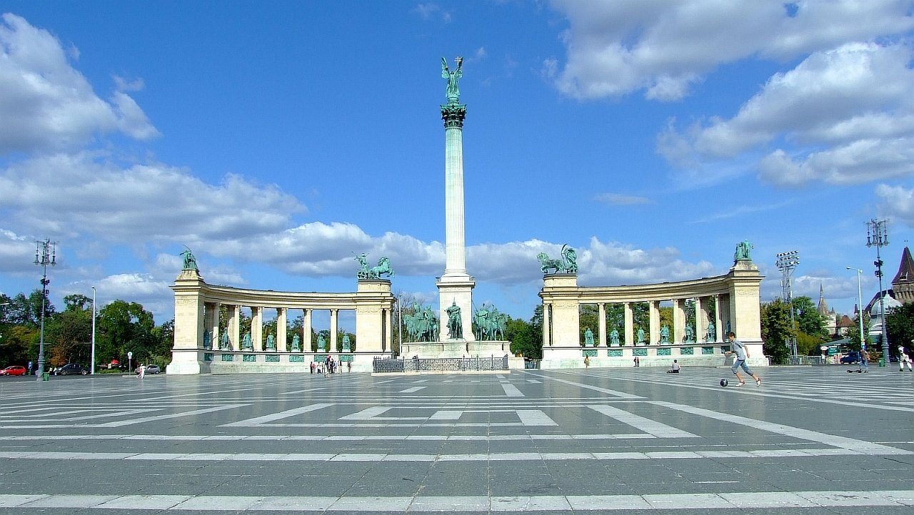

HOUSING
Once you have secured your dream job, you need to choose where you want to live. Budapest is divided into 23 districts – 6 in Buda on the west side of the Danube River, 17 in Pest on the east side.
A majority of expats choose to live in Buda because it offers more quiet residential areas and lovely green spaces. Where you choose to live depends on your budget. District 2 has many expensive villas, especially in the Rózsadomb (Rose Hill) neighborhood, but also less pricy apartments. Many people like this district as it is quiet, clean and not too far from the city centre. District 12 (Buda Hills) is also quiet while still lying within close proximity to the downtown area. Many prominent Hungarian politicians live there, including the president and prime minister.
For expats on a budget, several districts on the east side of the Danube in Pest may offer more practical housing options. District 14 (Zugló) is the preferred choice of many expat families. It has reasonable housing prices as well as many historical residential buildings. The district is home to the Budapest Zoo and Botanical Garden and an expansive city park. Expats living here will be able to reach quickly and easily.
District 13 (Downtown) lies between Zugló and the Danube. New residential buildings are currently being built here, which offer nice options for expats with a smaller budget.

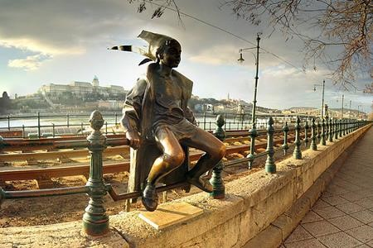

If you are coming to Budapest as a young and single expat, you may be attracted to District 5 (Belváros), which is the heart of the city, located right on the Danube and at the centre of all the nightlife action.
Before you move to Budapest, joining the Expatriate Community of InterNations is a good way to get in contact with other expats before your arrival. In the forums, you can ask expats already living in Budapest about their experiences of the city and the cost of living and much more.
If possible, it makes sense to try and negotiate rent payment in forints with your landlord. As the school pays salaries in forints, it avoids losing out on potentially expensive exchange rate conversions.

PUBLIC TRANSPORT IN BUDAPEST
Public transport is widely regarded as clean, efficient and reliable. It consists of the Metro, Buses, Trams, Trolley Buses and the ageing HEV suburban rail service.
It is overseen by BKK, whose ticket office staff nearly always speak enough English to carry out transactions. However, as you move into the outskirts of the city, this likelihood decreases.

The ‘main’ transport hub on the West (Buda) side is Szell Kalmanter, sometimes called by its old name, ‘MoszkvaTer’, by the locals. It serves the Metro Line 2, Trams and Buses to a wide range of destinations on the West side of the city.

DeakFerencter, usually shortened to ‘Deak’, serves the same function on the East (Pest) side and is the main Metro hub where the 3 original lines all meet.

For journeys further afield, all of the main overground train stations sit on the Metro;Keleti on the M2 and M4, Nyugati on the M3 and Deli on the M2.
Compared to most cities, Budapest public transport is pleasingly cheap. A monthly pass across all forms of public transport within Budapest borders (which stretch quite a way – check if you’re taking a long journey though because there might be a supplement) costs only 9,500-HUF. Students and Young People can obtain the same pass for only 3,500-HUF.
Single tickets are 350-HUF or 3,000HUF for a book of 10. Single tickets technically can be bought on buses for 450-HUF.

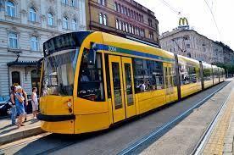
TAXIS
Taxis across Budapest have to comply with tight fare restrictions and charge a flat, government-set rate. Whilst this results in ‘fair’ and transparent rates, it has also eliminated any competitive element.
It is advisable to telephone for Taxis, no matter how short the journey. Taxis hailed in the street have a more relaxed fare code and will often hit English-speaking customers hard with the assumption they don’t know any better.

Some reliable, quick-serving and English-speaking phone numbers are:
CityTaxi - +361 211 1111 TaxiPlus - +361 888 8000
Basic cost is 450 HUF and 1 km fare is 280 HUF
Uber is also popular and available in Hungary.

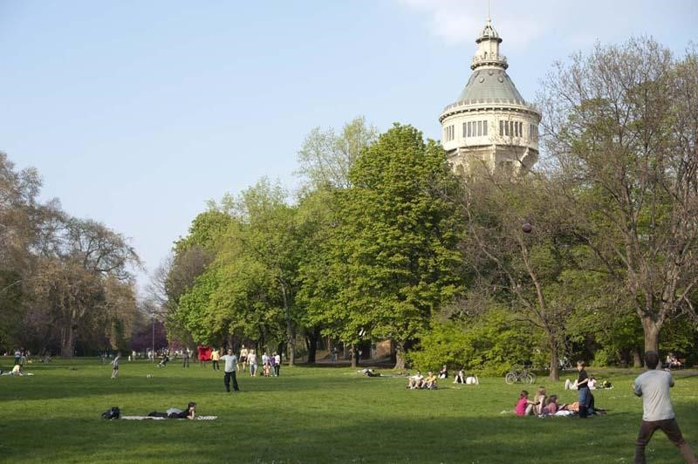

SHOPPING IN BUDAPEST
There are plenty of options to find good bargains. The number of shops has increased since the 90s - big shopping malls, new fashion stores and boutiques have appeared on every corner of the city.
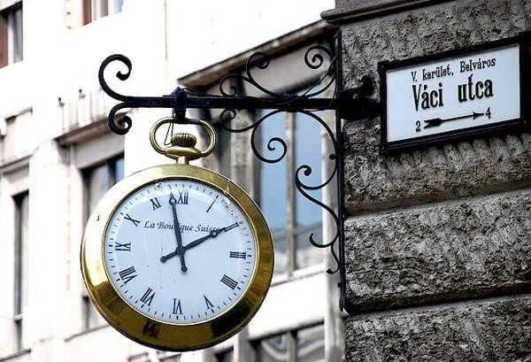
Tesco and some other supermarkets offers delivery to your home if you shop online.
In the centre, mainly in Pest, you'll find several non-stop, 24-hour shops. They sell soft drinks and snacks usually at a higher price.

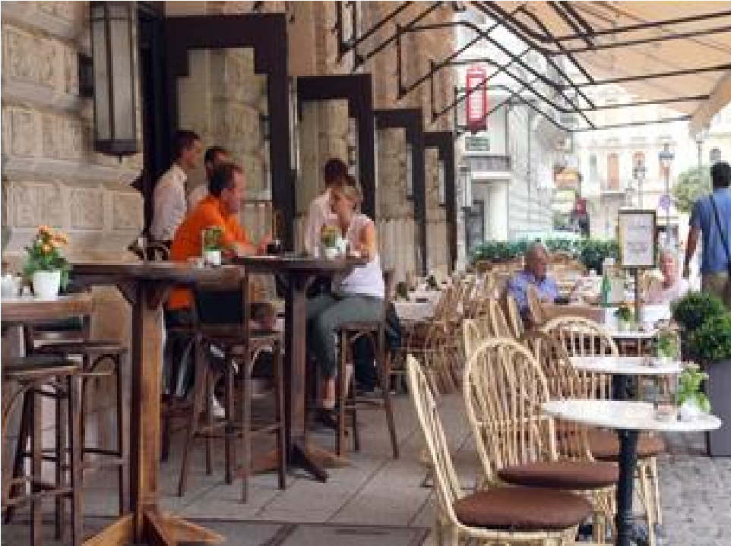
Food stores: larger food stores like SPAR, CBA, Aldi are open from 7.00 till 18.00 - 20.00, Monday to Friday and on Saturdays from 7.00 till 18.00. Other Budapest shops are open Monday to Friday from 10.00 till 18.00, on Saturdays from 10.00 till 13.00.

Some hypermarkets have longer opening hours.

For food the Great Market Hall is recommended at the Pest end of Liberty Bridge
(Szabadsághíd). It's not only the best and cheapest place to buy souvenirs, but it's the oldest market in the city. The market building's architecture itself is worth a visit.
Budapest is packed with Market Halls on both sides of the river. It’s worth going to these if you’re keen on fresh season vegetables, fruits, meat or dairy products. Most places accommodate a “farmer market” where organic products can be purchased.
Sometimes you can purchase the same quality food on much lower price in one shop than in another. Spar and CBA are more expensive than Lidl or Aldi.

If 1 GBP = 420 HUF
1 kg orange can be purchased between 0,5 – 1 GBP
1 kg potato 0,3 – 0,6 GBP
1 kg apple 0,4 GBP
1 kg bell pepper 2 – 4 GBP
1 kg chicken breast 3 GBP
1 kg beef 4 – 6 GBP
1 kg pork 3 GBP
1 litre milk 0,5 GBP
1,5litre mineral water 0,25 – 0,5 GBP
1 bottle of wine 2 – 4 GBP
1 kg cheese 3 – 4 GBP
0,2 kg butter 0,5 GBP
0,5litre olive oil 3 GBP
1 kg bread 0,4 – 1 GBP
1 dozen egg 1 GBP
If you crave your favourite British food, visit: www.britishpantry.hu or visit one of the Culinaris shops. https://culinaris.hu/
Tesco will also stock some of their home brands but they are limited.

Employment in another Orbital school.
Working in a Group school can have many advantages. We like to retain excellent teachers and so actively encourage movement between schools, especially for promotion opportunities. The Group has British style international schools in the following culturally attractive and historically important destinations: Palma de Mallorca, Spain; Budapest, Hungary; Shanghai, China; Ljubljana, Slovenia; Moscow, Russian Federation; and Quito, Ecuador. After two years’ successful employment teachers wishing to move on will be given full consideration for vacancies in these schools. All vacancies are posted on the respective websites of the schools.
www.orbitaled.com

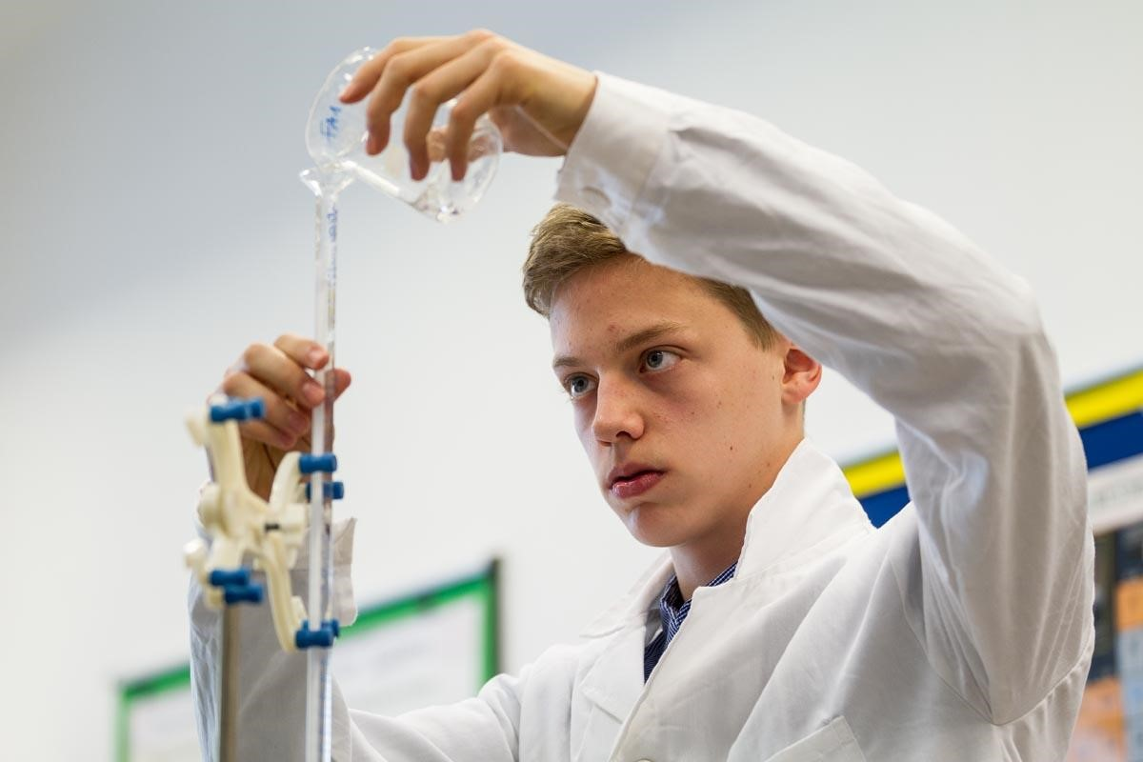

RECRUITMENT PROCESS
If you are interested in one of our posts then I would encourage you to visit our website.http://www.britannicaschool.hu/Recruitment
Applications should include a covering letter, colour photograph and updated CV with all relevant experience, along with the names and contact email addresses of at least three referees; one of whom should be your current or most recent employer.
Interviews will take place using a mixture of face to face meetings where possible and Skype calls.

Britannica International School is committed to safeguarding children and young people. All post-holders are subject to a satisfactory enhanced DBS (in the UK) or Criminal Records (Police Check) disclosure from their most recent country of residence. See a copy of our Safer Recruitment Policy by visiting the following link: http://www.britannicaschool.hu/Policies-and-Procedures

Applications should be sent to recruitment@britannicaschool.hu

Britannica International School1121 Budapest, Kakukk u. 1-3.Tel: +36 1 466 9794
Website: www.britannicaschool.hu

