Our Ethos:

Learning and achievement drives everything that we do at Hillingdon Primary School. Our job, in partnership with parents, is to build the foundations for a successful education, to enable each child to discover the joy of learning, to help them to fulfil every aspect of their potential and to encourage their growth into effective citizens, ready to play their part in the world and their community.

We endeavour to ensure that every child is successful in the key areas of English and Maths and we are keen to see this recognised in the results they secure. However, we also want them to learn and experience more than this through a varied curriculum and a range of extra-curricular and after-school opportunities that complement our work in the classroom. We value each child as an individual and aim to provide the opportunities for pupils to excel in areas where they have a special talent whether this is in science, sport, drama, art, music or through involvement in special projects.

Our Commitment to Staff:

At Hillingdon Primary School, we know teachers work best in a culture where they are trusted to do their job well and are given the time and support to do it. We scored highly in all aspects of the staff satisfaction questionnaire completed by the Elliot Foundation (June 2016). This included questions regarding the ability to balance work and home life, enjoyment of the job and workload.

We are an ‘outstanding’ school and are determined to maintain this status for our students, who deserve an excellent education. We know we can only do this by providing an environment in which teachers enjoy working and feel valued and supported by senior leaders to do well. We work hard to provide this environment, including the provision of additional management time, the support of a class learning support assistant, administrative support including data collection and PPA taught by specialist teachers. Please see our staffing structure diagram which best illustrates the supportive framework in which our teaching staff work.

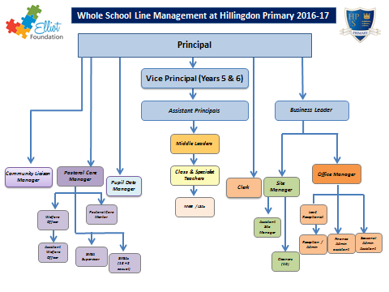

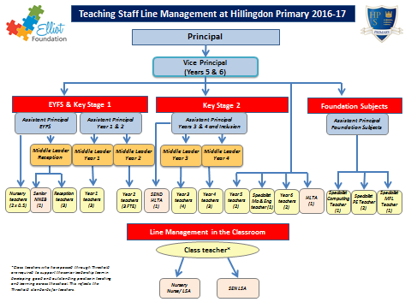

Professional Development:

The school is proud to be part of the Elliot Foundation and the opportunities this provides for continuing professional development as well as the collaboration and sharing of practice with other Elliot schools. A career in the Elliot Foundation is one full of opportunity with access to a wide range of comprehensive learning and development opportunities designed to bring the best out of you so you can help bring the best out of our children. Because the Elliot Foundation model is one of self-supporting, self-improving clusters schools you will also get the chance to explore and develop your particular passion in a range of contexts.

In addition to the opportunities available through our membership of the Elliot Foundation, Hillingdon Primary School is proud to have a successful track record of enabling career progression. As a large primary school with an established leadership structure we support staff to develop their leadership and management skills as part of our internal succession planning. Many of our NQTs have progressed to middle and senior leadership positions and a number of our more experienced teachers have progressed to Deputy Head and Head Teacher roles as a result of their development at Hillingdon Primary.

How to Learn More:

Further information about working in the Elliot Foundation can be found on their website.
http://www.elliotfoundation.co.uk/jobs/

If you would like to learn more about our school, please visit our website at:
http://www.hillingdon.hillingdon.sch.uk

We welcome enquiries from individuals interested in working at our school. General enquiries can be sent to hillprimary@hillingdonprimaryschool.org.uk or alternatively if you have a question about a specific role we are advertising, please contact the individual named on the advert as they will be best placed to answer your questions.

There is no better way to experience our school than to visit us in person. If you are interested in one of our vacancies and would like to get to know us better, without obligation, please contact our Office Manager, Mrs Grey, at sgrey@hillingdonprimaryschool.org.uk to make the necessary arrangements.

