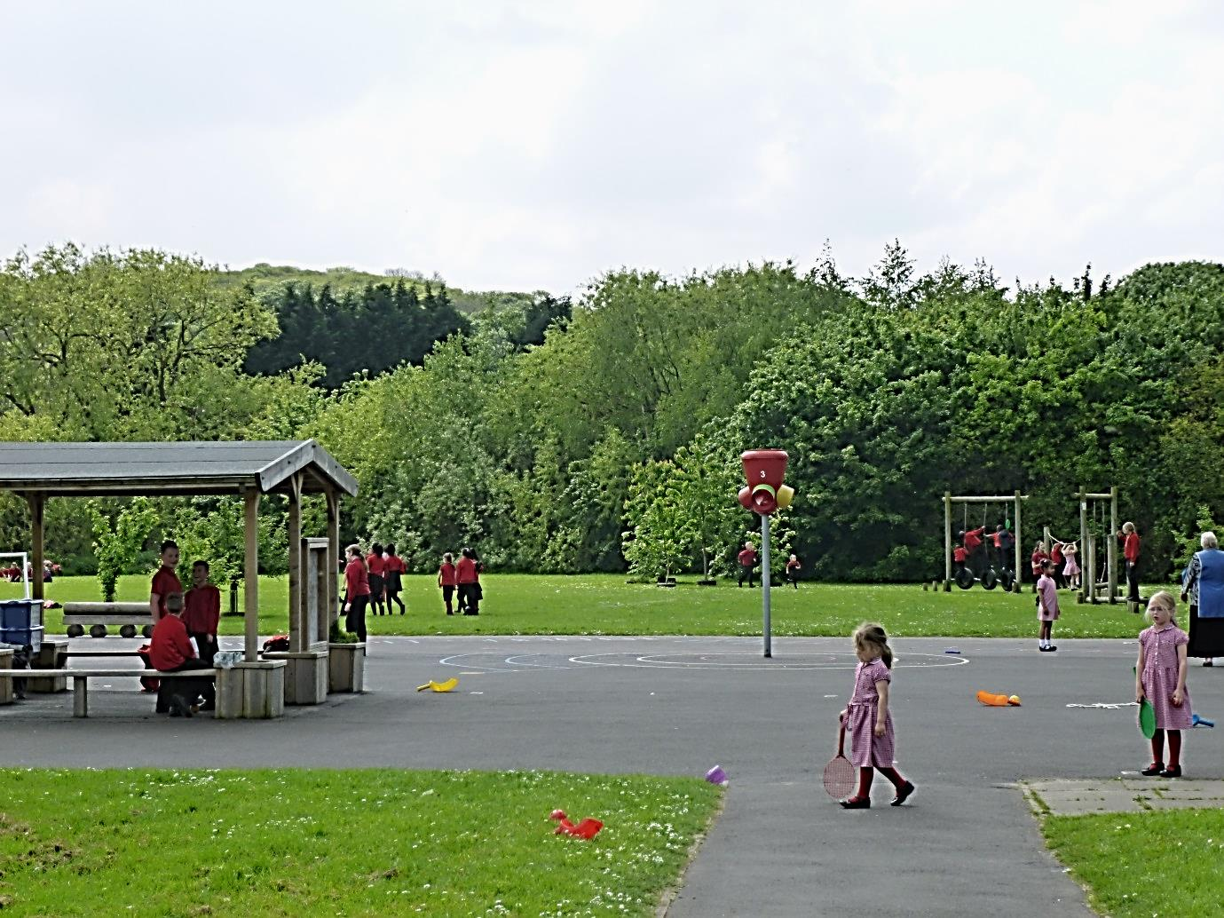

Parkway Primary School
Deputy Headteacher
Application Pack

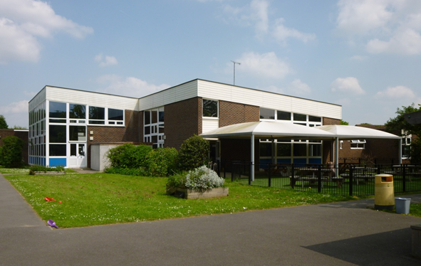

Contents

- Letter from Headteacher

- About Parkway Primary School

- About You and Your Application

- Job Description

- Person Specification

- Equal Opportunities Statement

- Ofsted Report

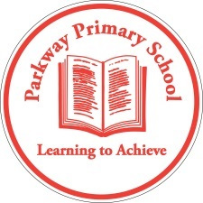
Parkway Primary School
Headteacher: Mr R. Celino-Stock Bed (Hons) NPQH
Alsike Road, Erith, Kent DA18 4DP
020 8310 0176
admin@parkway.bexley.sch.uk

April 2017

Dear Applicant

Thank you for your interest in applying for the post of Deputy Headteacher at Parkway Primary School.

I am delighted to provide this candidates information pack outlining the school and the position advertised.

We are a school which is growing over the next few years from a one-form-entry to a two-form-entry with an additional MLD provision for 40 children. We are situated in Thamesmead in the London Borough of Bexley.

In October 2014, the school was rated ‘Good’ in all categories by Ofsted and has a supportive and positive ethos. It is our aim to build on this and continue our journey to becoming ‘Outstanding’.

The current Deputy Headteacher has gained promotion at another school which he will take up in September. We now want to appoint a leader who has the highest expectations of everyone in our community, who enjoys working as a member of a team and who takes a solution-focused approach. The successful candidate will also take a leading role in supporting the professional development of all staff and will in turn receive opportunities to develop their professional skills.

We welcome applications from professionals who are keen to further develop their own career and who aspire to headship. This is an exciting time in the school’s development, with an expanding school, enthusiastic staff and governors who are committed to ensuring that we achieve the very best for all our children. The staff and governing body look forward to working with someone who wants to take a leading role in ensuring that our school continues on its journey of developing and improving outcomes for all our children.

You are most welcome to visit our school. Please contact Carol Downham, Office Manager, on 020 8310 0176 to make an appointment.

I do hope the information in this pack is helpful and I look forward to meeting you when you visit our school.

Yours sincerely

Robert Celino-Stock

ABOUT US

Parkway is a one-form entry primary Local Authority school situated in the Thamesmead area. We work in close co-operation with other Bexley schools and also in the BEIP, which encompasses primary and secondary schools in the immediate vicinity. We have high expectations in relation to standards of work and behaviour of the children. High quality teaching and learning across the school ensures that children at Parkway are given the support and challenge needed to make continuous progress in all areas of development.

Parkway is now home to Bexley’s MLD primary provision. The purpose built MLD provision building was completed in January 2017. This provision will cater for 40 children at capacity.

Additionally, the school will be moving to two-form entry from September 2018. The contract for this phase of the building work will be awarded in time for the work to start in May 2017, completed by April 2018.

Parkway provides a breadth of opportunities for all of our pupils and we are proud of the progress that the school has made in narrowing the gap for disadvantaged pupils.

We supplement the school curriculum with a range of clubs including various sports, reading, chess, computing, recorders and choir. Year 6 take part in a residential journey and also take part in the Shakespeare Schools Festival. We hold spelling and debating competitions with a nearby school.

Pupils are encouraged to play an active role in making the school a successful and happy environment. We operate a School Council and have House Prefects elected across the school. These children serve their community diligently.

Our Facilities and Resources

The school is situated in an area of high social deprivation. We have, however, spacious ground and buildings which have been enhanced through capital investment. New classrooms have Clevertouch boards which are planned to be rolled out across the school. Plans are also in place to develop a library area.

As part of our building programme, a new Nursery classroom has been built and equipped. A new EYFS outdoor area was installed in January 2017. As with all one-form entry schools, the budget is tight. However, careful financial planning has ensured that resources have been adequate and future spending plans have been identified.

Our Staff and Community

We operate a staffing model which encourages continuing professional development and allows career progression for our teachers and teaching assistants. This staffing team is complemented by our very experienced office and site staff. Last year saw a very high retention rate for staff.

Parents are supportive of the school and we consistently have positive feedback forms at Parents’ Evenings. Home-school arrangements have been built to foster a relationship of trust and respect on both sides. Our fledgling PTFA have supported the school in fundraising.

Our governors are enthusiastic and want to see the school succeed. They ensure accountability through challenge and are committed to the school’s ongoing development. There is a close working relationship between staff and governors and regular visits by the Governing Body are encouraged. They are fully involved in drawing up the school’s priorities for the future.

Our Area

Bexley is an outer London Borough offering affordable housing and a range of schools at secondary and primary levels. Within its boundaries are award winning parks, open spaces, historic houses and attractive waterways. Access to central London and the Kent countryside is very speedy and is an easy access to major motorways and strong public transport links.

About You and Your Application

It is important that you complete all sections of the form and that you provide full information in each section. Your application form may be submitted on line or on the paper form which should be completed in black ink or ball point or be typed to facilitate photocopying. You are asked to tabulate your experience and additionally to submit a letter setting out the main points of your application.
Referees must be able to comment authoritatively on your personal and professional competence and must include your current employers or their authorised representative.
Reference is made on the application form that you must disclose whether you are related to any senior officer in the Borough Council’s service, to an elected or co-opted member of the Governing Body. Canvassing for appointment disqualifies.
Visits to the school are welcome on the afternoon of 19th, 20th and 21st April 2017 and can be arranged by contacting Carol Downham on 020 8310 0176.

The closing date for receipt of applications is noon on 24th April 2017. Interviews are expected to be held on the 4th and 5th May 2017.

Please address your application to:

Mr R Celino-Stock
Alsike Road,
Erith,
Kent DA18 4DP

E-mail: head@parkway.bexley.sch.uk

What will happen if you are offered the post

If you are offered the post, we will ask for evidence of your identity, your right to work in the UK and your qualifications. We will ask you to complete an application form to obtain a certificate of enhanced disclosure from the Disclosure and Barring Service, unless we have agreed to accept a previous certificate issued and carried out a status check using the DBS Update Service which has confirmed there is no additional information available since the certificate was issued.

We will also check:

- Whether you are barred from working with children in regulated activity, where relevant. It is a criminal offence for someone who appears on the Children’s Barred List to engage, or seek or offer to engage, in the regulated activity from which they are barred;

- As manager of a childcare provision, the school will ensure that appropriate checks are carried out to ensure that individuals are not disqualified under the Childcare (Disqualification) Regulations 2009;

- Your qualified Teacher Status (QTS) or your qualified Teacher, Learning and Skills (QTLS) status with the Institute for Learning, if relevant; and

- That you are medically fit to undertake the role.

False Information

Please note that providing false information could result in your application being rejected or your dismissal from employment if you are appointed. The matter may also be referred to the police if we consider that you may have committed a criminal offence.

Equal Opportunities Statement

It is the policy of LB Bexley, reflected by the Governing Body, that all persons shall have equal opportunity for employment, advancement and training, on the basis of their ability, qualifications and fitness for the work according with the Council's policies in these areas. There must be no discrimination towards or against a person, whether in recruitment, promotion, training or in any other way on the grounds of colour, race, creed, nationality, ethnic or national origin, sex or marital status.

Employment of Disabled People

It is the policy of the School to provide employment opportunities for disabled persons that are superior to any statutory requirements. In particular:

- The Governing Body will give full and fair consideration to disabled people applying for employment. Special attention will be given to their particular aptitudes and abilities in respect of the position applied for.

- Employees who become disabled whilst in service will be enabled to continue working as long as their work is satisfactory. If, however, their disability prevents them from carrying out the work for which they were employed, every effort will be made to find suitable alternative employment within the School, taking into consideration the medical circumstances and ability of the employee; appropriate training will also be considered.

- Disabled employees will be given full consideration for training, career development and promotion in the same way as non-disabled employees, in accordance with the conditions of service.

Job Description

Job Title: Deputy Headteacher
Salary: (Group 2 - ISR L11-L15)
Responsible to: Head Teacher

Job Purpose

Through outstanding teaching and leadership, ensure that all young people educated within Parkway Primary School, reach their full potential and leave Parkway Primary School fully equipped to be successful at secondary school and beyond.

The post holder, In addition to the requirements of a general class teacher, will be required to undertake the following areas of responsibility and key tasks:

Main Duties and Responsibilities

- To take full responsibility for leading and managing significant aspects of the school, under the overall direction of the Headteacher

- To carry out teaching duties, as required, in accordance with the schools schemes of work and the National Curriculum

- To lead on and actively contribute to the development of the primary curriculum

- To ensure that parents/carers are well informed about the school curriculum, its targets, children’s attainment and their part in the process of improvement

- To take on specific tasks related to the day to day administration and organisation of the school

- To manage the school effectively in the absence of the Headteacher

- To support the Headteacher in developing positive working relationships with and between all staff

- To be responsible for planning and developing the primary assembly programme

- To lead by example and be a positive role model for all staff

- To undertake break and other such duties as may be required

- To lead in developing a positive and motivational learning environment

- To contribute to the development and implementation of the school development plan within the national and local context, and to take sole responsibility for appropriately delegated aspects of it

- To be the designated safeguarding lead

- To be responsible for putting in place strategies that ensure all groups make good academic progress

- To be the EVC

- To take full responsibility for leading and managing of university student teachers and NQTs

Teaching & Learning:

- To develop classroom environments and teaching practice which secures effective learning across the breadth of the National Curriculum

- To provide a professional model for quality first teaching, clearly demonstrating effective teaching, classroom organisation, display, and high standards of pupil achievement, behaviour and discipline

- To take responsibility for the development and monitoring of a curriculum area(s) or whole school curriculum aspect(s), as agreed with the Headteacher

- To support the Headteacher in monitoring of the quality of teaching and children’s achievement, including the analysis of performance data

- To support the Headteacher in developing links with parents / carers, other schools, educational institutions, business and industry and the wider community, in order to enhance teaching and learning as well as children’s personal development

- To support the Headteacher in the management and organisation of relevant groupings of pupils to ensure that effective teaching and learning takes place and that children’s personal development needs are met

- To effectively lead staff meetings and professional learning activities, delegating appropriately and evaluating outcomes and effectiveness

General:

- To actively support and promote Parkway Primary Schools aims and ethos

- To promote equal opportunities in the school and to strongly believe that every child can succeed

- To collaborate in the evaluation of the effectiveness of the school’s policies, with particular emphasis on the school self- evaluation

- To support the schools commitment to the continued professional development of all staff

- To undertake any additional responsibilities / duties as may reasonably be required by the Headteacher

Please note that this job description is subject to review on an annual basis and may be amended, with agreement, at any time.

April 2017

PERSON SPECIFICATION

Job Title: Deputy Headteacher
Salary: (Group 2 - ISR L11-L15)
Responsible to: Head Teacher

Qualifications and Professional Development: | Essential | Desirable
Education to degree level
Qualified Teacher Status e.g. Postgraduate Certificate in Education
An excellent track record of recent, relevant professional development
Other professional qualifications
Experience of: | Essential | Desirable
Excellent classroom practice
Working with children and families in diverse communities i.e. multi-cultural, multi-faith, social deprivation
Working across the primary age range - Foundation Stage to Year 6
Leadership of an area of school development and/or subject
Managing at a senior level
Accountability for the success of an initiative
Innovative use of resources
Working in more than one school
Positive behaviour management
Professional Knowledge and Understanding of: | Essential | Desirable
The principles behind sustaining success and raising standards
Innovative approaches to working with children, parents, staff and the local community
The principles and practices of strategic and operational planning and delivery
Effective review and evaluation procedures
Different methods of consulting with stakeholders
The characteristics of effective schools
Recent research and inspection evidence on school improvement
The application of ICT to effective management
Strategies for ensuring equal opportunities of staff, children and other stakeholders
Effective teaching and learning strategies
Leadership and Management Skills: | Essential | Desirable
Work effectively both as a leader and as a member of a team
Direct and co-ordinate the work of others
Assist in initiating, leading and managing change
Ability to analyse key areas of performance and information to determine improvement measures, recommended key targets and develop appropriate action plans.
Prioritise, plan and organise workload
Ability to lead, inspire and motivate others
Set high standards and provide a role model for children and staff
Use ICT for efficient and effective management and administration
Deal sensitively with people and resolve conflicts
Provide support and guidance for children, staff and parents
Seek advice and support when necessary
Liaise effectively with other organisations and agencies

Decision-Making Skills: | Essential | Desirable
Make decisions based on analysis, interpretation and understanding of relevant data and information
Think creatively and imaginatively to anticipate, identify and solve problems
Demonstrate good judgement
Communication Skills: | Essential | Desirable
Communicate effectively orally and in writing to a range of audiences
Communicate the vision of the school both internally and within the local community
Negotiate and consult fairly and effectively
Manage good communications systems
Chair meetings effectively, as required
Develop, maintain and use an effective network of contacts
Self-Management Skills: | Essential | Desirable
Prioritise and manage own time effectively
Work under pressure and to deadlines
Achieve challenging professional goals
Take responsibility for own professional development
Personal Qualities and Attributes: | Essential | Desirable
A commitment to inclusive education
Evident enjoyment in working with children and their families
Personal impact and presence
Vision, imagination and creativity
Ability to inspire confidence in children, staff, parents and others
Determination to succeed and the highest possible expectations of self and others
Adaptability to changing circumstances and new ideas
Have a clear educational philosophy
Ability to manage and overcome setbacks
A commitment to an open and collaborative style of management
Intellectual ability and curiosity
Reliability, integrity and stamina
Dynamic, organised and proactive
Good sense of humour
Further Requirements | Essential | Desirable
An excellent record of attendance and punctuality.
Application form should be fully completed
Supporting statement/letter of application should address the criteria identified in the person specification

KEY INFORMATION

Type of school | Primary
School category | Community
Age range of pupils | 3–11
Gender of pupils | Mixed
Number of pupils on  school roll | 234
Appropriate authority | The governing body
Chair | Dee Higham
Head Teacher | Robert Celino-Stock
Date of previous  school inspection | 1st - 2nd October 2014
Telephone number | 020 8310 0176
Fax number | 020 8311 9799
Email address | admin@parkway.bexley.sch.uk
Ofsted rating | Good

Parkway Primary School
Alsike Road
Erith
Kent
DA18 4DP
020 8310 0176
020 8311 9799

