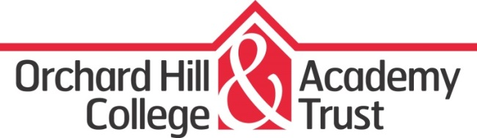

Secondary Class Teachers
Job Description
Job Title: Secondary Class Teacher
Reporting to: Secondary Key Stage Coordinator
Line Managing: Potential line management of classroom based staff
Responsibilities: Undertake professional duties of a teacher as set out in the STPCD and teacher standards
Working with: Leadership team and all staff

General responsibilities:

(1) The education and welfare of designated classes or groups of learners in accordance with the requirements of Conditions of Employment of School Teachers, having due regard to the Nightingale Community Academy’s aims, objectives, schemes of work, and policies.
(2) To share in the corporate responsibility for the wellbeing and pastoral care of all learners.
(3) To carry out any reasonable instructions given by the Principal or Senior Leadership Team.

Specific Duties

1) Management of Learning, Teaching and Resources

Have clear intentions for children’s learning and to use knowledge of school policy and National Curriculum requirements to plan differentiated work to meet the needs of individuals and groups promoting progression, continuity and quality of learning.
Use a variety of suitable teaching and learning styles and to communicate clear learning objectives and expectations.
Use relevant classroom management strategies to ensure that a purposeful environment for teaching is established and learning can take place.
Organise and maintain a stimulating working environment appropriate for the range of activities taking place.
Ensure that resources and the classroom environment are organised and readily available to promote learning.

2) Management of People and Learners

Support positive behaviour taking into account the personal, social and emotional needs of learners.
Establish and maintain a positive regard towards both learners and staff, promoting equality and diversity.
Work as a member of a team, planning co-operatively, sharing information, ideas and expertise.
Consult and plan with multi-agency colleagues, as appropriate.
Act as a class teacher/ form tutor and establish good relationships with families to promote learners’ learning and development.

3) Evaluation and Quality

Accurately assess learners’ progress and achievement as part of routine assessment expectations across subjects as required
Monitor and assess learners’ work and use assessment data effectively to inform planning and identify individual needs. Use these assessments to set appropriate targets.
Keep effective and in-depth records of learner progress and report overall achievement in line with school procedures and statutory requirements.
Write the report for Annual Review and learner progress meetings and provide high quality evidence to present at review.
Gather evidence of work for the purposes of moderation.

4) Management and administration

Attend and lead assemblies as required.
Register learners as required throughout the day
Supervise learners according to agreed rotas.
Attend weekly staff meetings and general meetings as part of the school meeting cycle.

5) Professional development

Attend school based in-service training.
Deliver in-service training to colleagues as appropriate.
Take an active part in identifying and working on one’s own professional development needs.

6) Whole-school responsibilities

To contribute to the school improvement planning and school self evaluation process as appropriate
To be an active member of a faculty/departmental team
Participate in the Appraisal process agreed in the Academy, in line with national guidelines.
The post-holder may be required to work in different provisions within the Academy Trust, following discussion.
To comply with all Academy policies and procedures.
To play a full and active part in the life of the school.

.............................................
General notes

(1) Job descriptions are to be reviewed annually.
(2) The responsibilities listed above are the basic essentials of the post; it is always open to the post-holder to propose ways of extending these responsibilities.
(3) Nightingale Community Academy is committed to safeguarding and promoting the welfare of children and young people and expects all staff and volunteers to share this commitment.

