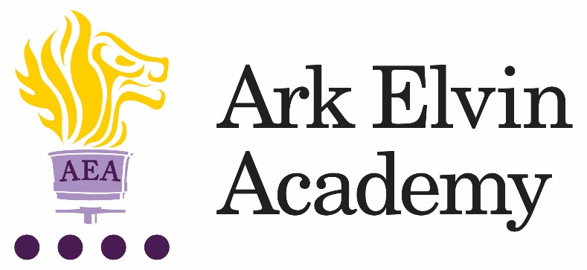

Head of Modern Foreign Languages (MFL)

At Ark Elvin Academy we are working hard to give all our pupils an excellent education and are looking for committed teachers and support staff to join us at this exciting stage in our school improvement journey. We are a large, non-selective secondary school in the London Borough of Brent, with excellent transport links to central London. We are committed to ensuring teachers can focus on teaching and have the opportunity to refine and develop their practice in the classroom and develop their leadership skills. Our new building works are underway and will be ready in December 2017, please visit our website www.arkelvinacademy.org to find out more about our new building.
We are looking to recruit a talented and creative head of MFL to deliver exceptional teaching and learning, develop the confidence and performance skills of our students and help them to achieve excellent results. We are looking for someone who will inspire and enthuse our students and establish a thriving MFL department at the heart of our school. The successful candidate will need to be able to teach French to KS4 and preferably KS5.
In recruiting for our Head of MFL we are seeking the following from applicants:
- A degree in languages, good A levels, or the equivalent
- A commitment to our school improvement process
- A growth mindset
- High standards of professionalism
- Courteousness
- Record of high quality teaching and evidence of supporting students to make beyond expected progress
- The potential to be an exceptional leader

You will become a part of a close knit professional community of enthusiastic teachers and benefit from guidance and support of experts from the Ark network, one of the country’s top performing school groups.

We encourage and welcome you to visit our school; to arrange a visit, please contact Venessa George on v.george@arkelvinacademy.org or 020 8902 6362.

For any technical queries about submitting your application, please contact the recruitment team on 0203 116 6345 or recruitment@arkonline.org.

To apply for the role, go to https://goo.gl/7MoKtv

Closing date: 11am, Friday 23rd June 2017
Start date: September 2017
Salary: Competitive (MPS Inner London + 2.5%) + TLR

Ark is committed to safeguarding children; successful candidates will be subject to an enhanced DBS check.
Job Description: Head of MFL

Reports to: Assistant Principal

The Role
Reporting to the Assistant Principal, the Head of Department is responsible for developing and leading an exciting curriculum which enables the highest level of pupil progress and attainment. The role involves managing the professional community of MFL teachers to ensure high attainment and to develop a love of learning in all pupils. The Head of MFL will be a member of a strong middle leadership team, making a significant contribution to the quality of learning and teaching across the academy, supporting our school improvement.

Key responsibilities
The full remit of the post will be negotiated dependent on the skills and experience of the candidate appointed. Specific responsibilities are subject to change.

The Subject Leader will take responsibility for the following specific roles within their wider role as a middle leader of the school:
- Coordinate MFL across the academy
- Lead the professional community of MFL teachers
- Plan, resource and teach MFL lessons and sequences of lessons to the highest standard that ensure real learning takes place and pupils make excellent progress
- Provide a nurturing classroom and academy environment that helps pupils to develop as learners
- Help to maintain discipline across the whole academy
- Contribute to the effective working of the academy

Academy Culture
- To support the academy’s values and ethos by contributing to the development and implementation of policies, practices and procedures
- To help create a strong academy community, characterised by consistent, orderly behaviour and caring, respectful relationships
- To help develop a school/department culture and ethos that is utterly committed to achievement and good discipline
- To be alert and active on issues relating to pupil welfare and child protection
- To support and work in collaboration with colleagues and other professionals in and beyond the school, covering lessons and providing other support as required.
Other
- To undertake , and when required, deliver or be part of the appraisal system and relevant training and professional development
- To undertake, within reason, other various responsibilities as directed by the Head of Department or Principal.
Person Specification: Head of MFL
Qualification Criteria
- Qualified to at least degree level in MFL languages
- Qualified to teach and work in the UK
Experience
- Evidence of being an outstanding teacher of the subject.
Knowledge
- Up to date knowledge in the curriculum area
- An understanding of what an outstanding education looks like in the classroom
- An understanding of the strategies needed to establish consistently high expectations
Behaviours
Leadership
- Effective team worker
- High expectations for accountability and consistency
- Vision aligned with Ark’s high aspirations, high expectations of self and others
- Genuine passion and a belief in the potential of every pupil
- Motivation to continually improve standards and achieve excellence
- Effective listening skills that lead to a strong understanding of others
- Commitment to the safeguarding and welfare of all pupils
Teaching and Learning
- Excellent classroom teacher with the ability to reflect on lessons and continually improve their own practice
- Effective and systematic behaviour management, with clear boundaries, sanctions, praise and rewards
- Thinks strategically about classroom practice and tailoring lessons to pupils' needs
- Understands and interprets complex pupil data to drive lesson planning and pupil attainment
- Good communication, planning and organisational skills
- Demonstrates resilience, motivation and commitment to driving up standards of achievement
- Acts as a role model to staff and pupils
- Commitment to regular and on-going professional development and training to establish outstanding classroom practice

Other
- Commitment to equality of opportunity and the safeguarding and welfare of all pupils
- Willingness to undertake training
- This post is subject to an enhanced Disclosure & Barring Service check

Ark is committed to safeguarding and promoting the welfare of children and young people in our academies. In order to meet this responsibility, we follow a rigorous selection process. This process is outlined here, but can be provided in more detail if requested. All successful candidates will be subject to an enhanced Disclosure and Barring Service check.

