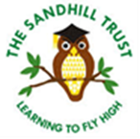
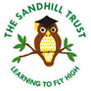
A Message from our School Council
“Learning to Fly High”
We think our school is brilliant and would be a great place for someone to work. We do lots of learning in lots of different ways. We always use a book to start our learning from, at the moment the books we’re working on at school are: The Three Little Pigs, Superworm and Arabian Nights.
We’ve got lots of space around our school: fields, playgrounds, wild forest areas and even courts to use. We really enjoy sport and loads of us do extra sporty things outside of school like dance, gymnastics, hockey, horse riding and football.
We try really hard to be a community and look after each other, our playground buddies always keep an eye out.
We think that Sandhill is really special and can’t wait to meet the new teacher.
Check out our work
http://sandhillschool.edublogs.org/
https://www.facebook.com/sandhillprimary/
Good Luck

