# College Information

## Ellesmere College is a special school situated on the south-west of Leicester city, near to Junction 21 of the M1 motorway. Leicester is a unique city and a wonderful place to work and live, with a superb range of visitor attractions and shopping that is second to none. It's a city that combines the finest English traditions with multicultural activities and the cosmopolitan buzz of city life.

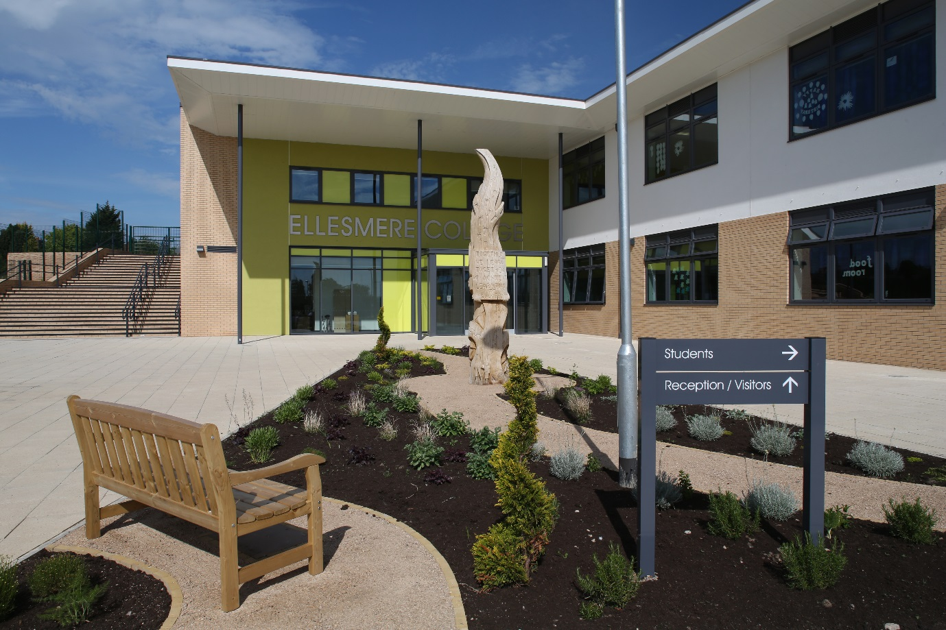

We currently have 251 pupils on role, and this will increase in the Autumn Term to 270. The pupils have a range complex learning needs, cognition and learning, communication and interaction and sensory needs. We teach pupils across all phases (4-19 years).

The college is one of eight special schools serving Leicester City, each with their own individual specialisms.

The college has a strong ethos and sense of purpose based on respect for staff, pupils and visitors.

**OFSTED**

Ofsted inspected the college in May 2017 and Ellesmere College was rated as good with many outstanding features. “Good teaching across a range of subjects and age ranges ensures that pupils make good progress, both in their academic work and in their personal development”.

**PUPILS**

Pupils live across the City, Rutland and Leicestershire, and most pupils are transported into college by minibuses or taxis.

We currently have 96 number of pupils who have a free school meal.

Pupils are taught in the following phases:-

Primary (EYFS, KS1, KS2) 31 Pupils

Phase 1 (KS3) 94 Pupils

Phase 2 (KS4) 57 Pupils

Post 16 69 Pupils

**COLLEGE STRUCTURE AND STAFFING**

The college will be led by a senior leadership team consisting of Principal, Acting Deputy, Assistant Principal, two Acting Assistant Principals and Strategic Resources Manager.

We employ approximately 130 staff as detailed below:-

Teachers (including SLT) 39

Teaching Assistants 59

Student Support Officers 3

Lunchtime Supervisors 5

Admin Staff 9

Premises Staff 8

Technicians 2

Kitchen Staff 5

**FACILITIES**

Ellesmere College moved into a fantastic new building in August 2014. It provides excellent facilities for our learners and we have extensive grounds.

In addition to classrooms and offices we also have:-

* Multi-purpose hall for assemblies, staff meetings, lunches and drama productions
* Café area
* ICT suite
* Two soft play areas
* Outdoor play areas for all phases
* Large gym
* Medical room
* Meeting rooms
* Horticultural area
* D & T workshop
* Cookery Room
* Sensory Rooms
* BMX track and cycle track
* Outdoor learning areas
* Access to 4G pitch.

Extensive use is made of local facilities, for example, further education colleges, off site providers, swimming pools, theatres, museums and other venues in the city/county.

**ASSESSMENT**

Ellesmere College uses B-Squared as a formative and summative assessment system which allows us to benchmark our pupils’ progress against national expectations. This assessment is supplemented by individual targets established through EHCP’s, PEP’s and other formal systems.

**PARENTS**

The overwhelming majority of the parents in the October 2016 survey said that they were really pleased with the college.

Comments from that survey include:-

“My child is happy, enjoys coming to school”

“Best news we have had on her progress”

“My child feels cared for by everyone”

“I think the school is excellent”

**COMMUNITY**

Ellesmere College has a strong and vibrant community programme which includes local community groups accessing the facilities during the evening, joint partnership arrangements for the management of the 3G pitch, and a PE and sport outreach programme across Leicester City, Leicestershire County Council and Rutland.

We also run a community café once a month and invite local residents to join us.

**PROFESSIONAL SUPPORT AND DEVELOPMENT**

A new Principal will have a mentor from the local authority to support their first month in post. Substantial and sustained support will come from the strong network of special school head teachers who meet monthly. Secondary and Primary head teachers also have strong associations, as well as area development groups where the heads of Special schools are welcome to participate.