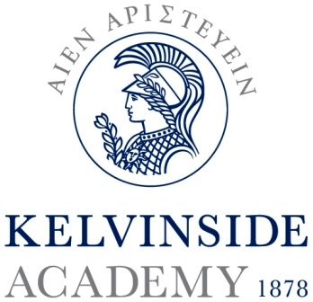
Kelvinside Academy

Founded in 1878, Kelvinside Academy is an independent, HMC co-educational day school for over 600 pupils aged from 3 to 18 in the West End of Glasgow. The school provides means-tested bursaries to enable families, who may not otherwise be able to afford the full cost of private education, to send children to the school. Kelvinside Academy combines high standards of teaching and a superb extra-curricular programme within an inclusive and caring ethos. Results in public examinations are well above the national average. Pupils are encouraged to take advantage of the many opportunities for personal development through sport, music, drama, outdoor pursuits and clubs and societies. Outdoor learning features throughout the curriculum, and in September 2017 the School will open its own Wilderness Campus within the Cairngorms National Park. For further information on the school, please visit our website: www.kelvinsideacademy.org.uk and social media channels, including: @Kelvinside1878.

Teacher of English
English operates within the Language Faculty which comprises English and Modern Languages (French and Spanish). The Faculty team of nine teachers is led by a Head of Faculty, and a Deputy Head with specific responsibility for delivery of the curriculum in Modern Languages.

All staff at Kelvinside Academy are expected to contribute to the extra-curricular life of the school. A willingness to become involved in the school community through sport, music, drama, outdoor pursuits or clubs and activities is essential. The salary is based on the SNCT scale and there is an additional KA allowance.

Applicants should be registered, or eligible for registration, with the GTCS. The successful applicant must also pass a PVG check with Disclosure Scotland.

Responsibilities
The successful applicant will be expected to:
- Build independent resourcing in response to the on-going needs of learners.
- Facilitate active learning and independence via imaginative approaches to teaching.
- Provide detailed and focused ‘next steps’ formative assessment of pupil work.
- Contribute to departmental development of pedagogy and collective practice.

An ability to teach Drama may be advantageous.

How to apply
The post is tenable from August 2017, however, a later start date will be possible for the right candidate. Applicants should send a completed application form and a covering letter to the Rector at the address below. The closing date for applications is noon on Monday 31 July 2017. Early applications are encouraged, and the School reserves the right to appoint before the closing date should a suitably qualified candidate present themselves.

33 Kirklee Road, Glasgow G12 0SW
Telephone: 0141 357 3376 Fax: 0141 357 5401
Email: rector@kelvinsideacademy.org.uk

