Application and Selection Process

This vacancy is for a Headteacher to start at the beginning of January 2018
(or as soon as possible thereafter).
The starting salary will be in respect of:
Group 2 ISR L14 – 20 (£53,712 - £62,240)
Your application form should be completed with reference to the job description and person specification, but we do ask that you limit your further information to two A4 pages.
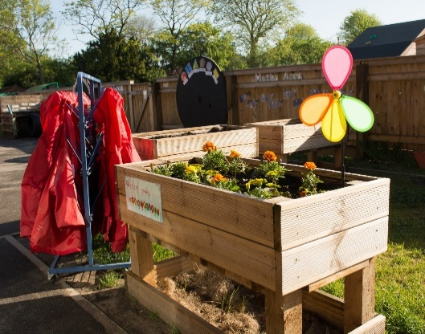
The selection panel will take into consideration the qualifications and skills of each applicant as well as their experience and personal attributes.
Key Dates
Closing date for application: Monday 18th September 2017 at 12 noon
Any application received after this date will not be accepted.

Shortlisting of applicants: Wednesday 20th September 2017
Candidates chosen for the shortlist will be notified as soon as possible afterwards. Unsuccessful applicants will also be notified.

Visits to school: Visits to school on the 8th or 12th September 2017 are warmly welcomed.
To arrange a visit please contact Diane Wadelin
DWadelin@woodendprimaryschool.co.uk
Telephone: 01902 558940

Assessment and Interviews: Tuesday 26th and Wednesday 27th September 2017. Successful candidates on day one will be invited to participate in day two

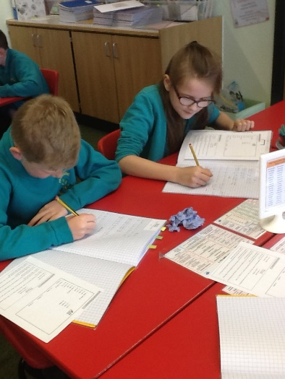
Full Governing Board decision: Wednesday 27th September 2017

Applications: Please return your completed application form, marked for the attention of:

Tracey Evans
Services4Schools
Midlands Technology Centre
Broadlands
Wolverhampton
WV10 6TA
Or via email to: Tracey.Evans@services4schools.org.uk

