APPOINTMENT OF A HEAD

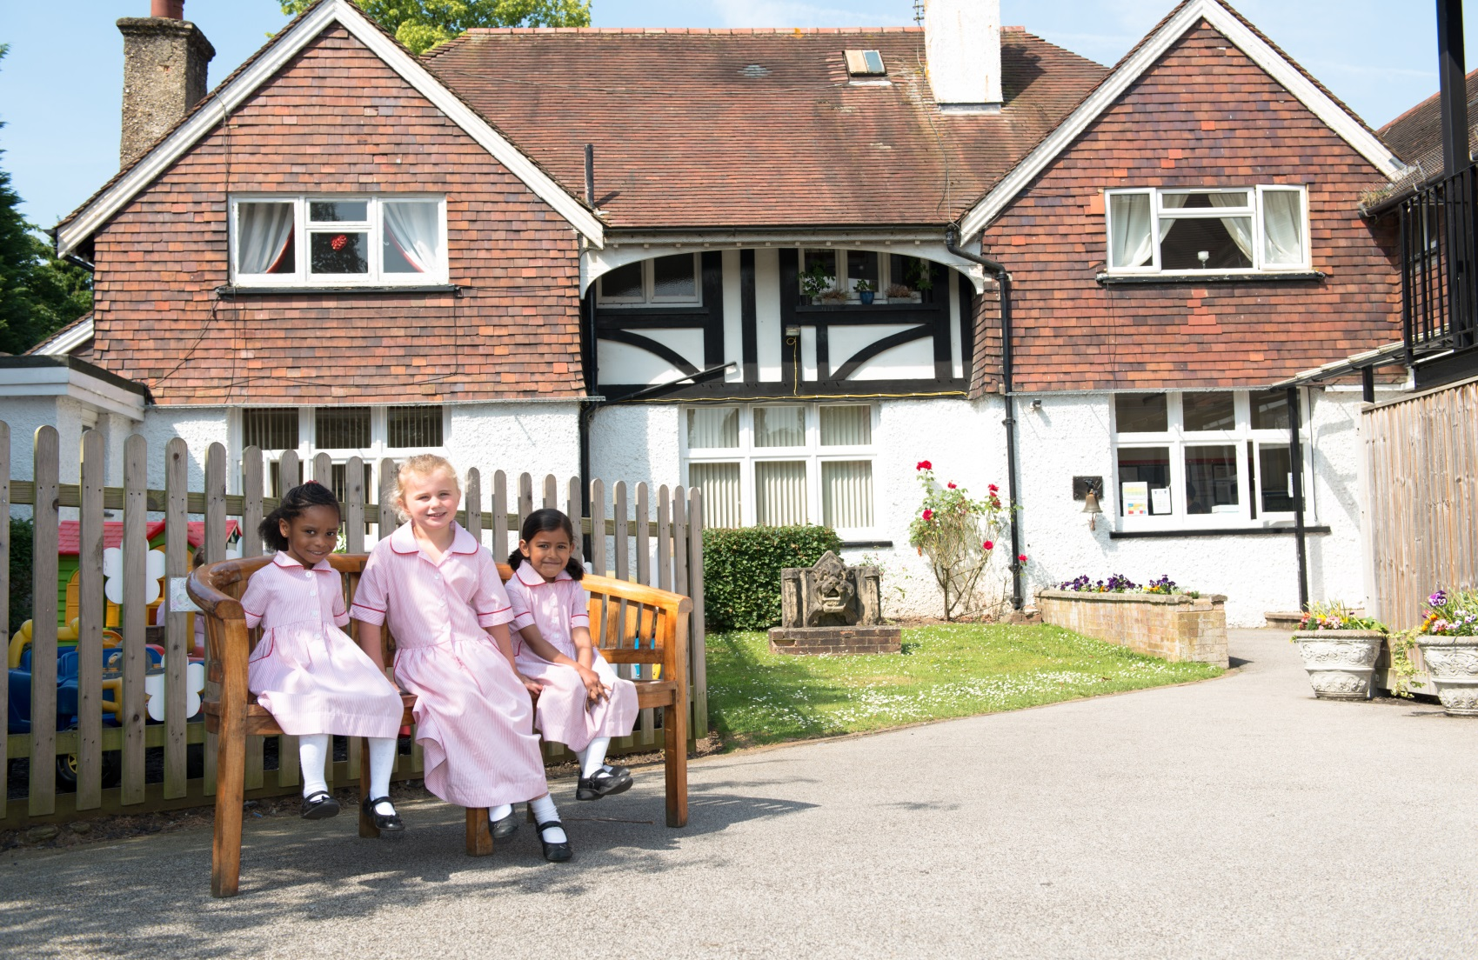

Cumnor House School
1 & 13 Woodcote Lane
Purley
Surrey
CR8 3HB
Cognita Schools
5-7 Diamond Court
Opal Drive
Eastlake Park
Milton Keynes
MK15 0DU
Executive Summary

Cumnor House School for girls is part of the Cognita family. Cognita is a group of independent schools that are all very different and we value these differences. Our schools share our commitment of, ‘inspiring and empowering children within a caring environment to achieve more than they believe possible’. We underpin our work by continually striving to live out the following values: excellence, respect, integrity, collaboration and accountability.

Our commitment to children is driven by our mantra of ‘Teaching Excellence’. We understand the difference that great teaching makes and know that teachers are central to unlocking the potential of every child in each school. If you are passionate about driving high standards and are uncompromising in your pursuit of high expectations please consider applying. It goes without saying that there is an expectation that every leader is fully committed to ensuring that our schools are safe and compliant in every aspect of their work.

We value authenticity – matching one’s actions with one’s words is arguably the most respectful quality in a headteacher. Integrity and a drive to achieve very high standards are key qualities for this role. You will be someone who embodies these. You will have a strong belief in the power of reflection and professional development, leading a team that continually evaluates and looks for improvements. Moreover, your loyalty to the school and to the Cognita family will be instrumental in your effective leadership and your close working relationships.

We are particularly keen to read in your application about who you are and how you will maintain the excellent standards at Cumnor House School for Girls; at the same time driving forward our core business – the quality of teaching. Please give us examples from your career and your life which exemplify your educational philosophy. We are looking to appoint an individual who thinks for themselves and is a strong and authentic leader. To succeed in the position you will have the intellect and people skills to know when and how to implement change. Your determination to work with colleagues to improve teaching will drive you; at the same time, you will not condone mediocre practice.

Cognita
Our purpose

Inspiring and empowering children within a caring environment
to achieve more than they believe possible

Since Cognita’s launch in 2004, we have built an international family of 68 schools that serve approximately 30,000 pupils across the UK, Latin America and Asia. Cognita is proud to be one of the largest and most successful school operators in the world.
Our schools are unique, each being a special and distinctive learning community. Parents choose our schools because of their difference and ability to meet the needs of their children. Underpinning these distinctive features are three key ingredients of a Cognita Education:
Academic | Pursuing academic excellence for every child
Character | Developing character
Global | Connecting with a global community

Cognita’s commitment to children is driven by teaching excellence. Cognita’s commitment to its staff is equally strong, and the group offers first class career opportunities with a global dimension.
The Cognita Way underpins teaching excellence with energised leadership, innovation, personalised learning, brilliant basics, people growth and by fostering the community.
Energised leadership  Leadership which inspires success for all in the school community | Innovation  Constant and never ending improvement | Personalised learning  Putting students and their needs first, now and in the future
Teaching Excellence

People growth  Attracting, developing, retaining and caring for great people | Community  Flourishing and productive relationships with all stakeholders | Brilliant basics  Embedding systems and structures that make the organisation safe, compliant and effective
As an important member of the School’s team, we hope you will find us an enjoyable and rewarding Company to work for. We aim to achieve this by;
- helping you to get to know your colleagues quickly;
- enabling you to contribute your particular strengths within your team; and
- developing new skills so that you continue to learn and grow as you build your career with us.
For more details about Cognita please visit our website.
Governance and Leadership

Cognita is the proprietor of Cumnor House School for Girls. As such, Cognita has the legal responsibility and accountability for ensuring that the School is compliant, demonstrating the highest standard of pupil safety, quality of education and effectiveness in all areas of school life.
Cognita schools do not have governing bodies. However they all have strong and established governance arrangements.
Each school has a nominated Assistant Director of Education (ADE). Each ADE works with a group of schools. The ADE is the line manager of the Head and represents the proprietor as the Chair of Governors. ADEs are a critical friend to the Head, supporting with a drive to ensure that each school is the very best it can be. Each ADE has a respected track record as a Headteacher and most of the team also have inspection experience.
The ADE for Cumnor House School for Girls is Robin Davies
Safeguarding governance visits are held at each school to evaluate the quality of safeguarding for our children. During these visits, the safeguarding reviewer will speak with the Head, Designated Safeguarding Lead, Educational Visits Coordinator and other staff, as well as always talking to groups of children. The safeguarding reviewer also scrutinises the Single Central Record.
Role Profile

Cumnor House School for Girls is one of two schools under the umbrella of Cumnor House School, the other being Cumnor House School for Boys, which includes the Cumnor House Nursery. The Head of Cumnor House School for Girls is expected to work in tandem with the Head of Cumnor House School for Boys to forward educational, pastoral, operational, commercial and regulatory provision. He or she will be responsible for leading a school which is entirely compliant and provides a safe learning environment for students and staff in addition to providing inspirational leadership which ensures continuing improvement with a focus on delivering Teaching Excellence to accelerate and sustain excellent pupil progress.
The job holder’s responsibility for promoting and safeguarding the welfare of children and young person’s for whom s/he is responsible, or with whom s/he comes into contact will be to adhere to and ensure compliance with the relevant Cognita Safeguarding; Child Protection Policy and Procedures at all times. If in the course of carrying out the duties of the role, the job holder identifies any instance that a child is suffering or likely to suffer significant harm either at school or at home, s/he must report any concerns to the School’s Child Protection Officer/Designated Safeguarding Lead or to the Head or indeed to the Regional CEO so that a referral can be made accordingly to the relevant third party services.

More specifically, the key roles and responsibilities of the Head are:
Setting direction
- Create and communicate a clear sense of purpose and direction for Cumnor House School for Girls for implementation alongside that of Cumnor House School for Boys.
- Translate the vision into a clear Strategic Plan which all stakeholders, including counterpart and colleagues at Cumnor House School for Boys, understand and see their place in; this includes the setting of educational and commercial objectives.
- Foster a shared drive to improve and sustain high aspirations and outcomes for pupils.
- Monitor and evaluate the impact of the agreed vision to ensure impact on pupil provision, pupil outcomes and commercial outcomes.
- Ensure that teaching excellence and high achievement are at the heart of all strategic and improvement planning.
- Lead through high expectation and aspiration - being prepared to challenge mediocrity and under-performance.
- Demonstrate and model commitment to Cumnor House School for Girls, Cognita, the pupils, the parents and the community.
- Collaborate with others outside the School to achieve goals.
- Lead a ‘customer focused’ school which listens to parents and pupils in order to improve the offer.

Leading teaching, learning and assessment
- Build and maintain a professional learning community focused on improved pupil outcomes.
- Implement strategies which secure high standards of teaching and learning.
- Expect a collaborative approach between members of both Boys’ and Girls’ Schools to maximise learning quality and opportunity
- Embed a broad, balanced and enriching curriculum which is assessed against its impact on learning, enjoyment and progress.
- Maintain a safe, stimulating and responsive learning environment.
- Ensure that assessment (summative and formative) is fit for purpose and impacting on progress.
- Ensure a rigorous focus on pupils’ achievement, using data and assessment tools to monitor pupil progress and challenge under-achievement.
- Develop other staff as leaders of teaching, curriculum and assessment.
- Lead the engagement of parents and families in supporting learning and progress.
- Monitor and evaluate classroom practice to celebrate excellence, challenge under-performance and develop a self-evaluative improvement culture.
- Embed and sustain effective systems for the management of pupil behaviour, including pastoral care and an effective anti-bullying policy.
Compliance and safeguarding
- Develop and maintain a culture which embeds safeguarding as part of the life of the School for every student.
- Ensure that Cumnor House School for Girls, on level terms with Cumnor House School for Boys, complies with all national, local and Cognita safeguarding requirements.
- Ensure that the child protection, safeguarding and health & safety policies and procedures are fully implemented and followed by all staff.
- Ensure that sufficient resources and time are allocated to enable staff to discharge their child protection related responsibilities effectively.
- Ensure that the School meets all requirements for a fully trained staff in relation to safeguarding and child protection, educational visits and health & safety.
- Take overall responsibility for the health, safety and welfare of all pupils, staff, parents and other visits to the School site.
- Ensure that Cumnor House School for Girls is consistently compliant with all statutory regulations and requirements, including the Independent School Standards Regulations, as amended.
Developing self and others
- Maintain a consistently visible approach within the School, modelling quality for others.
- Maintain an effective and productive working relationship with the Head of Cumnor House School for Boys
- Develop staff as leaders in order to build capacity for improvement.
- Lead a collaborative/team approach to improvement.
- Review own practice, set personal targets and take responsibility for own development; including taking account of feedback from others.
- Use performance management systems to challenge and develop self and others.
- Challenge under-performance, at all levels.
- Embed a professional development programme which meets the needs of all members of Cumnor House School and of individual improvement.
Developing the organisation
- Maintain an organisational and staffing structure which enables effective and efficient operational practice.
- Recruit, retain, develop and deploy staff appropriately and effectively.
- Manage, monitor and evaluate human, physical and financial resources effectively to achieve the targets of the strategic and improvement plan.
- Manage personnel to ensure that all HR requirements are met in full.
- Provide written and oral reports linked to resource management to a range of audiences.
Securing accountability
- Ensure that all staff and volunteer roles are clearly defined, understood and agreed; and that individuals are held to account.
- Ensure that the improvement plan, in parallel with that of Cumnor House School for Boys is aligned with Cognita priorities and well communicated to all stakeholders.
- Provide written and oral accounts of school performance to a range of audiences.
- Ensure that high quality communication is maintained within and beyond the School and with all stakeholders.
- Ensure that Cumnor House School for Girls has up-to-date policy and procedure documents in place, in line with Cognita guidance – and that these are communicated effectively to staff and volunteers.
- Hold staff to account in relation to safeguarding, the quality of teaching, curricular delivery, pupil outcomes and contribution to the life of the School.
Strengthening community
- Maintain the inclusive, family values of Cumnor House School for Girls as part of the wider Cumnor House community; including the promotion of British values.
- Create and sustain partnerships with parents to support and improve pupil achievement and well-being.
- Actively promote the School to current and prospective parents.
- Build the reputation of Cumnor House School for Girls and ensure that it is represented positively.
- Work with other agencies and individuals to promote learning beyond the School.
- Collaborate in Cognita-wide initiatives.
- Build and maintain links with schools and organisations, especially in relation to feeder schools and destination schools.
Equality and equity
- Ensure that Cumnor House School for Girls reflects a vibrant and inclusive ethos which actively values and promotes diversity, community cohesion, and supports pupils to become successful and rounded citizens.
- Actively challenge and address all forms of discrimination.
- Ensure that monitoring takes account of different pupil groups and data is used to close gaps; ensuring equity for all pupils.
Inspection and improvement
- Lead all requirements regarding inspection and external reviews; ensuring that the School is fully compliant with all current requirements.
- Maintain an effective working relationship with the designated Education Executive.
Commercial
- Lead and manage the commercial aspects of the School in conjunction with the Business Manager who also oversees Cumnor House School for Boys finances,
- Take responsibility for the recruitment and retention of pupils.
- Manage budgets, identifying cost saving initiatives which maintain standards of excellence.
- Review staffing structure to support educational delivery.
- Ensure efficient fee collection, driving the collection of any bad debt.
- Identify commercial development opportunities.
Requirement of all roles
- Actively support and model the Cognita values: Excellence, Respect, Integrity, Collaboration and Accountability.
- Undertake such additional duties as may reasonably be requested by the Chief Executive or their representative.
- Respect confidentiality of staff, pupils, families and visitors and not breach this trust.
- Participate in arrangements for performance management and in the identification of areas in which s/he would benefit from training and undergo such training.
- Proactively keep abreast of developments in relation to the post, and whenever possible and appropriate, attend professional development opportunities.
- Comply with and support all policies of Cognita and the School.
- Ensure that all statutory requirements and compliance requirements are met.
This job description is not exhaustive and may be changed at any time to meet the changing requirements of Cumnor House School for Girls or Cognita. This job description details responsibilities but does not direct any particular priorities or amount of time to be spent carrying out these duties.

Person Specification

We are seeking an inspirational, energetic and compassionate leader who can engage pupils, staff, parents and all other key stakeholders in maintaining and developing Cumnor House School for Girls as part of Cumnor House School within the Cognita group, as the successful school it is today .
The successful candidate will therefore possess the following:
- Integrity, humility, approachability and the highest aspirations for staff and pupils.
- A sense of humour which is complemented by a professional dignity and authentic approach.
- A good university degree.
- A dynamic and enthusiastic approach to leading the education of young people.
- Substantial experience across a broad range of educational activities.
- Knowledge of safeguarding and other child related legislation.
- Proven leadership of a diverse group, demonstrating success in an open and supportive learning environment.
- The ability to develop, implement and monitor strategic plans and change management to raise school standards.
- The ability to collaborate across school settings, in particular with counterpart at Cumnor House School for Boys
- The ability to adapt to the environment and audience, demonstrating experience of engaging and building effective communication with parents, pupils, staff and other third party stakeholders.
- Strong people management skills with the ability to build a team approach with particular experience of human resource processes: recruitment, development, retention and performance management.
- Successful experience of or the capacity to supervise operational management e.g. financial, marketing, etc.
- A conscientious attitude and professional work ethic with the ability to meet flexible deadlines.
- Outstanding teaching practice.

How to Apply

Applicants must submit a completed application form and covering letter of no more than two A4 sides.
A salary package commensurate with the skills and experience of the person applying will be offered.

