

**Raine’s Foundation School**

**Headteacher Information Pack**

**‘Achieving Excellence by Unlocking Potential’**

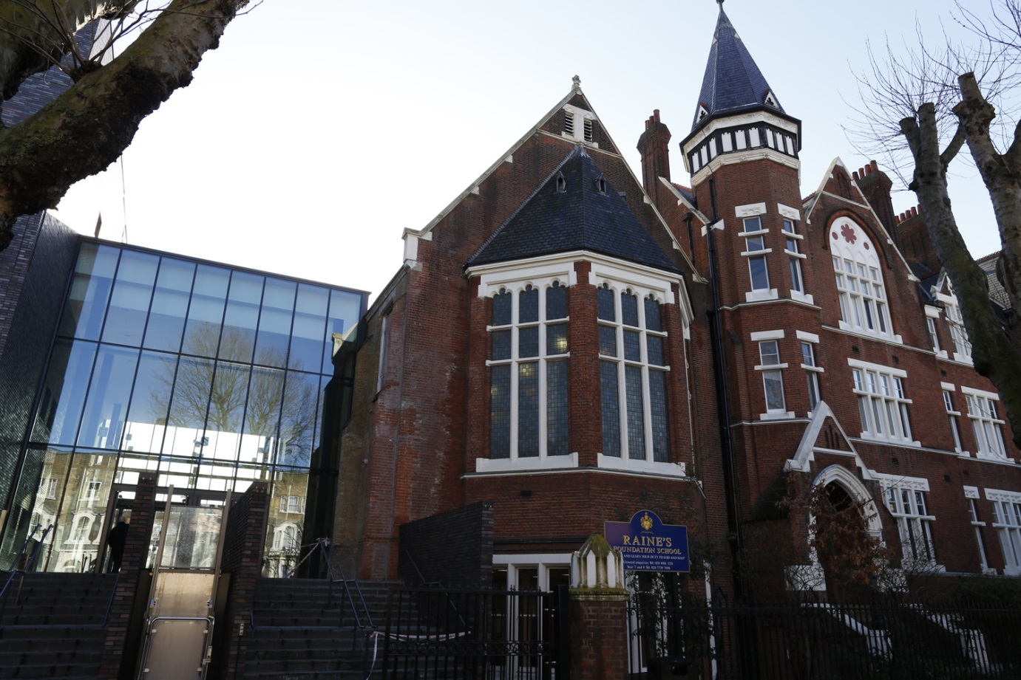

****INTRODUCTION**

Raine’s Foundation Church of England Secondary School is an all ability co-educational school for girls and boys aged 11-19. The School is rightly proud of its long tradition of achievement within a Christian ethos and **welcomes pupils from all faiths and those with none**. We are a local school for local children.

Raine’s Foundation School is one of the oldest schools in London and has played an important role in the East End for nearly 300 years. Our location in the London Borough of Tower Hamlets, on the edge of the City, gives us access to all the curriculum and enrichment opportunities central London has to offer. We are very well served by public transport.

We are an improving school as we strive towards our goal of ‘Achieving Excellence by Unlocking Potential’

Our aim at Raine’s is to ensure that all our pupils can be the best they can be, every day, ensuring they achieve their potential in all aspects of life

Contents

Letter from Chair of Governors

School history

Vision, values and ethos

OFSTED

Job description

Person Specification

Visiting, how to apply and selection process

**

Dear Candidate,

I am delighted that you are interested in the post of Headteacher at Raine’s Foundation School.

In the last twenty months the school staff and governors have worked hard to bring about improvements in every aspect of school life. There are now exciting plans for the next stages of development and we are looking for someone who shares our vision for the future but will also recognise the importance of treasuring the past history of the school and Raine’s Foundation in order to provide a wealth of opportunities for the pupils of the school.

The staff of the school have been extremely positive and loyally embraced the necessary changes. There is a welcoming atmosphere in the school and pupils recognise the quality of the care that is offered to them and trust the staff to be mindful of them.

Over the last few years numbers have declined but we are confident that the new and revitalised school will quickly begin to fill up and become 6FE once more.

There is a good Sixth Form with two students this year getting into Cambridge; students not pursuing the university route have gained prestige placements in successful companies.

The school is ready to move forward and the governors seek someone who shares their optimistic and positive approach and will be completely committed to raising standards and providing students with a happy and successful secondary education.

I hope that you will feel that this is a journey you would like to share with us. I am confident you will find it both exciting and worthwhile.

Yours faithfully

EW sig

Elizabeth Wolverson

Chair of Governors

**

**HISTORY AND RAINE’S SCHOOL FOUNDATION**

Henry Raine was a wealthy brewer from Wapping; he was a pious Churchman, highly respected in the community. In 1719, Henry Raine allocated part of his wealth to found Raine’s Foundation School which was to provide and education for 50 boys and 50 girls from the local area.

Henry Raine died a rich man in 1738, he stipulated that his wealth be invested for the benefit of Raine’s School and its pupils. In his will, Henry Raine also provided for two marriage portions of £100 to be drawn by lot each year for girls aged 22 and above who could produce certificates of good character from former masters and mistresses, and whose husbands were suitable members of the Church of England from the parishes of St George-in-the East. He specified that six small tickets or pieces of paper of equal size should be rolled and sealed up, in one of which should be written "the sum of one hundred pounds", the other five to be blank, and being all put into a tin canister for the draw – (the school still has the canister.) The Foundation stopped providing for marriages long ago, but now gives bursaries to former students to help them to continue their education



**

**VISION, VALUES AND ETHOS**

We seek to realise Henry Raine’s vision in the 21st century and ‘achieve excellence by unlocking potential’ for young people in our local community.

At Raine’s Foundation School we believe in:

* Providing a caring school community based on Christian morals and values that safeguard the welfare of all
* Providing high quality teaching and learning to enable all students to maximise their potential
* Creating a stimulating, rich and engaging curriculum tailored to meet the needs of the individual
* Being outward facing and working in partnership with parents, carers, the local community, diocesan board and local authority
* Encouraging students to participate in decision making, enabling them to become responsible, compassionate and empathetic
* Supporting students’ personal development through their journey to higher education and employment



**

**OFSTED AND SCHOOL IMPROVEMENT**

We have made rapid progress since OFSTED judged us to require improvement in November 2015.

The HMI monitoring visits in May 2016 and June 2017 found that

|  |
| --- |
| *“Senior leaders and governors are taking effective action to tackle the areas requiring improvement identified at the last section 5 inspection in order to become a good school.”*  In May 2016 HMI noted particularly that |

*“Senior leaders and governors speak of an absolute focus on school improvement.”*

*“The governors have established a targeted intervention group which meets monthly. This is a small group of governors with a high level of educational experience and skills. As a result, they have been able to bring about change rapidly.”*

*“There has been significant work on behaviour for learning since the last inspection.”*

*“Leaders display an unrelenting focus on ensuring minimum standards for pupils’ presentation of work in books and on the provision of helpful feedback by teachers. Increased monitoring activities have resulted in much-improved consistency in these areas.”*

*“Since the last inspection, there has been significant support from the new governing body.”*

Additionally in June 2017 HMI reported

*“Attendance has improved significantly this year and is now in line with the national average. This is due to a number of strategies, including an effective mentoring system, which encourage pupils to attend regularly.”*

*“The local authority has provided consistently good challenge and support.”*

**JOB DESCRIPTION - HEADTEACHER**

**JOB PURPOSE:** To provide excellent leadership for Raine’s Foundation School, creating, maintaining and developing the conditions which ensure high quality education for all pupils and the highest standards of learning and achievement in accordance with statutory requirements. As Raine’s Foundation is a Church of England school, the Headteacher will be required to uphold and embed the school’s Christian ethos and values within day-to-day working practices.

**RESPONSIBLE TO:** The Governing Board of Raine’s Foundation School.

The duties outlined here are linked to

* Those covered by the *National Standards of Excellence for Headteachers* (DfE 2015) and are outlined under the four Excellence As Standard domains
* Those covered by the latest School Teachers’ Pay and Conditions document which should be read in conjunction with this document.

Other duties include:

* Achieving any performance criteria, objectives and targets agreed with, or set by, the school’s Governing Board

**ACCOUNTABILITY:**

The Headteacher is legally and contractually accountable to the Governing Board of Raine’s Foundation School.

The Headteacher will

* Work closely with and provide information, advice and support to the Chair of Governors and Governing Board to enable it to meet its responsibilities
* Ensure that parents and pupils are well informed about curriculum attainment and progress and are able to understand targets for improvement
* Ensure individual staff accountabilities are clearly defined, understood and agreed and are subject to rigorous review and evaluation through performance management
* Develop and present an accurate account of the school’s performance to a range of audiences including governors, parents and carers, Children’s Services, The Local Authority, London Diocesan Board for Schools and Ofsted, to enable them to play their part effectively
* Ensure all legal requirements, including for health and safety, safeguarding, maintenance and financial management are fulfilled

**KEY PRIORITIES:**

* Value each individual pupil and enable them to reach their full potential within a stable, committed school community
* Develop the school so that it is outstanding in every respect
* Demonstrate commitment to the distinctive ethos of a church school in a diverse community, building understanding between those of different faiths and beliefs
* Set and maintain high standards and expectations of teaching and learning for all staff
* Inspire and promote a curriculum expanded beyond the confines of traditional academic subjects in order to boost pupil achievement
* Promote proactive involvement of the whole school in the safeguarding of pupils

**LEADERSHIP AND ETHOS**

The Headteacher will:

* Hold and articulate clear values and moral purpose, focused on providing a world-class education for the pupils they serve
* Promote the school’s ethos and vision, ensuring, with the governing board, that there is a shared set of values formed by consultation with all stakeholders and embedded into day to day practice
* Lead by example and create a shared commitment and responsibility to the school through teamwork, distributed leadership and professional reflection
* Establish and implement a strategic plan that inspires and motivates all stakeholders, and reflects the needs of the school and its community
* Work with political and financial astuteness, within a clear set of principles centred on the school’s vision
* Be able to translate local and national policy into the school’s context, anticipating local, national and global trends in education
* Pursue continuous professional development so as to sustain wide, current knowledge and understanding of education and school systems locally, nationally and globally
* Forge positive relationships and attitudes towards and between pupils and staff, and with parents, governors, Raine’s Foundation and members of the local community
* Demand ambitious standards for all pupils, overcoming disadvantage and advancing equality, instilling a strong sense of accountability in staff for the impact of their work on pupils’ outcomes
* Establish a culture that supports and facilitates pupil engagement in, and ownership of, their own learning
* Provide a safe, calm and well-ordered learning environment for pupils and staff, focussed on safeguarding pupils and developing their exemplary behaviour in school and in the wider society
* Create an environment within which all staff are motivated and supported to develop their own skills and subject knowledge, and to support each other
* Identify emerging talents, coaching current and aspiring leaders in a climate where excellence is the standard, leading to clear succession planning
* Implement strategies to secure high standards of behaviour and attendance

**SYSTEMS, PROCESSES AND RESOURCES**

The Headteacher will:

* Assist the governing board and ensure that the school’s systems, organisation and processes are well considered, efficient and fit for purpose, upholding the principles of transparency, integrity and probity;
* Welcome strong governance and actively support the governing board to understand its role and deliver its functions effectively
* In partnership with the governing board, set appropriate priorities for expenditure within a balanced budget and ensure efficient financial and administrative controls are maintained through regular monitoring
* Exercise strategic, curriculum-led financial planning to ensure the equitable deployment of budgets and resources, in the best interests of pupils’ achievements and the school’s sustainability
* Develop and maintain rigorous, transparent systems for the induction, professional development and performance review for all staff, addressing any under-performance, supporting staff to improve and valuing excellent practice
* Distribute leadership throughout the organisation, forging teams of colleagues who have distinct roles and responsibilities and hold each other to account for their decision making
* Regularly evaluate the allocation of roles, responsibilities, finance, school site and resources to ensure these underpin the best possible learning environment

**LEADING SCHOOL IMPROVEMENT**

The Headteacher will:

* Maintain the school’s focus on pupils’ achievement, using assessment information and benchmarks to monitor progress in every pupil’s learning
* Secure excellent teaching through an analytical understanding of how pupils learn and of the core features of successful classroom practice and curriculum design and monitor and evaluate the effectiveness of the curriculum to ensure it is providing the best opportunity for pupils to enjoy and achieve their potential, whilst providing financial value
* Create an outward-facing school, developing the partnership work with other schools and organisations – in a climate of mutual challenge – to champion best practice and secure excellent achievements for all pupils
* Develop effective relationships, and actively engage with fellow professionals and colleagues in other public services, including the local authority and London Diocesan Board for Schools and, where required, teachers’ unions, to improve academic and social outcomes for all pupils
* Promote positive strategies for challenging prejudice and building community cohesion

**SAFEGUARDING AND PROMOTING THE WELFARE OF PUPILS**

The Headteacher will: ensure that all statutory and advisory duties regarding safeguarding are in place and robustly monitored and will:

* Work with governors and senior colleagues to recruit, induct and develop high-quality staff within safer recruitment guidelines
* Ensure safeguarding policies and procedures are implemented rigorously and reviewed at regular intervals
* Ensure that all teaching, support staff and volunteers are fully inducted in school safeguarding procedures
* Ensure that the Designated Safeguarding Leader is given the appropriate resources to carry out the duties of the role effectively

**PERSON SPECIFICATION – HEADTEACHER**

*Please address the aspects under the headings below in your supporting statement of no more than 3 A4 pages (Arial font 12)*

*If you have not been in a classroom for a period of time we ask you to address your proven skills in the leadership of teaching and learning.*

|  |  |  |  |  |  |
| --- | --- | --- | --- | --- | --- |
| **CRITERIA** | **Essential/ desirable** | |  | **Assessed by application/ interview process** | |
| **EDUCATION, TRAINING AND QUALIFICATIONS** | | | | | |
| Honours degree or equivalent |  | **•** |  | **•** |  |
| Qualified Teacher Status | **•** |  |  | **•** |  |
| National Professional Qualification for Headteachers (NPQH) |  | **•** |  | **•** |  |
| Evidence of a commitment to continuing professional development so as to sustain up-to-date knowledge and understanding of education | **•** |  |  | **•** | **•** |
| Evidence of continuing and relevant professional development in school leadership and management | **•** |  |  | **•** | **•** |
| **QUALITIES** | | | | | |
| Commitment to the distinctive ethos of Voluntary Aided CE school | **•** |  |  | **•** | **•** |
| Member of a Christian Church |  | **•** |  | **•** | **•** |
| Evidence of clear values and moral purpose which place pupils at the heart of all decisions | **•** |  |  | **•** | **•** |
| Demonstrating personal behaviour consistent with the school ethos and vision | **•** |  |  | **•** | **•** |
| Commitment to a curriculum that is creative and relevant to the interests and needs of all pupils, including their well-being | **•** |  |  | **•** | **•** |
| Absolute commitment to ensuring the safety and well-being of pupils | **•** |  |  | **•** | **•** |
| Proven record of being transparent and accountable to parents, governors, relevant external bodies and the local community | **•** |  |  | **•** | **•** |
| **KNOWLEDGE** | | | | | |
| Knowledge of up to date legal requirements affecting schools | **•** |  |  | **•** | **•** |
| Evidence of a current knowledge and understanding of local, national and global education | **•** |  |  | **•** | **•** |
| **KEY SKILLS AND EXPERIENCE** | | | | | |
| Proven successful experience as a Headteacher or Deputy Headteacher in a secondary school | **•** |  |  | **•** | **•** |
| Experience of teaching in more than one school across the whole secondary age range including in a Voluntary Aided school |  | **•** |  | **•** | **•** |
| Experience of leading in a school which serves a challenging urban environment |  | **•** |  | **•** | **•** |
| Experience as Designated or Deputy Designated Safeguarding Lead |  | **•** |  | **•** | **•** |
| A highly effective teacher with proven consistent good/outstanding teaching in the secondary classroom | **•** |  |  | **•** | **•** |
| Knowledge and understanding of how to maintain and raise the quality of teaching and learning across the school and a proven track record for doing so | **•** |  |  | **•** | **•** |
| **LEADERSHIP AND COLLABORATION** | | | | | |
| Able to build, communicate and implement a coherent vision for the school in consultation with all stakeholders | **•** |  |  | **•** | **•** |
| Evidence of a drive to encourage and pursue excellence in all aspects of school life and a clear sense of what strategies might be effective for achieving this | **•** |  |  | **•** | **•** |
| Proven ability to lead by example and create a shared commitment and responsibility to the school through teamwork, distributed leadership and professional reflection | **•** |  |  | **•** | **•** |
| Proven ability to build a culture where pupils feel confident that their concerns will be listened to and acted upon | **•** |  |  | **•** | **•** |
| Proven ability to adapt to change, able to assess new ideas and embrace them if they improve pupils’ learning | **•** |  |  | **•** | **•** |
| Ability to encourage parents to play their part in their child’s learning (both in and out of school) | **•** |  |  | **•** | **•** |
| Proven experience of building mutually beneficial and supportive relationships with other schools, agencies and groups, including the local authority and diocesan board | **•** |  |  | **•** | **•** |
| Knowledge and experience of working productively with the governing body and an understanding of its statutory duties | **•** |  |  | **•** | **•** |
| **MANAGEMENT OF PEOPLE AND RESOURCES** | | | | | |
| Proven experience of managing people, including staff performance reviews and supporting ongoing professional development | **•** |  |  | **•** | **•** |
| Proven experience of prioritising, setting and managing a range of processes to contribute to school improvement (data, finance) | **•** |  |  | **•** | **•** |
| Excellent organisational skills which maintain the smooth running of the school whilst maintaining a focus on the long term vision | **•** |  |  | **•** | **•** |
| **PERSONAL CHARACTERISTICS** | | | | | |
| Physically able to do the job | **•** |  |  | **•** | **•** |

**

**VISITING, HOW TO APPLY AND SELECTION PROCESS**

Prospective candidates are welcome to visit the school before making an application. Visits will be held on 21 September (afternoon) and 26 September (morning). Please contact Alison Deady on 020 8981 1231 or [a.deady@rainesfoundation.org](mailto:a.deady@rainesfoundation.org).uk to make arrangements to visit.

Please email completed application forms and supporting statements to [a.adeady@rainesfoundation.org](mailto:a.adeady@rainesfoundation.org).uk

The closing date and time for receipt of applications is 12 noon on Friday 29 September 2017.

It is anticipated that interviews will be held on Tuesday 10 October and Wednesday 11 October.

