

WELCOME TO

RICARDS LODGE HIGH SCHOOL

LAKE ROAD WIMBLEDON LONDON SW19 7HB

T: 020 8946 2208 F: 020 8879 6801

E: office.manager@ricardslodge.merton.sch.uk

www.ricardslodge.merton.sch.uk

www.rr6wimbledon.org


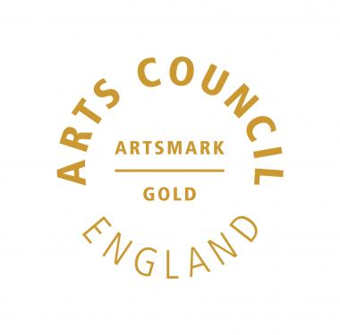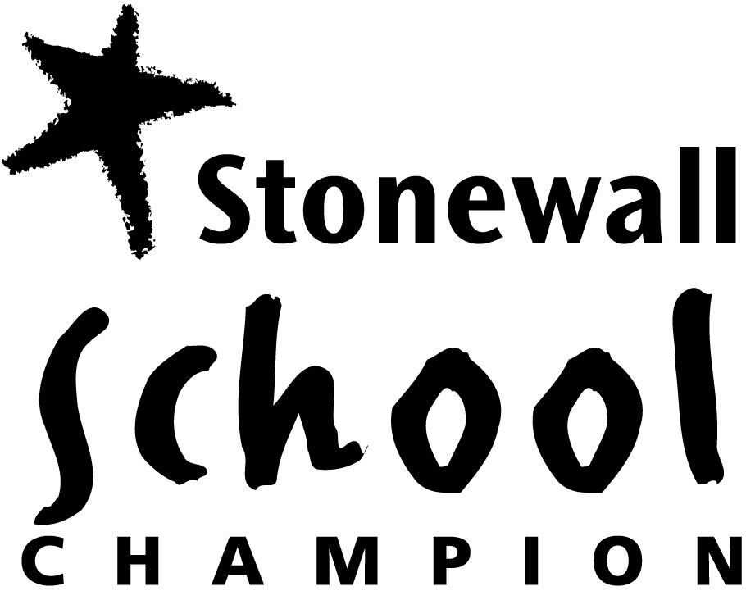

RICARDS LODGE HIGH SCHOOL / RR6

ABOUT OUR SCHOOL

EDUCATING SUCCESSFUL WOMEN OF THE FUTURE

Ricards Lodge is a successful, vibrant and innovative school with a tradition of academic excellence, catering for girls between the ages of 11-16, with a co-educational 6th form. We have opened our new sixth form, RR6, with a range of academic and applied courses on offer, set in a state of the art 6th form block. This provision runs jointly with Rutlish School. We have high expectations of our students, valuing and respecting the unique qualities each brings. We provide a dynamic and stimulating environment in which they learn and develop as individuals. Our staff are committed to delivering a high quality educational experience, emphasising academic excellence supported by personal growth and development.

We consider ourselves fortunate that our new and refurbished buildings and facilities provide us with excellent resources for learning, including a new teaching block, sports hall and all weather Astroturf pitch. We regularly review our provision for ICT to ensure we’re keeping up to date. We have an impressive and well-stocked Resource Centre open for study before, during and after school.

We are privileged to be such a diverse school and we are proud of the harmony that exists between us all. We believe that our curriculum and extra-curricular activities give us the opportunity to prepare our girls to take their place in the changing global society.

We have forged good links with the wider community in which we work and are always looking for opportunities for our girls to benefit from these links. We work in partnership with other high achieving and some independent local schools so we can pool and develop our knowledge and expertise to provide opportunity and enrichment.

Our Aims

- To ensure that all our students are able to take full and equal places as women, who take opportunities and assume responsibility in a changing global society.

- To deliver to all our students a broad, balanced and flexible curriculum irrespective of ethnicity, class or ability.

- To provide a stimulating secure and purposeful environment in which each student is motivated to strive for excellence in both academic achievement and personal growth.

- To work together in an effective partnership with parents, governors and the wider community.

SUPPORT AND DEVELOPMENT

When you come and work at Ricards Lodge High School / RR6 you will be able to benefit from a structured and comprehensive professional development programme. As a valued member of staff we want to ensure that you have access to all the benefits available to you.

Your first year in post will be crucial to ensuring your success as a member of staff and to maintaining the ongoing success of our school. For this purpose a mentoring system is in place to ease you into the structures and systems of the school and give support in your first year with us. There are excellent working conditions for all staff and opportunities for professional development.

Induction and Career Development
- A mentor programme for all newly qualified teachers
- Strong programme of in-service training
- Professional development opportunities for all teachers from newly qualified courses to the NPQH for aspiring headteachers
The staff are very supportive towards each other with a great camaraderie existing throughout the school with a number of social events that are open to all and well attended. In addition to this, benefits include the following:
- A Laptop for all teaching staff
- Social staff area and work area for staff
- Access to Merton’s Employee Assistance Programme
- Membership of the staff association

Childcare
The London Borough of Merton’s Children’s Information Service offers a comprehensive service to help meet your childcare needs. The service can be contacted on 020 8545 3800, or send an email to cis@merton.gov.uk. They can provide information on childminders, playgroups, and nurseries and out of school schemes.

Housing
The teacher recruitment and retention team at the London Borough of Merton operates the Merton Teacher JobMatch service.

Wimbledon is situated in the London Borough of Merton which was formed in 1965 when the areas of Mitcham, Merton, Morden and Wimbledon were joined together to create this attractive green borough nestling on the border of central London and leafy Surrey. Historically, evidence of Celtic settlers has been found in the borough. Caesar’s camp, a fortified village on Wimbledon common was in fact occupied 500 years before Julius Caesar was born. Today, after the creation of the new borough provided the impetus for more growth, five town centres have emerged – Colliers Wood, Mitcham, Morden, Raynes Park and Wimbledon. They are all primarily residential areas each with their own commercial and shopping centres.

LIVING AND WORKING

IN WIMBLEDON

Wimbledon is exceptionally well served by road, bus and rail links. The main road artery is the A219 which runs off the A3. The road network offers fast access to the M23, and M25 and thus to Channel Tunnel links, major airports and the south coast. The main railway station is Wimbledon which is also a terminus for the District Line of the London Underground network. Frequent trains run to Waterloo Station, (journey time 15 minutes) which is very near to central London. The Tramlink service connects Wimbledon, Merton and Croydon, and there is an extensive bus network. Close by are many attractions such as Hampton Court Palace, Epsom Downs and Racecourse and Box Hill.

Sports lovers are well served in the borough. There are 31 football pitches, 42 tennis courts, 8 bowling greens, 2 crazy golf, I croquet lawn, 15 cricket pitches (including one of the world’s oldest cricket greens at Mitcham), 7 rugby pitches and 3 trimtrails. There are 13 multisport areas and also a watersport centre, which has a Royal Yachting Association centre and a British Canoe Union approved centre. There is a local community football programme, which is a partnership between the council AFC Wimbledon and Tooting and Mitcham FC, as well as a Little League. Wimbledon Leisure Centre, one of three within the borough, has a fitness centre, dance studio as well as a 30m main pool and teaching pool.

Venues in Merton present entertainment across the board. The New Wimbledon Theatre is one of south west London’s biggest and most prestigious, frequently hosting performances straight from the West End. The famous Polka Children’s Theatre is also in the borough together with the All England Tennis Club and Wimbledon Greyhound Stadium. Cannizaro Park has a Grade II listed landscape: the Italian garden is used for art events and there is an outdoor theatre season. The Cannizaro Park Festival is one of London’s major summer events and has performances of jazz, pop, tribute bands, comedy and many more.

Merton has abundant green spaces and 13 local nature reserves. Wimbledon Common, together with Putney Heath and Common, is a 1140 acre site, 900 acres of which are a Site of Special Scientific Interest (SSSI). It has woodland, heathland and nine ponds and provides great opportunities for relaxed walks. For the green fingered there are also allotments that can be hired.

Merton Abbey Mills is a famous weekend market with 15 independent shops and over 100 market stalls. There is a riverside pub, children’s theatre and working watermill so it makes the perfect place for a family day out. There is also a craft village, antique and collectors market and a toy collector’s fair. Deen City Farm, an urban community farm, is another ideal place for family outings. The council also organise a wide range of summer and Easter activities for 3-16 year olds. Wimbledon and the surrounding area is dotted with numerous pubs, bars and restaurants catering for all tastes and purses.

For further information on what the London Borough of Merton can offer, visit www.merton.gov.uk


Ricards Lodge High School

Educating Successful Women of the Future

RR6

United in Excellence

An academically challenging environment for all:

- that celebrates the rigour and quality in our work

- where students are ambassadors within the community

- where excellence across the school is promoted through the school’s performing and visual arts specialism

- where technology is harnessed to ensure learning is creative and aspirational

  - with high achievement in Mathematics and English

  - and an outstanding sixth form



