28 September 2017

Dear Applicant,

Thank you for your interest in the position of Teacher of English at Ormiston Chadwick Academy.

Ormiston Chadwick Academy, or OCA as we fondly call it, opened on the 1st September 2014. Since opening, we have had an exceptional journey. Our results in 2016 put us not only at the top of the borough for progress and attainment, but in the top 5% of schools in the country (Top 100) for the new government measure Progress 8. Ofsted recently recognised this during a Section 5 visit in December 2016. We were judged as ‘Outstanding’ for overall effectiveness.

This did not happen by magic, it is because I have a committed, loyal, wonderful staff that go ‘above and beyond’ for our students. We serve a community with a very high proportion of disadvantaged students; half of all our students attract Pupil Premium funding. Staff who come and work for us are committed to making a difference to the lives of these young people, the work here is fast paced but extremely rewarding.

I am looking for a dynamic individual, a teacher who will go that extra mile and inspire confidence and ambition in every child in their classroom and form. We have a very strong and loyal community and the ability to relate well to parents and carers is a necessity. We put a lot of emphasis into staff training, including an excellent NQT programme. Every staff member is encouraged to develop their skills throughout their time with us.

The English department are extremely strong. Progress was in the top 10% in the country for English in 2016. There is a lot of experience within the department including the Associate Vice Principal, a Director of Literacy and Teacher Training and an experienced Head of Department. The department has been judged as outstanding both on internal and external reviews. All students do English language and literature at GCSE level regardless of prior attainment. We also run an LAMDA speaking qualification for our students in KS3.

If you feel that this is the type of school where you could help make the difference, I would love to hear from you.

Yours Sincerely,
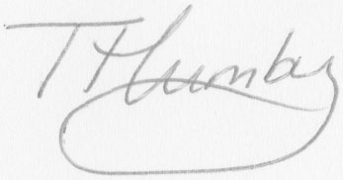
Tuesday Humby
Principal

