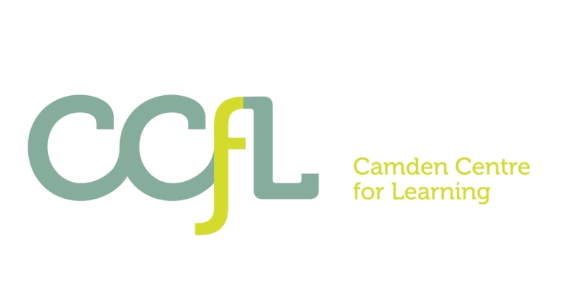

Camden Centre for Learning

(CCfL)

Information to Candidates

2017-18

Our Vision

- Challenge Yourself - We believe every student and adult should challenge themselves to achieve their best and achieve their potential.
- Celebrate Achievement - We personalise our learning programmes to ensure all students can achieve and we take every opportunity to celebrate student achievements at all levels.
- Focus on Success - We focus on what a student can do, identifying individual targets to support students to succeed in the next step in their learning as well as to make the right choice in their behaviour.
- Learn for Life - The education we provide is designed to improve a student’s life chances and supports a student’s learning not only whilst they are in school but at all stages of their life.

Director CCfL: Ms Jeanette Lowe

Head of Key Stage 3 School: Ms Gabriella Thomas

Head of Key Stage 4 School: Ms Liz Rattue

Camden Centre for Learning (CCfL)

What are our Aims?

- To provide high quality local provision for secondary aged students with SEBD who are unable to access mainstream provision.
- To provide a more flexible continuum of provision to meeting students’ needs from short term re-engagement programmes to long term placements for students with the most complex needs.
- To provide personalised learning opportunities and a broader more flexible range of curriculum pathways to ensure all students can achieve.
- To provide coherent and integrated multi agency provision for the young people and their families and to ensure effective and responsive approaches to meeting the holistic needs of young people and their families.

Who do we cater for?

The CCfL is Camden’s educational provision for secondary aged students whose primary need is their social, emotional or behavioural development.

We cater for up to a 100 young people who require specialist SEMH provision, including students:
- identified as requiring such provision through a statement of SEN (SEMH),
- who have been permanently excluded from mainstream school, or are at significant risk of being permanently excluded, and
- requiring a managed short term intervention to prevent permanent exclusion.

How are we organised?

The CCFL is comprised of the three specialist services in Camden that currently provide support for secondary aged children and young people with social, emotional and mental health difficulties (SEMH): The SEMH Special School; the KS3 Pupil Referral Unit and the KS4 Pupil Referral Unit. The provision is predominantly organised into two schools split by Key Stage.

The CCfL has embedded support from a multi-agency team to enable a more responsive and effective approach to meeting families’ and individuals’ needs.

CCfL Multi-Agency Team

CCfL aims to provide coherent and integrated multi agency provision for the young people and their families and to ensure effective and responsive approaches to meeting the holistic needs of young people and their families.

The service for students and families at the Camden Centre for Learning includes support from an integrated multi agency team.

This support could include staff consultation and sometimes direct involvement with students and their families from members of the Multi-Agency Team.

The range of disciplines and support include:

- Family Worker
- School Home Support Worker
- Social Worker
- Clinical Psychologists
- Educational Psychologists
- Youth Worker
- Connexions Workers
- Speech & Language Therapist
- Creative Therapists
- Educational Welfare Officer
- Safer Schools Officers

What did Ofsted Say about us?

Ofsted Success

I am absolutely delighted to confirm that Ofsted has now judged both the CCfL KS3 School and KS4 School as providing a ‘Good’ education. This is a really positive endorsement of all of the fantastic work that everybody has put into making the CCfL such a success. This is a huge credit to every single one of you for your consistent hard work and commitment; It is really appreciated. Both reports are now officially out and are on the Ofsted website and I also have attached the link.

What did Ofsted say?

- Innovative leadership … has created a clear and effective vision for the future, for the school to be at the ‘cutting edge’ of providing alternative education.

- Teaching is mainly good, with some that is outstanding.

- Parents and carers report that the school’s work is highly effective in helping their children re-engage with education.

- Staff have created a safe and secure place where students are nurtured and are able to thrive.

- The interesting range of subjects enables all Year 11 students to leave with relevant qualifications that prepare them well for the world of work, training and further education.

Where are we located?

The provisions are located predominantly on two school sites: one focusing on Key Stage 3 and one on Key Stage 4.

The provisions are currently located at the following sites:

- CCfL Key Stage 3 School
Head of Key Stage 3 School: Ms Gabriella Thomas
Harmood Street, London NW18DP
Tel No: 020 7974 3953 e-mail: gabriella.thomas.ccfl@camden.gov.uk

- CCfL Key Stage 4 School:
Head of Key Stage 4 School: Ms Liz Rattue
Agincourt Road, London, NW3 2NY.
Tel No: 020 7974 8906 e-mail: liz.rattue.ccfl@camden.gov.uk

