Haileybury Almaty: Appointment of Primary Teacher
Candidate information
The Role and the Department
The primary department provides the foundations for success at Haileybury Almaty. The department is staffed with talented teachers and teaching assistants who have the opportunity to teach and develop hard-working and motivated pupils in small classes. Pupils benefit from a broad curriculum, as well as specialist teachers, a wide range of extra-curricular activities, and excellent pupil voice opportunities. We are seeking to appoint individuals who have a positive attitude, are dedicated, reflective, and keen to continue their own professional development (a range of professional opportunities is offered). Positions of responsibility within the department may be available and can be discussed either at interview or via email.

If you would like any further information please contact the Head of Primary, Matthew Aston, on M.Aston@haileyburyalmaty.kz.
What are we looking for?
Our aim is to appoint excellent staff who will work hard, be good team players, support the ethos of the school, and bring something new to the strong primary team at an exciting time in the school’s development. Applicants should be native English speakers (or fluent to native speaker standard) and hold a recognised teaching qualification. The majority of our staff are from the UK, some with prior international experience and others with none, but we also have staff from other parts of the world who add to the international flavour of the school.

A full job description and person specification is provided on the following pages.

HAILEYBURY ALMATY
JOB DESCRIPTION: PRIMARY TEACHER
Responsible to: Head of Primary
Post: Class Teacher Responsible to: Year Leader

RESPONSIBILITIES
Teaching and Learning:
- Plan, deliver and continuously evaluate teaching and learning activities to maximise progression in pupil learning
- Ensure effective differentiation by planning activities for the whole class, groups and individuals, which challenge all pupils.
- Ensure there are opportunities for independent and collaborative learning.
- Ensure there are opportunities for peer and self-assessment to support learning.
- Ensure effective behaviour and resource management.
- Identify clear learning objectives specifying how pupils will be taught and assessed and ensuring the best use of teaching time.
- Use a variety of teaching strategies to ensure high levels of pupil interest.
- Set high expectations.
- Identify and cater for pupils who, are very able, have Special Educational Needs, are Gifted and / or Talented or are not yet fluent in English.
- Provide clear structure for lessons, maintaining pace and challenge.
- Integrate opportunities wherever possible to contribute to the pupil’s personal, moral, social and cultural development e.g. assemblies, House Days.
- Be proactive in providing opportunities for, and encouraging pupils engage in, leadership activities.
- Establish a safe, supportive, attractive and stimulating learning environment.

Monitoring, Assessment, Recording and Reporting:
- Assess how well learning objectives have been met and use this assessment to improve specific aspects of teaching.
- Mark and monitor work, providing constructive feedback and set targets for pupils’ progress.
- Assess and record each pupil’s progress systematically and use records to ensure that pupils make demonstrable progress.
- Provide written reports, relating to the pupil development and learning.
- Ensure assessment informs future planning.

Other Professional Requirements:
- Establish effective working relationships with professional colleagues.
- Set a good example to pupils through personal presentation and professional conduct.
- Build and maintain co-operative relationships with parents and communicate with them on pupils’ learning and progress, drawing attention to special skills and talents, as well as problems or difficulties.
- Keep up-to-date with current educational developments and practice.
- Participate in arrangements for further training and professional development as a teacher.
- Participate, if required, in any Staff Appraisal policy and procedures.
- Participate in meetings at school, which relate to the curriculum for the school or the administration or organisation of the school, including pastoral arrangements.
- Have a working knowledge of school policies and procedures.
- Undertake other duties as the Headmaster may reasonably direct.
EAL
All staff of Haileybury Almaty must remember that, in addition to the responsibilities set out in this Job Description, they are also teachers of EAL to all pupils. Many pupils at HAL have English as a second language, so if they are to achieve their maximum academic potential, it is important that staff take a proactive approach to reflect upon how they can further encourage pupils to develop their English language. All staff must follow and promote any EAL policy and procedures as set out by the school.

HAILEYBURY ALMATY
PERSON SPECIFICATION: CLASS TEACHER

The successful candidate is likely to have most of the following:

Qualifications
- Excellent degree with QTS or equivalent
- Evidence of study at post-graduate level or beyond as appropriate is desirable

Experience
- Sound teaching experience and successful results
- Teaching experience at either Key Stage 1 or 2, focused on improving the standards of teaching and learning
- Evidence of successful experience in academic and pastoral responsibilities

Personal qualities
- An enjoyment of working within a school environment and with young people
- Ability to use a variety of teaching styles and techniques to inspire pupils
- A commitment to principle centred leadership and respecting others
- Presence which inspires others
- Ability to develop and maintain excellent working relationships with all members of the school community and in particular that of the key stage
- A clear vision for and commitment to delivering the highest standard of education
- Excellent interpersonal and communication skills including the ability to communicate verbally with, and write reports on, all key stage members
- Ability to work well independently and under pressure and to meet targets
- Sound judgement and integrity
- Ability to use creativity, enthusiasm and a positive attitude to problem solving
- Good health, stamina, resilience and a sense of humour

Professional Competence
- Thorough knowledge and understanding of current education and /or leadership issues
- Understanding of, and ability to, implement key stage level planning, monitoring and evaluation strategies
- Ability to understand and systematically implement key stage procedures in line with whole school policy to raise all standards of pastoral care
- An understanding of the cycle of target setting, monitoring pupil progress and the identification of intervention strategies to meet the needs of individual students in order to improve standards
- An understanding of working with data to monitor pupil progress is desirable
- Ability to efficiently organise staff, others and resources
- Good ICT skills
Haileybury Almaty
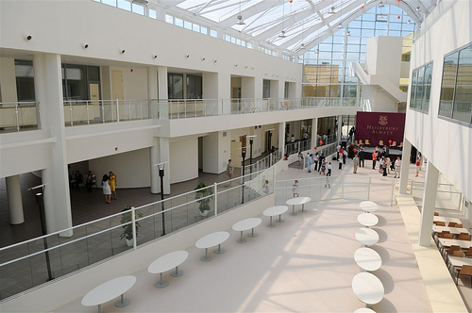
Haileybury Almaty opened in September 2008, followed by its sister school, Haileybury Astana, in 2011. Both schools have strong ties with Haileybury, the famous and highly successful British independent school, which dates back to 1862. The financial backers of Haileybury Almaty aspire to the standards of the best UK independent schools and they take a keen interest in the school, motivated by the desire to see it fulfil its potential. As a not-for-profit organisation, all operating surpluses are reinvested in the school. The majority of governors are also governors of Haileybury UK and therefore bring with them a wealth of experience. The UK-based governors visit the school twice a year, and there are also opportunities for staff to visit Haileybury UK and Haileybury Astana to share ideas with our colleagues there.
The pupils are approximately 75% local and 25% expatriate and the medium of instruction is English. The quality of English of the local pupils has improved significantly in recent years. All prospective pupils have to pass an admissions test to ensure they will be able to access our courses in English. The children here are pleasant and hard-working and a delight to teach.
As a young school, Haileybury Almaty is still evolving. The school is already established as the leading school in Kazakhstan and pupil numbers have increased every year. Pupil numbers currently stand at about 600, with a growing and thriving Sixth Form. The school already enjoys excellent facilities and an attractive, award-winning building, with plans for further construction projects in the future. Staff who come to work here need to share our vision - to provide a high quality education to prepare our children for tomorrow’s challenges - and ideally be committed to remaining beyond their initial two-year contract period. In return we are committed to the training and development of our staff.

The City of Almaty
Almaty is the cultural and commercial capital of Kazakhstan. Although Astana has been the capital of Kazakhstan since 1997, Almaty remains the largest city in the country by a wide margin, with a population of over 1,500,000 people. Its beautiful location and vibrant city life continue to attract families and ambitious young professionals from across Kazakhstan, as well as a diverse expatriate population from across the world.
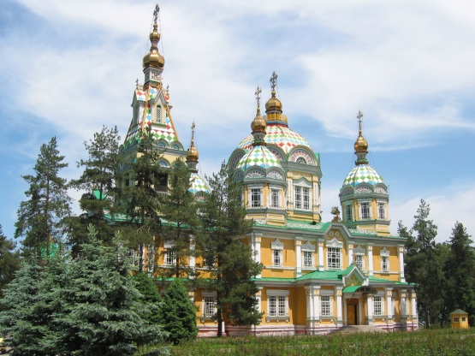
Located among the foothills and rivers of the stunning, snow-capped Tien Shan mountains, with the grassy steppe stretching away to Lake Kapchagai and Lake Balkhash to the north, Almaty enjoys sunny summers and crisp, dry, snowy winters, divided by a gorgeously colourful autumn and a refreshingly green spring. Almaty’s charmingly diverse architecture varies from the wooden nineteenth–century Zenkov Cathedral and colourful Tsarist-era academic buildings, to imposing Soviet concrete blocks, to the present day’s dazzling steel-and-glass towers and glitzy designer shopping malls. Almaty is blessed with an abundance of trees and parks - and like Kazakhstan in general, is a very family-oriented and child-friendly place to live.

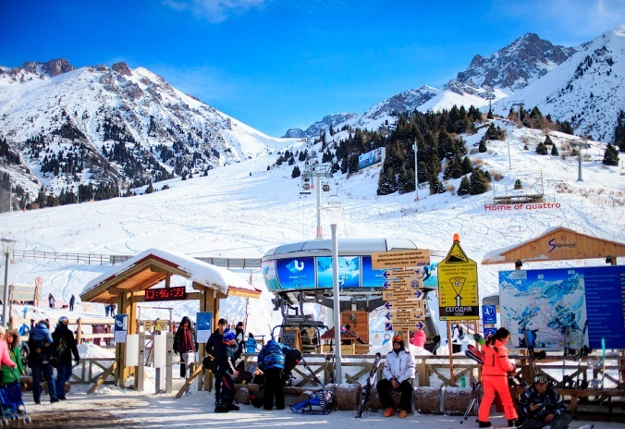
The city and its environs are ideal for outdoor pursuits such as hiking and mountaineering, running, road cycling and mountain biking, and of course winter sports such as ice-skating (on the world’s highest ice rink!), skiing and snowboarding at the Shymbulak ski resort – which can be easily reached within an hour by bus and cable car from the city. Other sights in the region include Great Almaty Lake and Charyn Canyon. Cultural life in the city includes numerous concerts, opera, ballet, English-language cinema, as well as an enormous variety of shopping, dining, bars and nightclubs, and the twin Kazakh obsessions of sushi and karaoke!

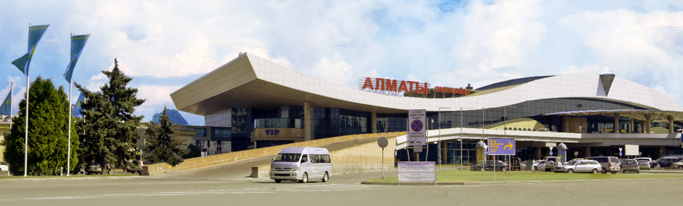
Almaty International Airport in is well served by a range of carriers with excellent links to many global hubs (including London, Amsterdam, Frankfurt, Moscow, Istanbul, Abu Dhabi, New Delhi, and Beijing) with new destinations being added regularly. Popular carriers include British Airways (flights to London via Astana take around 8 hours), Turkish Airlines, Lufthansa, and KLM. The national carrier Air Astana is rapidly expanding, and offers a high quality service to a wide range of destinations within Kazakhstan as well as internationally.
Living in Almaty
Almaty has all the advantages of a major city with few of the disadvantages. There is plenty to see and do and the city has a youthful, cheerful atmosphere. The range of cafes, bars and restaurants is similar to that of any western European capital and you will instantly recognise many of the products on sale in supermarkets. Some goods you can buy in the UK are hard to get and there may be one or two things you will miss, but on the whole shopping and cooking here are straightforward. The cost of living is similar to that of the UK, with some goods being relatively cheap here and others more expensive, especially imported electrical goods. Kazakhs love children and Almaty is both safe and welcoming for children. There is a good and very cheap network of buses, trams, and metros in the city, though you can get to many places on foot. Taxis are plentiful and inexpensive.

The biggest challenge in Almaty can be the extremes of weather. It is hot in the summer months and can be very cold in the winter, though frequent periods of high pressure give rise to clear, blue skies throughout the winter which allow you to enjoy the dramatic scenery. Although the winter temperatures sound daunting, it is a dry cold with little or no wind, and with the right clothing you will encounter few difficulties. Winter often feels colder in the UK than in Kazakhstan, even if the temperatures in Kazakhstan are lower!

An increasing number of locals in Almaty speak at least some English, but learning basic everyday Russian is worth the effort, as this is the language used in shops and restaurants. Using some Russian and being able to say please and thank you in Kazakh will be appreciated. Kazakhstan is quite bureaucratic, which can be frustrating, but Haileybury staff enjoy the support of an excellent and multilingual administration team. They will, for example, take care of all the paperwork involved in opening a bank account. Teaching assistants are also nearly all trilingual and many have teaching qualifications. There is a growing expat community here and it easy to build up a circle of new friends and acquaintances relatively quickly. Staff turnover is low and many staff are on their second or third contracts – and some who have been at Haileybury Almaty since the day the doors opened!

Terms and Conditions
Contracts are for two years and can be renewed for one, two or three years by mutual agreement. Staff receive their salaries tax paid, so earn significantly more than in the UK. Basic salary is calculated according to the number of years of relevant experience post qualification to a maximum of £35k. There is a generous gratuity payable at the end of each contract. In addition to the basic salary, staff are paid an extra 10% to contribute to a private pension scheme should they wish to do so. One annual return flight to the country of residence and a generous baggage allowance at the start and end of contract are also included. This includes spouses and dependent children if applicable. There is plenty of excellent accommodation in Almaty and staff are consulted in finding suitable accommodation to meet their needs. The school offers the highest level of healthcare protection through BUPA and staff here have 24/7 access to high level medical care delivered by English-speaking practitioners via the SOS Clinic. Staff have free bus travel to and from work, and free lunches. Staff children can attend the school assuming that they meet the entry criteria and places are available. Fees are not charged for the children of staff.

Application procedure
Applicants should hold a recognised teaching qualification and be either native English speakers or fluent in English to native speaker level. Applicants should send a current CV, including photo, with the names of at least two referees who have knowledge of their work as a teacher, one of whom should be their current or most recent employer.

The school is committed to the safeguarding of children and requires DBS checks or equivalent of potential new employees to ensure that there is no reason why they should not work closely with children.

Initial interviews will be by video, followed by Skype interviews for shortlisted candidates. Applications should be addressed to the Headmaster and sent to Kathryn Walsh at Haileybury UK at Almaty.Recruitment@haileybury.com .

Lynne Oldfield
Headmistress
September 2017

Haileybury Almaty Mission Statement and Aim
“Achievement for All”
Mission Statement
To provide our community with an educational experience which enables our students to fulfil their potential academically, physically, culturally and socially within a global and future context.
Aim
Our aim is to develop pupils who are resilient, resourceful, courageous, inquisitive, organized, and reflective in all that they do. Together, these qualities are known as the ‘Haileybury Habits’.
To achieve this aim, we:
- demand high standards of academic endeavour and personal development through a balanced and challenging curriculum, complemented by a rich extra-curricular programme;
- encourage our students to demonstrate ethical behaviour and to develop a keen understanding of their rights and responsibilities, the need for both teamwork and leadership, and the importance of contributing fully to society;
- reflect in ethos and action the traditions, values, heritage and cultural diversity of the Republic of Kazakhstan and Haileybury School.

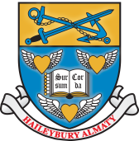
HAILEYBURY HABITS
Pupils of Haileybury Almaty are encouraged and expected to adopt the following habits.
Resilience
Our pupils do not give up at the first hurdle. They learn to set themselves challenging but realistic goals, to celebrate if they achieve them and to reflect on what they could have done differently if they do not. They try to stand on their own two feet, but know they have the support of others if they need it.
Resourcefulness
Our pupils think creatively, consider multiple approaches to problem-solving, and make full use of the resources available. They give due consideration to the ideas of others and are confident in putting forward their own ideas, however unusual they might be. Our pupils do not wait to be told what to do. They work things out for themselves and are not reliant on their teachers for everything they know. They ask the teacher as a last resort, not the first. They want to find out and do things for themselves. They generate solutions both individually and collectively and are able to think imaginatively and devise original responses.

Organisation
Our pupils understand the importance of organisation, planning, and thinking ahead in achieving success, either individually or as a team. They bring the correct materials to their lessons and are prepared to learn.

Courage
Our pupils are not afraid to take risks and make mistakes. They understand that taking on new challenges is important for their personal development, regardless of success. They stand up for what they believe in, challenge injustice and have a strong sense of right and wrong. They take responsibility for their actions. They respect the views of others but are not afraid to question them.

Inquisitiveness
Our pupils enjoy learning for its own sake. They see lessons as part of a learning process and undertake further research and enquiry outside the classroom. They use a wide range of resources intelligently and appropriately to support their learning. They are interested in what others have to say, and in the languages, cultures and beliefs of other communities around the world.

Reflection
Our pupils reflect on their experiences and are aware of their strengths and weaknesses. They know how to accept both praise and criticism and use both to become better learners and better people. They understand the need to develop physically and emotionally as well as intellectually and seek ways to achieve personal well-being.

As global citizens, our pupils are also aware of inequality and actively look for ways to make a difference. They are aware of global issues and have a social conscience. They understand their responsibilities as global citizens and as the future leaders in their fields. They help and support others without prompting. They understand and accept the differences in culture, language, appearance and beliefs of others, actively support the concept of universal human rights and treat all people with equal respect.

