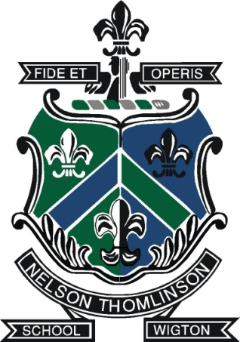

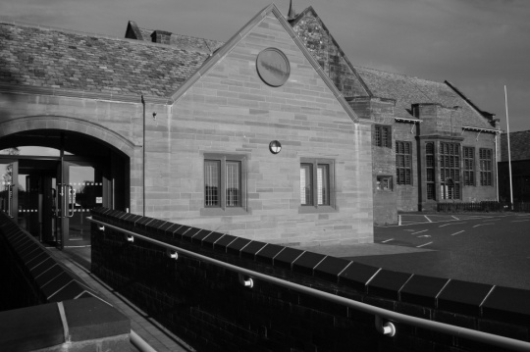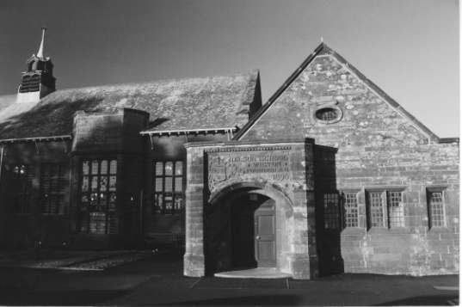

The School

Handsome listed buildings nestling amongst mature trees and surrounded by subtle new builds and extensions greet the visitor upon arrival. At the heart stands a lovely modern cloister containing the school’s original Foundation Stone and its 1995 counterpart, commemorating the unification of the school on a single site. This is a potent symbol for us: we are proud of our school’s history and see ourselves as guardians of its traditions; but we also see ourselves as continually adding to this heritage: it is our desire that tomorrow’s standards should always be higher than yesterday’s.

Nelson Thomlinson’s reputation for academic excellence is well founded. In 2006 Ofsted judged the school to be “outstanding” (a judgement that was then sustained in 2010). In May 2013, under new leadership, we were inspected again and were judged “outstanding” in all four categories. The Sixth Form was described as “first class”, the behaviour of pupils “impeccable”. We were the first secondary school in Cumbria to be judged “outstanding” under the new Ofsted framework.

In terms of A-level results, the school has been one of the top performing comprehensives for many years, with around a quarter of all entries being A/A*. On average, around four students take up places at Oxbridge every year, and one is currently studying at Yale University in the States. At GCSE around three-quarters of our pupils tend to gain 5 or more A*-C/9 - 4 grades including English and Maths and about 80% gain 5 or more ‘higher grades’. Our EBac figure is generally around 10% higher than the national average.

Teaching and Learning are at the heart of all we do at NTS and in order to give staff the freedom to teach without the need for ‘crowd control’, we insist on the best possible conditions for learning. It is this more than anything, perhaps, that impresses visitors to the school. For us, “outstanding” behaviour and “outstanding” teaching and learning are inextricably linked. “Strong leadership” (Ofsted, May 2013) ensures that no stone is left unturned in our pursuit of excellence. (Most of our senior managers hold Masters degrees in Educational Leadership.) Our systems and routines are neither trendy nor complicated. Instead they are based on common sense, with constant self-reflection and self-evaluation driving everything we do.

Whilst NTS prides itself on stretching every pupil academically, including the most able, it is equally proud of its Learning Support Department, its traditions and its vibrant extra-curricular life. More than anything, though, NTS defines itself by its focus on pedagogy and teaching methodology. (We were the first school in the country to have a mirror-sided classroom.) And importantly, our vision for the school is never based on the latest fad - it stems from real issues at grass roots.

The Nelson Thomlinson School has close links with the local community. Located in a small industrial West Cumbrian town, there is nothing inevitable about the success of the school. Our strong current position is based on many years of developing a culture of high expectations and aspiration among pupils, parents and staff alike. We are not a paper-driven school and prefer to follow principles rather than policies.

There are some key mantras at the school that are as relevant today as they were when introduced twenty years ago: “Would it do for my child?”/“Get your improvements in early” /“A story for every child”. More than any jargon or cycle of initiatives we find that these mantras keep us true to our core business - delivering high quality education to every one of our pupils.

Performance management is rigorous at NTS at all levels but whilst accountability is a priority, we pride ourselves in ensuring that we offer support. Underpinning our success is our Professional Development (PD) Department, a team of outstanding teachers who have an additional responsibility for continual professional development and the quality of learning. We have also designed a unique, in-house intervention initiative called the Complete Learner Programme. (Here PD staff help pupils to identify different aspects of learning and oversee the pupils’ observation of their own peers.) The PD Department has delivered training sessions at other schools, has worked on behalf of the Local Authority and has run numerous twilight training sessions for the benefit of all secondary school staff within a twenty-mile radius.

Whilst excellent exam results are a key priority of the school, we deeply value the importance of extra-curricular activity in developing our pupils, and our PE, Art and Music departments lead the way in offering high quality activities. Our sports teams have seen success at county and regional level and we have individuals who represent England and Great Britain in their sports. The Music department consistently delivers an extensive programme of events and activities. In July 2011 we organised and hosted the first Cumbrian International Expo as part of the Connecting Classrooms project and more recently we were awarded International School Status by the British Council.

Indicative of the community-based nature of the school is our relationship with the local factories, Innovia and Futamura, world leaders in the manufacture of polypropylene and cellulose films. It has a modern research and development centre in the heart of the town and is the largest employer in the area. In May 2010 Innovia Films received the Chemicals North West Corporate Social Responsibility Award, which directly recognised and championed the unique relationship it has with NTS. Recently we have been cited in CBI submissions to the Government on Business Investment in Skills as an example of good practice for other schools and companies.

Our pupils and staff are fiercely loyal to their school and the local community values what we do. Above all, at The Nelson Thomlinson School you will find a happy and purposeful atmosphere where staff genuinely enjoy teaching and pupils are enthused about learning. Our annual staff social event, hosted by a local hotel, sees colleagues dancing to the live music provided by our own staff band, whilst weekly events include staff choir and five-a-side football. As Head I conduct work-life balance interviews with all staff, irrespective of their role in the school.

More details can be found in our prospectus or on our website: www.nts.cumbria.sch.uk

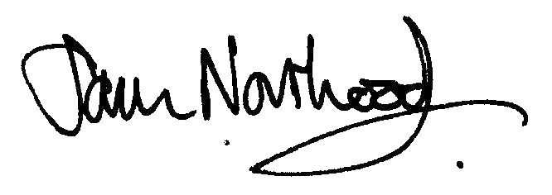
Mr DS Northwood
Headmaster

