Overview

The Director of Learning’s role is to lead the school’s teaching staff team to ensure successful implementation of our unique curriculum, to enable our students to achieve excellence and be well prepared for the global challenges of the 2st century.

The Director of Learning is expected to work collaboratively with the Director of Progress and Achievement & her teams to ensure the best possible learning experiences and outcomes for every one of our students.

To ensure that effective learning and teaching takes place consistently throughout the school, the Director of Learning is expected to inspire and support the curriculum coordinators and Heads of Faculty in delivering the curriculum.

Working relationships:

- The Director of Learning (DL) reports directly to the Principal.
- The DL will be a member of the Executive Leadership Team (ELT), together with the Director of Progress and Achievement, Director of Administration and Director of School Operations.
- He/she will lead curriculum initiatives, working primarily with Curriculum Coordinators for HKDSE, IBDP and IBMYP, and the 8 Heads of Faculty.
- Additionally he/she will also work with Heads of School, Head of Experiential Learning, the Learning Support Coordinator, the Teacher Librarian and other key staff.

Key responsibilities:

- Leading the review and implementation of the CSS curriculum, embracing the IBMYP, HKDSE and IBDP and associated pedagogical approaches; ensuring that our curriculum fully meets the needs and aspirations of all our students.
- Working with the Director of Student Progress & Achievement (DSPA) to lead a whole-school, evidence-based, value-adding approach to develop policies & practices to
  - enhance the quality of teaching and learning processes,
  - raise students’ ability to access the English-based curriculum
  - develop students’ engagement, motivation and approaches in learning
  - monitor & improve students’ progress and academic achievement.
- Supporting the Principal’s decision-making on staffing, and working with Heads of Faculty and Assistant Principal (Administration) to devise the school’s timetable that will implement our curriculum goals.

- Take on a share of whole-school responsibilities & duties.

Attributes, Expertise and Personal Qualities

- Culture, context & communication – ability to
- Embrace CSS’s culture that uniquely integrates Chinese and International educational ideals;
- Understand our specific challenges of operating a DSS school in the HK context;
- Communicate effectively with our diverse range of stakeholders.

- Student Learning & subject teaching expertise – demonstrating
- A track record of highly effective teaching & learning, in MYP as well as both IBDP and HKDSE preferred.
- Expertise in lesson observation & constructive feedback to teachers.
- Management & leadership - possessing
- expertise in teaching, learning & curriculum development,
- experience of previous schools where academic & pastoral domains are closely integrated is preferred

- Personal qualities – having
- Positive habits of mind and reflective practitioner
- Friendly personality and strong interpersonal skills
- Energy, initiative and ability to inspire and motivate people & teams
- Management of Change – understanding
- The theory and practice of change management and school improvement

Please refer to the addendum below for background of the school and further details of the position.

Background Information

A special kind of state school

Creative Secondary School is a co-educational day school located in the town of Tseung Kwan O in Hong Kong. The school began its operation in September 2006. Currently there are 720 students from Form 1 to Form 6 (equivalent to grade 7 to grade 12). Our first cohort of students graduated in August 2012. Typical class sizes are 20 – 25 in Form 1 to Form 4, and 10 – 20 in Form 5 & 6.

CSS is part of the state sector, operating under the Hong Kong Education Bureau’s Direct Subsidy Scheme (DSS), thus receiving the same funding per student as other Hong Kong state schools. DSS schools are privately operated and can hire their own staff, charge fees to enhance quality and introduce curriculum innovation. They must operate without profit-taking, must set aside a proportion of school fee income to offer grants to students in financial need and scholarships to talented students, and must principally offer the Hong Kong curriculum. CSS is governed by its own Board of Directors. (Please see school website for details).

CSS is the first DSS school to become an IB World School. It was authorised in Feb 2009 to offer the IB Middle Years Programme and in April 2010 to offer the IB Diploma. Before that, no other IB World Schools in Hong Kong offered the Hong Kong curriculum. Now there are several other DSS schools authorized as IB World Schools, but CSS remains the only MYP-authorised DSS school. Our affiliated Creative Primary School was authorized in the summer of 2011 and became the first and only Cantonese Chinese medium IB PYP school in the world.

CSS was reviewed in May 2012 by the Education Bureau. The report concluded:

“CSS values and commits itself to students’ all-round development. A wide range of activities is organised to achieve the aims of enabling whole-person development and to help students to develop life-long learning capabilities. Meticulous effort has been made in developing a school-based curriculum which lays equal emphasis on academic advancement, personal growth and fostering positive attitudes. Small group teaching is extensively implemented, with appropriate curriculum adaptation, ability grouping and differentiation strategies in place to cater for the diverse learning needs of students. Assessment for learning is widely and effectively practised. Due attention has been paid to fostering students’ creativity and international-mindedness. Students’ interests and potential are developed and realised through inter-disciplinary and inquiry-based learning. CSS sees the importance of school self-evaluation and demonstrates strong readiness to move from good to best.”

Likewise the school has had a positive evaluation of its IB Middle Years Programme implementation in 2013, and of its IB Diploma Programme in 2015. Both programmes are due to be evaluated by the IB again in 2019.

The student body and school culture
Our student body is around 85% ethnically Chinese, mostly native speakers of Cantonese, the city’s most widely spoken language. Around 5% are Chinese students from overseas. There are also a small but increasing number of native speakers of Putonghua, the national language of China. The other 15% include Caucasian, Filipino, Indian, Japanese, Korean, Nepalese and Pakistani students. There are over 15 nationalities represented in the student body. A good number of students will have more than one nationality / passport.

In 2010 CSS received the Inviting School Award from the International Alliance for Invitational Education (www.invitationaleducation.net). This was followed by the IAIE’s First Silver Fidelity Award received in 2015.
CSS has an active PTA and an elected Student Council. Students are organised into six Houses, named after 6 common trees in Hong Kong and they elect their House captains. All teachers belong to a house and act as house tutors to support student guidance and achievement, together with our guidance counsellor, careers adviser and a school-based social worker.

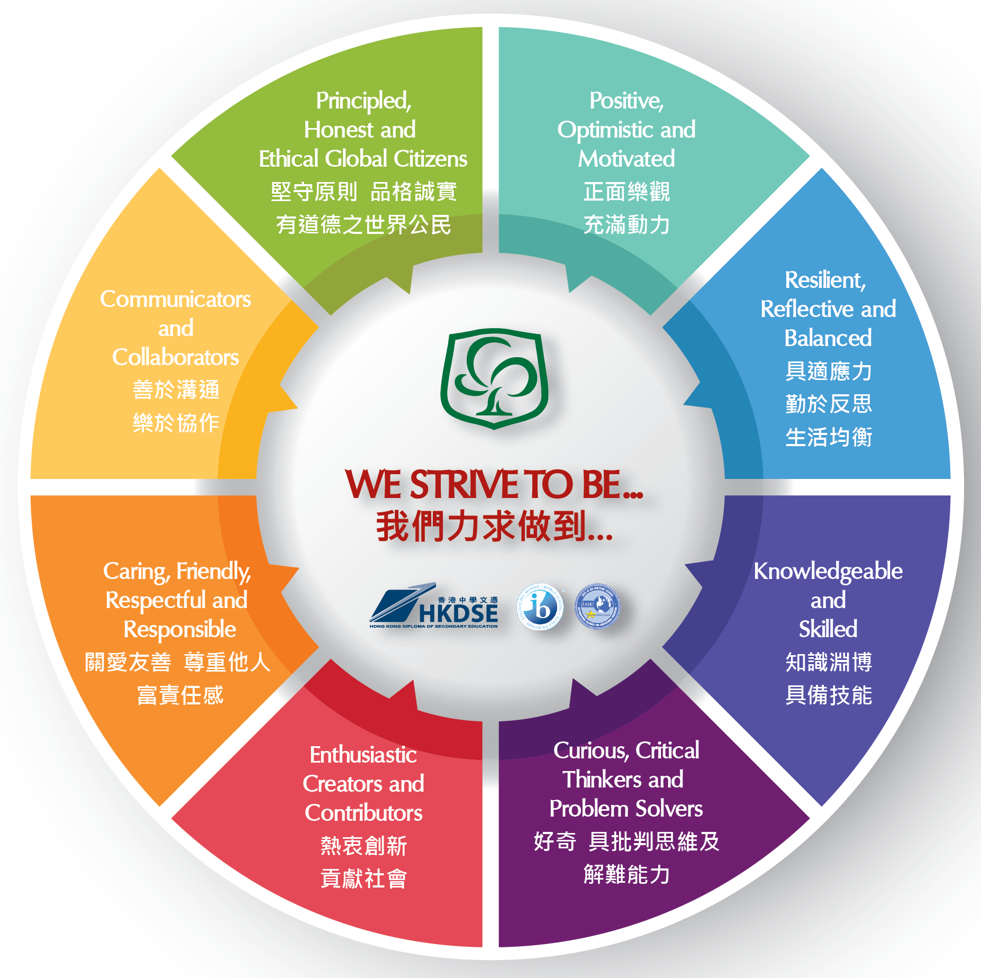

The CSS curriculum

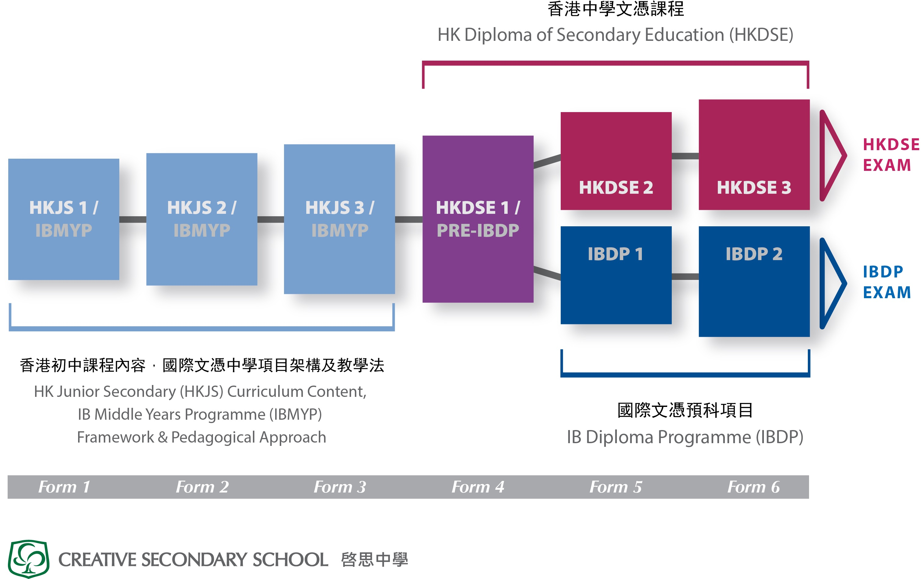

As a Direct Subsidy Scheme (DSS) school we principally offer the Hong Kong secondary school curriculum (www.edb.gov.hk) The junior secondary curriculum, operating from Form 1 to Form 3, is delivered through the framework of our three year IB Middle Years Programme.

Form 4 is the first year of the three-year Hong Kong Diploma of Secondary Education (HKDSE). In the Hong Kong Diploma of Secondary Education (HKDSE), students study 4

core subjects – Chinese Language, English Language, Liberal Studies and Mathematics, follow a programme of Other Learning experiences (OLE) which includes Physical Education, and choose up to 3 elective subjects. At CSS students can choose from the following:

Curriculum Area | Elective Subject Courses
Sciences | Biology, Chemistry, Physics
Humanities | Geography, History, Economics
Arts | Visual Art, Music
Technologies | Business, Accounting & Financial Studies (BAFS), Design & Applied Technology (DAT), Information & Communication Technology (ICT), Technology & Living (Food)
Mathematics | Mathematics Module 1, Mathematics Module 2
Languages | English Literature

Students who wish to opt for the IB Diploma will apply during Form 4, and the school will decide which students would be offered this option. Under the Government’s guidelines for DSS schools, at least 51% of F5 students must follow the HKDSE.

In the IB Diploma Programme, CSS offers the following subjects to students:

Curriculum Area | Elective Subject Courses
Language & Literature | Chinese Literature, English Language & Literature
Language Acquisition | English Language B, Chinese Language B, Spanish ab initio (online)
Individuals & Societies | Business Management, Economics, Geography, History
Sciences | Biology, Chemistry, Design Technology, Health Exercise & Sports Science and Physics
Mathematics | Mathematics HL, Mathematics SL, Mathematics Studies
Arts | Music, Visual Art, Theatre

Currently CSS is exploring the benefits and feasibility of offering the IB Careers-Related Programme (IBCP), to students that do not find either the IBDP or the HKDSE suitable for their development.

Language courses and languages of instruction

CSS offers Chinese and English courses to all students. Both languages are offered as Language & Literature (first language) and as Language Acquisition (2nd language) courses. About 30% of students study English as a first language and about 80 % study Chinese as a first language. About 20 % of students study Chinese Language Acquisition and about 15% study both English and Chinese first languages courses concurrently. For most students, English is their second language and many of them typically switch over from Cantonese-medium primary education to English-medium learning at CSS. Supporting their successful transition is a major whole-staff effort; all teachers are also expected to be teachers of language and expected to model good use of instructional language.

Students with other home languages are encouraged to maintain these and study them to examination levels. In the IB Diploma, we offer ab initio Spanish as an online course. In the HKDSE, we offer Chinese GCSE to students who do not speak Chinese as a home language, and encourage students to consider taking the GCSE examination in their home language whenever possible.

Chinese is taught through the medium of Putonghua From Form 1 to Form 4. In both Diploma programmes, students following Chinese first language courses may opt to be taught through the medium of Cantonese or Putonghua in HKDSE as well as in the IB Diploma. All other courses throughout the school are delivered through the medium of English.

Languages are also supported through a number of co-curricular activities – debating in English, Cantonese and Putonghua; drama in English & Cantonese; French, Korean and Spanish as club activities etc.

Experiential Learning

There is a rich programme of experiential learning that teachers and support staff contribute to. This includes co-curricular activities after school and on weekends, combined CAS / OLE programme for F5 & F6, exchange programmes with schools beyond Hong Kong (Denmark, Edinburgh, New York, Hangzhou) and Creative Week. During Creative Week, the school timetable is suspended and students and staff participate in camps, service excursions, overseas study visits or work-related experiences.

Examination results & Destinations of Graduates

IBDP average score over the past 6 years is around 34 pts. HKDSE results have averaged around 19 points for 6 subjects. Well over 90% of students continue to tertiary education. About half remain in Hong Kong, and the UK is the most popular overseas destination. The school is proud of its value-added track record, given that it is open to students of all abilities and backgrounds, subject only to their ability to access the curriculum delivered through the medium of English.

Leadership and management of the staff team

There is a teaching staff team of 84 full-time teachers, 3 part-time teachers and several assistant teachers, together with the Principal and two Vice Principals, both of whom will retire this year.

The teaching team is strongly collaborative, inter-culturally aware and good-humoured, with an exciting synergy between local and overseas colleagues from over a dozen countries. Biographical sketches of all teachers are on the school website.

The school is committed to promoting teachers’ professional growth and development through training opportunities, collaborative curriculum planning and sharing of good practice.

The school’s leadership team for 2018 – 19 will consist of the Principal and 4 Directors:

- Director of Progress and Achievement
- Director of Learning (position advertised)
- Director of Administration
- Director of Operations

The Director of Progress & Achievement is Kellie Fagan, who is currently also Head of Upper School. She oversees the work of the three school sections and Head of Experiential Learning. The heads of lower, middle and upper school sections are each responsible for student progress & achievement in two horizontal year groups, coordinating the work of house tutors. The Director of Progress & Achievement also oversees three other teams – careers, learning support, and guidance counsellors.

The Director of Learning will oversee the work of the MYP, IBDP and HKDSE curriculum coordinators, eight Heads of Faculty (English, Chinese, Mathematics, Physical Education, Science, Individuals & Societies, Arts and Technology), and the teacher librarian. Currently the 3 curriculum coordinators are sharing the Director of Learning role.

The Director of Administration is Assistant Principal Mr P.K. Poon. He oversees the work of the school office, including finance, procurement, student data management, supply cover, timetabling and other aspects of school administration.

The Director of Operations is Mr Cassy Yu. He oversees the day-to-day operations of the school (ICT, AV support, campus maintenance and other services), 3 way conferences, scheduling of school reports, and key events such as the Open Day & Graduation.

Cheung Siu Ming
Principal
csm@css.edu.hk
October 2017

