Vacancy: ASSISTANT HEADTEACHER
(Maths)
School Particulars

‘Staff are proud to work for the school‘, Investors In People Gold Award July 2015
‘Staff morale is outstanding,’ ‘The whole team works exceptionally well to ensure that pupils have a good opportunity to thrive both personally and academically’
Ofsted July 2016

Dear Applicant, I am very pleased that you are considering applying for a post at Northfield. I hope that you will take a few minutes to find out about the school’s many successes and achievements. Northfield School has been providing high quality education for the young people of Billingham for over forty five years. During this time the school has gone through several changes. With its latest transformation now complete, students have state of the art facilities in which to thrive.
In July 2016 the school was judged as Good in all categories by Ofsted. I am very pleased and proud that the hard work of our students, staff, governors and parents has been recognised by Ofsted. I am sure that anyone reading our report will be impressed with the many positive comments about the school. The report states that Northfield School and Sports College has improved substantially since the previous inspection and recognises our academic success. Ofsted highlights that our students are proud to belong to the school, that behaviour in lessons is good and frequently outstanding and serious bullying is exceptionally rare.
The report states that the vast majority of our parents are positive about the quality of education that the school provides and also that staff morale is outstanding. The valued work of the school’s governing body, as well as the wide range of extra-curricular activities offered by the school are also highlighted in the report.
I am particularly pleased with the comment that ‘Pupils succeed both personally and academically’ whilst at the school. I am sure that we will be able to use the report to continue our journey towards excellence in all areas.
Northfield is a very popular school. Last year the school received 416 applications for the 270 places in Year 7. Of these applications, 339 placed the school as their first choice.

This year’s examination results continue to build upon our academic success with improvements in a number of key areas. This year over 56% of our students achieved at least one A*/A grade. This success builds upon our other achievements such as Gold Investors in People, Arts Gold Mark (Exemplary) award, Gold School Games Award, Duke of Edinburgh Award Flagship School and Holocaust Education Beacon School to name a few.
Ofsted and Investors in People both acknowledged the fact that staff enjoy working at Northfield. This is something that we are very proud of. We are a large staff where people admire and respect one another. I feel that our staff work very hard, but enjoy one another’s company. As well as opportunities for CPD and career development, there are many sporting and social activities open to staff. For example, in 2016, 35 staff participated in a Duke of Edinburgh weekend camping expedition to achieve their Diamond Duke of Edinburgh Award. This year, 24 members staff competed in the Yorkshire Marathon Relay race. Next year, our target is to swim the English Channel! Northfield plays a leading role in the Campus Stockton Teaching Alliance with several staff CPD courses throughout the year.
The school’s reputation for sporting success is well founded. Our girls have been national champions for table tennis for a number of years, the school has won the Teesside School Sports Awards for Girls and Team for the past two years, our girls were badminton national finalists this year and our girls’ football team played in the national finals at Wembley in 2015. In 2017, our students became national champions at Dragon Boat Racing. Last year, School Sport magazine judged the school to be in the top 10 nationally for sporting achievement.
Our success is not restricted to our students. Amongst our staff we have national and world medalists in their chosen sports and in 2014 one of our teachers was a finalist in the Teacher of the Year Award.
The school’s website contains a considerable amount of information and our students and staff regularly update its content. Indeed, you can see from our opening page how busy we are as a school. I would ask you to visit the website to find even more about developments or access up to date information about Northfield. If you are unable to find what you want, or have some suggestions on how we can improve our website, please do not hesitate to contact us.
I thank you for your time and interest. I hope that you have a positive opinion of Northfield and that you will want to be part of our success by applying for this post.
Craig Walker

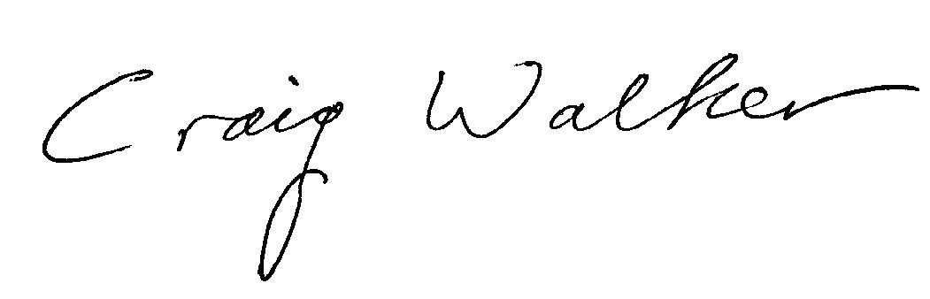
Headteacher
‘Pupils take a pride in their appearance and conduct themselves in a mature and sensible manner in lessons and around the school. They are polite, welcoming and helpful’. Ofsted July 2016

Information about the Maths Department
The Maths Department is an innovative and supportive department who seek to share their passion of the subject
with our well-motivated students. It is a successful and popular department with 6 full-time Teachers, 5 part-time Teachers and 1 full-time HLTA.
The Maths department gained 68.1% grade 4+, 36.6% grade 5+, 14.4% grade 7+ and 98.8% grade 1+ GCSE results in 2017.
The post holder will be expected to deliver the subject across all key stages and across the full ability range, following
a detailed scheme of work.

The department has access to 9 dedicated classrooms, all of which have interactive whiteboards and access to ipads; and it is well-resourced with appropriate text books.
All staff give generously of their time to benefit the students. In particular, we provide weekly revision lessons for all
of Year 11, throughout the year.

Maths tutor groups of target pupils are also created so that maths can be tackled during morning form time. We
share this equally with the English Department.

Exam board
Currently WJEC Foundation and Higher for the new 1-9 Syllabus.
Students are banded on entry into Year 7 using their KS2 results. They are then placed in sets during the 1st term onwards using half-termly tests.
All students are given an end of year target and progress is tracked regularly through department meetings and lines.

