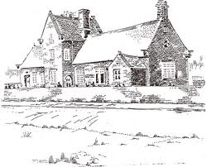
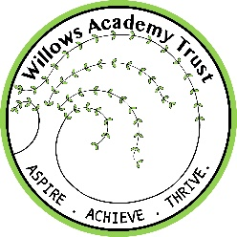
Willows Academy Trust
ASPIRE ... ACHIEVE … THRIVE
SHARDLOW PRIMARY SCHOOL
London Road, Shardlow Derbyshire, DE722GR
Tel/Fax: 01332792215 Email: enquiries@shardlow.derbyshire.sch.uk
Acting Head Teacher: Kylie Tabor

Letter from the Chair of Governors

The governing body of this successful school at the heart of a rural community are looking to appoint a new Head teacher from 1st September 2018. The school is part of the Willows Academy Trust which is made up of three other schools at the moment but is hoping to include more schools in the future.
You must have the ability to support, challenge and inspire our children to reach their full potential through the promotion of outstanding teaching and learning.
As this is a small school, with 103 children currently on role, building good relations with staff, parents and the community at large is vital.
Our values and ethos focuses on developing a love of learning, high achievement, both personally and academically, in a happy, supportive and safe environment.
The closing date for applications is 8th December and interviews will be held on 18th and 19th January 2018 with successful candidates attending on both days.
We welcome you to see our school operating during the day or after school if you are unable to visit during schools hours.
I wish you the best with your application and look forward to meeting you.

Judie Anderson
Chair of Governors

Willows Academy Trust … ASPIRE ... ACHIEVE … THRIVE … Willows Academy Trust

Company Name: Willows Academy Trust (www.willowsacademytrust.co.uk)
Company Registered No. 9093035 (England and Wales)
Registered Office: Sawley Junior School, Wilmot Street. Long Eaton, Nottingham. NG10 3DQ

