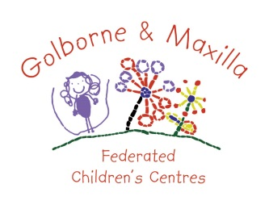 Person Specification
Golborne and Maxilla Federated Nursery Schools
POSITION: Deputy Head Teacher
GRADE: L1 – L5
CRITERIA
At this stage, you are asked to address only criteria 2, 3, 6, 8, 9, 10, 11, 13, 15 17 and 18 when completing your supporting statement. The remainder will be assessed at interview.

REQUIREMENTS ESSENTIAL CRITERIA
EDUCATION AND EXPERIENCE
E.1. Qualified Teacher Status and evidence of appropriate subsequent
professional development, learning and development of skills.
E.2. Recent, successful teaching experience in the Foundation Stage.
E.3. Experience as a leader and manager in a primary or nursery school.
E.4. Experience of staff management and ability to coach and mentor staff to high standards
E.5. Evidence of developing school policies, determining priorities and practical strategies for implementing them

PERSONAL QUALITIES
E.6. Enthusiasm, resilience and the personal and intellectual qualities required to develop the team, listen, support and lead others.
E.7. Curiosity and professional interest with a commitment to developing your own learning.
E.8. Energy, drive and commitment to achieving best practice and improved outcomes for children in early years

SKILLS, KNOWLEDGE AND ABILITIES
E.9. Understanding of child development from Birth to Five Years old, including emotional wellbeing and health issues.
E.10. Understanding of the principles of the Early Years Foundation Stage and ability to put these principles into practice.
E.11. Understanding of the importance of play and first-hand experiences to children’s development and learning, and the skills to help children develop their play.
E.12 Understanding of children’s cognitive development, how this links to emotional wellbeing, and ability to plan experiences and interact with children to develop their thinking.
E.13. A high level of competence in ICT.
E.14. Ability to listen carefully, consult with the team, communicate ideas and to make decisions clearly and decisively as appropriate, drawing on observation, evidence, and knowledge of best practice.

TEACHING AND LEARNING
E.15. Evidence of high quality EYFS teaching with high expectations
E.16. Understanding of planning and assessment for learning. Management of the learning environment inside and outside. Developing an effective partnership with parents and carers, working with other professionals to promote the learning and wellbeing of children.

EQUAL OPPORTUNITIES
E.17. Demonstrate a clear understanding of and a commitment to equal opportunities, informed by practical experience and application.

SAFEGUARDING
E.18 Ability to form and maintain appropriate relationships and personal boundaries with children and young people

