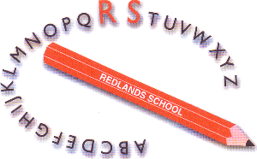

Job Description

Position: Deputy Headteacher | Salary Scale: L14 – L18
Purpose of the Job
- To assist the Headteacher in the leadership and management of the school, including taking responsibility for the school in the absence of the Headteacher

- To take full responsibility for leading and managing significant aspects of the school under the overall direction of the Headteacher

- To carry our teaching duties, as required, in accordance with the school’s policies and curriculum

- To carry out professional duties of a teacher and deputy headteacher as described in the School Teacher’s Pay and Conditions Document, including those duties particularly assigned by the Headteacher

Specific Responsibilities
- To assist the Headteacher in shaping a vision and direction for the school, setting out very high expectations and with a clear focus on pupil achievement

- To play a significant role in setting aims and objectives for the school and in formulating the School Improvement Plan along with the Headteacher, Governors and other staff

- To take responsibility for developing the curriculum and assessment procedures, in agreement with the Headteacher and in conjunction with the Subject Leaders

- To inspire, motivate and influence staff and pupils, taking a leading role in maintaining the highest standards of teaching, learning and pupil behaviour management

- To take a supporting role in improving the involvement of parents, carers and the community in the life of the school

- To support the school’s continuing professional development programme, including organising training programmes, induction, delivering INSET and working with individuals and teams in a variety of professional development activities

- To assist the Headteacher in school self review and evaluation and in the effective planning and management of school resources to secure improvements

- To maintain an informed view of standards and the quality of teaching and learning across the school

- To provide guidance and support to staff in order to improve the quality of teaching and learning

- To promote the safeguarding of children

- To carry out all duties in line with agreed school policies and procedures

- To ensure statutory policies and other legislation is adhered too

- To undertake, from time to time, any other reasonable duty as directed by the Headteacher

