How to Get Here
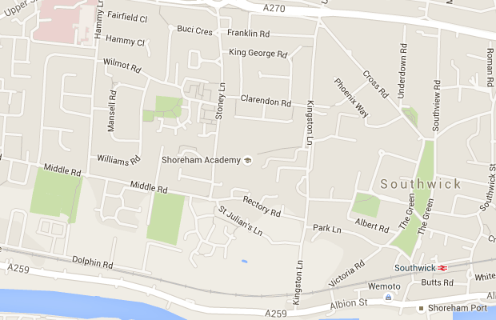

Click here for Google Maps

