The role
We are looking to appoint an exceptional teacher to the role of Teacher of Mathematics at an exciting time in our school’s development. In February 2017 the school moved into its new £16m accommodation offering excellent classrooms, including a dedicated computer suite for the department.
The successful candidate will be an impressive motivator and exceptional classroom practitioner. As a teacher of mathematics, you will help develop the taught curriculum across three Key Stages and for all abilities as we look to develop our provision in light of national curriculum changes. You will join a dedicated, experienced and well-resourced department and will receive excellent support for your own professional development.
Key Stage 3

At KS3 mathematics lessons are divided into five parts with an emphasis on problem solving skills. Pupils with special needs are supported within lessons by Teaching Assistants, although there may be small withdrawal groups in some year groups. Pupils are set challenging annual targets based around their attainment on Entry. These targets are rigorously monitored through regular skills tests and continuous assessment that highlight areas for development both for individuals and whole classes.

A Year 8 maths class working in the Academy’s new building

Key Stage 4

Pupils in both schools follow the AQA GCSE course. Typically, the top two sets sit Higher Tier with the rest of the year group sitting foundation. The department uses the textbooks for the new AQA GCSE supplemented by a host of resources which have been developed in the department. Students sit trial GCSE exams in maths in June of Year 10 and December, February and April of Year 11

Key Stage 5

Recruitment to A-Level is strong - Mathematics is currently one of the most popular A-Level in the sixth form. We also offer Further Maths A-Level to our most able students.

Lesson Structure
Students have 4 one hour lessons per week at KS3 and KS4. At KS5 students currently have 9 lessons per fortnight. To make the most of each hour lessons are structured into 5 parts, forming the acronym MATHS. Mixed Starter (M) is recap previous skills and address issues from homeworks. Acquire Fluency (A) practices previously taught skill which may be needed later in the lesson. Talk about it (T) gets the students talking to each other and discussing the best way to tackle new topics. In the Have a go (H) section students get to practice new skills. The final part of the lesson Sum it up (S) involves a problems solving task based upon the lesson objective. The 5 part lesson has proved popular, with students enjoying the structure it brings to their learning.
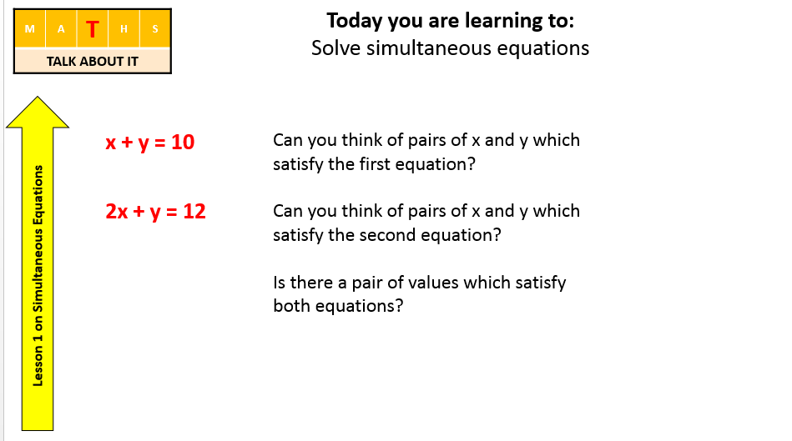
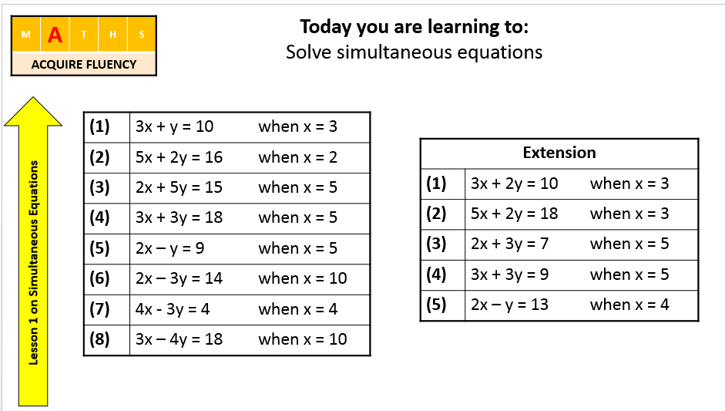
Part of a 5 part lesson on Simultaneous equations

Homework

Students are set homework every week. The department has developed ESP homework tasks, which stands for ‘Easier’, ‘Skills’ and ‘Problem Solving’. This is proving effective in preparing students for the different styles of questions in the new GCSE.

Enrichment

Each year around 30 students from each year group participate in the UKMT individual challenges. The school also enters the UKMT Team Challenges. An extra-curricular maths challengers club helps prepare students for the challenges. We have had success in both the individual and team challenges - in 2016 our junior team came third in the Cumbria heat and this year several students were invited to the follow on rounds with one student invited to the UKMT Summer School at Oxford University

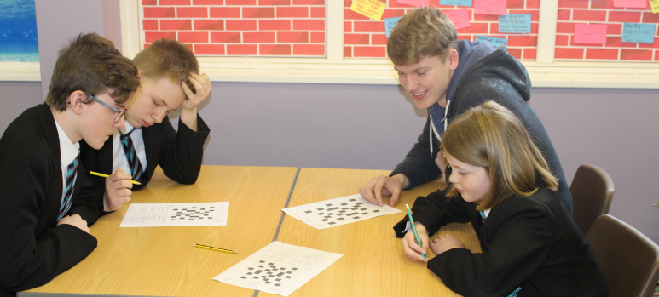

The Junior Challenge Team being trained by a Sixth Form Student

Professional Development

The department has a good record of developing staff. Two of our staff were appointed after completing a PGCE placement and both have progressed well, one of whom is now a TLR holder. We have also re-trained two non-specialists as maths teachers, supporting them to improve their subject knowledge and pedagogy. The academy offers Middle Leader development courses and also the NPQSL for those aspiring to Senior Leadership

Further Information

If you require any further information please contact Sarah Hibberts, Curriculum Leader of Mathematics shibberts@workingtonacademy.org .

